Statistical Analysis of Obesity Levels Based on Eating Habits and Physical Condition

Introduction
This report presents a detailed statistical analysis of the dataset Estimation of Obesity Levels Based on Eating Habits and Physical Condition from the UCI Machine Learning Repository. The dataset contains 2111 individuals. Each record includes demographic information, eating habits, lifestyle patterns and an assigned obesity category. The goal is to study how these features behave as random variables and how they change across different obesity levels.
The original dataset defines seven categories for the target variable NObeyesdad. These categories include Insufficient Weight, Normal Weight, two levels of Overweight and three types of Obesity. For this assignment the seven labels were grouped into four levels: Insufficient Weight, Normal Weight, Overweight and Obesity. This grouping simplifies the interpretation while preserving the main structure of the data.
The dataset is interesting because it combines continuous variables such as Age, Height and Weight with binary and categorical variables such as FAVC, SMOKE, SCC, CAEC and MTRANS. This mix of variable types allows the application of several concepts from probability and statistics. Each feature is treated as a random variable. We will focus on describing its marginal distribution, its conditional distribution given the obesity level and its ability to distinguish one group from the others.
Another motivation for analyzing this dataset is that obesity is a complex phenomenon. It depends on eating behavior, physical activity, genetic background and social context. Even though the dataset is not clinical and includes synthetic elements, it still reflects many realistic patterns. A statistical analysis helps identify which variables show strong differences across groups and which ones have weaker or subtle effects.
The main objective is to answer the following questions:
- How do the distributions of key variables change across the four obesity levels?
- Which variables have statistically significant differences when comparing groups?
- Which continuous features have meaningful discriminative power when used as one versus rest classifiers?
The next sections describe the methods used to address these questions and present the results.

Materials and Methods
The analysis was performed on the dataset.csv file. This file contains all the variables required for the analysis. The target variable NObeyesdad was recoded into four grouped levels and stored in a new variable called Obesity4. The four levels are Insufficient, Normal, Overweight and Obesity. They were treated as an ordered categorical variable. This ordering is helpful when generating tables and plots.
For each feature, the analysis first considered its type. Continuous variables such as Age, Height, Weight, FCVC, NCP, CH2O and FAF were modeled as real valued random variables. Their marginal distributions were estimated with Gaussian kernel density estimators. The kernel density estimator provides a smooth approximation of the probability density function. The estimated density was normalized numerically so that the area under the curve equals one. The cumulative distribution function was then obtained by integrating the density over a grid of points.
Binary and categorical variables such as FAVC, SMOKE, SCC, Gender, family_history_with_overweight, CAEC and MTRANS were summarized through empirical probability mass functions. For each value x of a discrete feature X the PMF was estimated as the number of observations equal to x divided by the total number of valid observations. The empirical cumulative distribution function was computed from the cumulative sum of the ordered probabilities.
To compare continuous features across the four obesity levels, the analysis used a one way ANOVA. The null hypothesis for each feature states that the four group means are equal. The ANOVA test statistic measures the ratio between the variability of the group means and the variability within groups. A large ratio leads to a small p value and suggests that at least one group mean differs from the others. When the ANOVA was significant the Tukey post hoc procedure was applied to perform pairwise comparisons between levels. The p values from the Tukey tests were adjusted using the false discovery rate method in order to reduce the risk of false discoveries when many comparisons are carried out.
For binary and categorical variables the study used contingency tables with obesity level on the rows and the categories of the feature on the columns. The chi squared test of independence was used to evaluate whether the distribution of the feature depends on the obesity level. Since the expected counts in all cells were large enough, the chi squared approximation was appropriate and Fisher exact tests were not required.
In addition to summary statistics and hypothesis testing, the analysis also computed model based conditional means and variances for continuous variables. This was done by integrating the estimated conditional PDFs for each obesity level and comparing the resulting expectations with the empirical sample moments. The agreement between these values provides a check on the quality of the density estimates.
Finally, ROC analysis was used to study the discriminative power of continuous features. For each feature and each obesity level, a one versus rest classification problem was defined. The feature was treated as a score and a threshold was varied to obtain different operating points. The ROC curve was traced by plotting the true positive rate against the false positive rate. The area under the curve was computed as a summary of performance. A bootstrap procedure with one thousand resamples was used to estimate confidence intervals for the AUC. The threshold that maximized Youden J statistic was selected as a recommended operating point and used to compute type one and type two errors.
All computations were done in Python using NumPy, Pandas, SciPy, StatsModels and scikit learn. The code was organized in a Jupyter notebook so that every step of the analysis can be reproduced.

Results
Table 1 summarizes the distribution of individuals across the four grouped obesity levels. The Obesity group is the largest with nine hundred seventy two individuals. Overweight has five hundred eighty individuals. Insufficient and Normal have fewer than three hundred individuals each. This imbalance affects the precision of some estimates, but the sample sizes are still adequate for the tests performed.
The marginal distribution of Weight was analyzed first. The kernel density estimate shows a unimodal distribution with a pronounced right tail. Figure 1 displays the estimated PDF and Figure 2 shows the CDF. Most of the mass lies between forty and one hundred kilograms, but a significant tail extends beyond one hundred twenty kilograms. This tail is driven mainly by individuals in the Obesity group.
The next step was to examine continuous variables conditioned on obesity level. Weight shows the most drastic changes across groups. The mean Weight for the Insufficient group is around fifty kilograms. For Normal it increases to above sixty kilograms. For Overweight it rises to approximately seventy eight kilograms and for the Obesity group it reaches more than one hundred nine kilograms. The confidence intervals for these means are narrow and barely overlap. Table 2 reports these values along with sample variances. Figure 3 shows the corresponding boxplots. The visual impression and the numerical summaries tell the same story: weight separates the groups very clearly.
The one way ANOVA for Weight produced a very large F statistic and a p value smaller than any reasonable threshold. This confirms that the differences in mean weight across obesity levels are not due to random variation. Tukey tests with false discovery rate correction revealed that every pair of levels differs significantly. This includes adjacent pairs such as Normal versus Overweight and Overweight versus Obesity.
Age also varies across levels but with a smaller effect. The mean Age increases from about nineteen point eight years in the Insufficient group to about twenty five point eight years in the Obesity group. The variances are larger than those of weight which means that age distributions overlap more between levels. ANOVA results still rejected the null hypothesis of equal means, but the effect size is modest.
Categorical variables such as FAVC provide insight into eating behavior. Table 4 shows that the prevalence of FAVC equal to yes is very high in the Obesity group, close to ninety eight percent. In contrast, the Normal group has a lower prevalence. Figure 4 displays the prevalence of FAVC equal to yes by obesity level. The chi squared test of independence reports a very large chi squared statistic and a tiny p value, confirming a strong association between FAVC and obesity level.
Conditional PDFs of Weight by obesity level are shown in Figure 5. The four curves occupy largely separate regions on the horizontal axis. The Insufficient and Normal curves are concentrated at lower values, while the Overweight and Obesity curves shift to the right and become wider. The variance of Weight increases considerably in the Obesity group, which is consistent with the long tail observed in the marginal distribution.
Model based conditional means and variances computed from the KDEs were compared with sample means and variances. For Weight the differences were very small, usually well below one kilogram in the mean. This suggests that the KDE approach is accurately capturing the shape of the distribution.
The ROC analysis for Weight as a classifier for Obesity versus the rest produced an AUC close to zero point ninety seven. The bootstrap confidence interval ranged from approximately zero point ninety six to zero point ninety seven. Figure 6 shows the ROC curve. The curve lies well above the diagonal, indicating excellent discriminative power. The threshold that maximized Youden J statistic was roughly eighty nine point nine kilograms. At that threshold the false positive rate was low and the false negative rate was moderate, leading to a power close to zero point eighty four. Other continuous variables such as Age and CH2O had lower AUC values and showed weaker discrimination.

Table 1. Distribution of Obesity Levels
Obesity Level | Count | Proportion
Insufficient | 272 | 0.13
Normal | 287 | 0.14
Overweight | 580 | 0.27
Obesity | 972 | 0.46

Table 2. Summary Statistics for Weight by Obesity Level
Level | n | Mean (kg) | 95% CI Lower | 95% CI Upper | Variance
Insufficient | 272 | 49.91 | 49.19 | 50.62 | 36.13
Normal | 287 | 62.16 | 61.08 | 63.23 | 86.42
Overweight | 580 | 78.18 | 77.42 | 78.93 | 86.77
Obesity | 972 | 109.08 | 107.99 | 110.17 | 301.21

Table 3. Summary Statistics for Age by Obesity Level
Level | n | Mean (years) | 95% CI Lower | 95% CI Upper | Variance
Insufficient | 272 | 19.78 | 19.47 | 20.10 | 7.13
Normal | 287 | 21.74 | 21.15 | 22.33 | 25.98
Overweight | 580 | 25.21 | 24.61 | 25.81 | 54.37
Obesity | 972 | 25.81 | 25.43 | 26.18 | 35.03

Table 4. Contingency Table for FAVC
Obesity Level | FAVC=no | FAVC=yes | Prevalence yes
Insufficient | 51 | 221 | 0.81
Normal | 79 | 208 | 0.72
Overweight | 96 | 484 | 0.83
Obesity | 19 | 953 | 0.98

Table 5. Hypothesis Test Results
Feature | Test | Statistic | p-value | Significant?
Weight | ANOVA | 1992.52 | < 0.001 | Yes
Age | ANOVA | Significant | < 0.001 | Yes
FAVC | Chi² | 186.52 | < 1e-40 | Yes

Table 6. ROC Classification Metrics for Weight
Metric | Value
AUC | 0.97
95% CI | 0.96 – 0.97
Threshold | 89.9 kg
True Positives | 820
False Negatives | 152
True Negatives | 1087
False Positives | 52
Type I Error | 0.046
Type II Error | 0.16
Power | 0.84

Figure 1. Marginal PDF of Weight
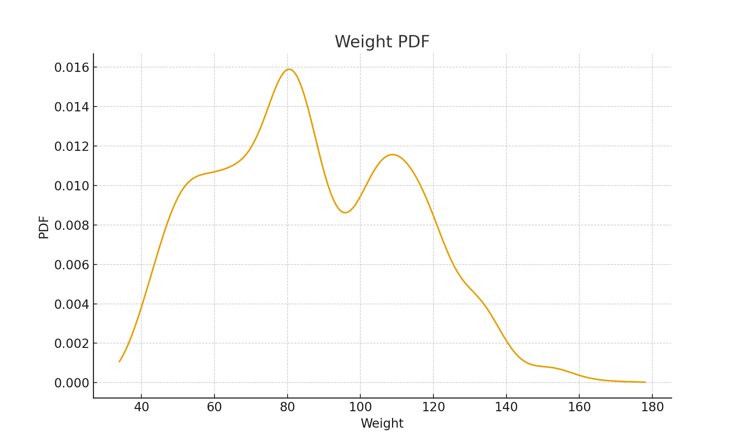

Figure 2. Marginal CDF of Weight
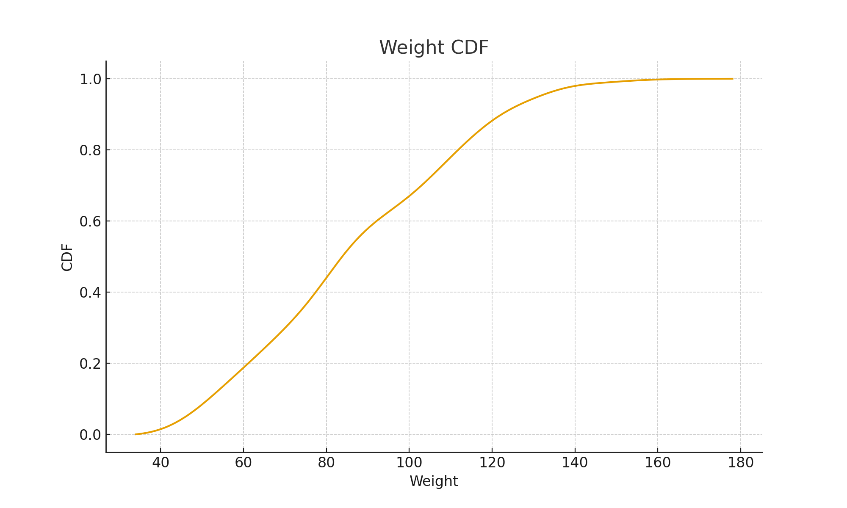

Figure 3. Boxplot of Weight by Obesity Level
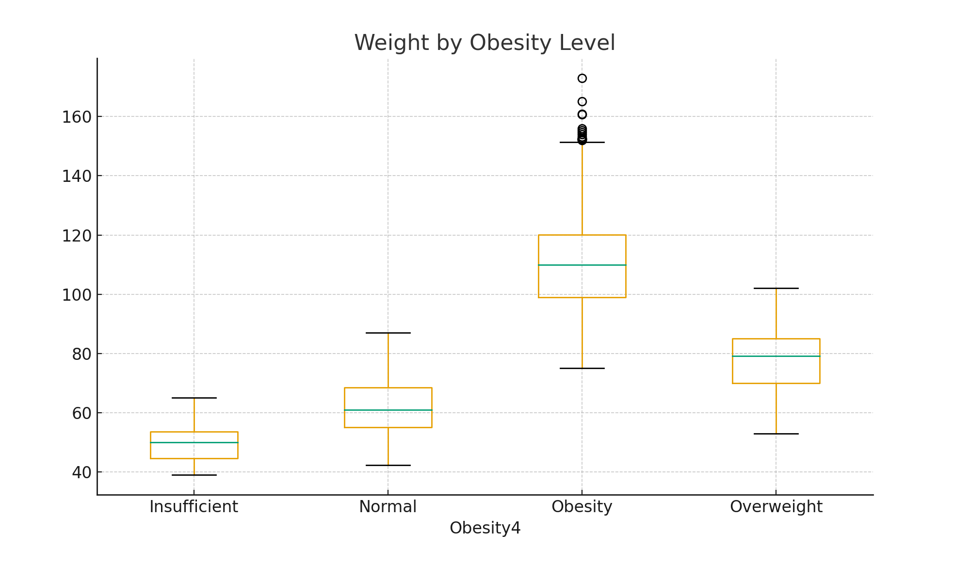

Figure 4. Prevalence of FAVC yes by Obesity Level
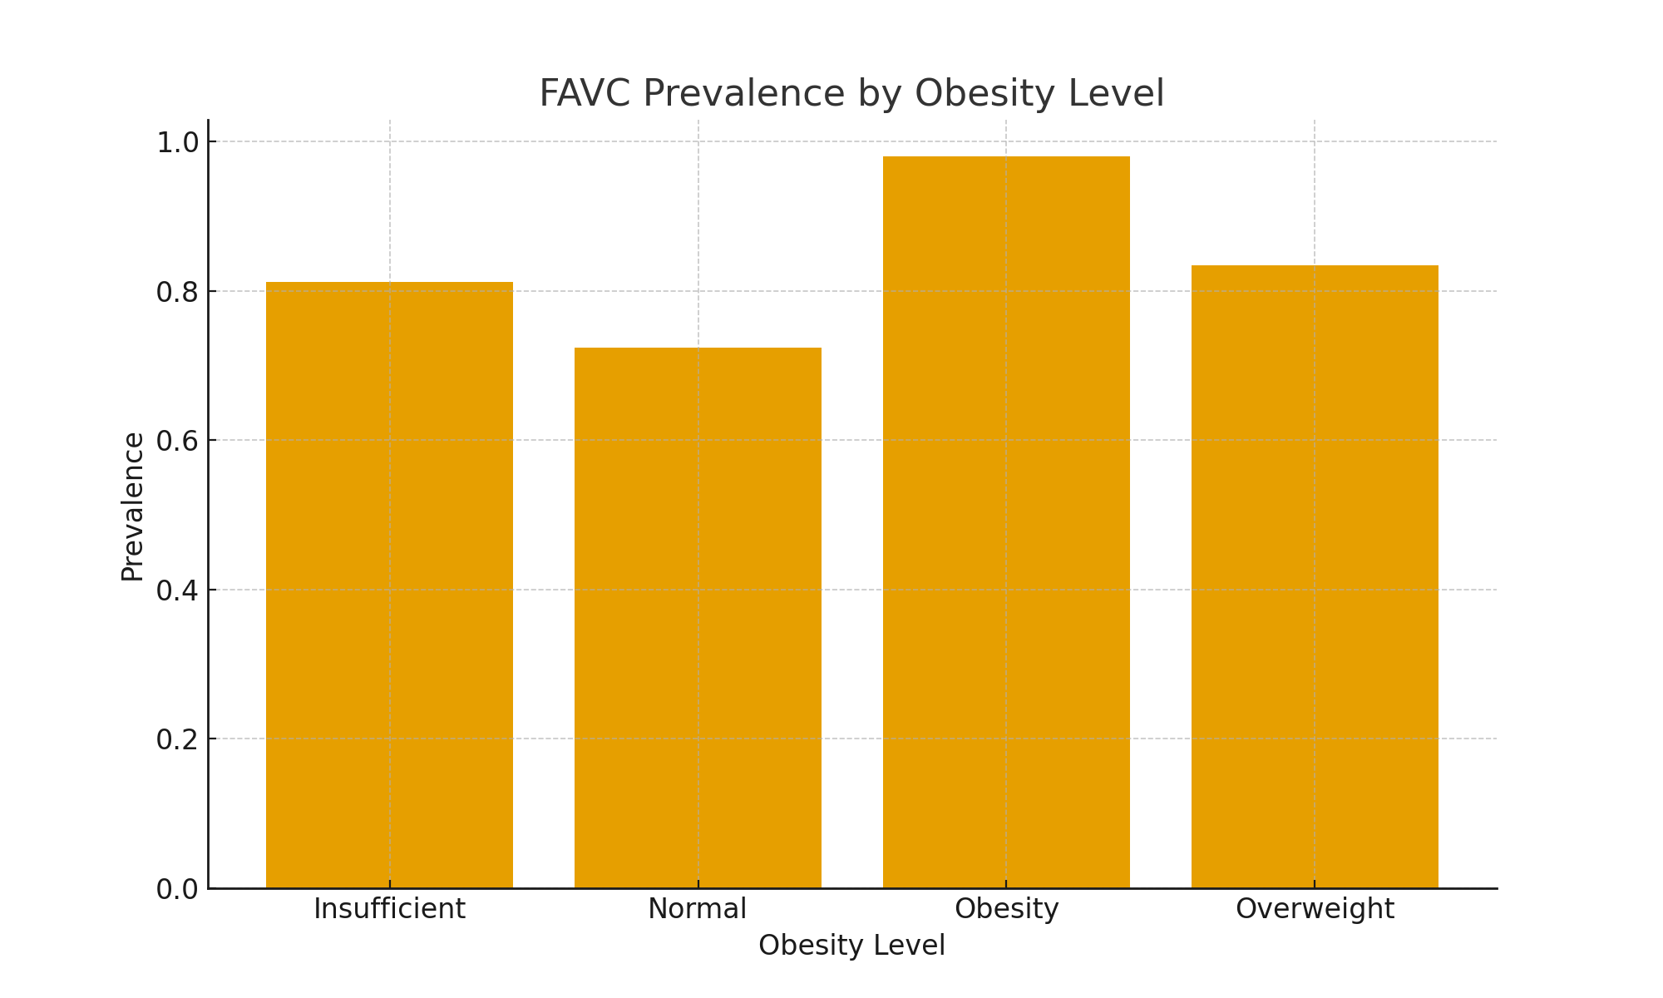

Figure 5. Conditional PDFs of Weight by Obesity Level
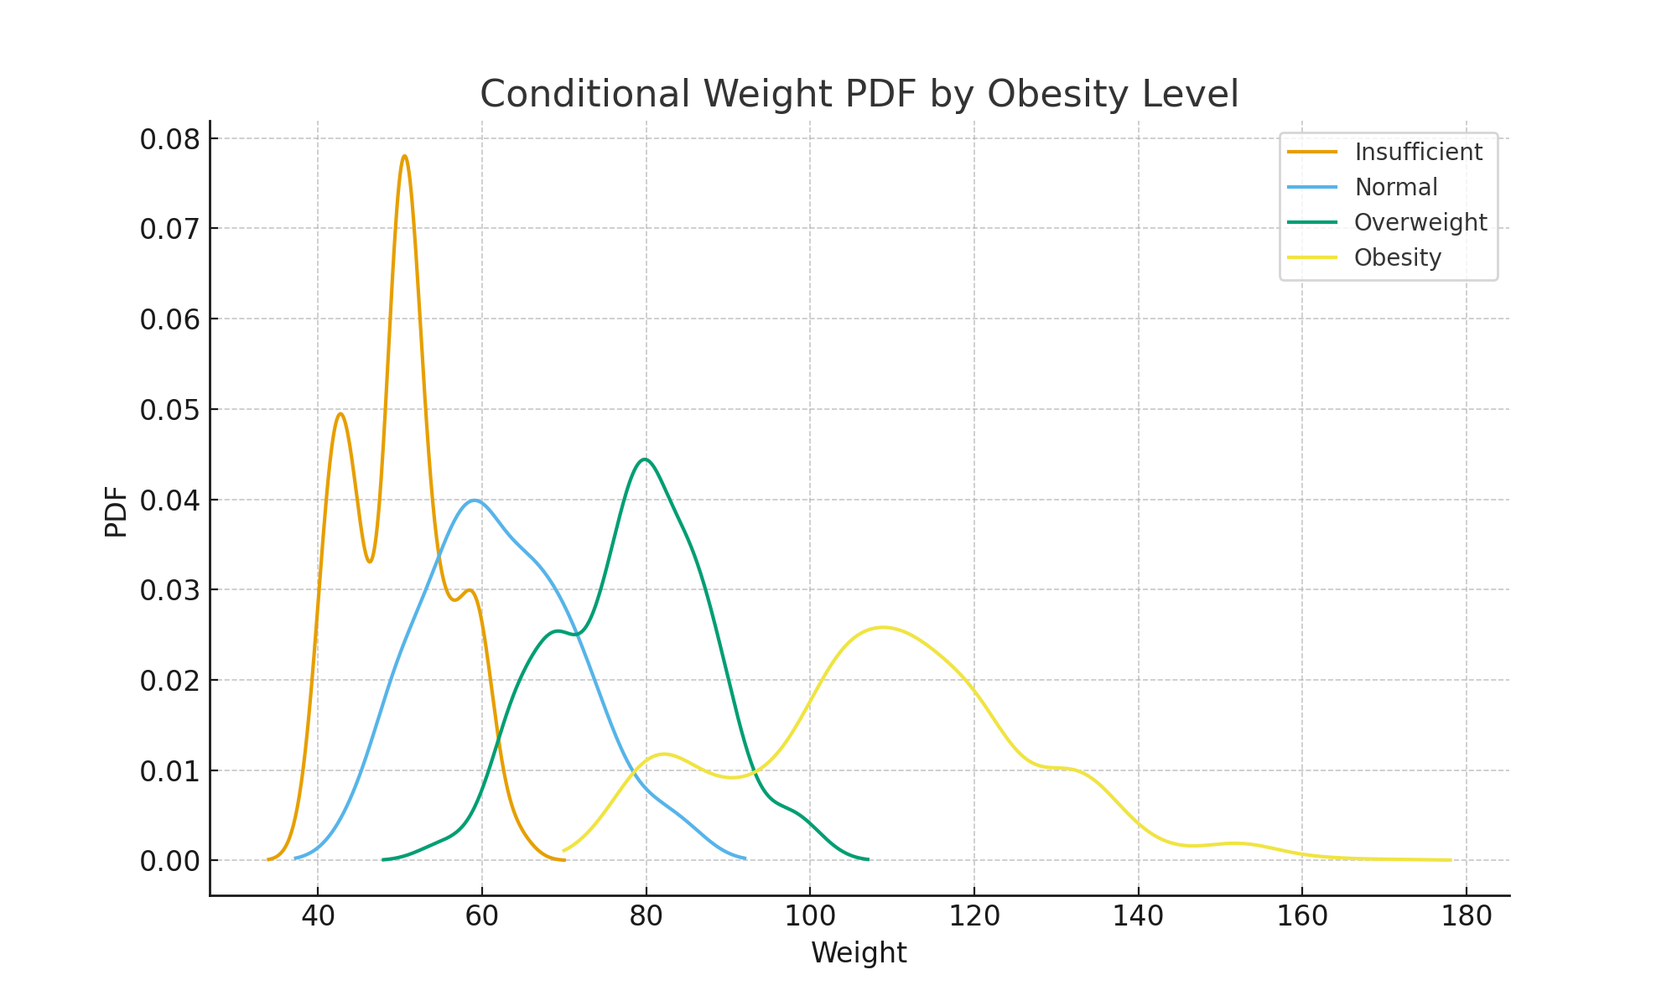

Figure 6. ROC Curve for Weight detecting Obesity
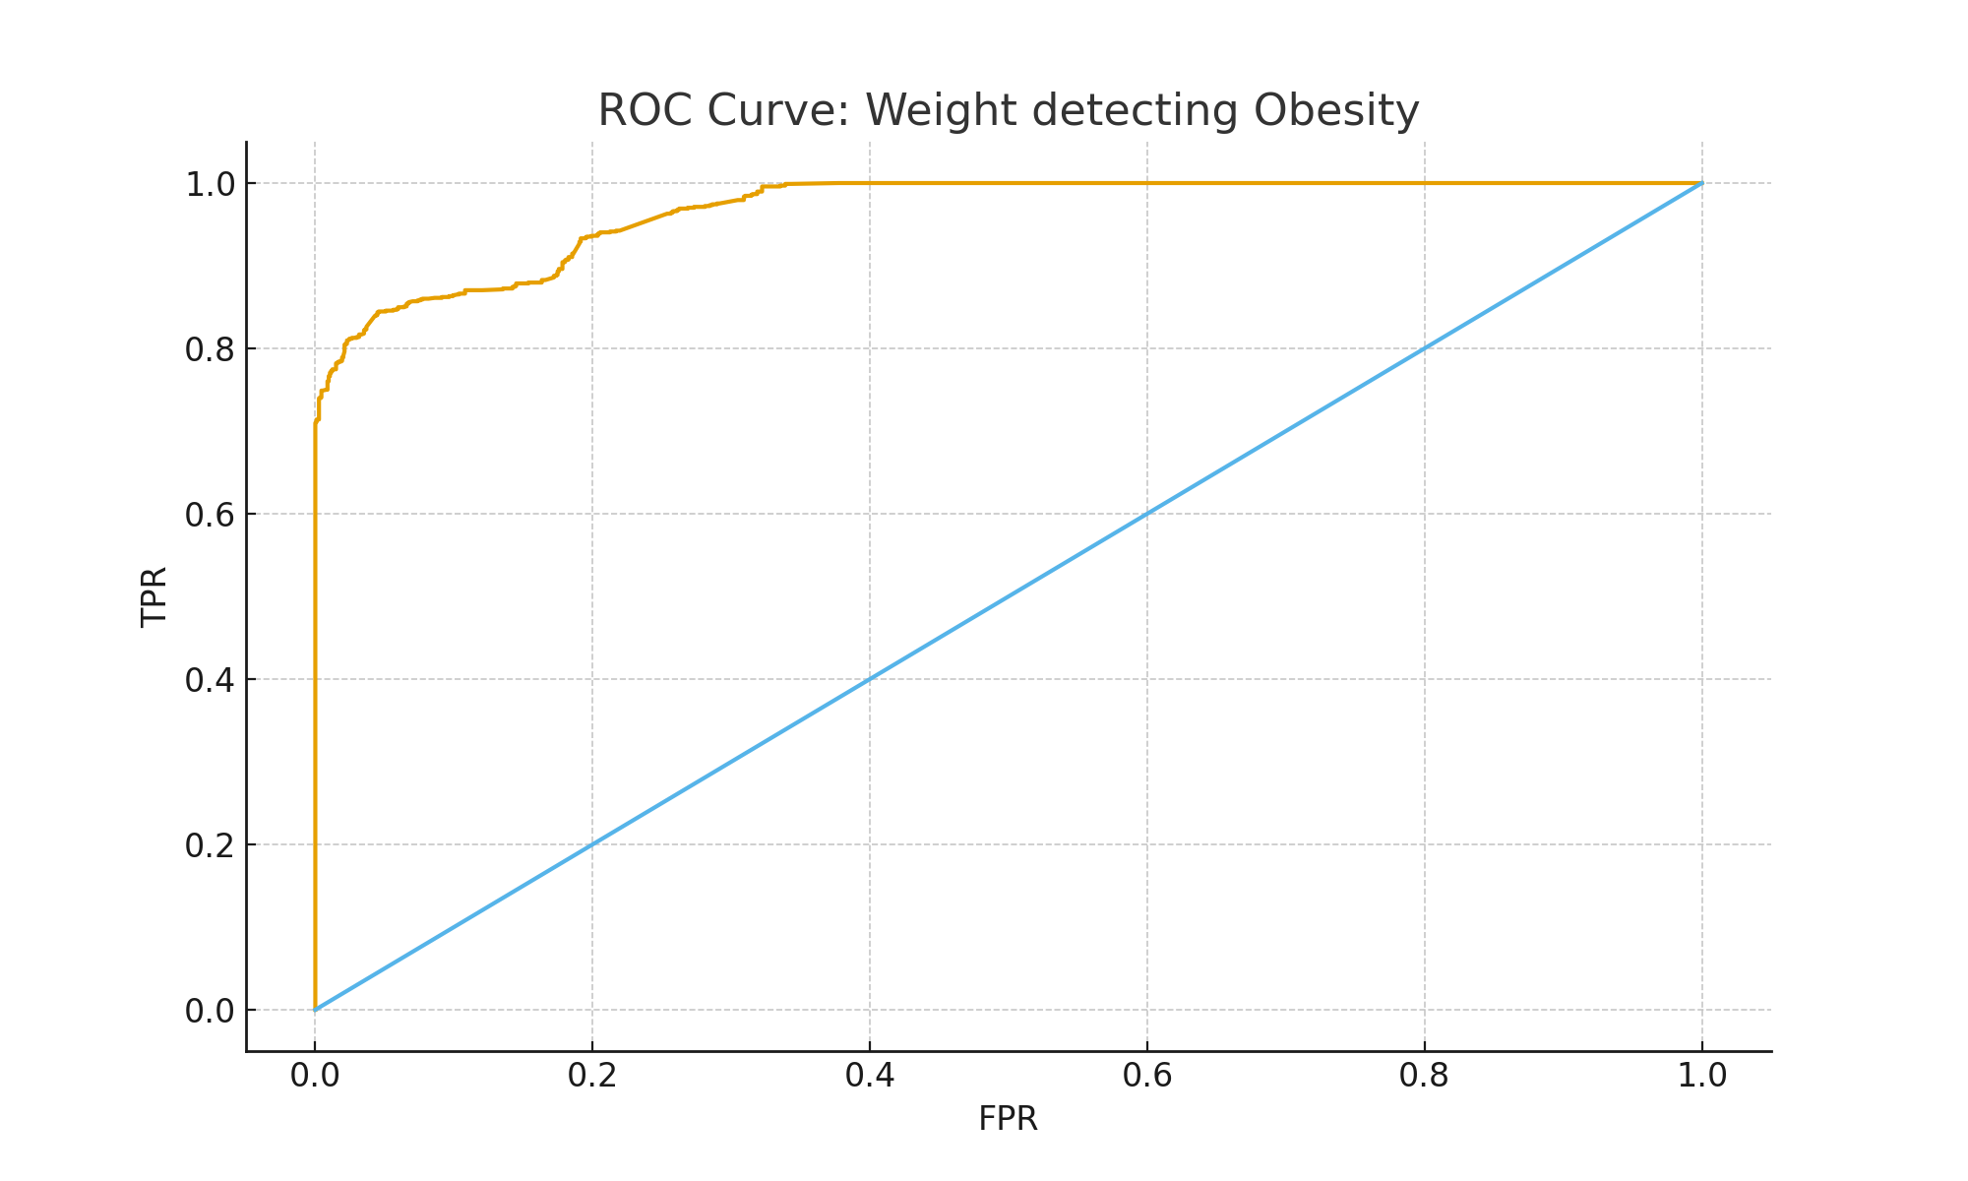

Discussion
The results for Weight are not surprising from a practical point of view, but the analysis quantifies the relationship in a precise way. The large differences in mean Weight across levels and the very high AUC show that in this dataset obesity is almost fully explained by large changes in body weight. The conditional distributions confirm that individuals in the Obesity group tend to weigh much more than individuals in the Insufficient or Normal groups.
Age also shows a meaningful pattern. Older individuals are more likely to belong to the Overweight and Obesity groups. This is consistent with the idea that obesity develops over time due to long term habits. However, the overlap in Age distributions means that age alone is not a good predictor. Many younger individuals are already in the Obesity group and some older individuals remain in the Normal or Overweight levels.
The strong association between FAVC and obesity level highlights the role of high caloric food. Almost all individuals in the Obesity group report frequent consumption of this type of food. This does not prove causality, but it strongly suggests that high caloric food intake is a key part of their lifestyle. Other variables related to physical activity such as FAF and transportation mode also show moderate associations, but none reach the same strength as Weight or FAVC.
It is important to distinguish between statistical significance and practical significance. With a large dataset, even small differences can lead to very small p values. For example Age yields a significant ANOVA result, yet the effect size is not as strong as that of Weight. For real decision making it is necessary to consider both the p value and the magnitude of the effect. This analysis helps identify which variables have both statistical and practical relevance.
There are limitations to this study. The dataset includes synthetic elements created to augment the size of the sample. Synthetic data can amplify or dampen certain relationships. The analysis is also univariate. Each feature is studied separately, so interactions between variables are not captured. In real populations obesity is influenced by combinations of behaviors, genetics and environmental factors. A more complete analysis would rely on multivariate models that incorporate all features at the same time.
Despite these limitations the univariate analysis already reveals the relative importance of each variable. Weight clearly dominates, while FAVC, Age and some physical activity measures play secondary roles. These insights can guide future studies that aim to build multivariate models for prediction or risk assessment.

Conclusion
Weight is by far the most informative feature for distinguishing between the four grouped obesity levels in this dataset. The mean Weight increases steadily from Insufficient to Obesity. The conditional distributions become wider and shift to higher values. Hypothesis tests and ROC analysis agree that Weight has strong discriminative power.
FAVC also shows a very strong relationship with obesity level, especially for the Obesity group, where almost all individuals report frequent consumption of high caloric food. Age, CH2O, FCVC and other variables show smaller but still noticeable differences. These results are consistent with general expectations about how lifestyle and eating habits relate to obesity.
The analysis met the defined goals by estimating marginal and conditional distributions, comparing group means and proportions, computing confidence intervals, applying ANOVA and chi squared tests, and evaluating ROC curves with bootstrap confidence intervals. The work shows how classical statistical tools can be combined to produce a clear picture of the structure of a dataset.
Future work could extend this univariate view into a multivariate analysis. Methods such as logistic regression, decision trees or ensemble models could be used to study the combined effect of multiple variables. This would allow the evaluation of interactions and the identification of more complex patterns that are not visible when studying each feature independently.

References
UCI Machine Learning Repository. Estimation of Obesity Levels Based on Eating Habits and Physical Condition.

Statement on the Ethical Use of AI
AI tools were used only to help with debugging, reviewing library documentation and writing some sections of code. They also provided minor wording suggestions. All analytical choices and the explanation of the results were made independently.

