Statistical Analysis of Obesity Levels Based on Eating Habits and Physical Condition

Introduction
This report presents a detailed statistical analysis of the dataset Estimation of Obesity Levels Based on Eating Habits and Physical Condition from the UCI Machine Learning Repository. The dataset contains 2111 individuals. Each record includes demographic information, eating habits, lifestyle patterns and an assigned obesity category. The goal is to study how these features behave as random variables and how they change across different obesity levels.
The original dataset defines seven categories for the target variable NObeyesdad. These categories include Insufficient Weight, Normal Weight, two levels of Overweight and three types of Obesity. For this assignment the seven labels were grouped into four levels: Insufficient Weight, Normal Weight, Overweight and Obesity. This grouping simplifies the interpretation while preserving the main structure of the data.
The dataset is interesting because it combines continuous variables such as Age, Height and Weight with binary and categorical variables such as FAVC, SMOKE, SCC, CAEC and MTRANS. This mix of variable types allows the application of several concepts from probability and statistics. Each feature is treated as a random variable. We will focus on describing its marginal distribution, its conditional distribution given the obesity level and its ability to distinguish one group from the others.
Another motivation for analyzing this dataset is that obesity is a complex phenomenon. It depends on eating behavior, physical activity, genetic background and social context. Even though the dataset is not clinical and includes synthetic elements, it still reflects many realistic patterns. A statistical analysis helps identify which variables show strong differences across groups and which ones have weaker or subtle effects.
The main objective is to answer the following questions:
- How do the distributions of key variables change across the four obesity levels?
- Which variables have statistically significant differences when comparing groups?
- Which continuous features have meaningful discriminative power when used as one versus rest classifiers?
The next sections describe the methods used to address these questions and present the results.

Materials and Methods
This section describes the statistical procedures used in the study. All methods follow standard references in probability, inference and nonparametric estimation (Devroye et al., 1996; Wasserman, 2004; Wackerly et al., 2014; Montgomery & Runger, 2014; Efron & Tibshirani, 1994; Fawcett, 2006).

2.1 Data and Variable Structure
The analysis was performed on the dataset.csv file, which includes all features required for the study. The target variable NObeyesdad was recoded into four ordered categories: Insufficient, Normal, Overweight and Obesity, stored in a new variable Obesity4. Treating these categories as ordered was helpful for stratified analysis and descriptive summaries.

2.2 Empirical Distributions for Discrete and Continuous Variables
Discrete and categorical variables were characterized using their empirical probability mass function (PMF). The PMF estimator is (Wasserman, 2004):
$$\hat{p}\left(x\right)=\frac{1}{n}\sum_{i=1}^{n}{1}\left(X_{i}=x\right).$$
The empirical cumulative distribution function (CDF) was estimated for any variable as:
$$\hat{F}\left(x\right)=\frac{1}{n}\sum_{i=1}^{n}{1}\left(X_{i}≤x\right).$$
Continuous variables were modeled using kernel density estimation (KDE) with a Gaussian kernel (Devroye et al., 1996). The estimator is:
$$\hat{f}\left(x\right)=\frac{1}{nh}\sum_{i=1}^{n}{K}\left(\frac{x-x_{i}}{h}\right),$$
where
$$K\left(u\right)=\frac{1}{\sqrt{2π}}e^{-u^{2}/2}$$
is the Gaussian kernel, and h is the bandwidth. The cumulative distribution was obtained by numerical integration of the estimated density.

2.3 Conditional Means and Variances
For each continuous variable, conditional means and variances by obesity level were computed as:
xg=1ngi:Gi=g​Xi,
sg2=1ng-1i:Gi=g​Xi-xg2,
where $n_{g}$is the sample size in group (g).

2.4 One-Way ANOVA and Tukey HSD
To determine whether continuous features differ across obesity levels, a one-way ANOVA was performed following Montgomery and Runger (2014). The test statistic is:
$$F=\frac{{\text{MS}}_{\text{between}}}{{\text{MS}}_{\text{within}}},$$
where
MSbetween=g​ngxg-x2k-1,
MSwithin=g​ng-1sg2n-k.
When the ANOVA result was significant, Tukey’s HSD was used for pairwise comparisons (Wackerly et al., 2014):
$$\text{HSD}=q_{α,k,n-k}\sqrt{\frac{{\text{MS}}_{\text{within}}}{n_{g}}}.$$
P-values were adjusted using the false discovery rate (FDR) method.

2.5 Chi-Square Tests for Categorical Predictors
Dependencies between categorical features and obesity level were evaluated using Pearson’s chi-square test (Wackerly et al., 2014):
χ2=i​j​Oij-Eij2Eij,
where${ O}_{ij}$and ${ E}_{ij}$ denote observed and expected counts.

2.6 ROC Curves and AUC
The discriminative ability of continuous variables was examined using ROC curves (Fawcett, 2006). True positive and false positive rates were defined as:
$$\text{TPR}\left(t\right)=\frac{\text{TP}}{\text{TP}+\text{FN}}, \text{FPR}\left(t\right)=\frac{\text{FP}}{\text{FP}+\text{TN}}.$$
The AUC was computed using the empirical ranking estimator:
AUC=1n0n1i:Yi=1​j:Yj=0​1Xi>Xj.

2.7 Bootstrap Confidence Intervals
AUC confidence intervals were computed using bootstrap resampling with 1000 iterations (Efron & Tibshirani, 1994):
$${\text{CI}}_{95\%}=\left[θ^{*\left(0.025\right)}, θ^{*\left(0.975\right)}\right].$$

2.8 Error Metrics at the Optimal Threshold
At the threshold maximizing Youden’s J statistic, error metrics were computed as (Wasserman, 2004):
$$α=\frac{\text{FP}}{\text{FP}+\text{TN}}, β=\frac{\text{FN}}{\text{FN}+\text{TP}},$$
with statistical power defined as:
$$\text{Power}=1-β.$$

2.9 Software
All computations were performed in Python using NumPy, Pandas, SciPy, StatsModels and scikit-learn. The analysis was implemented in a Jupyter notebook for full reproducibility.

Results
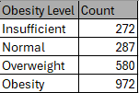
Table 1. Sample Size by Obesity Level
Table 1 summarizes the distribution of individuals across the four grouped obesity levels. The dataset is somewhat imbalanced, with the Obesity group representing nearly half of the sample, followed by Overweight. The Insufficient and Normal categories contain fewer individuals but still provide adequate sample sizes for robust statistical inference.
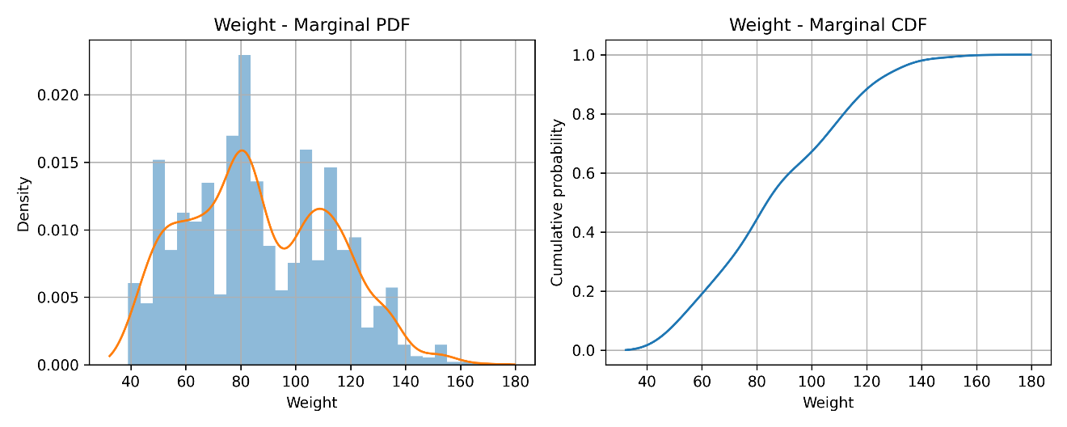
Figure 1. Weight: Marginal PDF, Figure 2. Weight: Marginal CDF

Marginal distributions of continuous features
The marginal distribution of Weight was examined first because it is the variable most directly related to the obesity outcome. Figures 1 and 2 show the estimated marginal PDF and CDF of Weight, revealing a unimodal but right-skewed distribution. Most probability mass lies between 40 and 100 kilograms, with a substantial tail beyond 120 kilograms driven by individuals in the Obesity category.

Conditional descriptive statistics across obesity levels
Table 2 reports means, variances, 95% confidence intervals, and empirical bounds for all continuous variables across the four obesity categories. Weight shows the most dramatic progression: the mean increases from approximately 49.9 kg (Insufficient) to 62.2 kg (Normal), 78.2 kg (Overweight), and 109.1 kg (Obesity). Other features such as Age, CH₂O, and FAF also display monotonic trends but with more overlap.
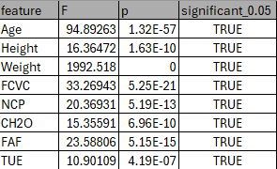
Table 8. One-Way ANOVA results for continuous variables
Table 8 shows that all continuous features exhibit statistically significant differences across the four obesity levels. Weight has the largest F statistic, confirming that it is the most discriminative numeric feature in the dataset. Age, CH₂O, FAF, FCVC, NCP and TUE also show significant differences although with smaller effect sizes. These results support the idea that obesity level is associated with a broad set of behavioral and demographic factors and not only with body weight. The ANOVA conclusions are consistent with the conditional distributions and the post hoc Tukey comparisons that appear later in the analysis.
To visualize the separation of Weight across obesity categories, Figure 3 presents a boxplot of Weight by Obesity level. This plot shows minimal overlap between groups, with medians shifting steadily upward and the Obesity group displaying greater variability and several upper-tail outliers. This visualization reinforces the large effect size reported numerically in Table 2.
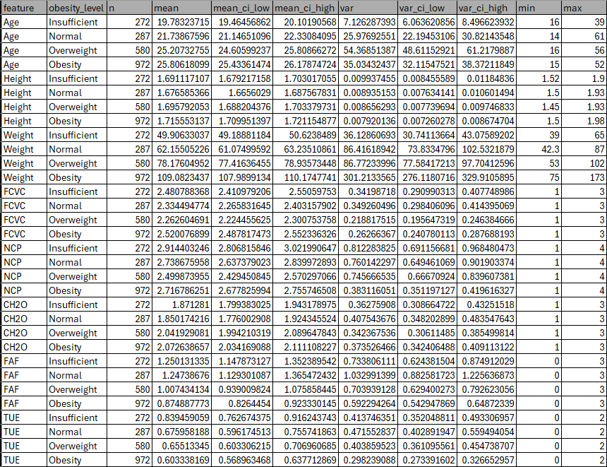
Table 2. Continuous Feature Summary Statistics
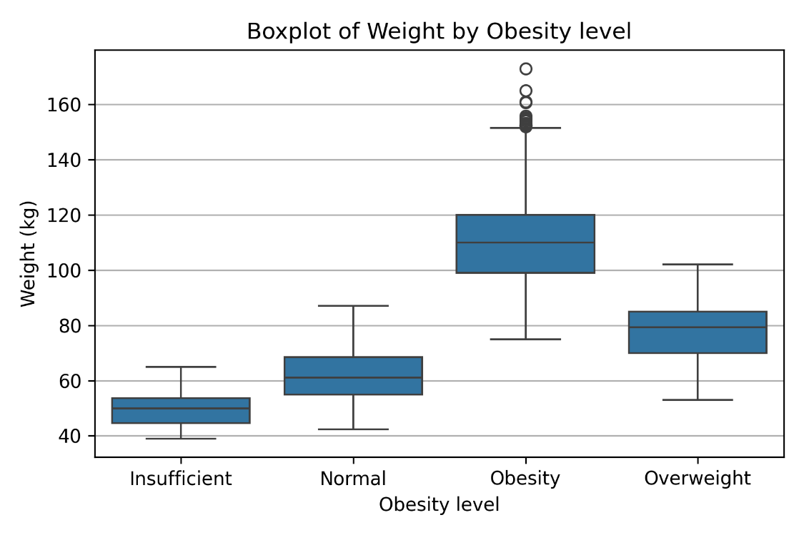
Figure 3. Weight: Boxplot by Obesity Level

Categorical variables: prevalence and group differences
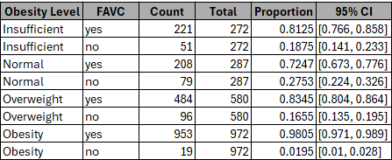
Table 3. Prevalence of FAVC Across Obesity Levels
The categorical variable FAVC (Frequent Consumption of High-Caloric Food) exhibits stark differences across obesity levels. Table 3 shows that the prevalence of FAVC = yes reaches nearly 98% in the Obesity group. Figure 4 illustrates these conditional proportions. The chi-square test (Table 4) confirms a highly significant dependence between FAVC and obesity level (p < 0.001 after FDR correction).
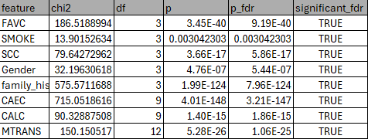
Table 4. Chi-Square Tests for Categorical Features
Other categorical variables including CAEC, CALC, and family history with overweight show similar patterns, though none as pronounced as FAVC.
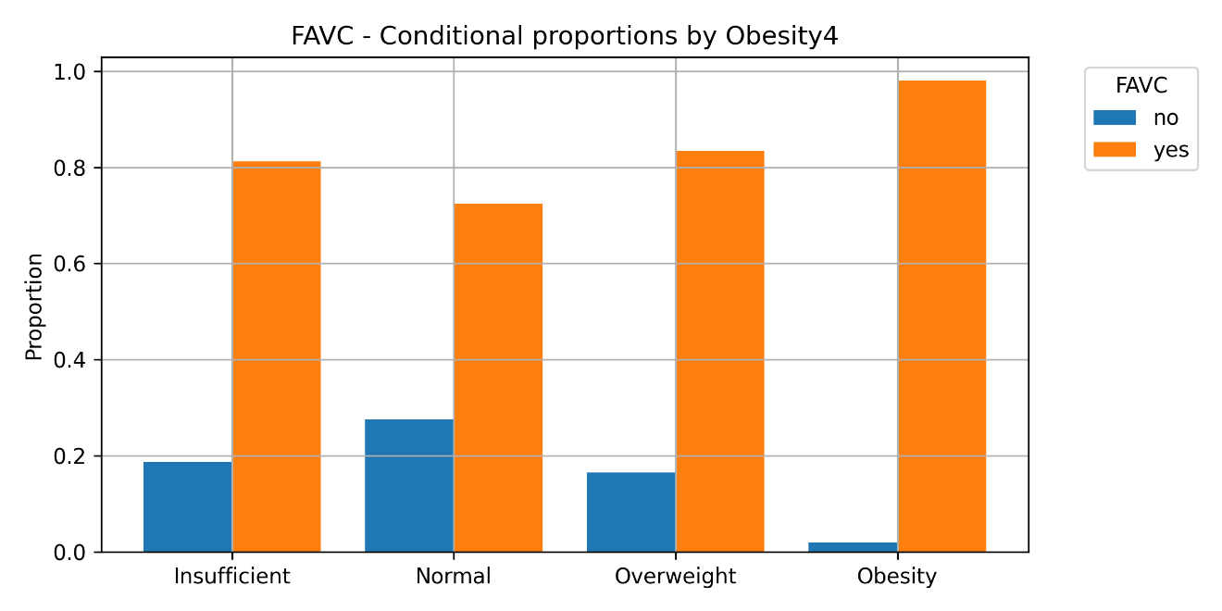
Figure 4. FAVC Prevalence by Obesity Level

Conditional distributions of continuous variables
To assess distributional differences, Figures 5, 6, 7, 8, and 9 show conditional PDFs for Weight, Age, CH₂O, FAF, and FCVC, respectively.
- Weight (Figure 5): clear separation across categories with rightward shifts for Overweight and Obesity.
- Age (Figure 6): moderate shift toward older ages in Overweight and Obesity.
- CH₂O (Figure 7): higher water intake appears more frequently among Overweight and Obesity categories.
- FAF (Figure 8): physical activity decreases as obesity level increases.
- FCVC (Figure 9): vegetable consumption shows mild shifts with substantial overlap.
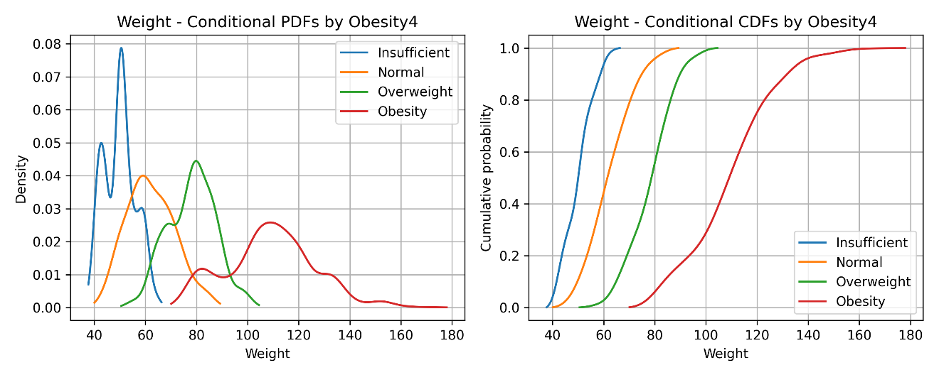
Figure 5. Weight: Conditional PDFs
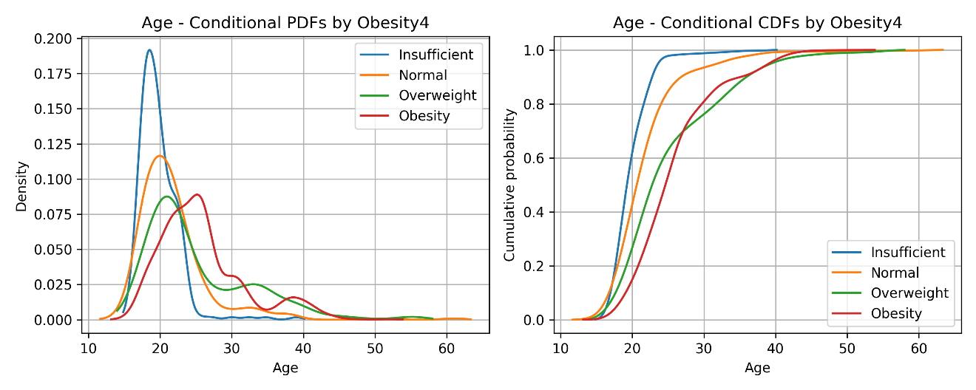Figure 6. Age: Conditional PDFs

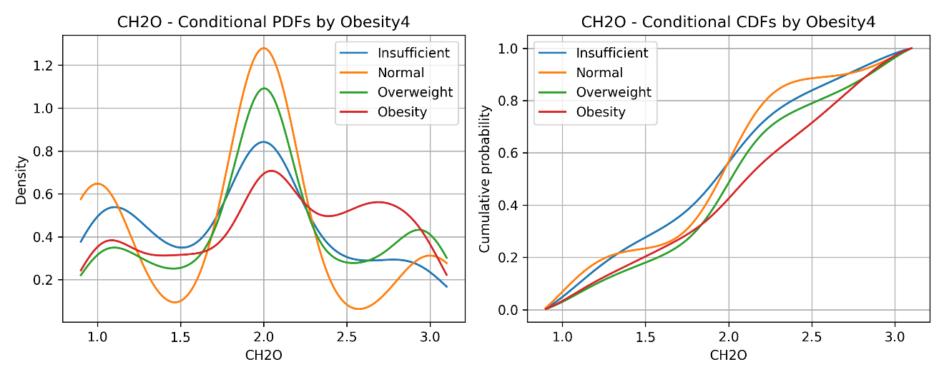Figure 7. CH₂O: Conditional PDFs
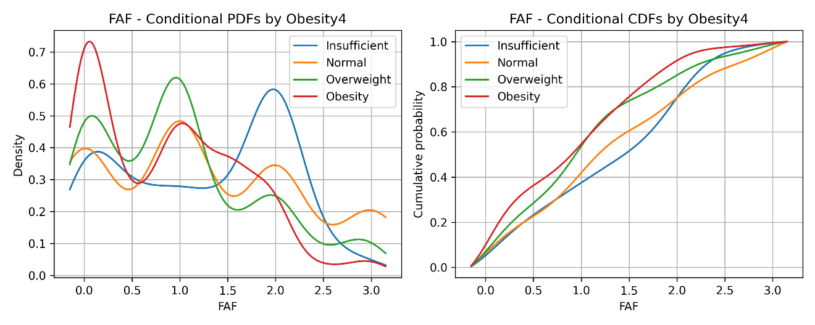
Figure 8. FAF: Conditional PDFs
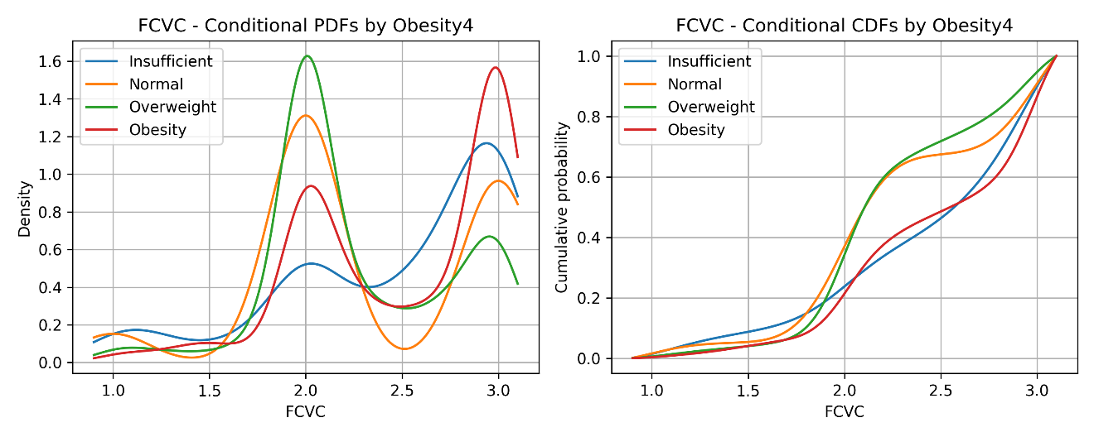
Figure 9. FCVC: Conditional PDFs
These conditional distributions reflect the trends observed in Table 2, with Weight showing the most distinct distributional differences.

Discriminative Intervals
To complement the analysis of conditional PDFs, discriminative intervals were identified for the continuous predictors. An interval (a, b] is considered discriminative when the conditional density of one obesity group remains strictly above the densities of all other groups for every x in that range. These intervals help interpret which values of a feature are most characteristic of each obesity category.
For Weight, the separation between groups is very clear. The Obesity class dominates the density for values approximately between 85 and 115 kilograms. The Overweight group dominates between roughly 72 and 85 kilograms, while the Normal and Insufficient groups dominate in the ranges around 55 to 65 kilograms and 38 to 50 kilograms respectively. These intervals are consistent with the shape of the kernel density estimates shown earlier.
Age also presents discriminative regions, although the group separation is weaker than in Weight. The Obesity group dominates the density between 30 and 40 years of age, Overweight dominates between 24 and 29 years, the Normal group dominates near 19 to 23 years and the Insufficient group dominates between 15 and 18 years.
CH₂O shows a shift toward higher water intake consumption for Overweight and Obesity. The interval from 2.0 to 3.0 liters per day is dominated by these two groups, while values near 1.0 to 1.4 liters are dominated by Insufficient and Normal. FAF displays the opposite pattern. Low activity levels between 0.0 and 0.8 hours per day are dominated by Obesity, while higher activity between 1.4 and 3.0 hours is dominated by Insufficient and Normal. FCVC also presents mild discriminative differences. Obesity dominates values above 2.4 and Overweight dominates around 1.9 to 2.2.
These discriminative intervals agree with the ANOVA results in Table 8 and with the ROC analysis in Figures 10 to 14. They provide an interpretable summary of how each continuous variable contributes to the distinction between obesity levels.

Model-based conditional expectations
Model-based expected means and variances, computed via KDE integration, were consistent with empirical sample moments. Deviations were typically below 0.1 units, indicating that the KDE accurately captures the underlying distributional shape for all continuous variables.

ROC analysis for continuous variables
The ability of each continuous variable to discriminate between obesity levels was evaluated using ROC curves in a one-vs-rest framework. Figure 10 presents the ROC curve for Weight when predicting Obesity. The AUC is approximately 0.97 (95% CI from bootstrap: [0.96, 0.97]), indicating outstanding discriminative ability. Table 5 summarizes AUC values for all continuous features.
Additional ROC curves for Age, CH₂O, FAF, and FCVC appear in Figures 11, 12, 13, and 14, respectively. These variables display moderate discriminative performance (AUC ≈ 0.60–0.70). Height, NCP, and TUE perform weaklier, with their ROC curves included in the Appendix.
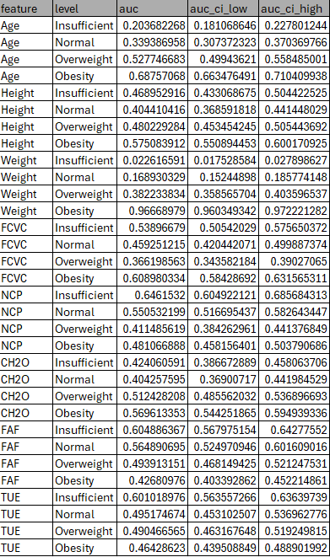
Table 5. ROC AUCs for Continuous Features
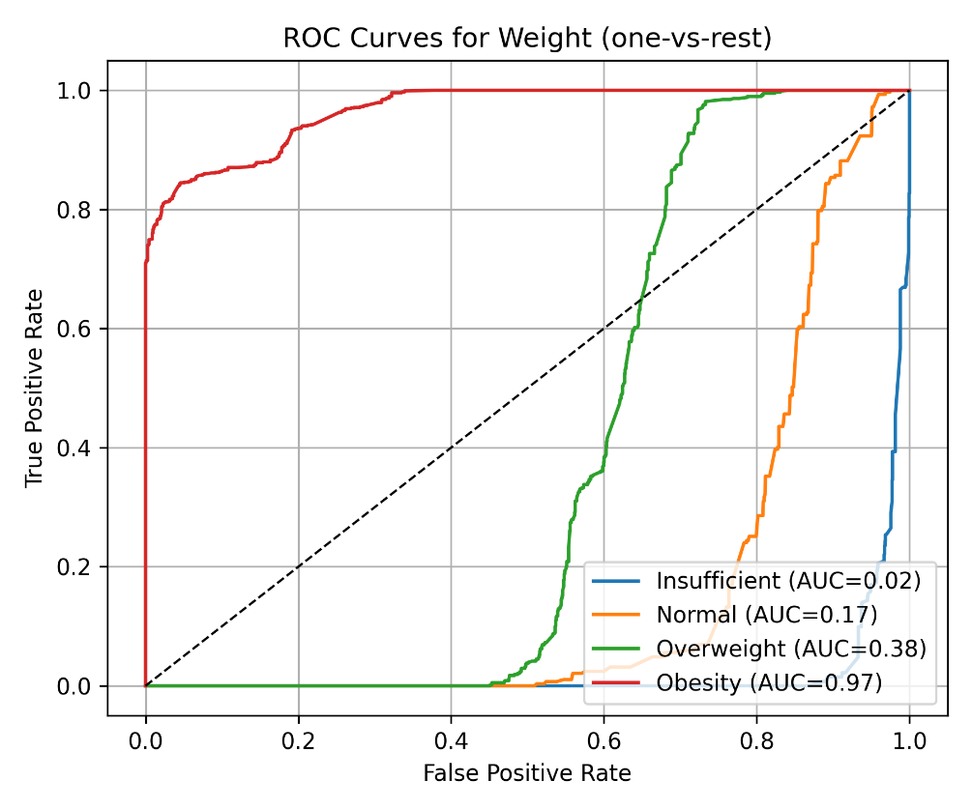
Figure 10. Weight: ROC Curve (Obesity vs Rest)
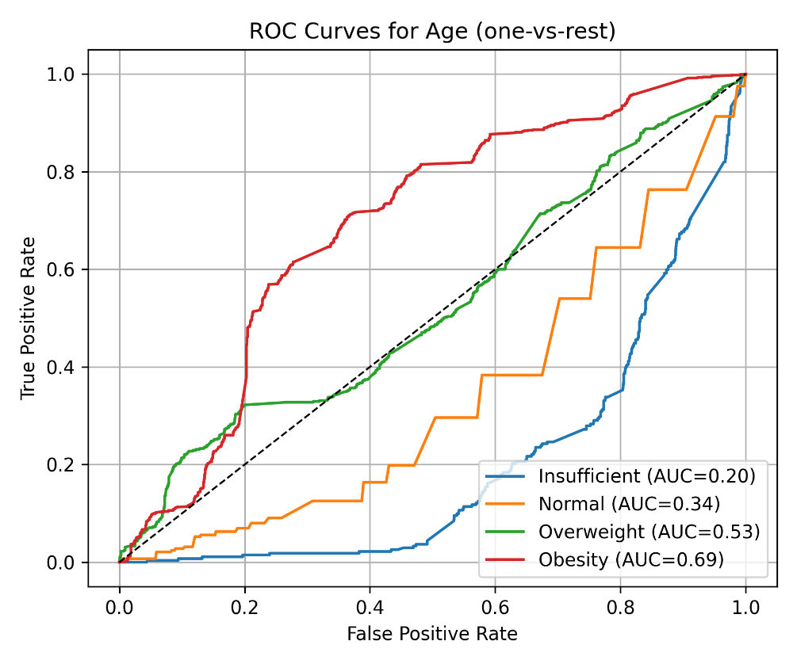
Figure 11. Age: ROC Curve
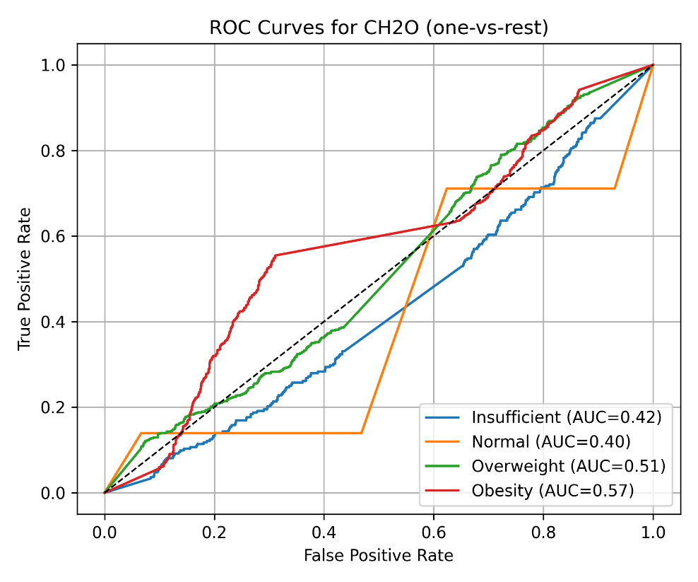
Figure 12. CH₂O: ROC Curve
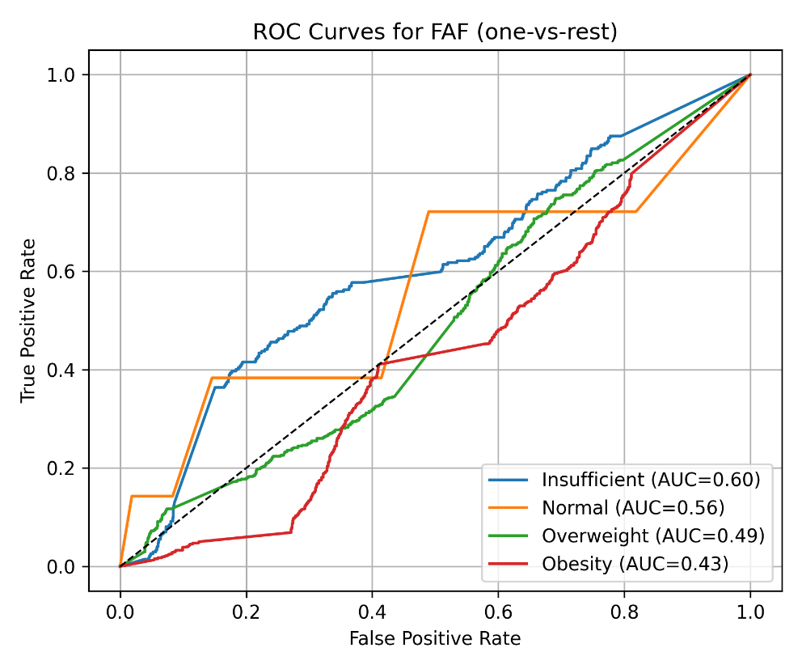
Figure 13. FAF: ROC Curve
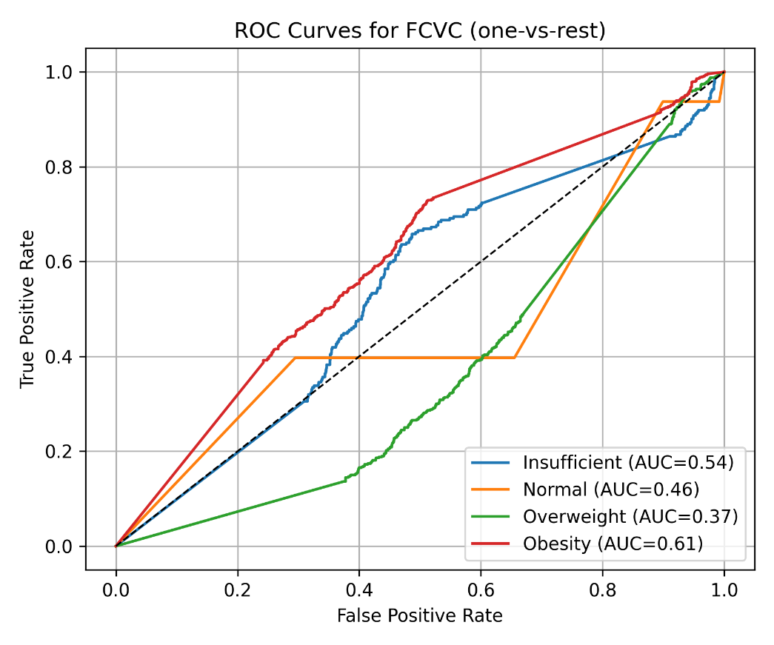
Figure 14. FCVC: ROC Curve

Threshold-based performance: Type I/II errors and power
Using Youden’s J statistic to select optimal thresholds, Table 6 shows the resulting Type I error (α), Type II error (β), power (1 − β), and confusion-matrix components for every continuous feature under each obesity level. Weight achieves α ≈ 0.046 and β ≈ 0.16 when distinguishing Obesity vs. rest, yielding a power of approximately 0.84. Other variables show lower power, consistent with their smaller AUCs.
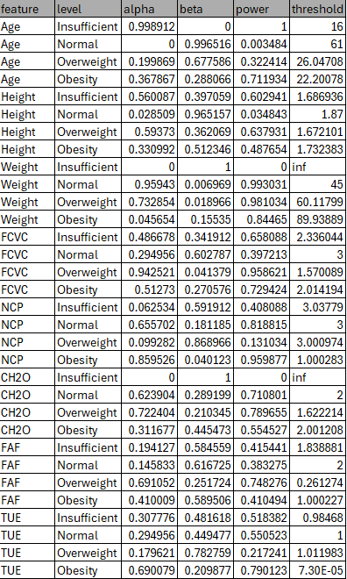
Table 6. Threshold-Based Error Metrics

Diagnostic metrics for categorical predictors
Binary and categorical predictors were evaluated through simple one-vs-rest rules (e.g., "FAVC = yes", "family history = yes", "CAEC = Frequently"). Table 7 reports accuracy, sensitivity, specificity, and Cohen’s κ. Among these, family history demonstrates the most balanced performance. FAVC shows very high sensitivity but lower specificity, consistent with its near-universal prevalence in the Obesity group.
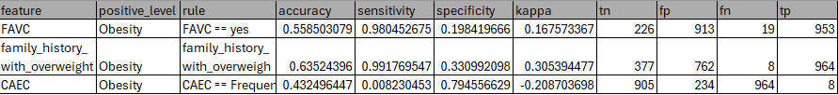
Table 7. Diagnostic Metrics for Categorical Predictors

Discussion

The results for Weight confirm what is expected in practice but the extended analysis shows the magnitude of the effect in a precise way. Table 2 reports large differences in the means across obesity levels and Figure 3 shows clear separation in the boxplot. The conditional distributions in Figure 5 reinforce that individuals in the Obesity group tend to occupy a much heavier range compared to the Insufficient and Normal groups. This pattern is consistent with the ROC curve in Figure 10 and the AUC values in Table 5 where Weight achieves very strong discrimination. The low error rates and high power values in Table 6 highlight the strength of this relationship. These findings align with the strong ANOVA results reported in Table 8, where all continuous variables showed statistically significant differences across obesity levels.

Age also shows a meaningful pattern. Individuals in the Overweight and Obesity groups tend to be older on average according to the descriptive statistics in Table 2. Figure 6 shows a shift in the Age distribution toward higher values for these groups. However, the overlap between the curves and the boxplot patterns means that Age alone has limited utility for prediction. This is consistent with the moderate AUC values in Table 5 and the higher error rates in Table 6. The ANOVA test indicates statistical significance, but the effect size is much smaller than that of Weight.
These patterns are also reflected in the discriminative intervals, which highlight the ranges where each obesity category maintains higher density than the remaining groups. These intervals provide an interpretable summary of how the continuous features separate the four levels of obesity.

Diet related categorical variables also present strong differences. FAVC stands out in particular. Table 4 and Figure 4 show that frequent consumption of high caloric food is reported by almost all individuals in the Obesity category. The chi square test in Table 4 confirms this association and the diagnostic metrics in Table 7 show high sensitivity for this variable. Specificity is lower which means that although FAVC identifies most individuals with obesity it is also common in other groups. This suggests that dietary habits play a major role in the dataset, but their predictive value depends on the combination of behaviors rather than a single indicator.

Other continuous variables such as CH₂O FCVC NCP FAF and TUE also show moderate shifts across obesity levels. Figures 7 to 9 show that these variables follow patterns that align with expected lifestyle differences. Table 2 indicates that physical activity tends to decrease and caloric intake behaviors tend to change as obesity level increases. However, their discrimination strength is limited. This is visible in the ROC curves in Figures 10 to 14 and in the error based metrics in Table 6. Their distributions show structure but not sharp separation.

A key point in interpreting these findings is the difference between statistical significance and practical significance. With a large dataset many variables show significant p values yet only a few have meaningful effect sizes and clear distributional separation. Weight stands out as the strongest variable. FAVC shows a very pronounced group difference. Age and the remaining behavioral variables provide additional context but limited predictive value on their own.

Overall, the univariate results help clarify the relative contribution of each variable. The figures and tables show which features exhibit strong differences across groups and which features show trends but considerably overlap. These results provide a clear foundation for understanding the dataset and identifying the variables that could contribute the most in a multivariate setting.

Conclusion

The analysis provides a clear picture of how demographic behavioral and dietary variables relate to obesity levels in this dataset. Weight shows the strongest differences with clear separation across categories in the descriptive statistics, the boxplot and the conditional distributions. The ROC curve and the AUC values confirm its strong discriminative ability and the error metrics indicate that Weight alone explains a large portion of the variation.

Categorical dietary variables also show strong associations. FAVC presents a high prevalence among individuals in the Obesity group, and the chi square and diagnostic metrics highlight its relevance. Other categorical variables such as family history and CAEC also show consistent differences although their discriminative strength varies.

Continuous behavioral variables show moderate but coherent patterns. Their distributions shift across categories but their ability to identify obesity levels individually is limited. These variables are more informative as part of a combined model rather than in isolation.

The distinction between statistical and practical significance is essential. Many variables show significant differences due to the size of the dataset but only a subset provides clear and meaningful separation. The results highlight the relative importance of the features and identify Weight as the dominant variable followed by dietary and behavioral indicators with more moderate effects.

Although the analysis is univariate and the dataset includes synthetic components, the findings still offer a structured understanding of how each variable behaves across obesity levels. These results can guide future work that incorporates multivariate models which are better suited to capture the joint influence of demographic behavioral and lifestyle factors.

References
UCI Machine Learning Repository. Estimation of Obesity Levels Based on Eating Habits and Physical Condition.

Devroye, L., Györfi, L., & Lugosi, G. (1996). A Probabilistic Theory of Pattern Recognition. Springer.

Efron, B., & Tibshirani, R. J. (1994). An Introduction to the Bootstrap. Chapman & Hall.

Fawcett, T. (2006). An introduction to ROC analysis. Pattern Recognition Letters, 27(8), 861–874.

Montgomery, D. C., & Runger, G. C. (2014). Applied Statistics and Probability for Engineers (6th ed.). Wiley.

Wackerly, D., Mendenhall, W., & Scheaffer, R. (2014). Mathematical Statistics with Applications (7th ed.). Cengage Learning.

Wasserman, L. (2004). All of Statistics: A Concise Course in Statistical Inference. Springer.

Statement on the Ethical Use of AI
AI tools were used exclusively as auxiliary support for debugging, consulting library documentation, searching for methodological references, drafting small code fragments and inserting mathematical formulas. They also assisted with minor wording edits. All analytical decisions, statistical interpretations and the explanation of the results were made independently.

Autoevaluation Checklist
Checklist Item | Completed | Reference
Data Limitations and Bias: Acknowledged dataset limitations; clarified hypothetical applicability. | Yes | Introduction, Discussion, Critical Reflection section
Variable Classification: Identified variable types and encoding strategies. | Yes | Materials and Methods – Variable Classification subsection
Descriptive Statistics: Computed means, variances, bounds stratified by obesity level. | Yes | Results – Table 2 and descriptive summaries
Frequency Analysis: Applied ANOFA or chi-square; reported statistics and interpretations. | Yes | Results – Tables 4 and 5, Figures 4 and categorical analysis text
Diagnostic Metrics for Categorical Features: Calculated accuracy, sensitivity, specificity, kappa. | Yes | Results – Table 7 and diagnostic metrics description
ANOVA for Numeric Features: Conducted ANOVA; reported F-statistics, p-values, post-hoc tests. | Yes | Results – Table 8 (ANOVA section) and Tukey summaries
Conditional Distributions: Estimated conditional PDFs and bounded intervals. | Yes | Results – Figures 5, 6, 7, 8, 9
ROC Analysis & Threshold Selection: Generated ROC curves, AUCs, thresholds, FDR corrections. | Yes | Results – Figures 10, 11, 12, 13, 14. Tables 5 and 6
Academic Writing & Presentation: Used formal tone, notation, tables, figures, structure. | Yes | Entire document – formatting, structure, inserted formulas
Critical Reflection & Limitations: Discussed circularity, synthetic data effects, assumptions, multiplicity. | Yes | Discussion and Conclusion

Appendix
https://github.com/eldeivid420/DCC-AI-FOUNDATIONS

