Day 1: 15/1/2024

- Read up on STRIDE framework, MITRE ATT&CK and OpenAI’s API.

* Briefing on internship, phase 1 and 2.

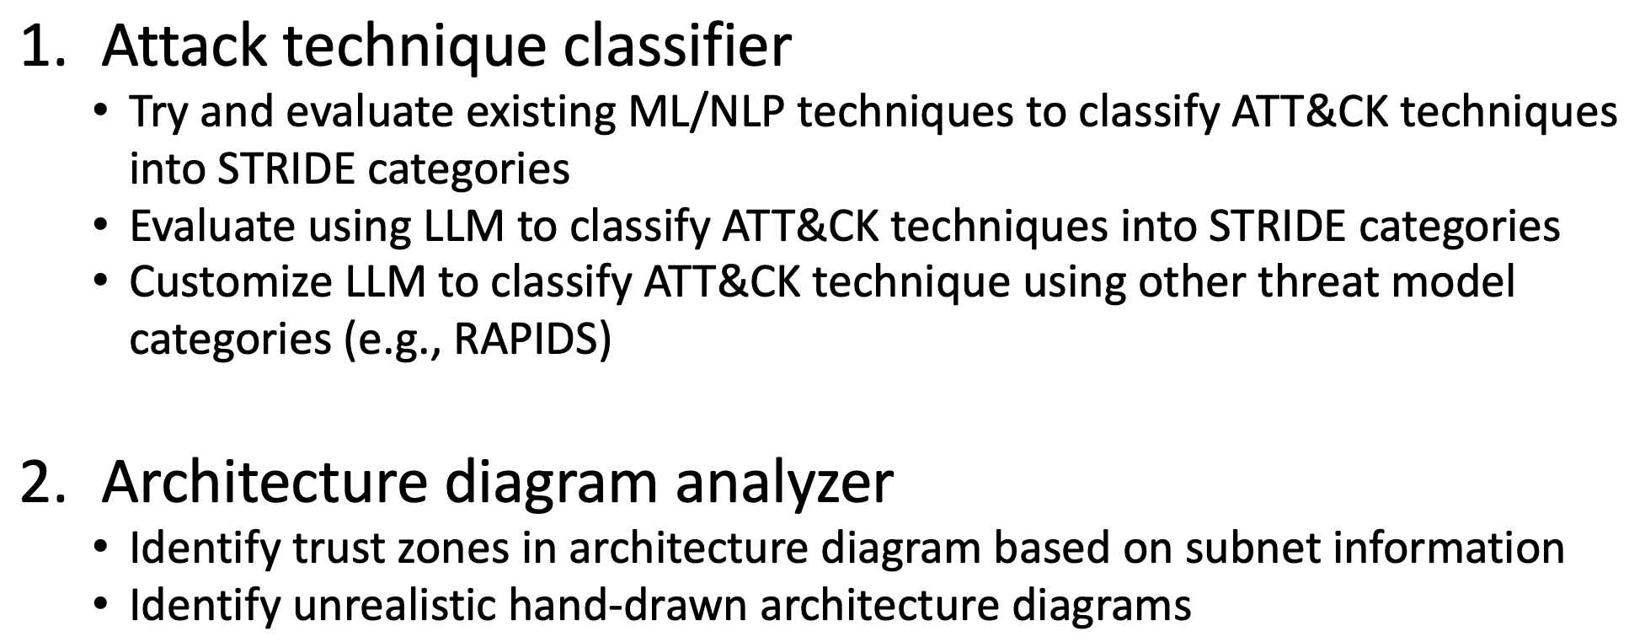

* Studied code from current stride (supervised) model classifier: https://github.com/sebyakuya/stride-classifier/tree/master
* There are many Naïve Bayes classifiers used which I am not familiar with.
* Work for tmr: Read up more on the classifiers and the estimators used.

Day 2: 16/1/2024

* Understood the supervised model’s code. Looking at the raw_capec_data.xlsx to try clustering methods to create an unsupervised model. The trained supervised model might be useful in feature extraction to train the unsupervised model. What features exactly? Still not too sure.