Here’s the final design... The big onslaught logo (in sideborder every second line, so we can have 7 sprites and sideborder)
will be scrolling (and repeating) 2 pixels each frame,
the lower left part is a char-typewriter like in the original legend intro:
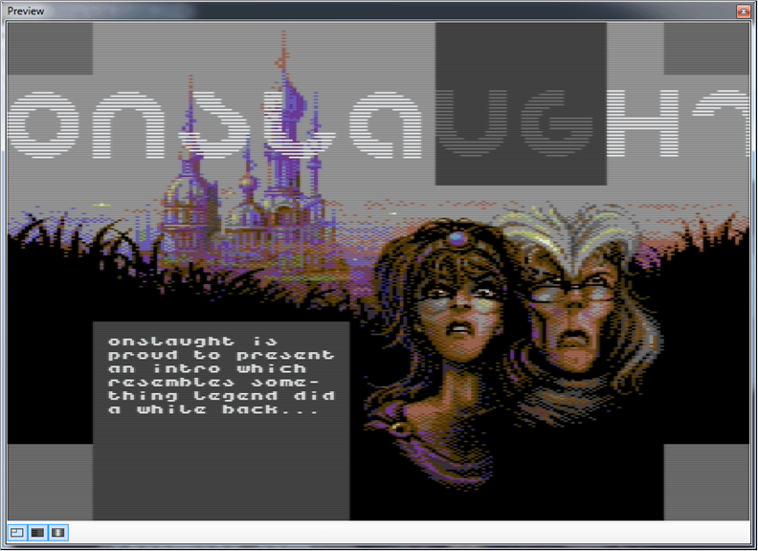

The multicolour bitmap (only 10 char-rows, so it should be able to colour-fade in the whole screen at once):

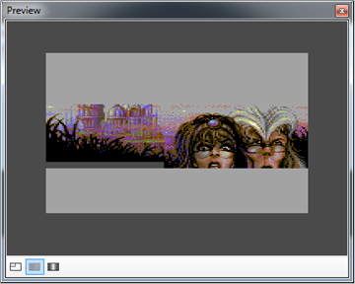

About 50 sprites:

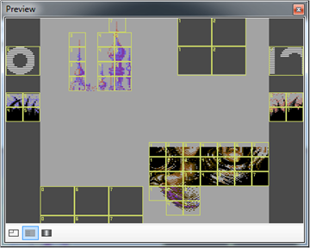

One 251 chars charset which contains the small font, underlying sprite colours and all scrolled versions of the big onslaught logo in it:


