Question 3 - Finding the shape of the web with node connections

A --> B

Figure 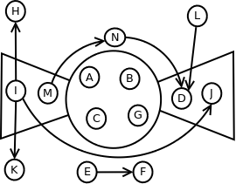1: Bowtie chart with node connectivity

B --> C

C --> D

C --> A

C --> G

E --> F

G --> C

G --> H

I --> H

I --> J

I --> K

J --> D

L --> D

M --> A

M --> N

N --> D

Figure 1. shows the relationships between nodes A through N in the context of the shape of the web. The nodes which are part of the IN component are I and M. Out tendrils are formed by the connections from I to node H and node K. The nodes contained in the Strongly Connected Component are A, B, C, and G. The nodes which are part of the OUT component are D and J. There is one out tendril formed by the connection between node L and node D. There are two tubes formed by the node connections, the first tube from node I to node J. The second tube is formed by the connection of three nodes, from node M to node N to node D. Nodes E and F compose the Disconnected component of the chart.