Joseph Elder
00844802
ODU CS 495
Michael Nelson

NCAAF Score Grabber

1. Overview

The NCAAF Score Grabber is a computer program designed to grab the scores from actual National Collegiate Athletic Association Football games. The scores are reported from the Yahoo Sports College Football website. This version of the program can only access the score from one game at a time, however it is capable of updating the score on a time interval which can be set. The program which is written in the python programming language (python 2.7.6). To execute the program on a linux machine use the command prompt to navigate to the folder where the python file exists and enter “$ ./NCAAF.PY” However in order for the program to run it must be supplied three command line arguments to return the back the scores from the desired game.

1.1 Usage of Arguments

Command line arguments in this program are handled by a python module called “argparse.” The purpose of the argparse module is to simply parse the command line arguments supplied when running the program. A benefit of using the argparase module is that the module automatically supplies a help option which can be accessed by using either the -h or --help arguments. Help will supply a full list of all arguments which are to be supplied to the program.
The required arguments for the NCAAF Score Grabber are the “team”, “seconds”, and “uri” options. The team argument is for the user to supply the name of the team they are trying to look up. The actual team name must be inserted into double or single quotes when being input at the command line. The program is capable of updating scores on a settable interval, the seconds argument is used to set that interval. Note that it may take up to several seconds to access and process the HTML from the Yahoo Sports website so depending on your Internet speed and computer there may be a minimal delay in addition to the update interval.

Option Name | Option Syntax | Description
Help: | ./NCAAF -h  or  ./NCAAF --help | Displays all options of the program in a similar fashion to this table.
Team: | ./NCAAF -t”Sample team”  or  ./NCAAF --team”Sample Team” | Argument for the user to supply the name of the team which they are searching for.
Seconds: | ./NCAAF -s60  or  ./NCAAF –seconds60 | Argument for the user to supply the time interval in seconds on which the scores will be updated.
URI: | ./NCAAF -u”http://sports.yahoo.com/college-football/scoreboard/”  or  ./NCAAF --uri”http://sports.yahoo.com/college-football/scoreboard/” | Argument for the user to supply the URI of the Yahoo college football website which supplies the scores.
Table 1: List of all program arguments

The last option is the URI option which is supplied to direct the Score Grabber to the correct set of games. Different options in the URI include different football conferences and the weeks which the games are played. Team names must be entered just as they are on the website. The seconds interval can be any number other than.

Example with all arguments:
./NCAAF.py -t"Old Dominion" -s60 -u"http://sports.yahoo.com/college-football/scoreboard/?conf=all&week=2"
Table 2: All arguments required to run the program

2 PROCESS

The NCAAF Score Grabber gets its information from the web in a process called “scraping.” Scraping involves taking the source code of a website and processing it for valuable or useful information which would be difficult to obtain otherwise. While it is not a perfect permanent solution, in application it allows for rapid development of programs which can access data in the real world. After taking the command line arguments the program grabs the HTML from the specified URI by using the module “urllib2.” The purpose of the urlib2 module is specifically to take down the HTML from the Internet and get it into an accessible form inside of python. That HTML is then parsed by another module named Beautiful Soup (BS4.) Beautiful Soup is designed to parse HTML for specific information. The Beautiful Soup module is used to find three specific pieces of information from the source HTML, the team name, the name of the team they are playing against, and finally the score for that game.

(This space intentionally left blank)

3. Program Output

After scraping the site to locate the team, their opponent, and the current score of the game, that information is printed to the command prompt screen. In addition the program informs the user of whether the teams playing are at home or away. Scores will be reported the same way regardless of
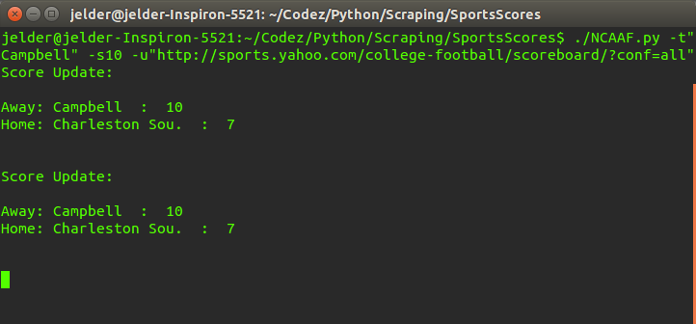Illustration 1: Console output from a live game

whether or not the team being searched for is at home or away. The scores of the game will be updated and reprinted after the amount of seconds entered for the seconds interval has elapsed. This output will continue until the program is terminated using “control+c” on the keyboard or exiting the terminal all together.

