Question 3 - Finding the shape of the web with node connections

A --> B
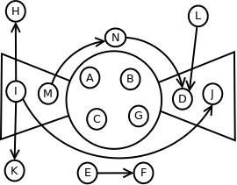Figure 1: Bowtie chart with node connectivity
B --> C
C --> D
C --> A
C --> G
E --> F
G --> C
G --> H
I --> H
I --> J
I --> K
J --> D
L --> D
M --> A
M --> N
N --> D

Figure 1. shows the relationships between nodes A through N in the context of the shape of the web. The nodes which are part of the IN component are I and M. Out tendrils are formed by the connections from I to node H and node K. The nodes contained in the Strongly Connected Component are A, B, C, and G. The nodes which are part of the OUT component are D and J. There is one out tendril formed by the connection between node L and node D. There are two tubes formed by the node connections, the first tube from node I to node J. The second tube is formed by the connection of three nodes, from node M to node N to node D. Nodes E and F compose the Disconnected component of the chart.

