2017 BULLRUN

AFTER SEPTEMBER RECOVERY, THE CHART KEPT IT UP IN A PARABOLIC UPTREND. AT THE START BTC PRICE WAS AROUND $6K BUT PEAKED AT $19K

START DATE: SEPTEMBER 2017

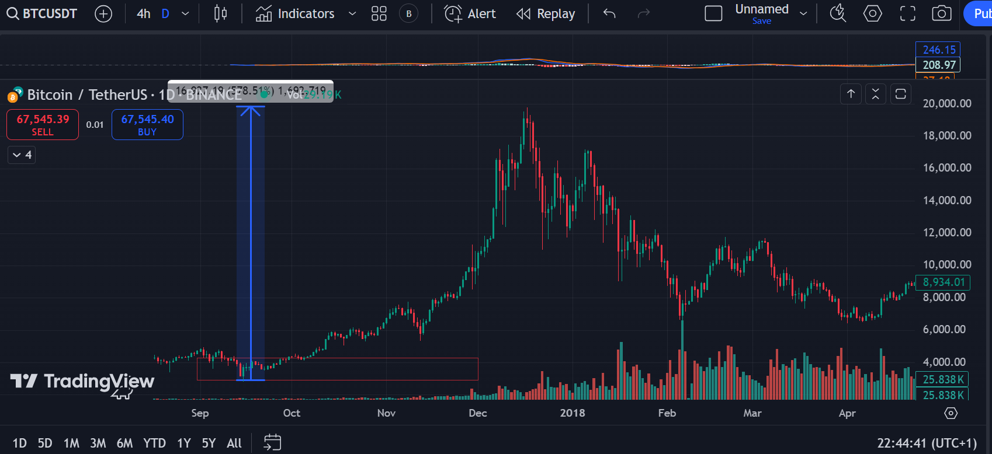

2020/2021

ALTHOUGH THE RALLY BEGAN ON OCTOBER, WE CAN CLEARLY SEE THE SEPTEMBER EEFCT ON THE CHART BEFORE ANY PROCEEDING RALLYS.

START DATE: OCTOBER 2020 WHEN BTC WAS PRICED 10.5K

2020

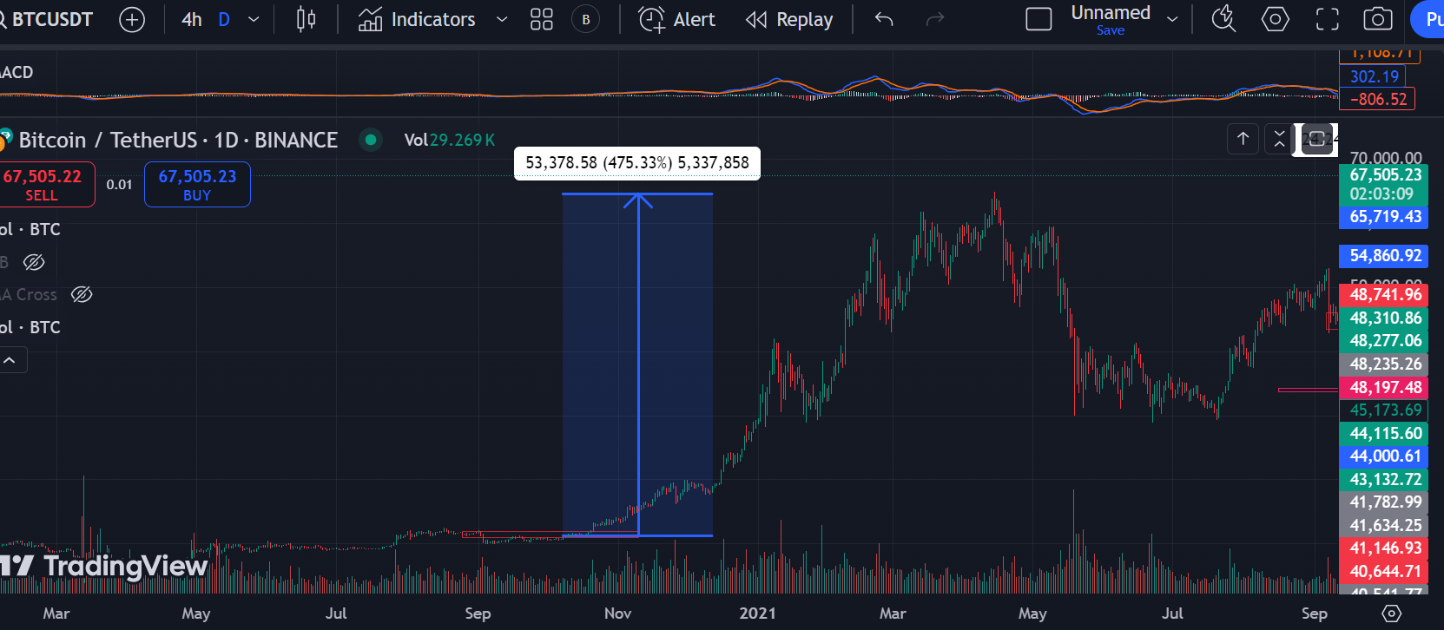

2021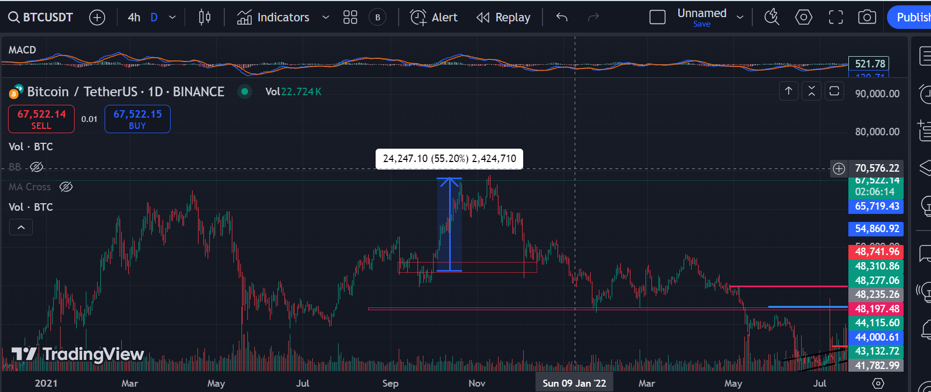

SEPTEMBER 2024

AS SEEN FROM THE PREVIOUS CHART, SEPTEMBER HAS ALWAYS BEEN A BEARISH MONTH. BUT CONTIOUSLY IT TURNED OUT BULLISH ON OTHER MONTHS

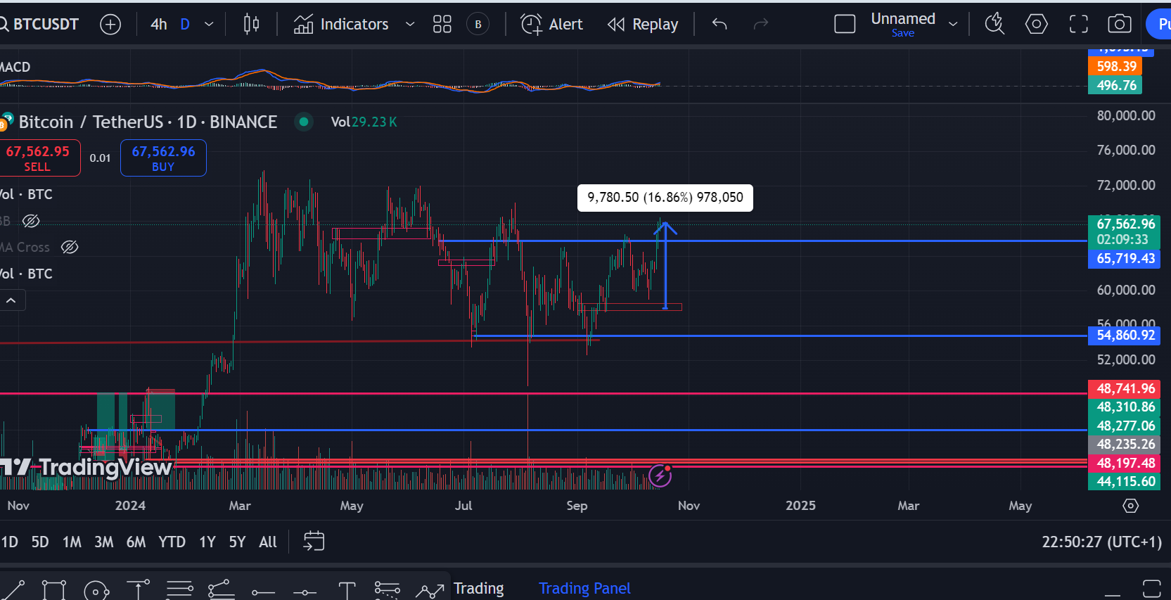

October

2017; KEY EVENT DURING THIS PERIOD WAS CHINA CRACKDOWN ON ICOS. THIS WAS WHAT MADE IT HOLD 3K AT THAT TIME. THERE WAS A RETEST DURING NOVEMBER BUT IT PULL BACK UP

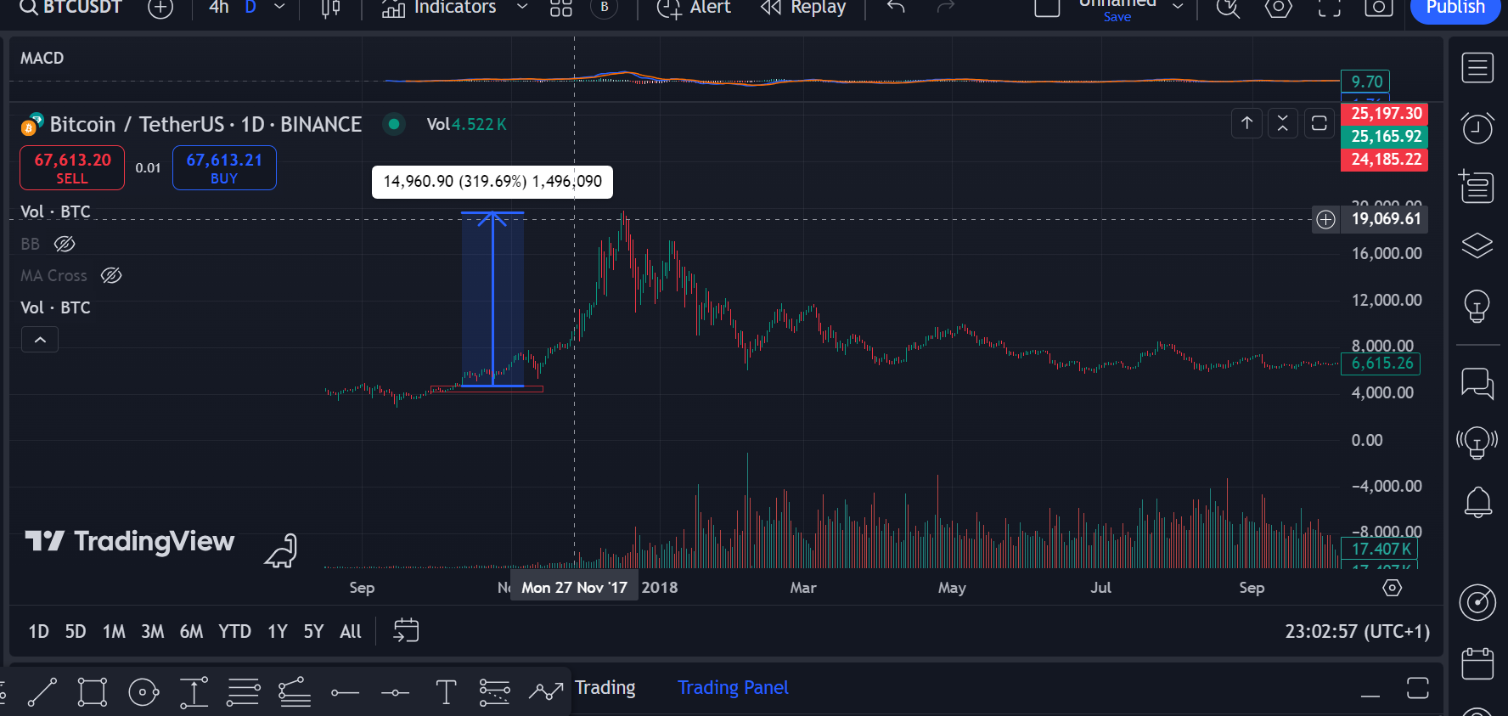

2020/2021

2020

OCTOBER IS ALWAYS A START OF SOMETHING SMOOTH. AS SEEN IN OUR THESIS

BUT THEN PUMP HERE WAS MAJORLY BECAUSE OF INSITUSIONAL MONEY.

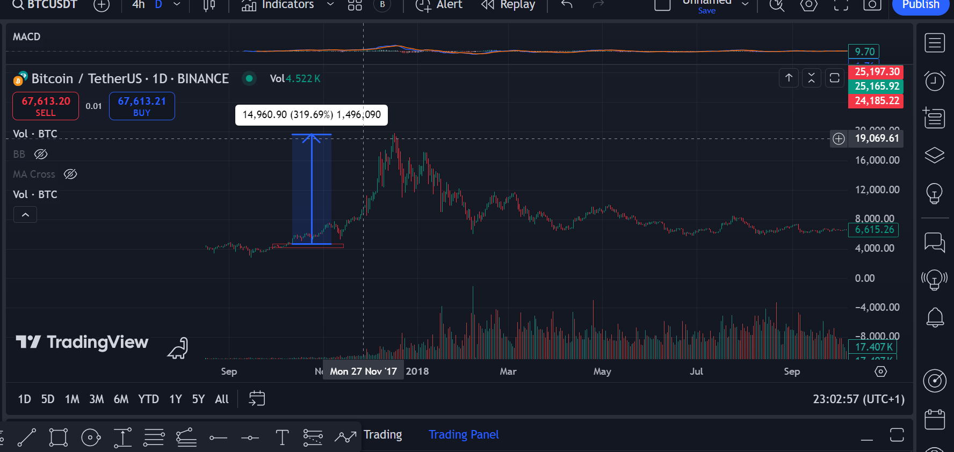

2024

ALWAYS A RISE

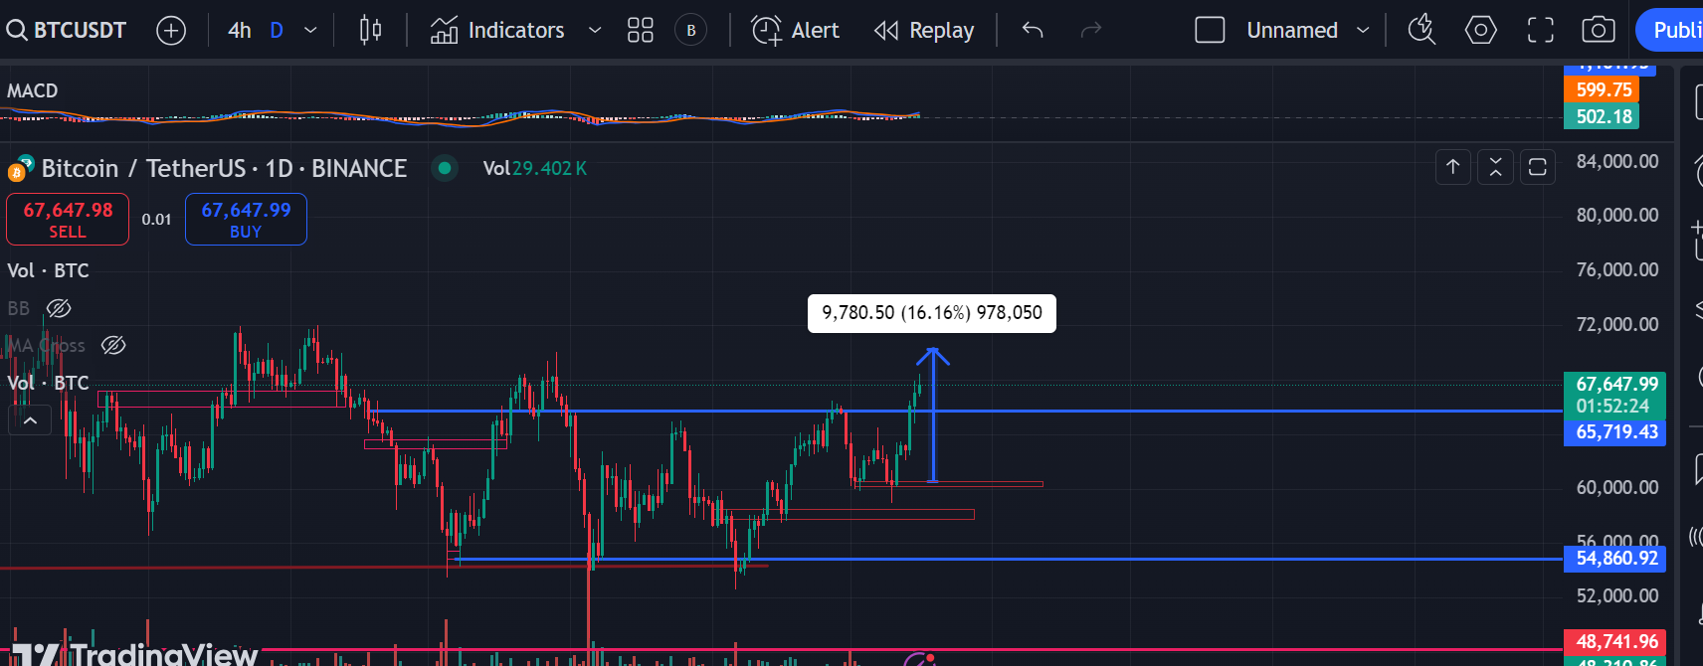

NOVEMBER

IN MOST CYCLES, OCTOBER AND NOVEMBER HAS BEEN PIVOTALMONTHS WHERE BTC BROKE OUT OF CONSOLIDATION PHASES

2017

HERE BEFORE THE MAIN PLAY, THERE WAS A HUGE RETEST THAT TOOK PLACE AND HELD FOR OVER A WEEEK. LETS TAKE LOOK AT OTHER CYCLES

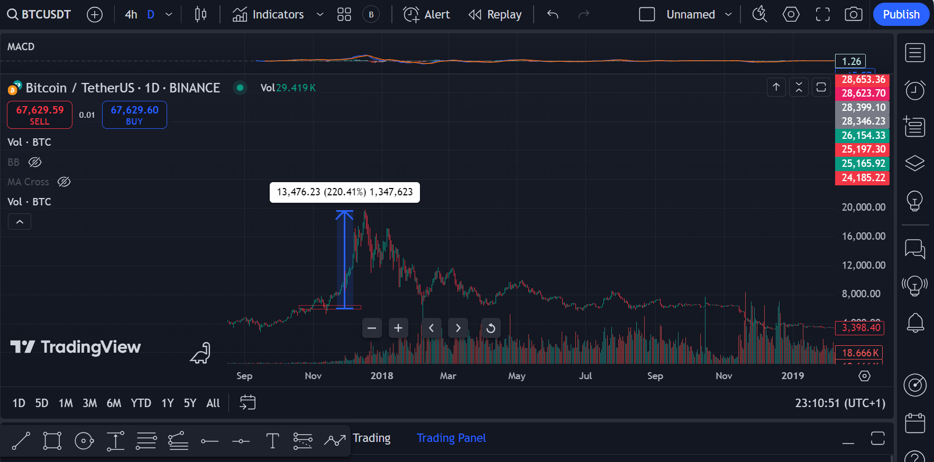

2021/2020

FROM WHAT IS SEEN HERE AS WELL LOOKS LIKE THERE ARE ALWAYS MASSIVE RESTEST IN NOVEMBER THOU THIS ONE LASTEDFO ONLY 3 DAYS.

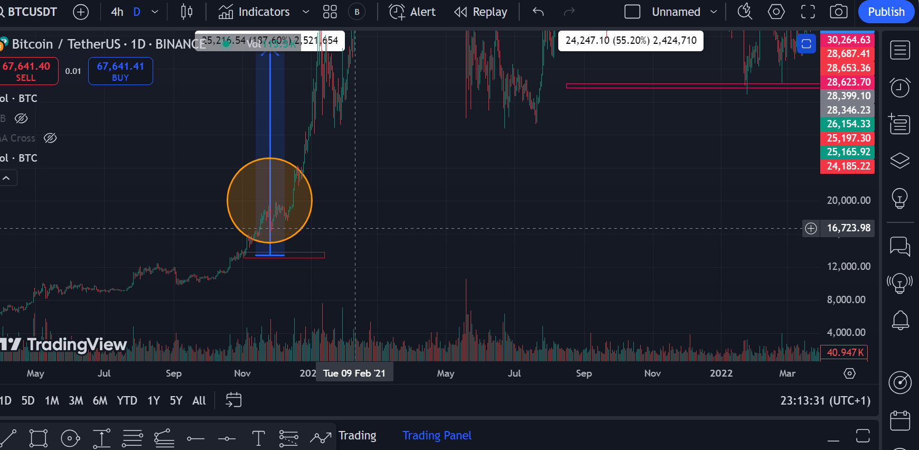

THERE WAS ALSO A RESTEST AT NOVEMBER HERE AS WELL

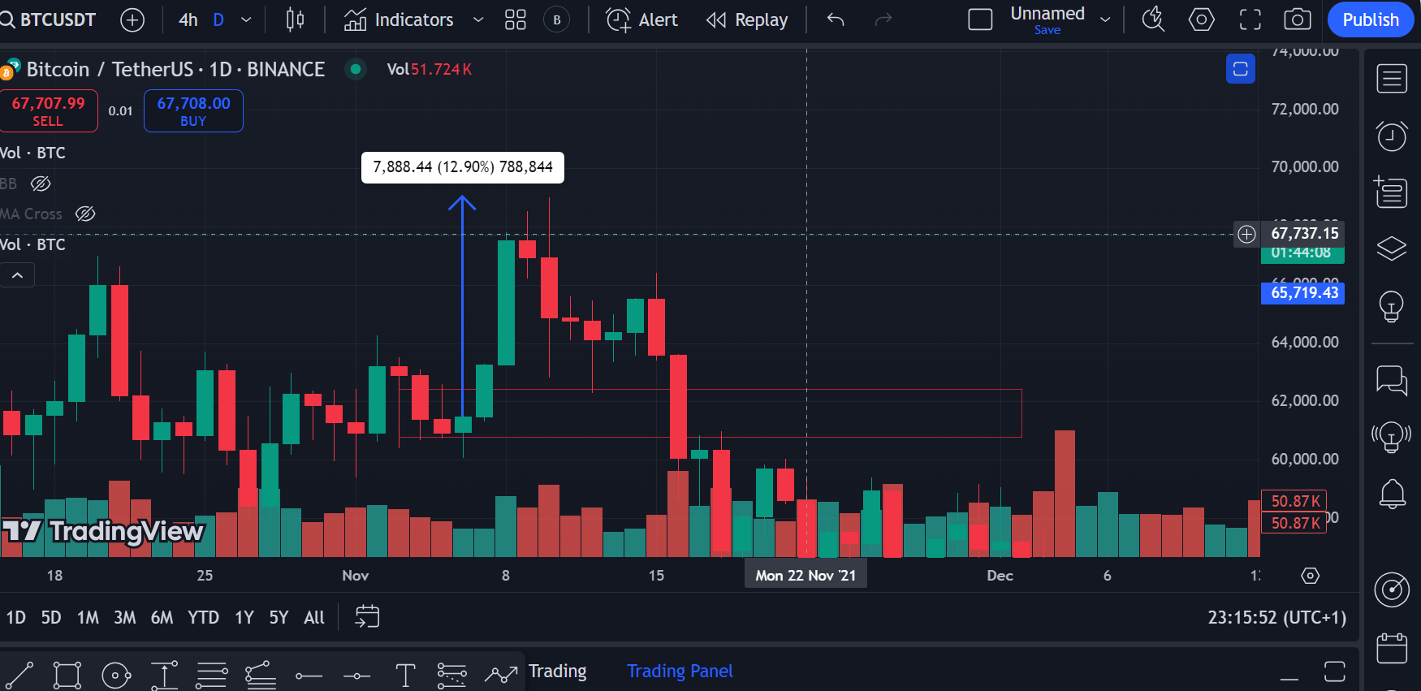

AND THEN PREDICTION 2024 NOVEMBER

DAILY

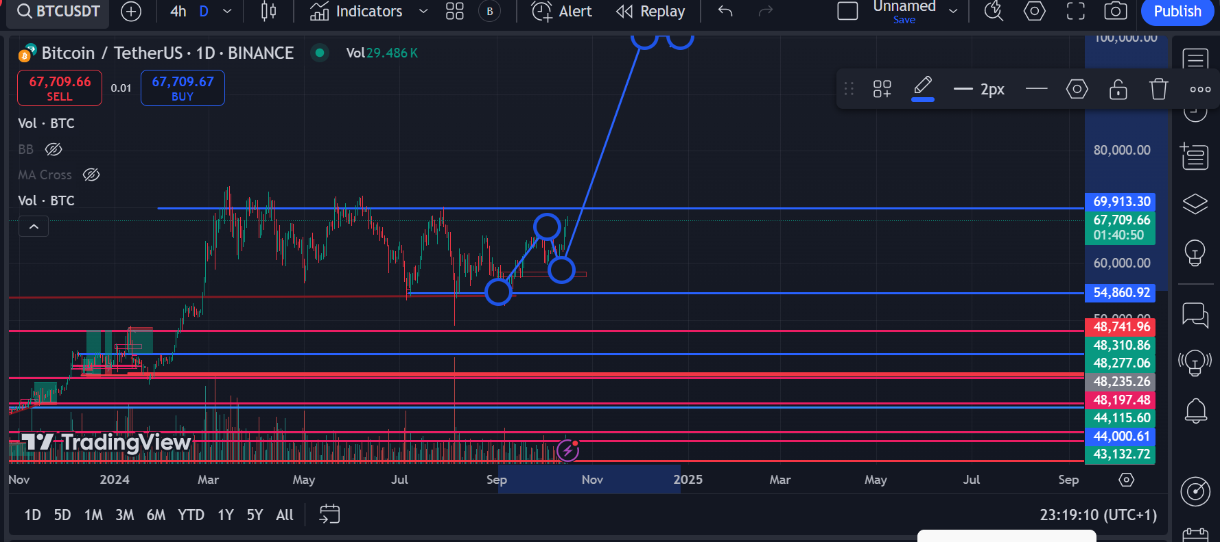

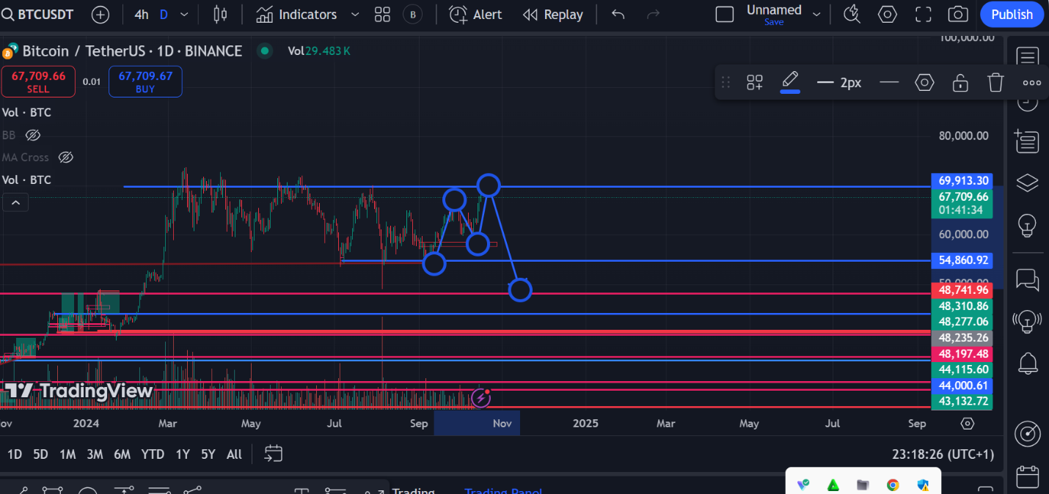

4HR