Web Applications Development (TC-2026)
Professor: María de los Ángeles Constantino González
First Partial Exam August-December 2015
Practice Part (30 points)
Subject: Backbone, JQuery Validation, HTTP Protocol, Web Servers, Ajax, XML, XSL,
Web Applications in PHP
Registration ID: 00947301 Name: Elder Rodriguez Salas Career: ITIC
Following the ITESM Students’ Code of Ethics, I commit that my performance on this test is governed by academic honesty. In keeping with the commitment made by signing the code, I will make this test honestly by myself, to reflect, through it, my knowledge and to accept later the evaluation obtained.

ELDER RDZ SALAS 00947301 Sign

1.- Download the file named ordenes.xml from Blackboard and do the following activities: (10 points)
- Build an XSL file, named ordenesYourName.xsl, that shows a table within an html file. The table should display the orders available (orderId, nombreCliente, saldo, Fecha). The data should be displayed in descending orden according to the “saldo” element. Add a caption to the table. At the bottom of the page “Total Saldo” should be displayed.
<?xml version="1.0" encoding="UTF-8"?>

<xsl:stylesheet version="1.0" xmlns:xsl="http://www.w3.org/1999/XSL/Transform">

<xsl:template match="/">
<html>
<head>
<link rel="stylesheet" type="text/css" href="compras.css"/>
</head>
<body>
<table border="1">
<caption><h2>Compras</h2></caption>
<tr id="header">
<th>ID</th>
<th>Nombre</th>
<th>Saldo</th>
<th>Fecha</th>
</tr>
<xsl:for-each select="compras/orden">
<xsl:sort select="fecha"/>
<tr id="tabledata">
<td><xsl:value-of select="@id"/></td>
<td><xsl:value-of select="nombreCliente/nombre"/></td>
<td>$<xsl:value-of select="saldo"/></td>
<td><xsl:value-of select="fecha"/></td>

</tr>

</xsl:for-each>
<tr id="tabledata">
<td colspan="2">Total saldo: </td>
<td>$<xsl:value-of select="sum(compras/orden/saldo)"/></td>
</tr>
</table>
</body>
</html>
</xsl:template>

</xsl:stylesheet>

- Use an external css file “compras.css” to define table background header green and table data background light green. The title of the table should be 12 points color #0033cc.

<style>
h2{
font-size: 12px;
color: #0033CC;
}
#header{
background-color: green;
}
#tabledata{
background-color: #00FF00;
}

</style>

- Upload the xsl file and a Word document in which you display the screenshot of the page.

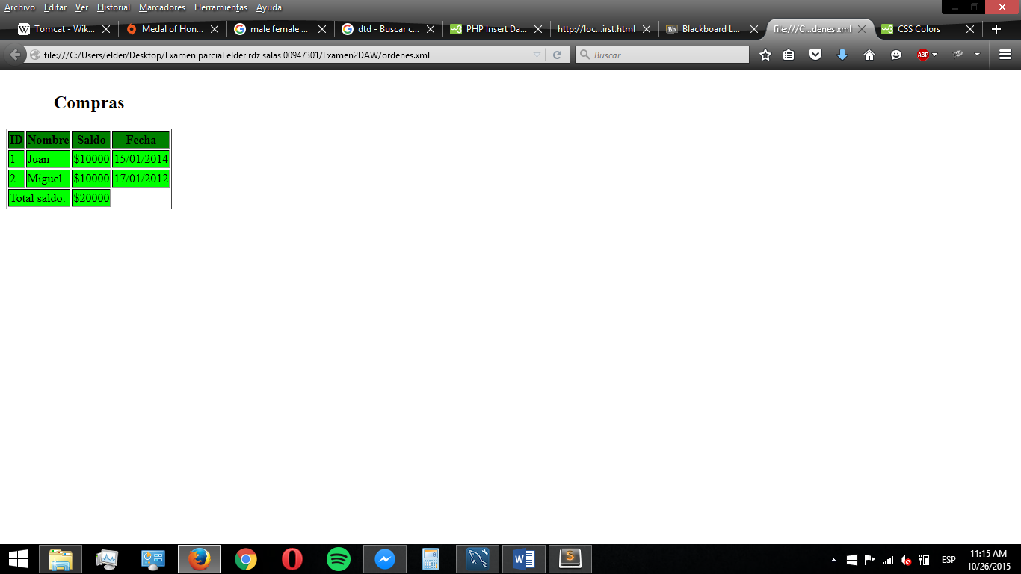

2.- Develop a web application named Exam2YourName according to the following requirements: (20 puntos)
- Create a header.php file with the class name, your name, and actual date. All pages should include this header in the top of the page..
- Download an html page to register carOptions, CarForm.php. Include the header page in this page.

- Add form validation using rules and messages in JQuery validation library. All elements are mandatory. Email address should have 8 characters minimum. Zip should be greater than 100
- Create a table named Clients to store email, color, doors and zip within a MySQL database named cars. The email is the primary key.
- Create a PHP file, CarData.php, to save this data in the database and display this data in an html page.
Give as a result:
- Project, Word document. Send files to aconstan@itesm.mx and aconstang@gmail.com

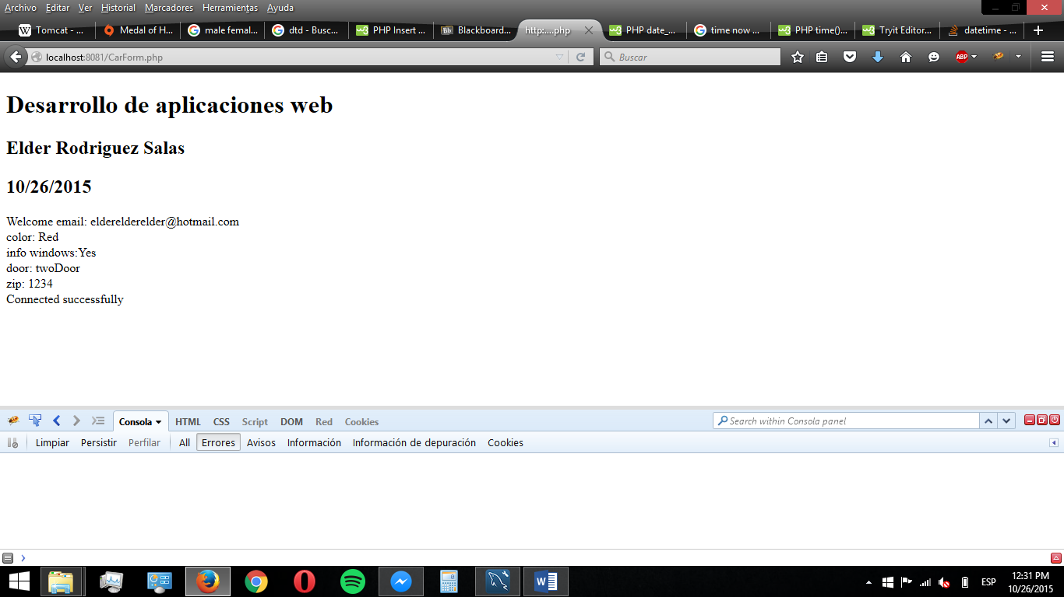
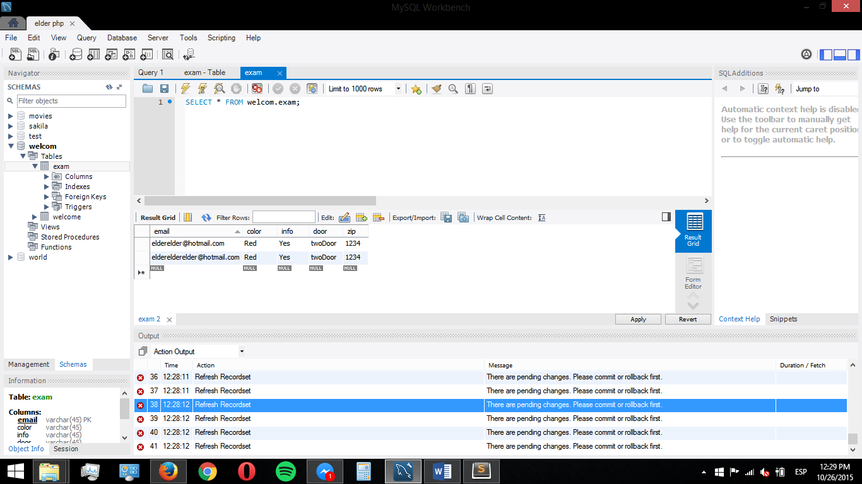

<html>
<head>
<script src="http://code.jquery.com/jquery-latest.min.js"/>
<script src="js/jquery.validate.js"></script>
<title>Car Picker</title>
<meta http-equiv="Content-Type" content="text/html; charset=UTF-8">
</head>
<body>
<?php include "header.php";?>
<h2 align="center">Car Picker</h2>
<form action="CarForm.php" id="fx" method ="POST">
<p><label for="emailAddr">Email Address: <input name="emailAddr" id="emailAddr" type="email" size="30" class="reqd" required/></label></p>
<p><label for="color">Colors:
<select name="color" id="color" class="reqd" required>
<option value="" selected="selected"> Choose a color</option>
<option value="Red">Red</option>
<option value="Green">Green</option>
<option value="Blue">Blue</option>
</select>
</label></p>
<p>Options:
<label for="pWindows"><input type="checkbox" name="pWindows" id="pWindows" value="Yes" required/>Power Windows</label>
</p>
<p><label for="DoorCtL">Doors:&nbsp;&nbsp;
<input type="radio" id="twoDoor" name="DoorCtl" value="twoDoor" class="radio" required/>Two
<input type="radio" id="fourDoor" name="DoorCtl" value="fourDoor" class="radio" required/>Four
</label></p>
<p><label for="zip"> Enter your Zip code: <br />
Zip: <input id="zip" type="text" size="5" maxlength="5" class="isZip dealerlist" required name="zip"/>
</label> </p>
<p><input type="submit" value="Submit" />&nbsp;<input type="reset" /></p>
</form>

<script type="text/javascript">
$("#fx").validate();
</script>
</body>
</html>

<!Doctype html>
<html>
<head>
<meta charset="utf-8">

</head>
<body>
<?php include "header.php";?>
Welcome
email: <?php echo $_POST["emailAddr"]?><br>
color: <?php echo $_POST["color"]?><br>
info windows:<?php echo $_POST["pWindows"]?><br>
door: <?php echo $_POST["DoorCtl"]?><br>
zip: <?php echo $_POST["zip"]?><br>

<?php
$em= $_POST["emailAddr"];
$co= $_POST["color"];
$in= $_POST["pWindows"];
$do= $_POST["DoorCtl"];
$zi= $_POST["zip"];

$servername = "localhost";
$username = "elder";
$password = "elder";

try {

$conn = new PDO("mysql:host=$servername;dbname=welcom", $username, $password);
// set the PDO error mode to exception
$conn->setAttribute(PDO::ATTR_ERRMODE, PDO::ERRMODE_EXCEPTION);
echo "Connected successfully <br/>";

$sql = "INSERT INTO exam (email, color, info, door, zip) VALUES (:email,:color,:info,:door,:zip)";

$q = $conn->prepare($sql);
$q->execute(array(':email'=>$em,'color'=>$co,'info'=>$in,'door'=>$do,'zip'=>$zi));
}
catch(PDOException $e)
{
echo "Connection failed: " . $e->getMessage();
}
?>

</body>
</html>

