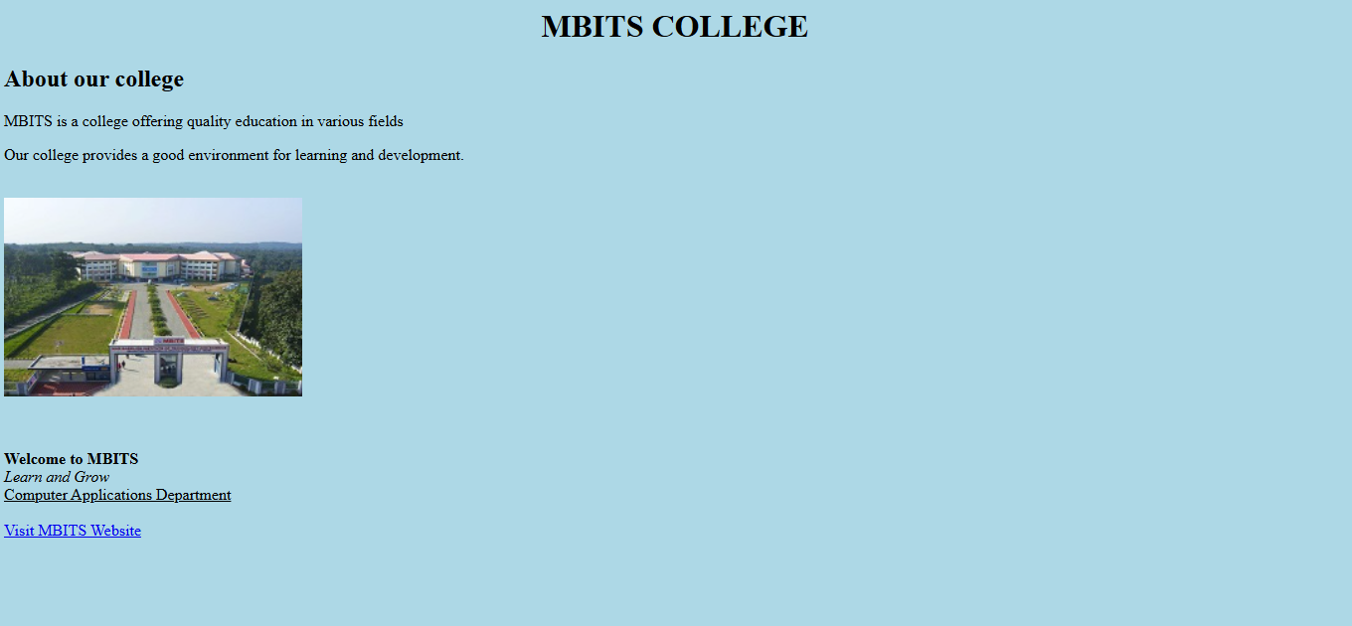
PGM1
<html>
<head>
<title>MBITS COLLEGE</title>
</head>
<body style="background-color:lightblue;">

<h1 align="center">MBITS COLLEGE</h1>
<h2>About our college</h2>
<p>MBITS is a college offering quality education in various fields</p>

<p>Our college provides a good environment for learning and development.</p>

<br>
<img src="college.jpg" width="300" height="200">
<br><br>

<br><br>

<b>Welcome to MBITS</b><br>
<i>Learn and Grow</i><br>
<u>Computer Applications Department</u>

<br><br>

<a href="https://mbits.ac.in">Visit MBITS Website</a>

</body>
</html>

