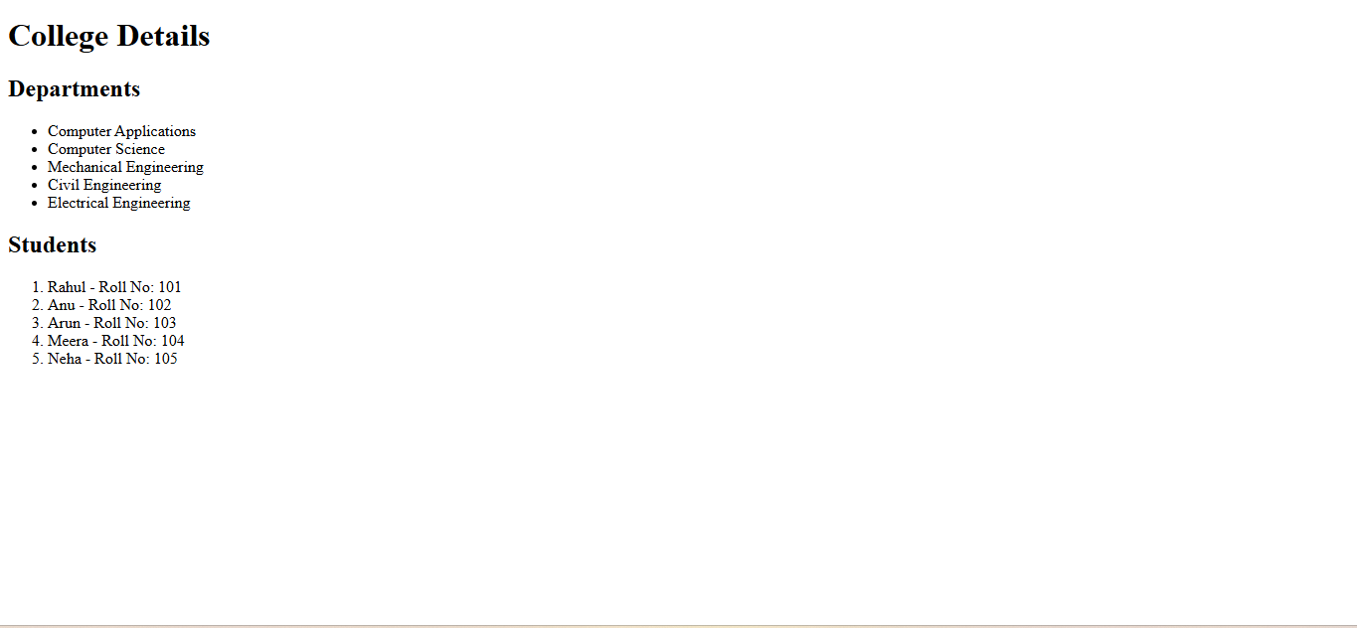
PGM2
<html>
<head>
<title>College Lists</title>
</head>
<body>
<h1>College Details…</h1>
<h2>Departments</h2>
<ul>
<li>Computer Applications</li>
<li>Computer Science</li>
<li>Mechanical Engineering</li>
<li>Civil Engineering</li>
<li>Electrical Engineering</li>
</ul>
<h2>Students</h2>
<ol>
<li>Rahul - Roll No: 101</li>
<li>Anu - Roll No: 102</li>
<li>Arun - Roll No: 103</li>
<li>Meera - Roll No: 104</li>
<li>Neha - Roll No: 105</li>
</ol>
</body>
</html>

