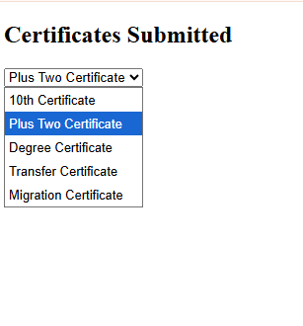
PGM-3
<html>
<head><title>Certificates</title></head>
<body>
<h2>Certificates Submitted</h2>
<select>
<option>10th Certificate</option>
<option>Plus Two Certificate</option>
<option>Degree Certificate</option>
<option>Transfer Certificate</option>
<option>Migration Certificate</option>
</select>
</body>
</html>

