Pgm13
Floating frame
<html>
<body>
<h2>Floating frame</h2>
<iframe src="https://www.example.com" width="600" height="300"></iframe>
</body>
</html>
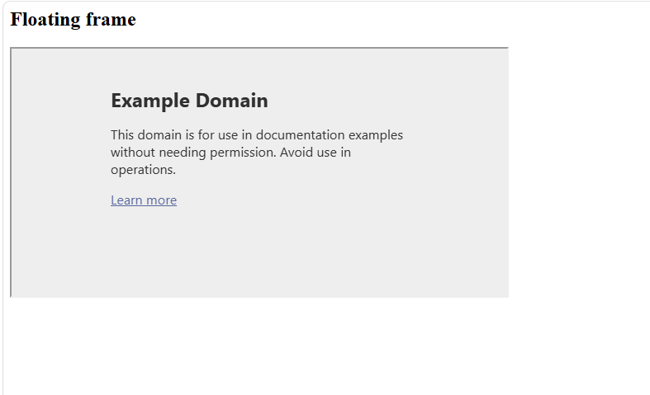

Navigation frame
<html>
<frameset cols="30%,70%">
<frame src="menu.html">
<frame src="home.html" name="content">
</frameset>
</html>
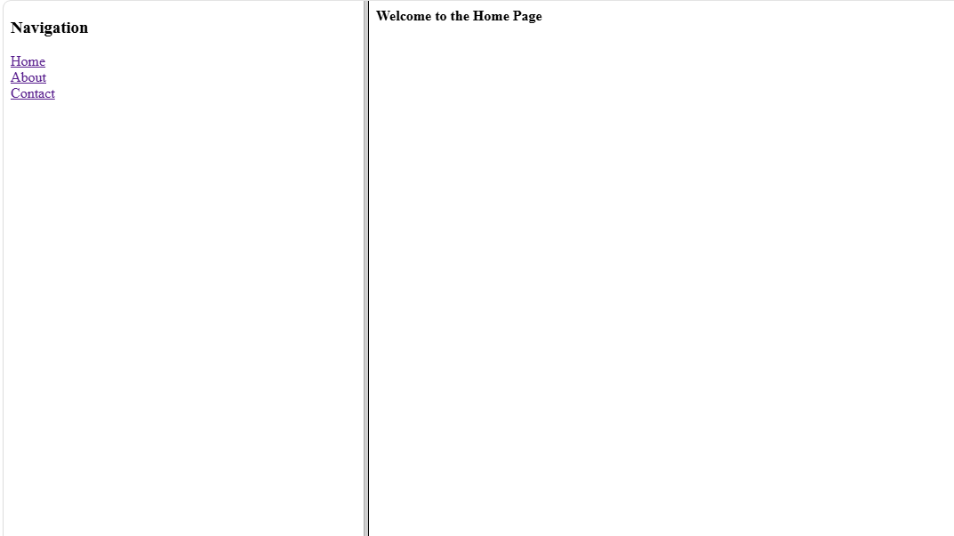

Menu.html
<!DOCTYPE html>
<html>
<body>
<h3>Navigation</h3>
<a href="home.html" target="content">Home</a><br>
<a href="about.html" target="content">About</a><br>
<a href="contact.html" target="content">Contact</a>
</body>
</html>
Home.html
<html>
<body>
<h4>Welcome to the Home Page</h4>

</body>
</html>
About.html
<html>
<body>
<h2>This is the about Page</h2>
</body>
</html>
Contact.html
<html>
<body>
<h1>This is the Contact Page</h1>
</body>
</html>
Mixed.html
<html>
<frameset rows="30%,80%">
<frame src="header.html">
<frameset cols="30%,70%">
<frame src="menu.html">
<frame src="home.html" name="content">
</frameset>
</frameset>
</html>
