Pgm7.html
<!DOCTYPE html>
<html>
<head>
<title>MBITS Website</title>
</head>

<body>

<h1>MBITS COLLEGE</h1>

<a href="image.html">Images</a><br>
<a href="table.html">Student Table</a><br>
<a href="links.html">Useful Links</a>

</body>
</html>
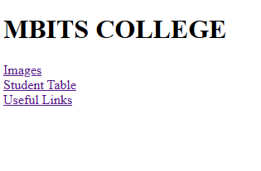

Image.html
<html>
<head>
<title>Images</title>
</head>

<body>

<h2>College Image</h2>

<img src="college.jpg" width="300">

<br><br>

<a href="PGM7.html">Home</a>

</body>
</html>
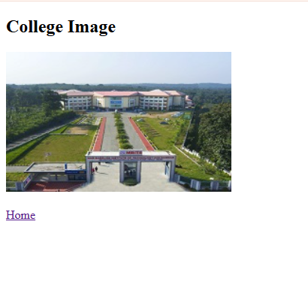
Table.html
<!DOCTYPE html>
<html>
<head>
<title>Student Table</title>
</head>

<body>

<h2>Student Details</h2>

<table border="1">

<tr>
<th>Roll No</th>
<th>Name</th>
<th>Mark</th>
</tr>

<tr>
<td>1001</td>
<td>ALBIN</td>
<td>80</td>
</tr>

<tr>
<td>1002</td>
<td>ANJU</td>
<td>85</td>
</tr>

</table>

<br>

<a href="PGM7.html">Home</a>

</body>
</html>
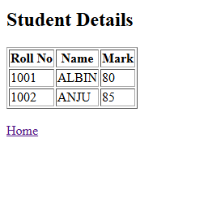
Links.html
<!DOCTYPE html>
<html>
<head>
<title>Useful Links</title>
</head>

<body>

<h2>Useful Links</h2>

<a href="https://www.youtube.com">YouTube</a><br>
<a href="https://mbits.ac.in">MBITS</a><br>

<br>

<a href="PGM7.html">Home</a>

</body>
</html>
