1. 실행 ./bin/karaf

시스템 생성 대체 텍스트:
odlaodl-standard- 
/karaf 
karaf: JAVA_HOME 
VI 
pc-i 440Fx-P11x-1996 : —/edgar/odl/di stri but i on-karaf-O. 2. 3-He1 i um-SR3S 
not set; results may vary 
/bi n 
vv 
v 
Hit 
and 
Hit 
' CcmdJ 
-help' for help on a specific command. 
' «ctrl-b' or type system: shutdown' or ' logout 
for a list of available commands 
to shutdown OpenDay1ight. 
opendayl i ght-user 

1. RestAPI를 동작 시키기 위한 third party feature

feature:install odl-base-all odl-aaa-authn odl-restconf odl-adsal-northbound odl-mdsal-apidocs odl-l2switch-switch

1. RestAPI 호출은 admin:admin 을 base 64로 인코딩 한 결과를 해더에 포함

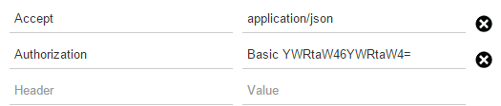

curl 명령어로 접속시 -u admin:admin 옵션 추가