Antimicrobial Resistance in Organic and Conventional farms: A sytemic literature review
December 16, 2022
We identified 1836 references in three search databases: Pub Med, Web of Science, and PubAg, from studies published between 2000 and 2022. The studies reported the point prevalence of antimicrobial resistance in Organic and Conventional farms. Three duplicates were removed, and the remaining 1833 unique references were subjected to relevance screening, with 1744 references being removed. After assessing the remaining 89 references for eligibility, 17 were removed. The systematic review included 72 studies that met our criteria (fig.1). The North America accounted for 46% (n=33) of the surveys.Europe accounted for 36% (n=26), 14% (n=10) of studies were from Asia while Oceania and South America contributed to 3% (n=2) and 1% (n=1) of the studies respectively.
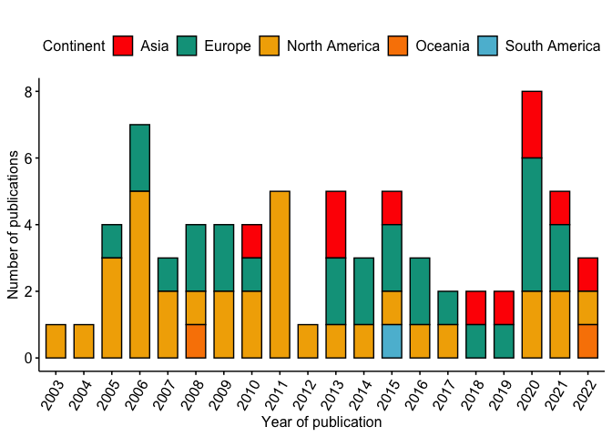

Antimicrobial resistance trends in Organic and conventional farms
Percentage resistance of antimicrobial compounds increased in both organic and conventional farms between 2001 and 2020. The percentage resistance in organic farms increased from 10% 95% Confidence interval (CI: 2-18%) to 32% (CI: 23-41%) while in conventional farms the percentage resistance increased from 18% (CI: 12-28%) to 42% (CI: 33-51%) (p = 0.0215) (fig2). Generally, the mean resistance is higher in conventional farms 28% as compared to organic farms 18% (supplementary materials).
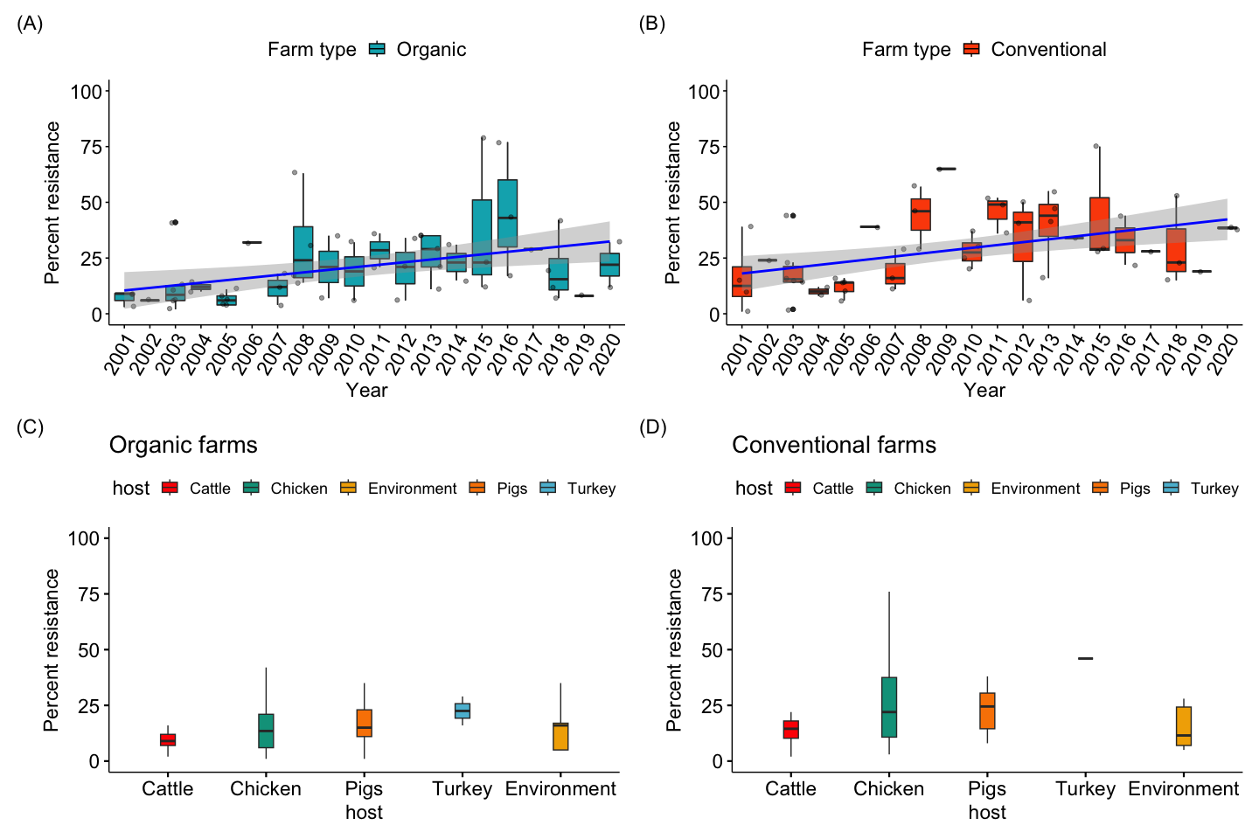
Resistance of foodborne pathogens across different regions
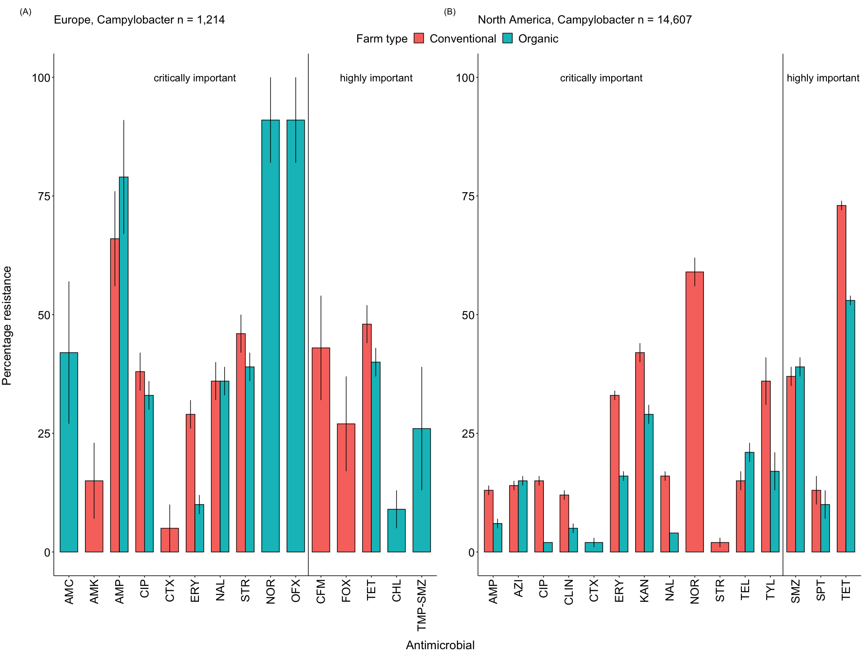
## TableGrob (2 x 2) "arrange": 3 grobs
## z cells name grob
## 1 1 (1-1,2-2) arrange gtable[layout]
## 2 2 (2-2,2-2) arrange text[GRID.text.1284]
## 3 3 (1-2,1-1) arrange text[GRID.text.1283]
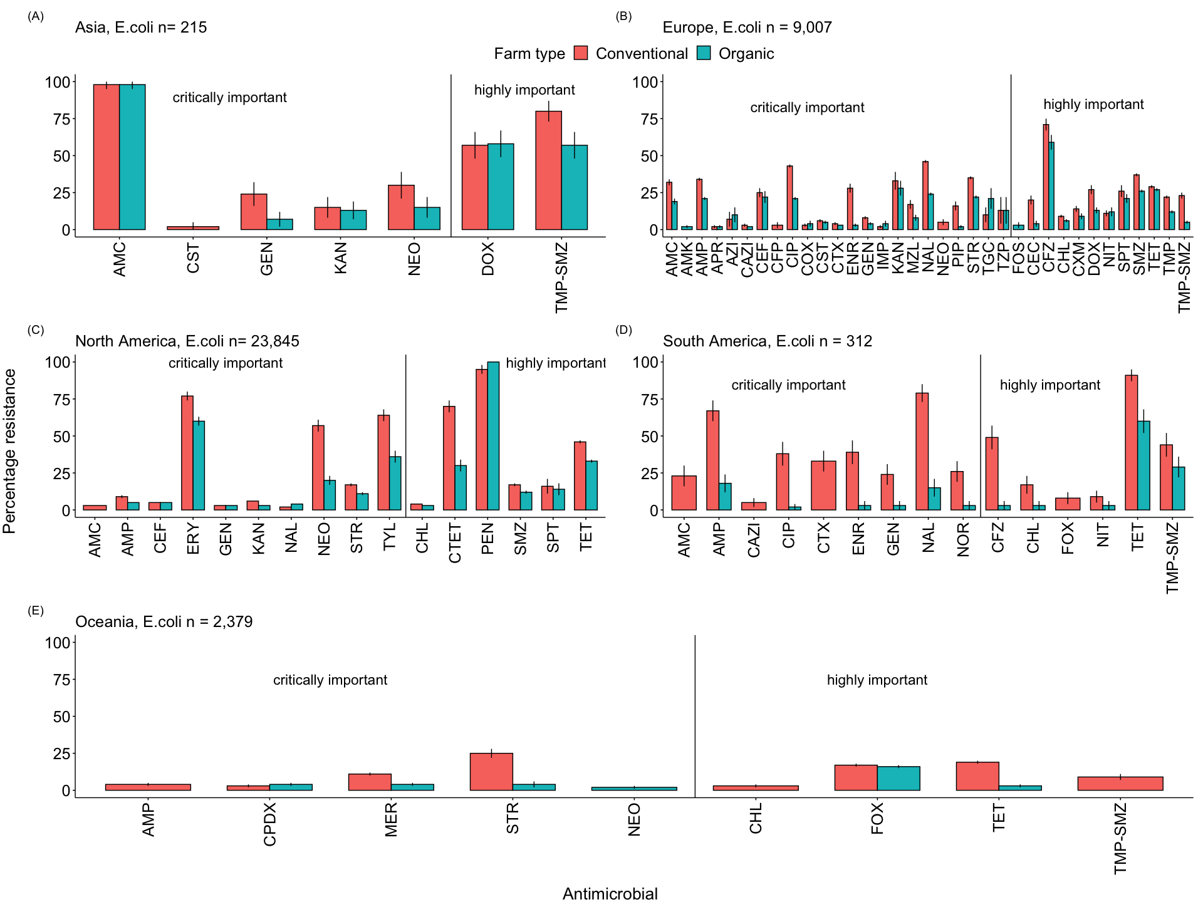
## TableGrob (2 x 2) "arrange": 3 grobs
## z cells name grob
## 1 1 (1-1,2-2) arrange gtable[layout]
## 2 2 (2-2,2-2) arrange text[GRID.text.1284]
## 3 3 (1-2,1-1) arrange text[GRID.text.1283]
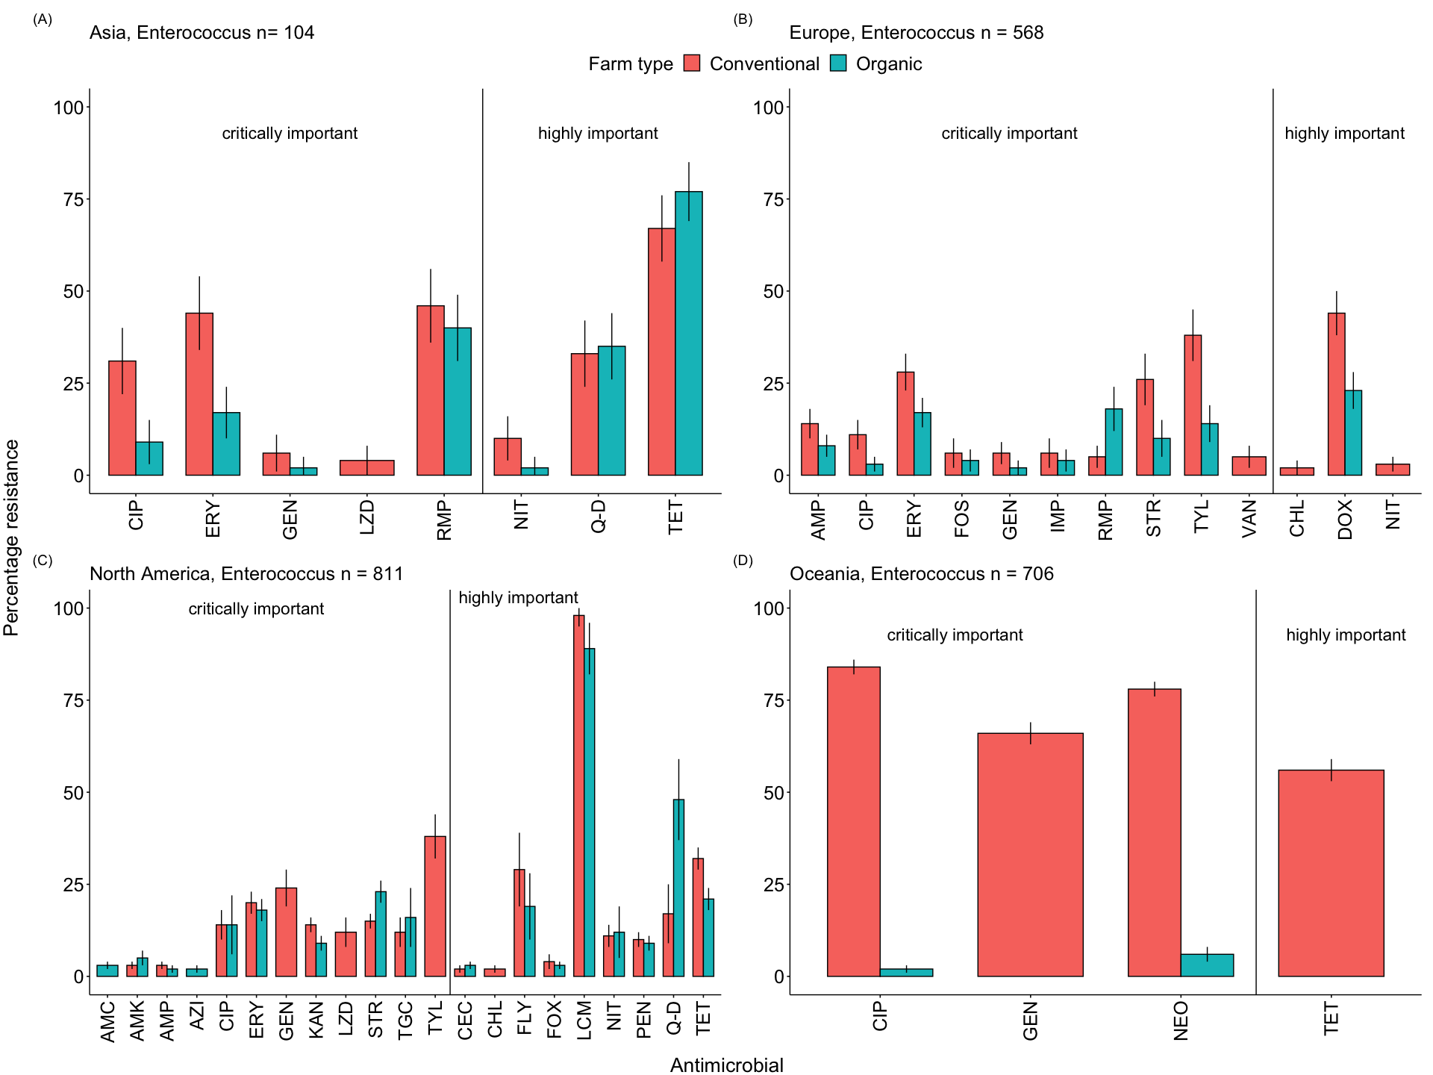
## TableGrob (2 x 2) "arrange": 3 grobs
## z cells name grob
## 1 1 (1-1,2-2) arrange gtable[layout]
## 2 2 (2-2,2-2) arrange text[GRID.text.1284]
## 3 3 (1-2,1-1) arrange text[GRID.text.1283]
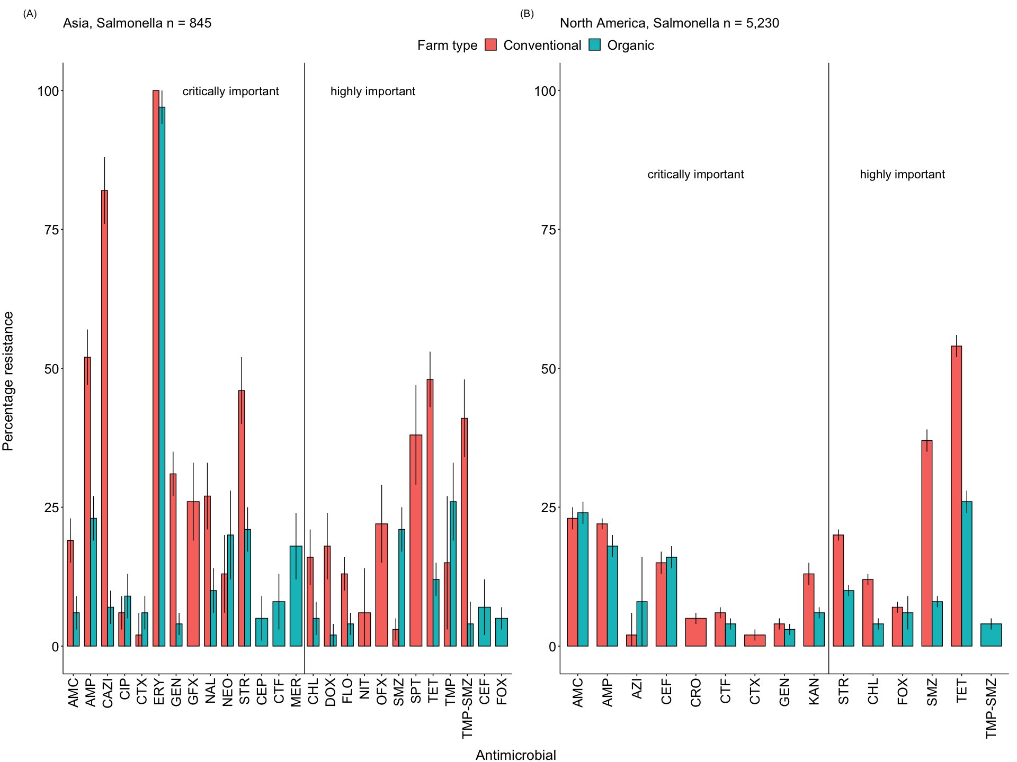
## TableGrob (2 x 2) "arrange": 3 grobs
## z cells name grob
## 1 1 (1-1,2-2) arrange gtable[layout]
## 2 2 (2-2,2-2) arrange text[GRID.text.1284]
## 3 3 (1-2,1-1) arrange text[GRID.text.1283]
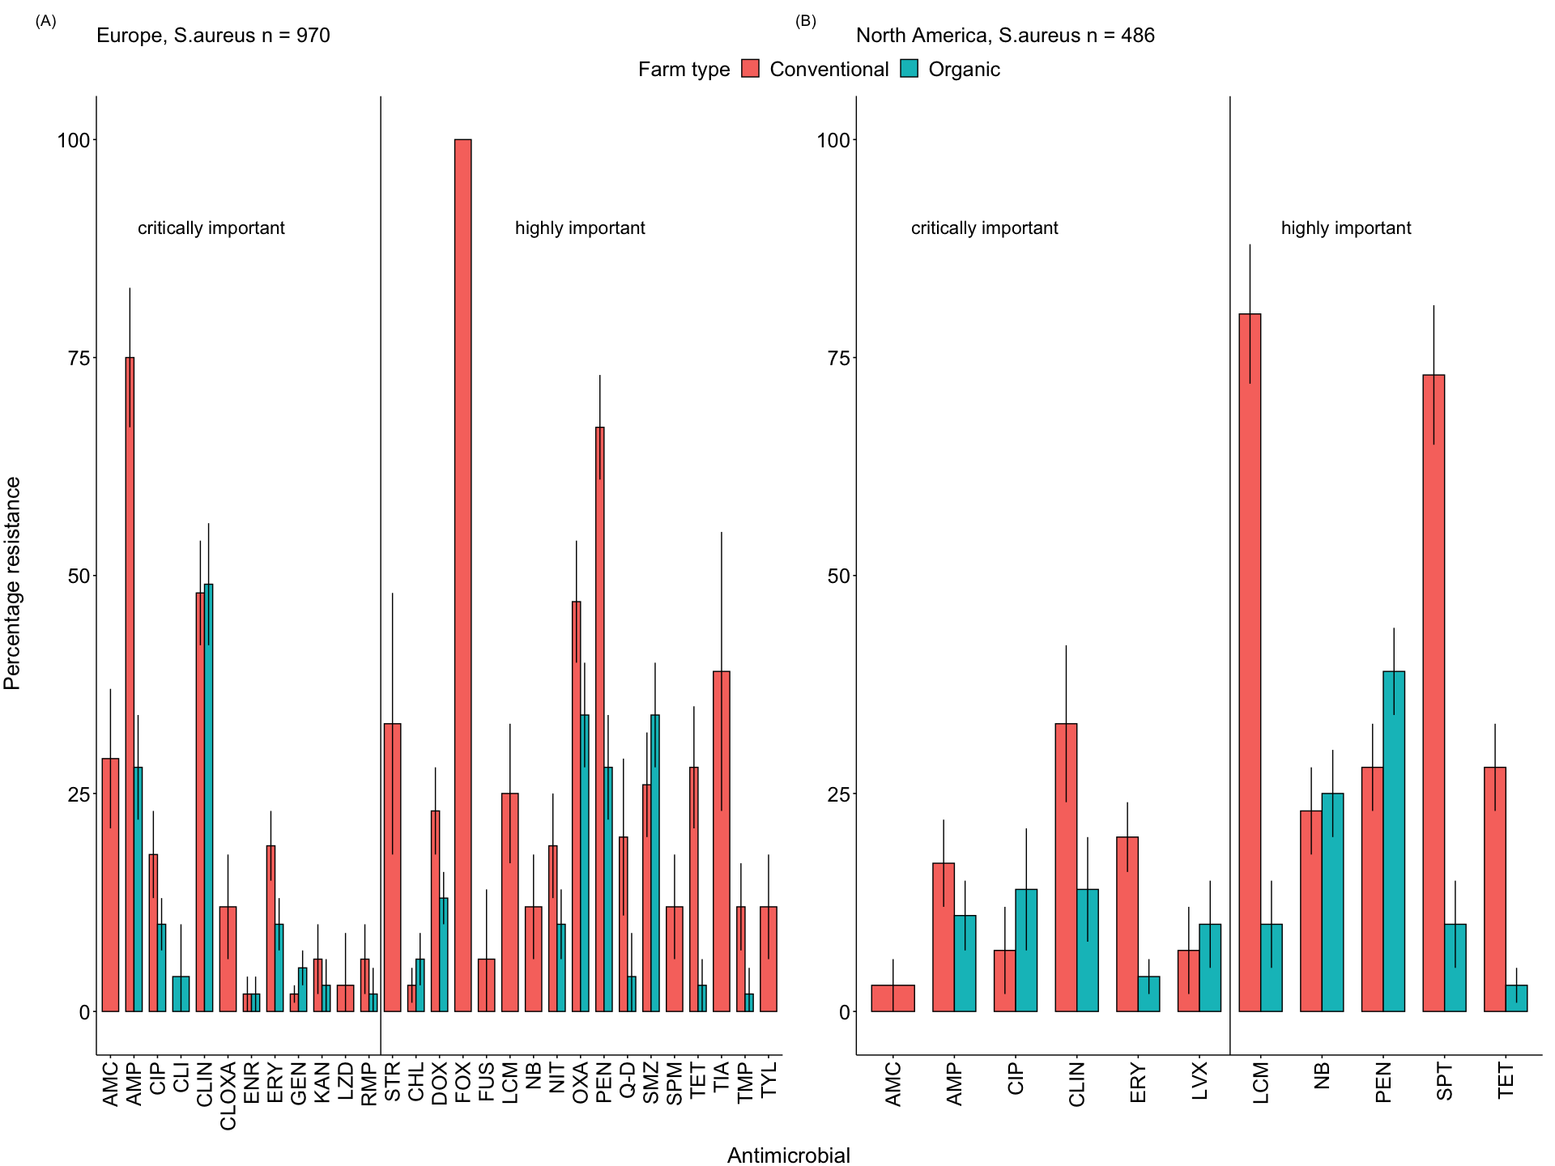
## TableGrob (2 x 2) "arrange": 3 grobs
## z cells name grob
## 1 1 (1-1,2-2) arrange gtable[layout]
## 2 2 (2-2,2-2) arrange text[GRID.text.1284]
## 3 3 (1-2,1-1) arrange text[GRID.text.1283]

Antimicrobial class resistance in chicken at the country level
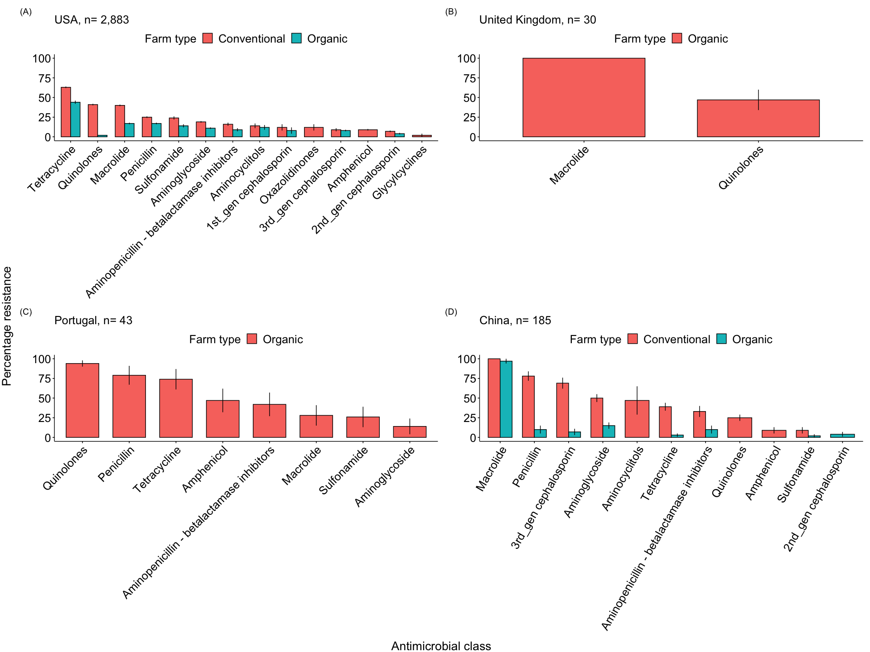
## TableGrob (2 x 2) "arrange": 3 grobs
## z cells name grob
## 1 1 (1-1,2-2) arrange gtable[layout]
## 2 2 (2-2,2-2) arrange text[GRID.text.2306]
## 3 3 (1-2,1-1) arrange text[GRID.text.2305]

Drug acronyms
Antimicrobial
Acronym
Antimicrobial class
WHO classification
Amikacin
AMK
Aminoglycoside
Critically important
Amoxicillin-clavulanic acid
AMC
Aminopenicillin - betalactamase inhibitors
Critically important
Amoxicillin-clavulanic acid
AMC
Aminopenicillin - betalactamase inhibitors
Highly important
Ampicillin
AMP
Penicillin
Critically important
Ampicillin
AMP
Aminopenicillin - betalactamase inhibitors
Critically important
Apramycin
APR
Aminoglycoside
Critically important
Azithromycin
AZI
Macrolide
Critically important
Cefaclor
CEC
2nd_gen cephalosporin
Highly important
Cefazolin
CFZ
1st_gen cephalosporin
Highly important
Cefepime
CEP
4th_gen cephalosporin
Critically important
Cefoperazone
CFP
3rd_gen cephalosporin
Critically important
Cefotaxime
CTX
3rd_gen cephalosporin
Critically important
Cefoxitin
FOX
2nd_gen cephalosporin
Highly important
Cefoxitin
COX
2nd_gen cephalosporin
Highly important
Cefpodoxime
CPDX
3rd_gen cephalosporin
Critically important
Ceftazadime
CAZI
3rd_gen cephalosporin
Critically important
Ceftiofur
CTF
3rd_gen cephalosporin
Critically important
Ceftiofur
CET
3rd_gen cephalosporin
Critically important
Ceftiofur
CEF
3rd_gen cephalosporin
Critically important
Ceftriaxone
CRO
3rd_gen cephalosporin
Critically important
Ceftriaxone
CTX
3rd_gen cephalosporin
Critically important
Ceftriaxone
CTX
1st_gen cephalosporin
Highly important
Cefuroxime
CXM
2nd_gen cephalosporin
Highly important
Cephalothin
CEF
1st_gen cephalosporin
Highly important
Cephalothin
CEF
3rd_gen cephalosporin
Critically important
Chloromphenicol
CHL
Amphenicol
Highly important
Chlortetracycline
CTET
Tetracycline
Highly important
Ciprofloxacin
CIP
Quinolones
Critically important
Ciprofloxacin
CIP
Aminoglycoside
Critically important
Clindamycin
CLIN
Macrolide
Critically important
Clindamycin
CLI
Lincosamides
Highly important
Cloxacillin
CLOXA
Penicillin
Critically important
Colistin
CST
Polymyxins
Critically important
Colistin
CTL
Polymyxins
Critically important
Doxycycline
DOX
Tetracycline
Highly important
Enrofloxacin
ENR
Quinolones
Critically important
Erythromycin
ERY
Macrolide
Critically important
Flavomycin
FLY
Phosphoglycolipids
Not used in humans
Florfenicol
FLO
Amphenicol
Highly important
Florfenicol
FLL
Amphenicol
Highly important
Fosfomycin
FOS
Phosphonic acid derivatives
Critically important
Fusidic acid
FUS
Steroids antibacterials
Highly important
Gatifloxacin
GFX
Quinolones
Critically important
Gentamycin
GEN
Aminoglycoside
Critically important
Imipenem
IMP
Carbapenem
Critically important
Kanamycin
KAN
Aminoglycoside
Critically important
Levofloxacin
LVX
Quinolones
Critically important
Lincomycin
LCM
Lincosamides
Highly important
Linezolid
LZD
Oxazolidinones
Critically important
Meropenem
MER
Carbapenem
Critically important
Mezlocillin
MZL
Penicillin
Critically important
Nalidixic acid
NAL
Quinolones
Critically important
Neomycin
NEO
Aminoglycoside
Critically important
Nitrofurantoin
NIT
Nitrofuran derivatives
Important
Norfloxacin
NOR
Quinolones
Critically important
Novobiocin
NB
Aminocoumarin
NA
Ofloxacin
OFX
Quinolones
Critically important
Oxacillin
OXA
Penicillin
Critically important
Oxacillin
OXA
Penicillin
Highly important
Penicillin
PEN
Penicillin
Highly important
Penicillin-novobiocin
PEN-NB
NA
NA
Piperacilin
PIP
Penicillin
Critically important
Piperacilin
PIT
Penicillin
Critically important
Piperacillin-tazobactam
TZP
Penicillin
Critically important
Quinopristin-dalfopristin
Q-D
Streptogramins
Highly important
Rifampicin
RMP
Ansamycin
Critically important
Spectinomycin
SPT
Aminocyclitols
Important
Spiramycin
SPM
Macrolide
Critically important
Streptomycin
STR
Aminoglycoside
Critically important
Sulfamethaxazole
SMZ
Sulfonamide
Highly important
Sulfisoxazole
SMZ
Sulfonamide
Highly important
Tetracycline
TET
Tetracycline
Highly important
Tiamulin
TIA
Pleuromutilins
Important
Tigecycline
TGC
Glycylcyclines
Critically important
Trimethoprim
TMP
Sulfonamide
Highly important
Trimethoprim-Sulfamethaxazole
TMP-SMZ
Sulfonamide
Highly important
Tylosin
TYL
Macrolide
Critically important
Vancomycin
VAN
Glycopeptides
Critically important
To be added when maps are ready

