model diagnostics
Eldon
October 11, 2022

Model diagnostics

Assumptions
Linear mixed effects models are based on the following assumptions;
- Independent variables measured without an error (Fixed x)
- Errors are normally distributed
- Errors are independent
- Errors have constant variance
- Relationship between X and Y is linear
We use the graphs to determine weather the model assumptions are fulfilled or we can improve it.
- Turkey-Anscombe plot
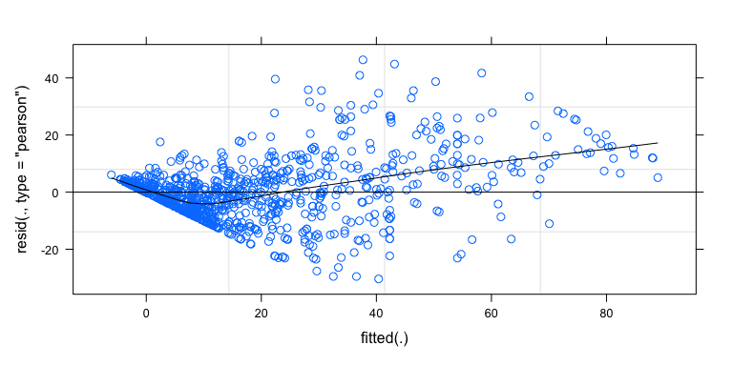
From the above figure, the variance of the residuals does not seem to increase or decrease with the fitted values this is referred to as homoscedasticity (stable variance)
- Quantile-quantile plots
We assumed that both the errors and the random intercepts come from a normal distribution we test this using Q-Q plot
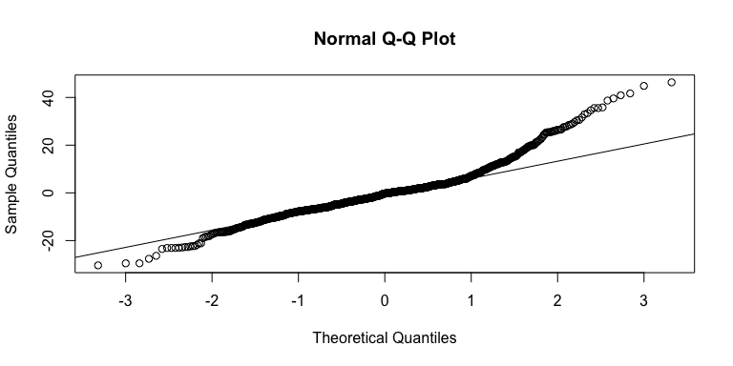
The QQ-plot above shows that there is no clear evidence that the data does not follow a normal distribution. Although not perfect, this plot does not show a clear violation of the normality assumption for the random effects.

3.Residuals against predictors
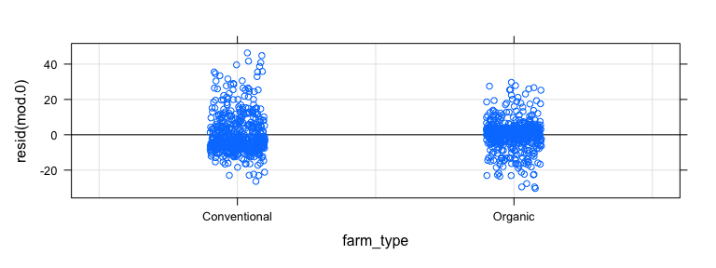
The graph above indicates that residuals in the conventional farms have a higher variance as compared to organic farms, nevertheless, the is no dramatic difference between two farm types
We now plot the residuals against the host. In order to better identify deviations from linearity we add a line connecting the average values at each age.
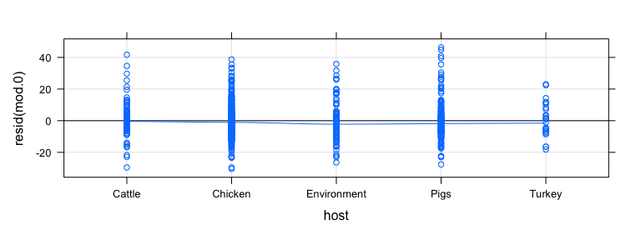
There seems to be no clear deviation from zero. This implies that at this stage there is no evidence against percent resistance of modelled hosts. In addition, the variance of the residuals seems to be constant along the five time points (i.e homoscedasticity).
We use the dot plot below to check whether all studies have similar variences
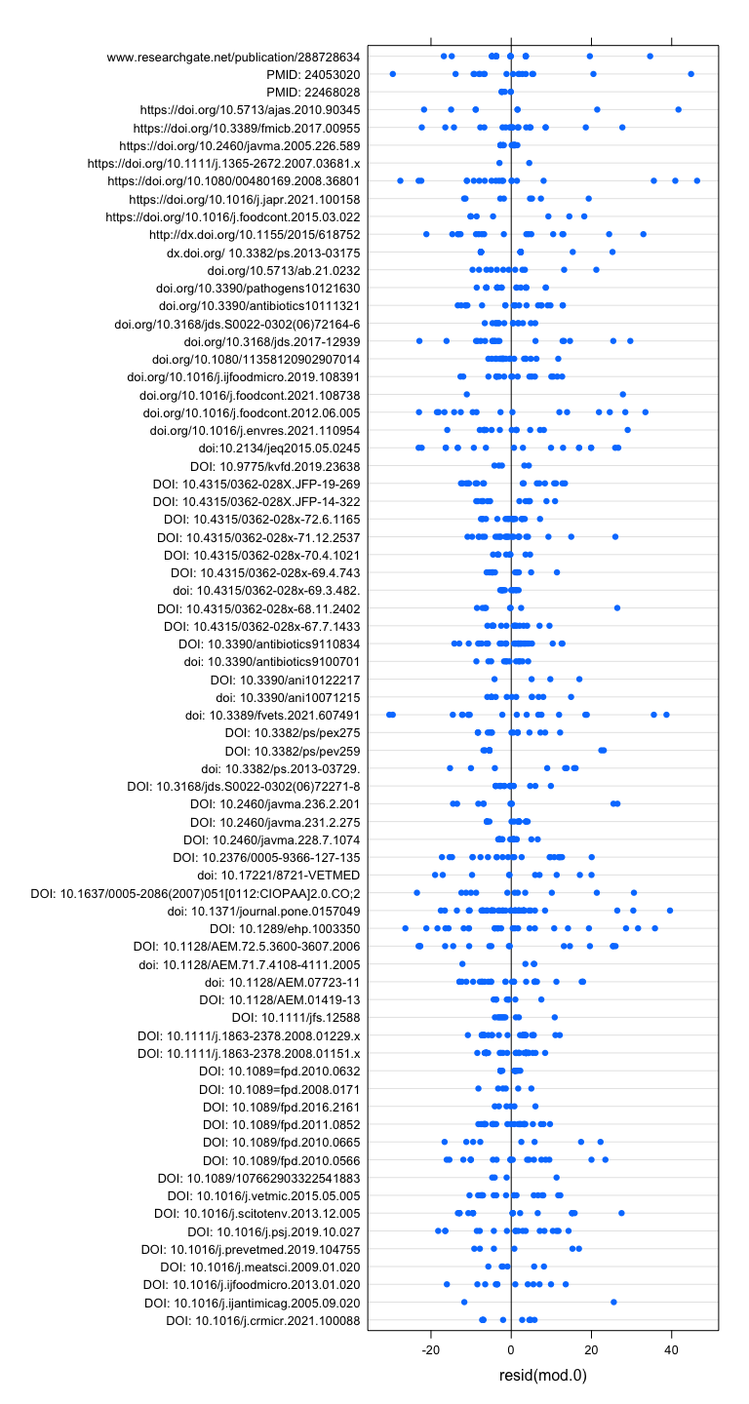
I don’t think there is a striking difference in variability among the studies. I would like to hear your thoughts on this plot.

