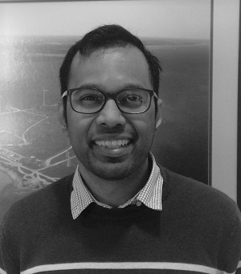Eldrich Rebello received a Bachelor of Engineering with honors from Mumbai University and an M.S. in Electrical Engineering from Aalto University, Finland in 2014. He has worked as a graduate researcher at the KTH Royal Institute of Technology's SmarTS lab in Stockholm, Sweden during which time this work was carried out. Subsequently, he was an Electrical engineer with EWT Direct Wind in the Netherlands. He is presently a Grid Integration Engineer at the Wind Energy Institute of Canada. He is a licensed Professional Engineer in Canada.

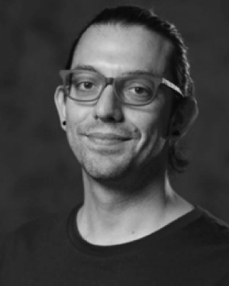

Luigi Vanfretti received the M.Sc. and Ph.D. degrees in electric power engineering from the Rensselaer Polytechnic Institute, Troy, NY, USA, in 2007 and 2009, respectively. He was an Associate Professor at the Rensselaer Polytechnic Institute, in 2017, where he is currently developing his laboratory and research team ALSETLab. He was with the KTH Royal Institute of Technology, Stockholm, Sweden, as an Assistant Professor from 2010 to 2013, and an Associate Professor (Tenured) and Docent from 2013 to 2017, where he led the SmarTS Lab and research group. He was with Statnett SF, the Norwegian transmission system operator, from 2013 to 2016 as a Special Advisor in the Research and Development Department and as a Consultant from 2011 to 2012 and in 2017. His research interests include the synchrophasor technology applications, and cyber-physical power system modeling, simulation, stability, and control.

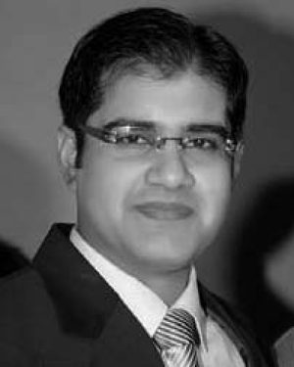Muhammad Shoaib Almas received the B.E. degree from the National University of Sciences and Technology, Pakistan, and the M.Sc. degree in electric power engineering from the KTH Royal Institute of Technology, Stockholm, Sweden, in 2011, where he has recently completed a Ph.D. degree with the Electric Power Systems Division. His work experience includes designing protection schemes for substations (132 kV, 220 kV, and 500 kV) through microprocessor-based protection relays (GE Multilin \& GE Energy). He was a member of Smart Transmission System Laboratory Research Group, KTH and is currently with ABB HVDC, Ludvika, Sweden. He has a keen interest in real-time simulations, hardware-in-the-loop approach, substation automation, wide-area monitoring, protection and control, Internetworking, and cyber-security.