Table of Contents

Experiment 1A and 1B merged 1

Analyses on Rts in trials with null (0 ms) cue-context onset asynchrony 1

Analyses on Rts in trials with positive (300 ms) cue-context onset asynchrony 1

Analyses on error rate in trials with null (0 ms) cue-context onset asynchrony 2

Analyses on error rate in trials with positive (300 ms) cue-context onset asynchrony 2

Experiment 2A and 2B merged 2

Analyses on reaction times in trials with null (0 ms) cue-context onset asynchrony 2

Analyses on reaction times in trials with positive (300 ms) cue-context onset asynchrony 2

Analyses on error rate in trials with null (0 ms) cue-context onset asynchrony 3

Analyses on error rate in trials with positive (300 ms) cue-context onset asynchrony 3

Figures 4

Mean Reaction Times in Exp 1A and 1B 4

Mean Error rate in Exp 1A and 1B 5

Mean Reaction Times in Exp 2A and 2B 6

Mean Error rate in Exp 2A and 2B 7

# Experiment 1A and 1B merged

## Analyses on Rts in trials with null (0 ms) cue-context onset asynchrony

We found a significant main effect of task relation, *F*(1, 121) = 126.38, *p* < .001, due to task switch costs of 102 ms. Task relation also entered in a significant interaction with response relation, *F*(1, 121) = 17.89, *p* < .001.

Context relation main effect was significant, *F*(1, 121) = 7.51, *p* = .007, as we found context switch costs of 12 ms. This interacted with task relation *F*(1, 121) = 6.16, *p* = .014, such that task switch costs were smaller in context switches (88 ms) than in context repetition trials (116 ms).

Response relation was modified by experiment version (laboratory versus online), *F*(1, 121) = 4.38, *p* = .038, so that, overall, we found a small response repetition benefit of 3 ms in the dataset collected in the laboratory, against a 22 ms response repetition *cost* in the one collected online.

## Analyses on Rts in trials with positive (300 ms) cue-context onset asynchrony

We found a significant main effect of task relation, *F*(1, 121) = 122.37, *p* < .001, indicating task switch costs (100 ms), which also entered in a significant interaction with response relation, *F*(1, 121) = 11.92, *p* < .001.

Response relation, context relation and experiment version (online versus laboratory) entered in a significant three-way interaction, *F*(1, 121) = 7.55, *p* = .007. When analysing response repetition and response switch trials separately, context relation significantly interacted with experiment version in response switch trials only, *F*(1, 121) = 4.36, *p* = .039, indicating context switch costs of 20 ms in the laboratory dataset and context switch cost of 8 ms in the online one. No other main effect or interaction was significant.

In trials with onset asynchrony 300 ms, task relation did not interact with context relation, as it did in trials with 0 ms onset asynchrony. Indeed, when data from both values of onset asynchrony are merged together, we found a significant three-way interaction of task relation, context relation and onset asynchrony.

## Analyses on error rate in trials with null (0 ms) cue-context onset asynchrony

Task relation main effect was significant, *F*(1, 121) = 24.02, *p* < .001, indicating task switch costs (5.5% versus 7.5% error rate). Response relation main effect was also significant, *F*(1, 121) = 42.15 *p* < .001, indicating response switch benefits (7.8% versus 5.2% error rate), and the two variables entered in a significant two-way interaction, as in rts, *F*(1, 121) = 10.12, *p* = .002.

Finally, we found a marginally significant main effect of context relation, *F*(1, 121) = 3.26 *p* = .073, indicating very small benefits when context switched (6.3%) than when it repeated (6.7%) in the subsequent trial. All the other main effects and interaction were not significant.

## Analyses on error rate in trials with positive (300 ms) cue-context onset asynchrony

Task relation main effect was significant, *F*(1, 121) = 32.05, *p* < .001, indicating task switch costs (5.4% versus 8.1%), and so was response relation main effect, *F*(1, 121) = 19.95, *p* < .001, indicating response switch benefits (7.6% versus 5.6% error rate). The two main effects also entered in a significant two-way interaction, *F*(1, 121) = 16.69, *p* < .001.

As in the corresponding analysis on reaction times (trials with onset asynchrony of 300 ms), response relation entered in a significant 3-way interaction with context and experiment version, *F*(1, 121) = 4.38, *p* = .039. However, in error rate this result was driven by a different data pattern: when trials were divided according to experiment version, context relation interacted with response relation in the online dataset only, *F*(1, 90) = 5.71, *p* = .019, in such a way that response repetition costs were greater in context switches (+ 2.9% error rate), than in context repetitions (+ 1.1% error rate).

# Experiment 2A and 2B merged

## Analyses on reaction times in trials with null (0 ms) cue-context onset asynchrony

Task relation main effect was significant, *F*(1, 124) = 127.04, *p* < .001, indicating task switch costs (100 ms).

Similarly, context relation main effect was significant, *F*(1, 124) = 4.16, *p* = .043, indicating context switch costs (12 ms). No other variable was significant.

## Analyses on reaction times in trials with positive (300 ms) cue-context onset asynchrony

Task relation main effect was significant, *F*(1, 124) = 112.26, *p* < .001, indicating task switch costs (103 ms), and this significantly interacted with response relation *F*(1, 124) = 10.16, *p* = .002

We found a marginally significant main effect of context relation, *F*(1, 124) = 3.68, *p* = .057, indicating context switch costs (15 ms), and this was further modulated by experiment version, *F*(1, 124) = 4.62, *p* = .033, as context switch costs were negative, and very small in the lab dataset (-2 ms), whereas they were positive in the online dataset (21 ms). Context relation also interacted with response relation *F*(1, 124) = 3.93, *p* = .05, so that response switch benefits were greater in context repetition trials (12 ms), than in context switch trials (3 ms).

Context relation and response relation entered in a significant three-way interaction with experiment version, *F*(1, 124) = 3.94, *p* = .049: when separating response repetition trials from response switch trials, as in the corresponding analysis for experiment 1, context interacted with experiment version in response repetition trials only, *F*(1, 124) = 6.64, *p* = .011, whereas this was this was the case in response switch trials in experiment 1, so that we observed context switch *benefits* (-19 ms) in the lab data, whereas we observed context switch costs (+19 ms) in the online sample.

## Analyses on error rate in trials with null (0 ms) cue-context onset asynchrony

Task relation main effect was significant, *F*(1, 124) = 35.33, *p* < .001, indicating task switch costs (5.2% versus 7.7% error rate). Response relation main effect was also significant, *F*(1, 124) = 22.76, *p* < .001, indicating response switch benefits (7.31% error rate in response repetitions versus 5.6% in response switches) and the two entered in a significant two-way interaction, *F*(1, 124) = 11.64, *p* < .001, whereas this was not the case in reaction times. Such interaction was further modulated by experiment version, *F*(1, 124) = 4.91, *p* = .029, in such a way that the difference between task switch costs in response repetition versus response switch trials was 0.9% error rate in the online sample and 4.2% error rate in the lab sample.

No other variables or main effect were significant.

## Analyses on error rate in trials with positive (300 ms) cue-context onset asynchrony

Task relation main effect was significant, *F*(1, 124) = 32.75, *p* < .001, indicating task switch costs (5.6% versus 7.6% error rate). Response relation main effect was also significant, *F*(1, 124) = 24.19, *p* < .001, indicating response switch benefits (7.7% error rate in response repetitions versus 5.7% in response switches) and the two entered in a significant two-way interaction, *F*(1, 124) = 15.51, *p* < .001, which was not moderated by experiment version in this case.

The results are almost identical to the onset asynchrony 0 ms results. When these were merged together, we observed a significant interaction of task-, response- and context relation, which we do not find separating 0 ms from 300 ms onset asynchrony trials. A trace of this effect is found in the latter, where that interaction was significant at a 10% alpha level, *F*(1, 124) = 2.75, *p* = .1.

# Figures

## Mean Reaction Times in Exp 1A and 1B

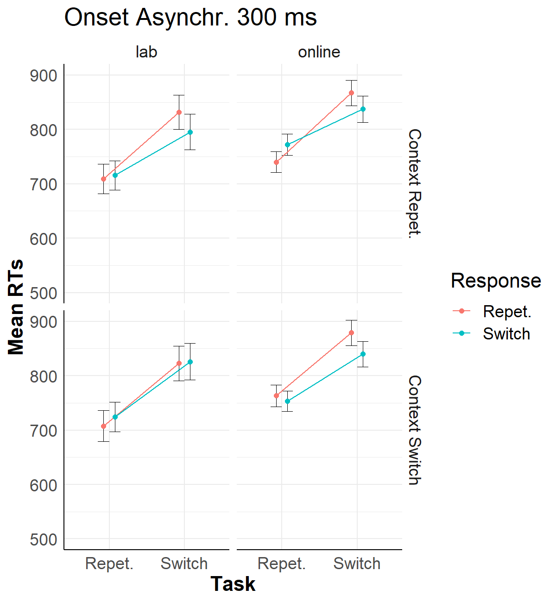

## Mean Error rate in Exp 1A and 1B

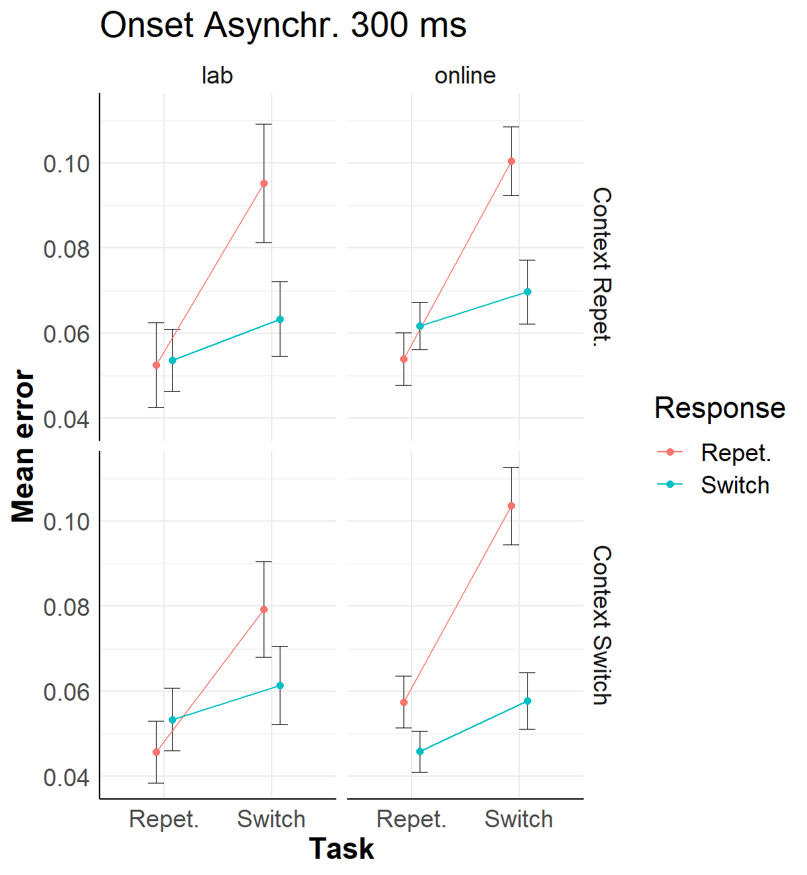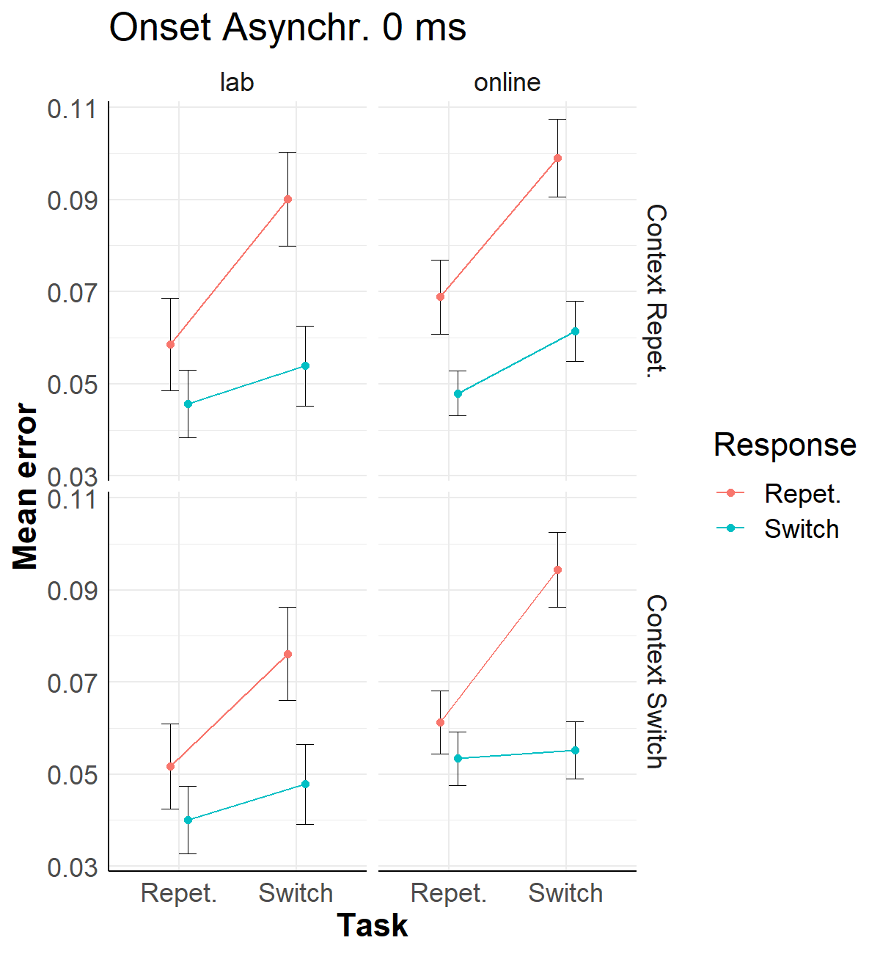

## Mean Reaction Times in Exp 2A and 2B

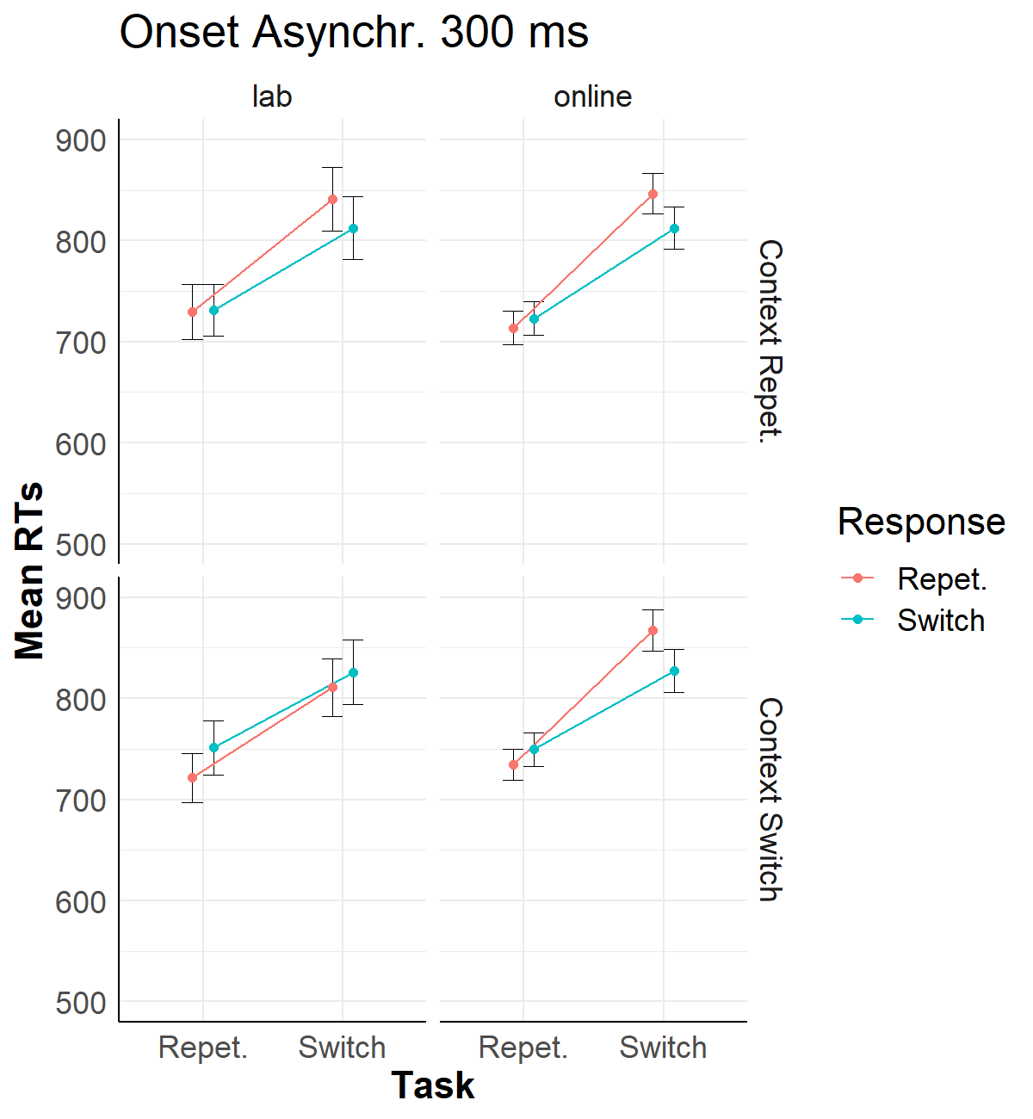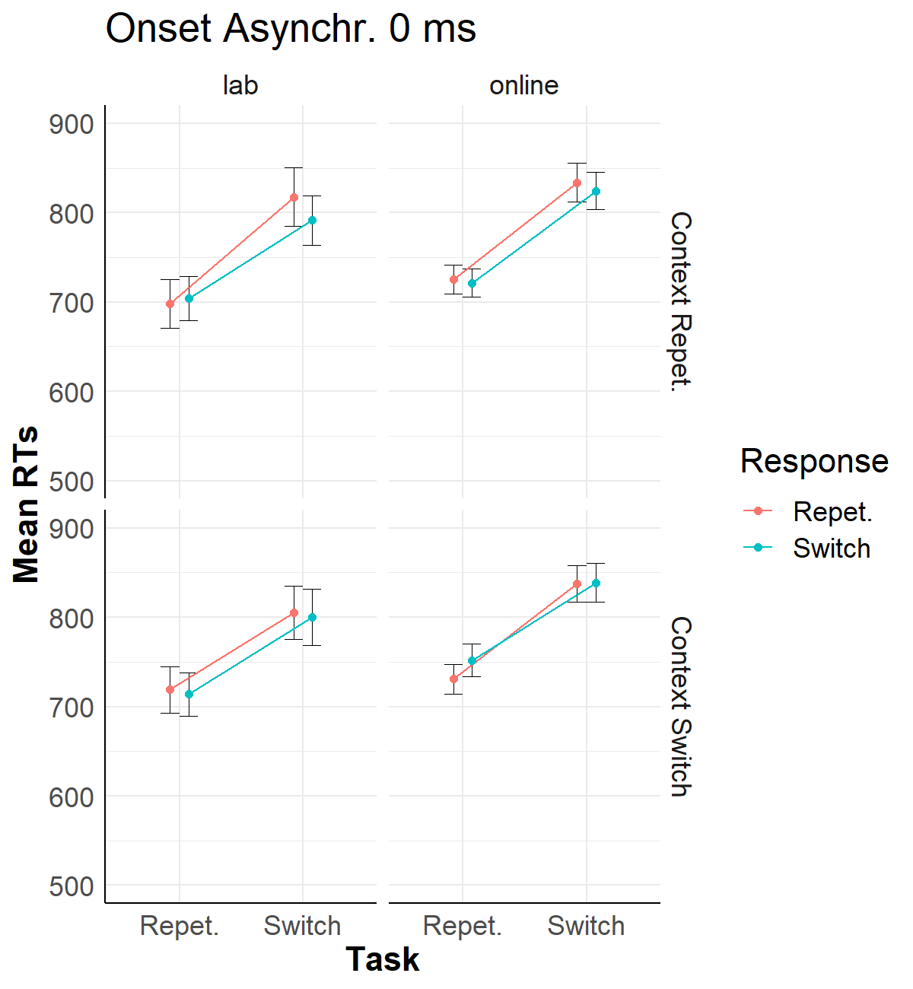

## Mean Error rate in Exp 2A and 2B