**A binding perspective on task and language switching: Exploring the influence of episodic repetition priming on flexible action control.**

In this file, two experiments are described belonging to the project as in the title. This project is a branch of a wider research unit, “Binding and retrieval in action and control”, BRAC from now onward. Within BRAC framework, the two experiments presented here investigate the effects of features binding in task switching paradigms. Particularly, it is investigated whether task-irrelevant features are bounded together with task-relevant features in the mental representation of a task set. We refer to such irrelevant features as “context”. Experiment 1 and 2 differ in how the context is operationalized. The two studies are presented first, while below it follows a brief description of a pilot study, to be conducted before the main works.

Experiment1: BRAC01_inCueContext

The experimental paradigm is a task switching between two tasks which are magnitude (whether the number is less or greater than 5) and odd-even judgement. There are 2 possible pairs of response keys (thus, the keys overlap between tasks). Stimuli are numbers from 1 to 9 included, 5 excluded, which results in bivalent stimuli, since for each it can be stated its magnitude and its parity. In each trial, the relevant task is announced by a cue that can be a vertical or a horizontal bar at the top of the screen. The cue remains on the screen for the whole trial duration. After 600 msec from cue onset**,** the stimulus appears in the centre of the screen and both cue and stimulus remain visible until a response is given or response deadline is reached. Such response deadline is set to 2500 msec from stimulus onset. In this experiment, it is taken into account the effect of “context” switches or repetitions in consequent trials. Context is supposed to be irrelevant for task execution and it is operationalized as the colour of the cue. Cue can assume colour 1 or colour 2. Moreover, it is manipulated the asynchrony between the cue and the context, between blocks: this can be “null” or “positive”. In half of the blocks, asynchrony is null, thus the cue appears in a certain colour from the beginning of the trial and remains so until the current trial ends. In the other blocks, where asynchrony is positive, the cue is black for the first 300 msec and then assumes the established colour for that trial and remains so until the current trial ends (see Figure 1 and Figure 2).

During each trial, from cue onset to the following ITI, there will be a black empty square framing the cue and the stimulus, as this appears. The area of the black line drawing such square will be equal to the area of the cue. The square is irrelevant for the present experiment, while serves for creating the same environment of Experiment 2. This allows to safely compare results of the 2 experiments in a between-subject design.

We are going to recruit 32 participants who will perform 8 blocks of 96 trials each.

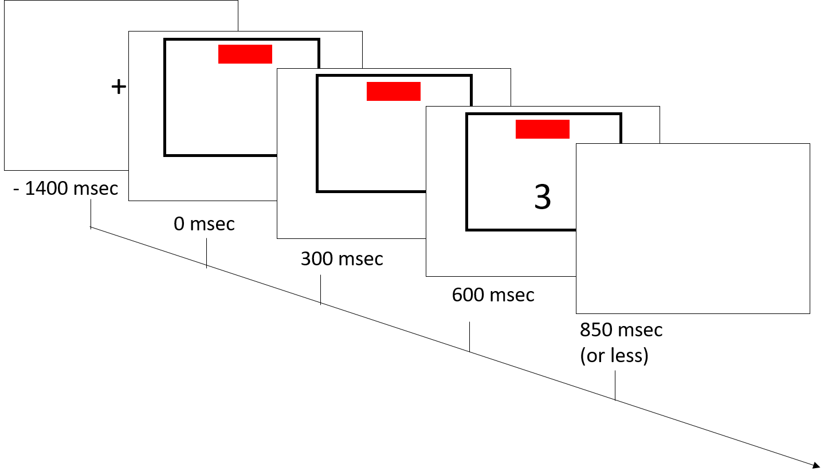

Figure 1 Example for trial with null asynchrony. In all of the Figures there will just be the horizontal cue, but half of the trials will have the vertical cue, that is an identical bar, rotated 90 degrees with respect to these ones.

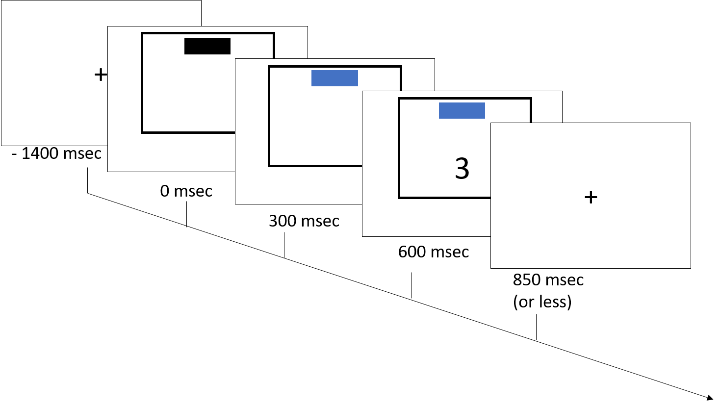

Figure 2. Example of a trial timeline with asynchrony between cue and context appearance.

**Counterbalancing stimuli within blocks (or participants when not possible):**

|  |  |  |
| --- | --- | --- |
| 2 x | Task | Magnitude, Parity |
| 8 x | Numbers | 1, 2, 3, 4, 6, 7, 8, 9 |
| 2 x | Cue colour | Colour 1, 2 |
| = 32 | combinations | |
| 96/32 | Each number will appear 3 times in colour1 and 3 times in colour2 | |

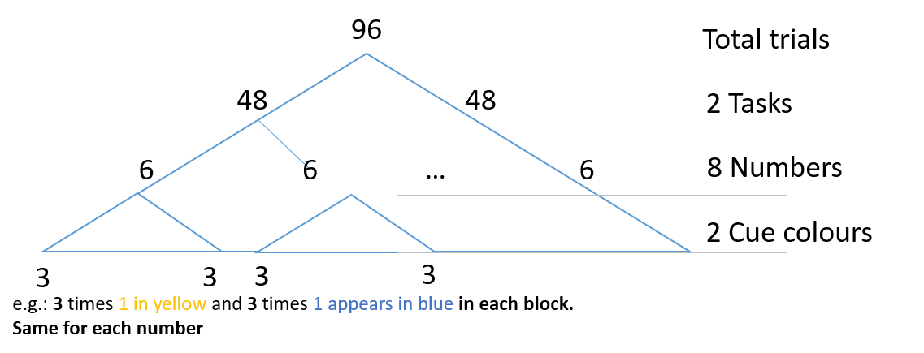

Figure 3. Counterbalancing stimuli within each block.

**Counterbalancing between participants:**

|  |  |  |
| --- | --- | --- |
| 2 x | Task – cue map | each task x 2 cues (Magn-horizontal, Parity-vertical, the reverse) |
| 4 x | Resp – keys map | 2 tasks * 2 keys (<5-right, even-right, <5-right, even-left, ect…) |
| 2 x | Starting CoCOA | Null or positive asynchrony in the first block |
| = 16 | combinations | |
| 32/16 | Each 2 participants undergo a unique combination | |

**Trials sequences**

In each block the trials sequence is pseudorandom, namely it is derived from the permutation of a sequence of 96 trials with the following rules:

1. 48 trials Magnitude task and 48 Parity;
2. Each number appears the same number of times in each trials (6 times Magnitude and 6 times Parity);
3. Each number does not repeat in 2 subsequent trials.

Experiment 2: BRAC_2_outCueContext

This second experiment is identical to the first one with the exception of the operationalization of context. In this case, the context will not be a feature of the cue, instead it will be a feature of the experimental trial visual screen. Namely, it will be an empty square, surrounding both the cue and the stimulus, as described in BRAC01. The area of the context (only the coloured contour is considered) is the same of the area of the cue rectangle. Again the context may assume colour 1 or colour 2. As in Experiment 1, the asynchrony between cue and context onset will be manipulated between blocks.

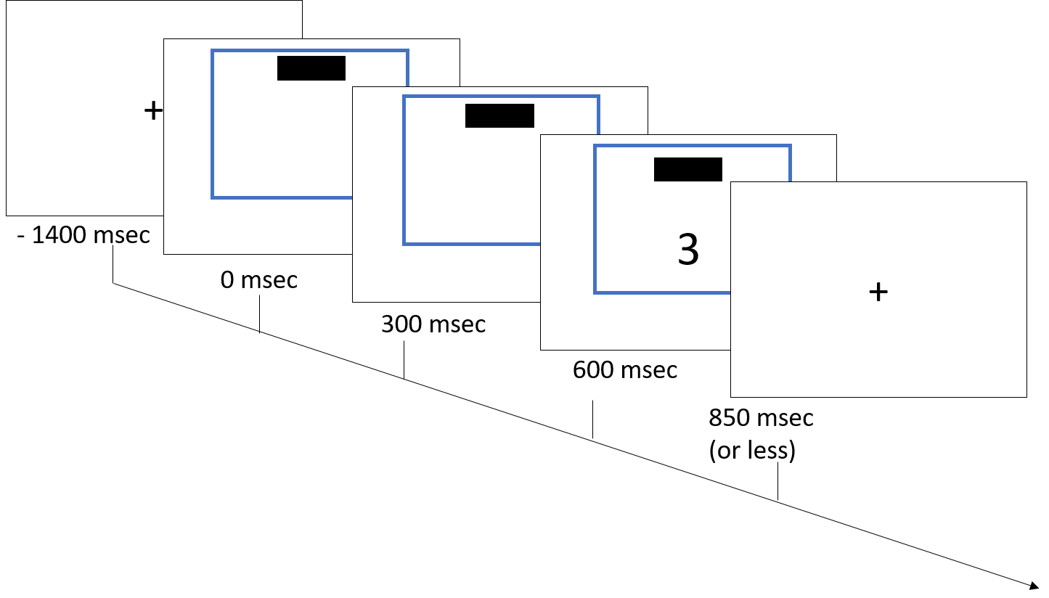

Figure 5. Example of a trial timeline with null asynchrony between the cue and the context onset.

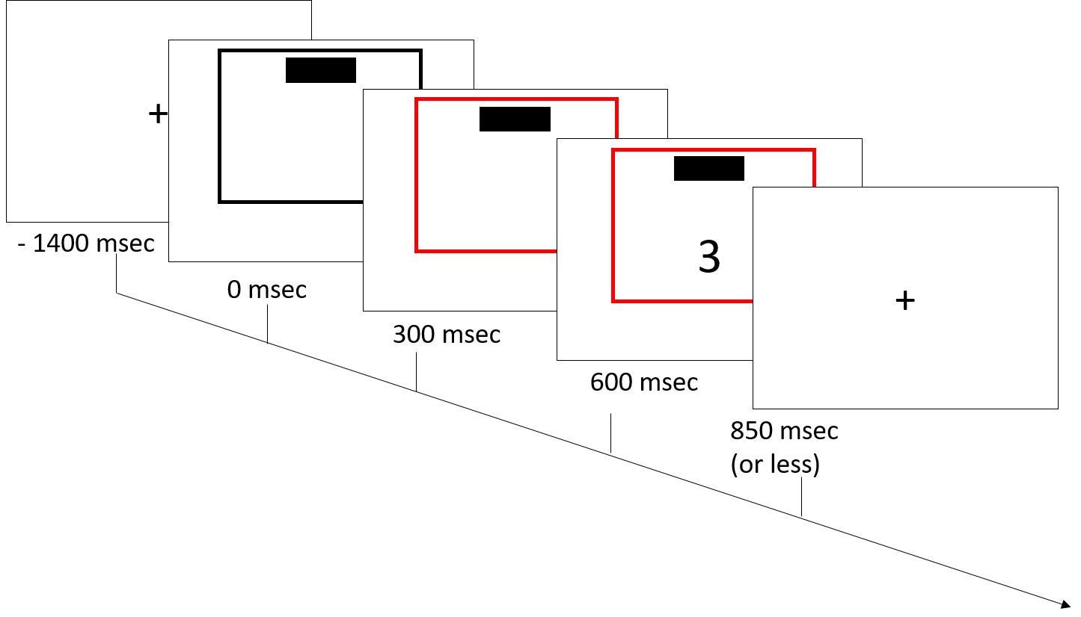

Figure 6. Example of a trial timeline with asynchrony between cue and context appearance.

Pilot Experiment

It assesses whether the coloured cue is detected faster than the coloured square and, orthogonally, whether a certain colour is detected faster than the other.

In this pilot, the stimuli appear in the same position on the screen as in Experiments 1 and 2, so that the environment will be identical to the one of the studies of interest. Participants see 50% of trials with the square coloured (half trials in blue, half in red) and the cue in black and 50% with the cue coloured (half trials in blue, half in red) and the square in black. Moreover, cue orientation (vertical, horizontal), will be orthogonally varied.

Both stimuli disappear as soon as a response is given. Then, a screen with a fixation cross follows, before a new stimulus appears again. To each colour it will be arbitrarily associated a key (on the left or right side of the keyboard, A, L) that participants have to press as fast and as accurately as possible, upon seeing the stimuli configuration. Their task is to detect the colour of the coloured stimulus and press the correct key, independently from the colour belonging to the little filled cue or to the bigger empty square. The 2 possible mappings of keys and colours will be counterbalanced between participants.

We plan to collect 12 participants. Each of them will complete 2 blocks of 40 trials each. Thus, in each block, a participant responds 5 times to each of the 8 combinations of colour (blue, red) * coloured stimulus (cue, square) * cue orientation (vertical, horizontal).