Sommario

Study 1 – Context in the cue 1

Analyses on RTs 2

Error Analyses 3

Discussion of Study 1 4

Study 2 – Context out of the cue 5

Analyses on RTs 5

Error Analyses 6

Discussion of Study 2 7

Study Between Subjects 8

Analyses of RTs 8

Error Analyses 9

Discussion of Between-subjects Study 10

General Discussion 11

Appendix 11

Study 1 11

Study 2 13

Between-Subjects Study 14

Between-subjects Raw Means Table 16

# Study 1 – Context in the cue

Online experiment with N = 76 participants (35 females, 1 didn’t declare), of which 63 were recruited via Prolific and the rest among the students at RWTH. It was planned to collect 96 participants for this experiment, but we could only collect 13 RWTH students, out of the 32 that we planned. Mean age was 23.95 ±3.71 (4 didn’t declare their age) and 5 participants were left-handed (one didn’t declare his handedness).

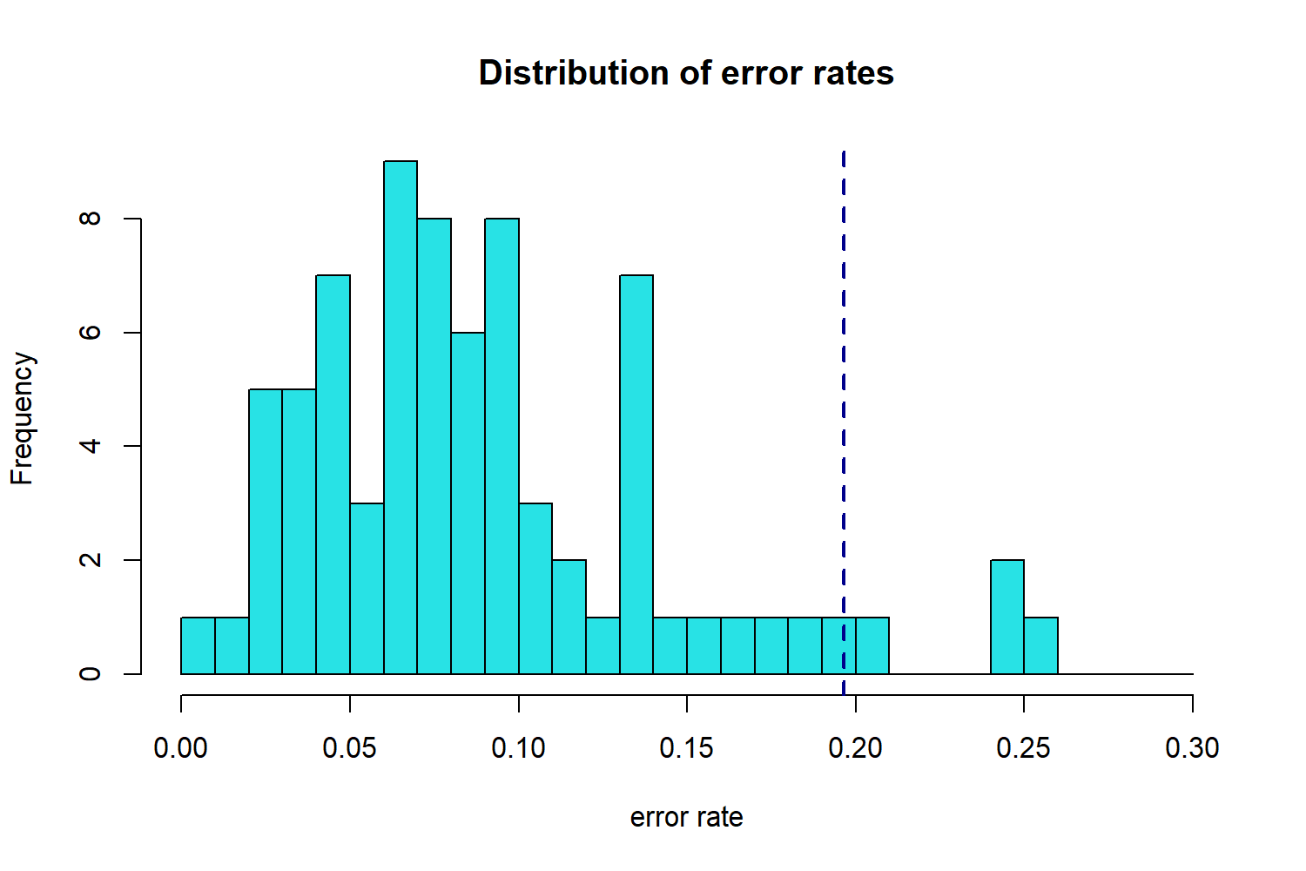

Note. The blue dashed line indicates 2 standard deviations from the mean

Mean error rate in the sample was 8.94%. Removing the participants whose average error rate lays outside 2 standard deviations from the mean, lead to remove 4 participants, 1 RWTH student and 3 Prolific participants.

The analyses of RTs and error as independent variables were run using linear mixed models with participant as random factor (and in some cases also with stimulus as random factor). Rts were log-transformed to achieve an approximately normal distribution (see Figure 7). The linear mixed models allowed to run statistical analyses on interesting variables, partialling out the effect of possibly confounding variables as demographics, recruitment method, type of browser and of operating system on the participant pc, etc. This is probably an interesting tool for online experiments, in which many variables are out of the control of the researcher. If these irrelevant variables have an effect on the DV, this is “controlled” by adding them along the predictors. In lab-controlled experiments, this is usually not necessary because less variables change between participants and the researcher will try to counterbalance them or to make sure that these are orthogonal to the variables of interest. Other than that, the table can be interpreted as an ANOVA table, which furthermore indicates the direction and the size of the effect through the coefficient. It is easier to interpret the *exp Estimate* column, since the coefficients represent how much the logarithm of RT changed, when a certain variable changes values (e.g. change from repetition to switch). It is cumbersome to imagine how many millisecond a variation of 0.03 in the log of RT implies, thus we can use the exp Estimate column which indicates the ration between the 2 conditions, that is, to which quantity RTs must be multiplied when passing from task repetition to switch.

## Analyses on RTs

In these analyses, error and post-error trials were removed, together with the first trial of each block and the responses faster than 200 ms that constituted roughly 15% of the initial dataset. It emerged a significant main effect of task relation (coeff. = 1.175, p < .001) and of context relation (coeff. = 1.031, p < .05) with switch that were significantly slower than repetitions. There was a marginally significant effect of response relation (*p* = .075) in the same direction. Furthermore, task and response relation interacted significantly along the lines of the RR effect (coeff. = 0.94, p <.001). The coefficient of this interaction smaller than 1 indicates that task switch costs were smaller in complete switches than in partial switches. Post-hoc analyses revealed that the task by response interaction is significant in 3 panels of Figure 1 (all p <.01), whereas it didn’t reach significance when context switched and appeared with a delay (bottom right panel, p = .091). If binding were to disappear with context switch, we would expect it to happen with cocoa 0, when the switching context was supposedly more bound to task and response. However, this happened in cocoa 300 trials. From the graph, Figure 1, it emerges that what nullified the task-response binding effect was the increasingly smaller difference between response repetition and switch in task repetitions from the upper to the lower panels. In panel 3, this smaller difference is compensated by a significant difference between response repetition and switch in task switch (*ratio* = 1.05, p < .001, this is not, however, significantly different from the difference between response repetition and switch in cocoa 300 trials, ratio = 0.986, p = .256, nor task switch costs in response repetitions-context switch are different between cocoa 300 and 0 trials, ratio = 1.001, p = .966): this probably yields the significant interaction between task and response relation which instead in non-significant in panel 4. A post-hoc checking whether task-response binding in panel 3 was significantly smaller than in panel 1 resulted non-significant (*ratio* = 1.01, p = .839). Thus, task-response binding in cocoa 0 trials was not different when context switched or repeated, while we expected a weaker task-response binding in context switch.

When focusing on the difference in response times between response repetitions and response switch in task switch trials only, this didn’t differ significantly at the two levels of cocoa (p = .442). Another post-hoc test investigated the distractor-response binding effect as the difference between response switches and response repetitions in task repetitions when context repeated or switched. The test was computed in task repetition trials, subtracting the difference between response switch and repetition when context switched, from the same difference when context repeated. The delta between these 2 differences only approached significance (ratio = 1.04, p = .0892): the ratio greater than 1 indicates that the response repetition benefit when context switched was less than the benefit when context repeated, even if not significantly. A further test compared RTs in task repetition and context switch, specifically comparing response switches when cocoa was equal to 300 or to 0. The test showed that response switch in task repetition and context switch were significantly slower when cocoa was 0 than when it was 300, (*ratio* = 1.03, p < .05, comparison of the lowest blue dots in the bottom panels of Figure 1).

Figure . Study 1 - Estimated and Raw RTs

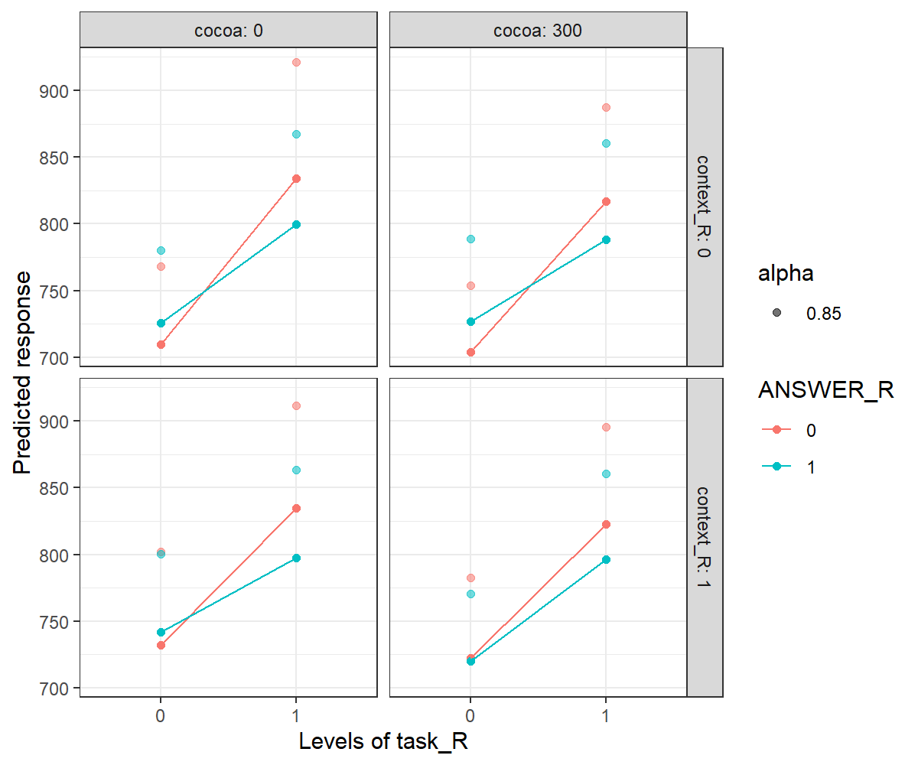

Response relation:

**---- repetition**

**---- switch**

Note. 0 indicates repetitions and 1 indicate switch. Task relation is plotted on the x-axis, response relation is plotted on the colours (red = repetition, blue = switch), context relation is plotted on the uppers and lower panels, cocoa is plotted on the leftmost and rightmost panels. The dots connected by a line are the predicted values of the model, whereas the floating and more transparent dots are the true values. Post-hoc tests are run on the predicted values, as these are cleaned by the irrelevant effects of the control variables inserted in the model.

## **Error Analyses**

For the analyses of the error rates, the first trial of each block was removed, together with the observation faster than 200 ms. Analyses consisted in estimating the coefficients of a logistic mixed model featuring the logarithm of the odd ratio (OR) as the dependent variable. The OR is the ratio between the number of errors over the number of correct responses. To interpret the output of the model is then more convenient to look at the Odd Ratio column rather than at the estimates. For example, if the coefficient for the variable task switch is 0.51 and the OR is 1.67, this indicates that switch trials showed an average error rate which is 67% greater than error rate in repetition trials. Similarly, if the coefficient for the variable response switch is – 0.32 and the OR is 0.72, this indicates that error rates in response switch trials were smaller than in response repetitions trials. Imagining that error rate in response repetition trials is 10%, then error rate in response switch trials is 7.2%.

The model yielded a significant effect of task relation, with task switch being more prone to error than task repetitions (4.5% versus 6.5%). On the contrary, response switches were on average more accurate than response repetitions (OR = 0.72, p < 0.5). There was a significant interaction between response and cocoa, such that response switch benefit was reduced when cocoa was equal to 300 (the benefit in the predicted error rate goes from 1.83% to 1.42%). Finally, response and context relation interacted with cocoa. Post-hoc tests showed that when context repeated and cocoa was 300, response switch benefit was not significantly greater than 0 (OR = 0.79, p = .237). In facts, such switch benefit is significantly smaller than the switch benefit with context switch and cocoa 300 (OR = 0.52, p < .05, cfr the top and the bottom right panels of Figure 2). On the contrary, switch benefit did not significantly differ in context switch trials, when comparing cocoa 0 and cocoa 300 trials (OR = 0.75, p = .305). Further post-hoc showed that response switch-task repetition-context switch trials were significantly faster when cocoa was 300 than it was 0 (blue lines in the bottom panels, OR = 1.36, p < .05). The same comparison, calculated for context repetition instead (top panels), resulted only marginally significant (OR = 0.78, p = .0656). A similar comparison on response repetitions in task repetition in the top panels was also only marginally significant (OR = 1.32, p = .079).

Post-hoc test aimed at investigating binding effects, showed that switch costs were significantly different in response switch and in response repetition trials in the top right panel of Figure 2 and in the bottom left panel. When context repeated and cocoa was 300, switch cost was 4.3% in response repetitions against 0.7% in response switch trials (p < .01). Also, when context switched and cocoa was 0, switch cost was 2.6% in repetition trials and – 0.02 % in response switches. In the other two cases p were > .0804.

Figure . Study 1 – Predicted and Raw Error Rates

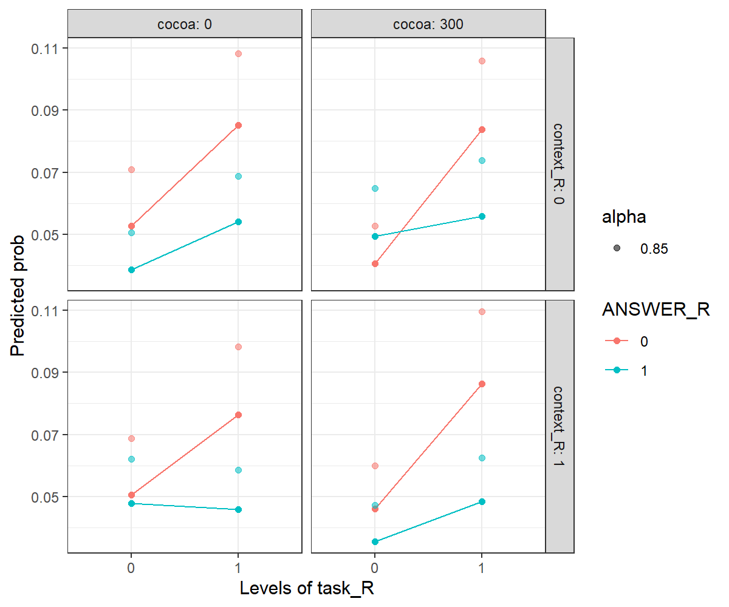

Response relation:

**---- repetition**

**---- switch**

## Discussion of Study 1

In this study we could observe a task-response binding effect defined as the significant interaction of response relation and task relation. Such effect was not significant for context switch and cocoa 300: in this case, repeating a response in task repetitions trials was not as beneficial as in the other conditions. It is along the lines of our hypotheses that context switch has such effect on the RR effect, however this was hypothesized to be greater for cocoa 0, whereas it results greater for cocoa 300. Somehow the disruptive effect of context switch benefited of a delayed onset, arguably because this makes it more salient with respect to the other elements fixed in the screen. We found traces of distractor-response binding effect, but this didn’t reach significance.

We ran a post-hoc test on the response switch trials in the bottom panels of the Rts, to further investigate the effect of cocoa that showed different interesting effects throughout the studies. Here we found a beneficial effect of cocoa 300 in task repetitions – response and context switch trials. Particularly, when context switched and so did response, responses were faster for cocoa 300 than for cocoa 0. This result may indicate that context delayed onset had the effect of augmenting the effect of context relation on response relation, rather than reducing it.

In errors we found an unexpected beneficial effect of response switches. This interacted with cocoa and context and indeed it was not significant in trials with context repetition and cocoa 300. There, response repetitions in task repetitions were particularly faster and response switch were particularly slower than the other conditions. Arguably, we are observing a DR effect (in which response switch are faster when context switches and response repetitions are faster when context repeats) which is made observable by a more salient onset of the distractor, which suddenly appears on an otherwise black and white screen and which is instead not visible when the distractor appears together with the other features.

# Study 2 – Context out of the cue

Online experiment with N = 76 participants, of which 64 were recruited via Prolific and 12 via an email sent to the psychology student at RWTH. We had planned 96 participants for this experiment, but we could only collect 12 RWTH students, out of the 32 that we planned. Mean error rate in the sample was 8.92% (± 4.5%) and 3 participants showed an average error rate that laid further than 2 standard deviations from the mean: these were removed from the subsequent analyses.

## Analyses on RTs

In these analyses, error and post-error trials were removed, together with the first trial of each block and the responses faster than 200 ms that composed roughly 15% of the original dataset. To analyse RTs, we estimated the coefficients of a linear mixed model with participant and stimulus as random factors. RTs were log-transformed as for Study 1. Task switch were, on average, 12% slower than task repetitions (*coeff* = 1.126, *p* < .001). When cocoa was equal to 300, responses were faster than when cocoa was equal to 0 (*coeff* = 0.965, *p* < .05). Both task and context relation interacted with cocoa: the beneficial effect of having delay in context onset (cocoa = 300) was reduced when task (coeff. = 1.06, p < .01) or context (coeff. = 1.048) switched. The interaction of cocoa and response relation went in the same direction but was only marginally significant (coeff. = 1.038, p = .053). Finally, we observed a significant 3-way interaction of task, response, and cocoa (coeff. = 0.93, p < .01) that indicates that the effect of having a delay in context onset (cocoa 300) was instead reversed when both task and response switched. More in detail, if we define binding effect as the difference between switch costs in response repetition trials and switch cost in response switch trials, we can observe how binding effect was moderated by the experimental conditions: post-hoc test revealed that the task by response interaction was significant when cocoa was equal to 300, for both context switch and repetition (all p < .01), and it was not significant when cocoa was 0 (all p > .4). This is due to the fact that cocoa 300, with respect to cocoa 0, inflated switch costs in response repetitions and reduced them in response switch (cfr. with Figure 3 and with the negative coefficient of the 3-way interaction of task, response, and cocoa). We compared those two significant task-response interactions to check whether they differed for context switches and repetitions, but the test resulted non-significant (ratio = 1.01, p = .645).

Figure . Study 2 - Estimated and Raw Rts

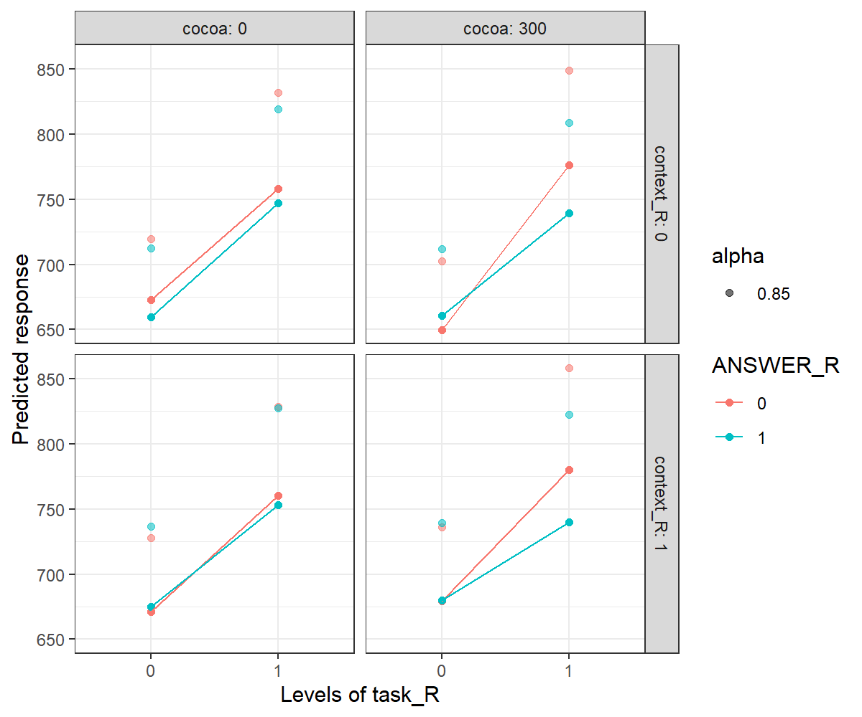

Response relation:

**---- repetition**

**---- switch**

When contrasting RTs in the trials with and without delay in context onset (cocoa 0 minus cocoa 300) in the different conditions, only one contrast resulted significant. Trials with cocoa 0 were significantly slower than trials with cocoa 300 in triple repetitions trials (when task, response and context repeated, 673 ms versus 650 ms, p < .05). Furthermore, the predicted means were numerically greater for cocoa 0 than for 300 in task and response switch – context repetition trials (upper right panel) and in “triple switch” trials (task, context and response switched, bottom right). Otherwise, the estimated means in the other 5 cells numerically pointed in the opposite direction, in that cocoa 300 trials were slighter slower than cocoa 0 trials.

## Error Analyses

To investigate the effects of the predictor on errors, a logistic mixed model was used. As in Study 1, it was found a significant task switch cost (OR = 1.63, p <.001) and a significant response switch benefit (OR = 0.64, p < .01). This was the same result we had with N = 43 and it has not changed with N = 76. This might be due to the fact that participants learnt that a switch in response was slightly more likely than a repetition. However, if the interaction between block number and response relation is included in the model, this results not significant: this, in my opinion, undermines the hypothesis that participants learnt the different likelihoods of response switch and repetitions as blocks were unfolding, otherwise we should have observed a stronger effect of response relation in the later blocks. It is still possible, however, that they learnt such likelihoods already within the first block, so that there is no observable difference on average when block number increases by 1. The beneficial effect of response switch is mitigated by cocoa, that, when equal to 300, reduces the difference between the probability of error in response switch and in response repetitions trials (OR = 1.62, p < .05). Moreover, the interaction between context relation and cocoa resulted marginally significant (OR = 1.51, p = .056). These two interactions are further qualified by a 3-way interaction of response, context, and cocoa (OR = 0.46, p < .01). Dissecting this interaction, it was found out that context interacted significantly with cocoa across the 4 combinations of task and response relations (all ps < .05), with the exception of the double switch condition (p = .82). For response repetition – task repetition trials, context switch cost was 2% when cocoa was 300 and – 0.05% when cocoa was 0. For response repetition – task switch trials, context switch cost was 1.78% for cocoa 300 and – 1.1% for cocoa 0. For task repetition – response switch trials, the pattern was reversed, so that context switch costs were greater for cocoa 0 (1.3%) than for cocoa 300 (- 0.7%). We furthermore compared the right panels of Figure 4 (when cocoa is equal to 300) and we observed that that error rates for repetition of task and response was significantly higher in context switch than in repetition (OR = 1.37, p <.05).

Further post-hoc tests aimed at seeking binding effects revealed that only when context repeated and cocoa was equal to 300 there was a significant interaction of task and response relation (switch costs were 3.4% in response repetitions and 0.3% in response switch trials, p < .05).

Figure . Study 2 Predicted and Raw Error Rates

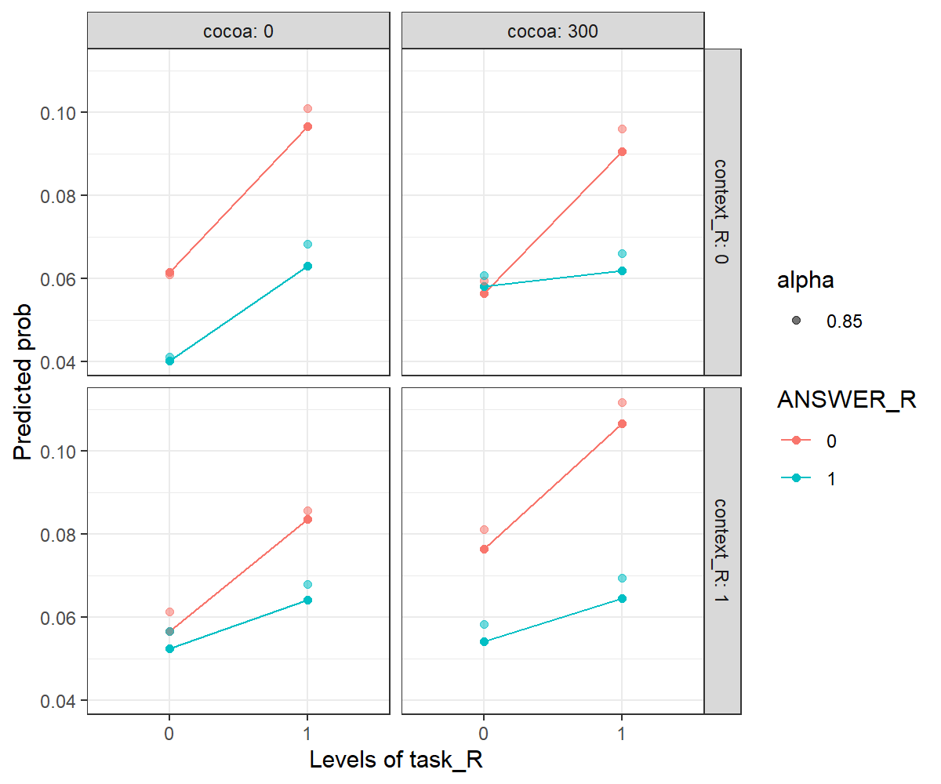

Response relation:

**---- repetition**

**---- switch**

## Discussion of Study 2

Binding effects were defined as the difference between switch costs in response repetitions and in response switch trials. In this study, such binding effect was found only for cocoa 300 and context repetition in both errors and Rts and also for context switch in Rts. In RTs, this was indeed further moderated by cocoa: when context appeared with a delay, with respect to when it didn’t, task switch costs were greater in response repetition and shrank in response switch. Thus, the delayed onset of context seems to exacerbate the RR effect. Context repetitions were indeed expected to augment (or at least leave unaffected) the RR effect, with respect to context switches which were supposed to reduce it, and this is what we observed for cocoa 300.

In this study, cocoa 300 showed a significant beneficial effect which was unexpected. Arguably, this could be due to the increase in alertness provoked by the delayed appearance of something coloured on a black and white screen. However, increased alertness would be more likely to reduce the RR effect, rather than augmenting it, since an increase in attention should help overcoming the more automatic effects. Noticeably, such cocoa 300 benefit is not very robust across conditions, in facts it only reaches significance in the “easiest” of the conditions, in which everything repeats from trial n-1. Thus, while in this latter condition it is reasonable to think of increased alertness, it is probably more accurate to think of increased salience of the repeating context for what concerns the exacerbation of the RR effect. This appeared clearly in errors, in which the exacerbation was there only in context repetitions. On the contrary, Rts results are more difficult to interpret in this sense, given that the task-response bindings were strengthened by cocoa 300 in context switch as well.

For both Rts and errors, cocoa interacted with context relation in the same way, augmenting context switch costs for cocoa 300 with respect to cocoa 0. In errors, we noticed that whenever response repeated, it was more disruptive to have a contrasting *delayed* context, rather than a contrasting *simultaneous* context. This may imply that when the same response was to be executed, but the irrelevant context pushed for a response switch, this “pushing” is more effective, more salient, if it appears, suddenly, on a previously black and white screen. On the contrary, when response switched and task repeated, we observed greater context switch costs for cocoa 0. It is possible that, since the task set is still activated from the previous trials, a context switch directly affects task set activation in this case, and specifically, it impairs the processing of an already active task set, incorrectly pushing for a task switch. Maybe, in response switch trials, context switch affects task set activation more evidently, while this effect is masked in response repetition trials, in which context switch affects response selection.

# Study Between Subjects

The sample is composed by 152 participants (70 females, 2 not declared) and mean age is 24 years (±4.5 years, 10 participants did not disclosure their age). Mean error rate was 8.9% (±5%). Seven participants showed an average error rate greater than 2 standard deviations from the mean, and thus were removed. These were the same participants that were removed in Study 1 and 2.

## Analyses of RTs

As for study 1 and 2, error and post-error trials were removed, together with the first trial of each block and the trials faster than 200 ms. RTs were log-transformed to achieve an approximately normal distribution.

From the analyses it resulted that task switch trials were responded significantly slower than repetitions (17.4% slower, p < .001), as context switch trials that showed significantly slower RTs with respect to repetitions (3.1% slower, p < .05). Response relation coefficient did not reach significance (response switches 2.4% slower, p = .06), but it goes in the same direction as in Study 1. Task relation interacted with response relation, so that switch costs were smaller in response switch than in response repetition trials (6% smaller, p < .001). Switch costs were also significantly different in the two studies, specifically, these were smaller in Study 2 (4% smaller, p < .05). Response relation interacted with the study in a similar way, so that response switch costs were smaller in Study 2 than in Study 1 (4% smaller, p < .05). These significantly interactions were further qualified by a significant 3-way interaction of task and response relation with the study. Particularly, the RR effect was significantly reduced in Study 2 than in Study 1 (7.1% smaller, p < .01), as shown by the positive coefficient, that thus goes in the opposite direction as the negative coefficient of the task by response relation interaction. Post-hoc tests show that the task by response interaction was significant for most of the levels of context relation and cocoa in Study 1 (all p < .01), whereas it didn’t reach for context switch and cocoa 300 (p = .117), as we have observed in the analyses of Study 1. On the contrary, in Study 2 the interaction was significant only for cocoa 300 for both context switch and repetition (all p < .01), whereas it didn’t reach significance in those trials in which context repeated, with both cocoa 0 and 300 (all p > .389 cfr. with Figure 5), as we observed in the analyses of Study 2. Finally, we found a significant 3-way interaction of task relation, cocoa, and study. A post-hoc test revealed that switch costs were significantly smaller in study 1 (55 ms) than in study 2 (78 ms) in context switch – response switch and cocoa 0 trials (difference significant with p < .05).

Figure . Between-subjects Estimated and Raw RTs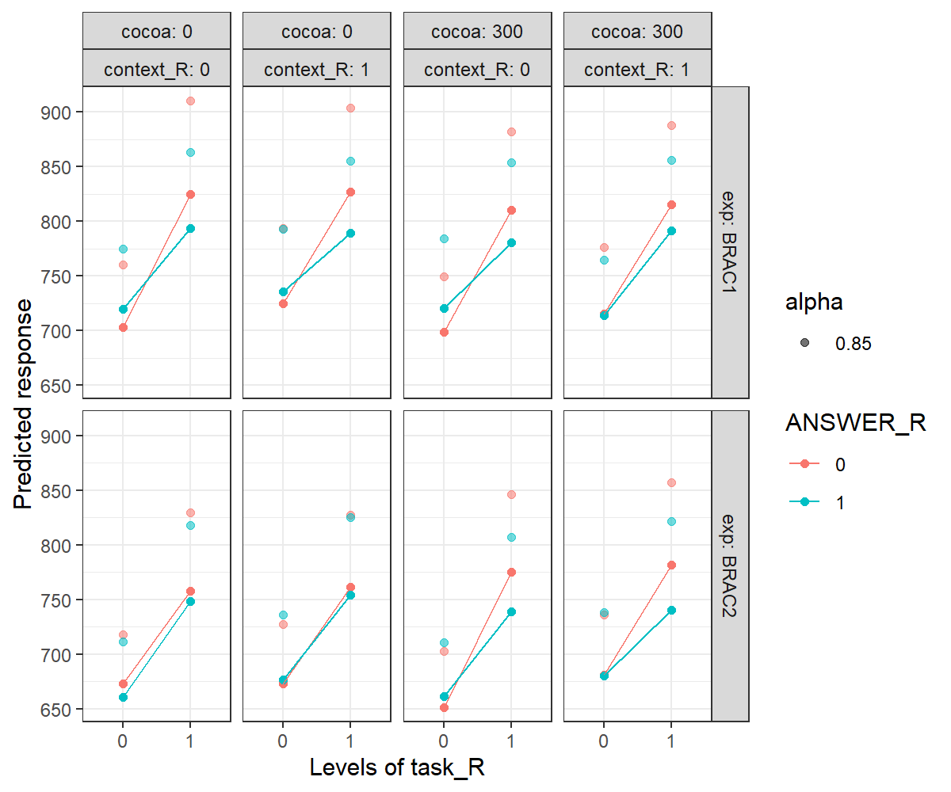

Response relation:

**---- repetition**

**---- switch**

Note. The same legenda applies as for the previous figures, however here the first row of panels is for study 1 and the second is for study 2. Furthermore, context and cocoa re now plotted adjacently, context repetition on the odd columns, switch on the even column, cocoa 0 in the first 2 columns and cocoa 300 in the 2 rightmost ones.

## Error Analyses

Trials faster than 200 ms were removed together with the first trial of each block. The model yielded a significant effect of task relation, with task switch trials that were significantly slower than task repetitions trials (63.8% slower, p < .001). As in Study 2, response switch trials were faster than response repetition trials (average RTs was 69.5% of average RTs in response repetition trials, p < .05). Response relation interacted with cocoa, (coeff. = 1.73, p < .01), so that the response switch “benefit” was significantly smaller when cocoa was equal to 300. Finally, this interaction was further qualified by a significant three-way interaction of response and context relation with cocoa (coeff. = 0.5, p <.05). As in Study 2, the reduction of response switch benefit in cocoa 300 trials was modulated by context relation, so that cocoa has a smaller impact on response switch benefit when also context switched than when this repeated. The pattern was very close to the one of Study 2: we examined the difference of switch costs for cocoa 0 and cocoa 300 trials and for double repetition of task and response, context switch costs were greater for cocoa 300 (1.2%) than for cocoa 0 (0.4%), but this was only marginally significant here (p = .055). Similarly, context switch costs were greater for cocoa 300 (0.8%) than for cocoa 0 (- 1.2%) in response repetitions - task switches trials (p < .05). As in Study 2, the effect was instead reversed for task repetition and response switch (context switch cost 0 = 0.9%, switch cost 300 = - 1%, p < .01) and didn’t reach significance for double switch trials (context switch cost 0 = - 0.5%, switch cost 300 = - 0.3%, p = .858).

Post-hoc test showed that the task by response interaction was significant in three cases: In Study 1, when context switched and cocoa was 300 and, in both Study 1 and Study 2 when context repeated but cocoa was 0. As it appears from Figure 3, in these 3 cases task switch costs in response switch trials, were much smaller than in the other cells (the blue lines are more horizontal). Thus, the significant interaction seems to be driven by the fact that task switch costs were particularly mitigated by a complete switch (task plus response switch) in these three conditions.

Figure . Between-subjects Error Estimates and Raw Means

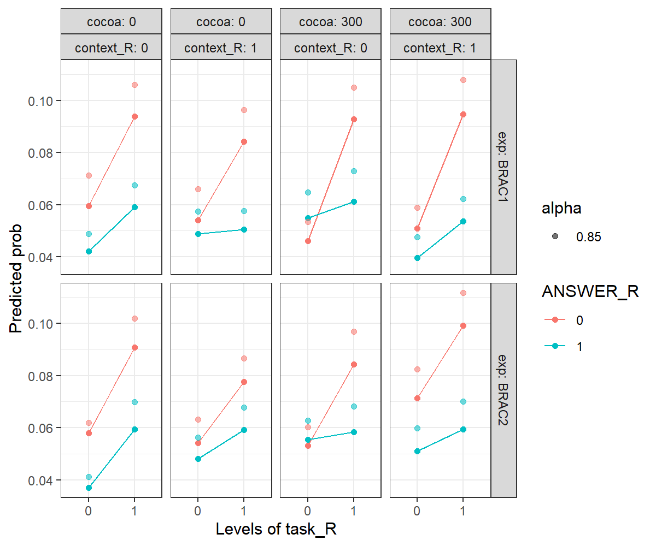

Response relation:

**---- repetition**

**---- switch**

Note. The same legenda applies as for the previous figures, however here the first row of panels is for study 1 and the second is for study 2. Furthermore, context and cocoa re now plotted adjacently, context repetition on the odd columns, switch on the even column, cocoa 0 in the first 2 columns and cocoa 300 in the 2 rightmost ones.

## Discussion of Between-subjects Study

When analysing together the data from experiment 1 and 2, we found binding effects as the interaction of task and response relation resulted significant. Binding was further modulated by the study. We expected the study to modulate binding effects, however, the modulation should have passed through context relation, such that a more attended context (in cue) would have had a greater effect on binding than a less attended context (out of cue). On the contrary, we could not find significant interaction of task and response with context, nor a 4-way interaction including study. Thus, we will simply interpret this result noticing that both task switch costs and response repetition benefits are reduced in study 2 and this may suggest that the coloured outer frame increased alertness.

In error rates, binding effects are less ubiquitous and seemed to be driven by very small task switch costs in response switch trials. The patterns are generally very similar to error data in Study 2, in which binding was found only for context repetition and cocoa 300 trials. We also observed here the same 3-way interaction of response, context, and cocoa, which, when dissected, revealed a very similar pattern as for the one of Study 2.

# General Discussion

Binding effects were visible across the studies, although they appeared in different combinations of conditions. In Study 1, binding effects are consistently found in context repetition - delayed onset trials and in context switch - simultaneous onset trials. We hypothesize that this effect is due to the the fact that cocoa 300 exacerbates the effect of context switch on RR effect. Cocoa 300, with respect to cocoa 0, speeded up responses in task repetition - response switch trials when context switched. Switching a response is hypothesized to be beneficial in context switch, and this distractor-response binding effect was augmented by cocoa 300 (and not cocoa 0). Same effect was found for errors, in that, when context switches, response switch in task repetitions are significantly faster when cocoa is 300 than when it is 0. Interestingly, this is not found for context repetitions, in which switching a response is hypothesized to be more costly than repeating it.

In study 2, binding effects are found only for cocoa 300 across context relation conditions (but in errors only when also context repeated). Thus, the results are different from Study 1, but they have in common the fact that cocoa interacted with context relation to affect RR effects. Namely, in this study cocoa seemed to exacerbate the effect of context *repetition* on RR effect, whereas in Study 1 we observed the exacerbation of the expected effect of context *switch* on RR effect.

In between-subjects study we found that task switch costs were smaller in study 1 than in study 2 in a specific combination of conditions, that is context and response switch and cocoa 0 trials. This may indicate that, in study 1 more than in study 2, context and response relation had the expected effect on task switch costs (triple switches are better than partial switch) and that was more evident in cocoa 0 than in 300 as predicted.

# Lab Study 1 – Context in the cue

I have added here the data from the lab experiment with N = 29 participants (16 females) aged 24.3 years old on average recruited among RWTH students. Results reported here are obtained with linear mixed models analyses or logistic mixed models for errors analyses of 28 participants (one was removed for having mean error rate greater than 2 standard deviations from the sample mean).

## Analyses of RTs

|  |  |  |  |  |  |  |
| --- | --- | --- | --- | --- | --- | --- |
|  | **Estimate** | **Std. Error** | **exp_Estimate** | **t value** | **Pr(>|t|)** |  |
| (Intercept) | 6.979 | 0.317 | 1074.215 | 21.999 | < .001 |
| task | 0.179 | 0.017 | 1.196 | 10.753 | < .001 |
| resp | 0.034 | 0.016 | 1.034 | 2.13 | < .05 |
| colour | 0.05 | 0.017 | 1.051 | 2.917 | < .01 |
| cocoa300 | 0.047 | 0.017 | 1.048 | 2.775 | < .01 |
| blockNum | -0.034 | 0.001 | 0.966 | -27.977 | < .001 |
| sexm | 0.05 | 0.06 | 1.052 | 0.834 | 0.411 |
| handrechts | 0.106 | 0.074 | 1.111 | 1.429 | 0.164 |
| respRepetitions | -0.002 | 0.001 | 0.998 | -1.717 | 0.097 |
| task:resp | -0.061 | 0.022 | 0.941 | -2.701 | < .01 |
| task:colour | -0.053 | 0.023 | 0.948 | -2.272 | < .05 |
| resp:colour | -0.028 | 0.022 | 0.973 | -1.228 | 0.22 |
| task:cocoa300 | -0.045 | 0.023 | 0.956 | -1.925 | 0.054 |
| resp:cocoa300 | -0.032 | 0.022 | 0.968 | -1.439 | 0.15 |
| colour:cocoa300 | -0.058 | 0.024 | 0.944 | -2.429 | < .05 |
| task:resp:colour | 0.027 | 0.032 | 1.027 | 0.847 | 0.397 |
| task:resp:cocoa300 | 0.012 | 0.032 | 1.012 | 0.388 | 0.698 |
| task:colour:cocoa300 | 0.052 | 0.033 | 1.054 | 1.595 | 0.111 |
| resp:colour:cocoa300 | 0.056 | 0.032 | 1.058 | 1.767 | 0.077 |
| task:resp:colour:cocoa300 | -0.008 | 0.045 | 0.992 | -0.184 | 0.854 |

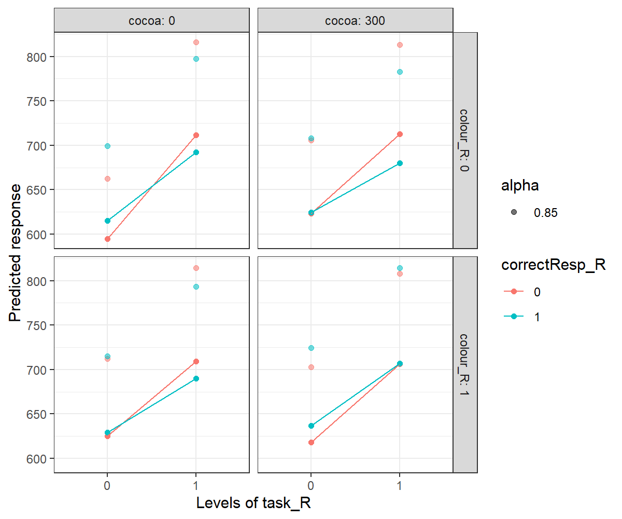

## Error Analyses

|  |  |  |  |  |  |
| --- | --- | --- | --- | --- | --- |
|  | **Estimate** | **Std. Error** | **z value** | **OddRatio** | **Pr(>|z|)** |
| (Intercept) | -2.892 | 0.356 | -8.123 | 0.055 | < .001 |
| task | 0.369 | 0.162 | 2.282 | 1.447 | < .05 |
| resp | -0.312 | 0.177 | -1.759 | 0.732 | 0.079 |
| colour | -0.242 | 0.188 | -1.288 | 0.785 | 0.198 |
| cocoa300 | -0.118 | 0.18 | -0.654 | 0.889 | 0.513 |
| blockNum | -0.093 | 0.013 | -7.119 | 0.911 | < .001 |
| sexm | -0.061 | 0.282 | -0.216 | 0.941 | 0.829 |
| handrechts | 0.461 | 0.337 | 1.369 | 1.586 | 0.171 |
| respRepetitions | -0.117 | 0.152 | -0.767 | 0.89 | 0.443 |
| task x resp | -0.144 | 0.237 | -0.608 | 0.866 | 0.543 |
| task x colour | 0.151 | 0.237 | 0.64 | 1.164 | 0.522 |
| resp x colour | 0.054 | 0.263 | 0.205 | 1.055 | 0.837 |
| task x cocoa300 | 0.211 | 0.229 | 0.919 | 1.234 | 0.358 |
| resp x cocoa300 | 0.299 | 0.248 | 1.209 | 1.349 | 0.227 |
| colour x cocoa300 | 0.006 | 0.269 | 0.021 | 1.006 | 0.983 |
| task x resp x colour | -0.241 | 0.351 | -0.687 | 0.786 | 0.492 |
| task x resp x cocoa300 | -0.333 | 0.332 | -1.003 | 0.717 | 0.316 |
| task x colour x cocoa300 | -0.087 | 0.336 | -0.259 | 0.916 | 0.795 |
| resp x colour x cocoa300 | 0.147 | 0.364 | 0.404 | 1.159 | 0.686 |
| task x resp x colour x cocoa300 | 0.211 | 0.485 | 0.435 | 1.235 | 0.663 |

# Appendix

## Study 1

Figure . Study 1 – Rts Log-transformation

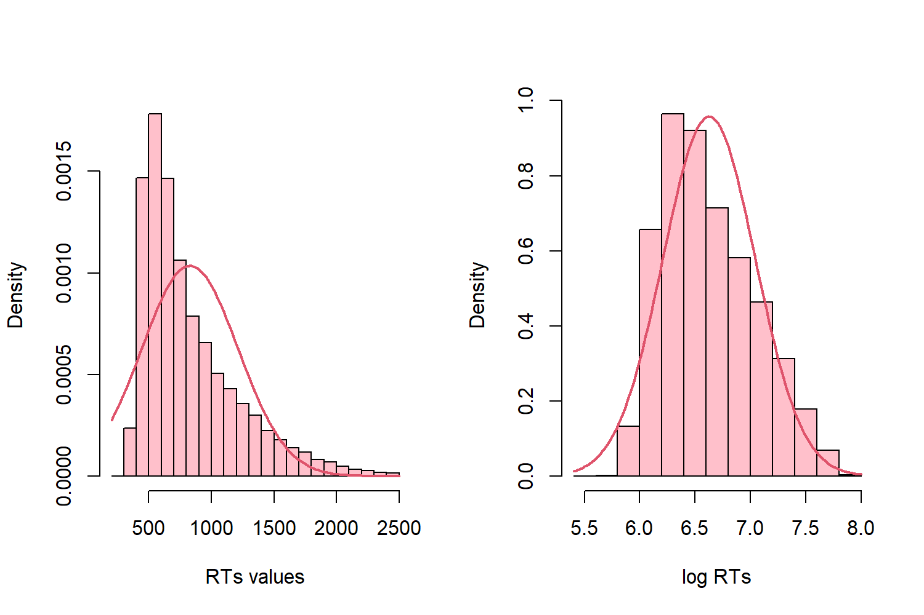

Table . Study 1 - Model on RTs

|  |  |  |  |  |  |
| --- | --- | --- | --- | --- | --- |
|  | Estimate | Std. Error | exp_Estimate | t value | Pr(>|t|) |
| (Intercept) | 6.995 | 0.323 | 1091.705 | 21.663 | < .001 |
| task sw | 0.161 | 0.013 | 1.175 | 12.123 | < .001 |
| resp sw | 0.022 | 0.013 | 1.023 | 1.781 | 0.075 |
| context sw | 0.031 | 0.014 | 1.031 | 2.22 | < .05 |
| cocoa300 | -0.008 | 0.014 | 0.992 | -0.622 | 0.534 |
| blockNum | -0.055 | 0.002 | 0.946 | -27.428 | < .001 |
| sexmale | -0.119 | 0.052 | 0.888 | -2.29 | < .05 |
| Participant.BrowserSafari | 0.19 | 0.126 | 1.209 | 1.506 | 0.136 |
| Participant.OSMacOs | -0.161 | 0.179 | 0.851 | -0.899 | 0.372 |
| Participant.OSWindows | -0.096 | 0.151 | 0.909 | -0.636 | 0.527 |
| handednessright-handed | 0.116 | 0.108 | 1.123 | 1.073 | 0.287 |
| prolific1 | 0.107 | 0.069 | 1.112 | 1.549 | 0.126 |
| respRepetitions | -0.003 | 0.002 | 0.997 | -1.674 | 0.098 |
| task sw x resp sw | -0.065 | 0.018 | 0.938 | -3.619 | < .001 |
| task sw x context sw | -0.03 | 0.019 | 0.971 | -1.568 | 0.117 |
| resp sw x context sw | -0.009 | 0.018 | 0.991 | -0.49 | 0.624 |
| task sw x cocoa300 | -0.013 | 0.019 | 0.988 | -0.671 | 0.502 |
| resp sw x cocoa300 | 0.009 | 0.018 | 1.01 | 0.528 | 0.598 |
| context sw x cocoa300 | -0.005 | 0.019 | 0.995 | -0.271 | 0.786 |
| task sw x resp sw x context sw | 0.005 | 0.026 | 1.005 | 0.203 | 0.839 |
| task sw x resp sw x cocoa300 | -0.003 | 0.026 | 0.997 | -0.117 | 0.907 |
| task sw x context sw x cocoa300 | 0.012 | 0.026 | 1.012 | 0.445 | 0.657 |
| resp sw x context sw x cocoa300 | -0.026 | 0.025 | 0.975 | -1.003 | 0.316 |
| task sw x resp sw x context sw x cocoa300 | 0.032 | 0.036 | 1.033 | 0.893 | 0.372 |

Table . Study 1 - Logit Model on Error

|  |  |  |  |  |  |
| --- | --- | --- | --- | --- | --- |
|  | Estimate | Std. Error | z value | OddRatio | Pr(>|z|) |
| (Intercept) | -2.704 | 0.558 | -4.847 | 0.067 | < .001 |
| task sw | 0.513 | 0.129 | 3.974 | 1.67 | < .001 |
| resp sw | -0.324 | 0.144 | -2.25 | 0.723 | < .05 |
| context sw | -0.044 | 0.15 | -0.295 | 0.957 | 0.768 |
| cocoa300 | -0.275 | 0.157 | -1.752 | 0.76 | 0.08 |
| blockNum | -0.243 | 0.022 | -11.286 | 0.785 | < .001 |
| sexmale | 0.092 | 0.151 | 0.611 | 1.097 | 0.541 |
| Participant.BrowserSafari | -0.152 | 0.36 | -0.421 | 0.859 | 0.674 |
| Participant.OSMacOs | 0.284 | 0.51 | 0.557 | 1.328 | 0.578 |
| Participant.OSWindows | 0.066 | 0.432 | 0.154 | 1.069 | 0.878 |
| handednessright-handed | 0.093 | 0.313 | 0.297 | 1.097 | 0.767 |
| prolific1 | 0.094 | 0.2 | 0.469 | 1.098 | 0.639 |
| respRepetitions | -0.015 | 0.072 | -0.21 | 0.985 | 0.834 |
| task sw x resp sw | -0.162 | 0.188 | -0.86 | 0.851 | 0.39 |
| task sw x context sw | -0.074 | 0.188 | -0.394 | 0.929 | 0.694 |
| resp sw x context sw | 0.264 | 0.204 | 1.293 | 1.302 | 0.196 |
| task sw x cocoa300 | 0.258 | 0.191 | 1.351 | 1.295 | 0.177 |
| resp sw x cocoa300 | 0.528 | 0.209 | 2.533 | 1.696 | < .05 |
| context sw x cocoa300 | 0.178 | 0.219 | 0.811 | 1.195 | 0.417 |
| task sw x resp sw x context sw | -0.319 | 0.273 | -1.169 | 0.727 | 0.242 |
| task sw x resp sw x cocoa300 | -0.478 | 0.271 | -1.761 | 0.62 | 0.078 |
| task sw x context sw x cocoa300 | -0.027 | 0.27 | -0.099 | 0.974 | 0.921 |
| resp sw x context sw x cocoa300 | -0.739 | 0.295 | -2.504 | 0.477 | < .05 |
| task sw x resp sw x context sw x cocoa300 | 0.613 | 0.39 | 1.573 | 1.847 | 0.116 |

## Study 2

Table . Coefficients for model on Rts BRAC 2

|  |  |  |  |  |  |
| --- | --- | --- | --- | --- | --- |
|  | Estimate | Std. Error | exp_Estimate | t value | Pr(>|t|) |
| (Intercept) | 6.846 | 0.227 | 940.239 | 30.117 | < .001 |
| task sw | 0.119 | 0.014 | 1.126 | 8.43 | < .001 |
| resp sw | -0.02 | 0.013 | 0.98 | -1.474 | 0.141 |
| context sw | -0.002 | 0.014 | 0.998 | -0.164 | 0.87 |
| cocoa300 | -0.035 | 0.015 | 0.966 | -2.394 | < .05 |
| blockNum | -0.06 | 0.002 | 0.942 | -28.951 | < .001 |
| sexmale | -0.05 | 0.045 | 0.951 | -1.12 | 0.266 |
| Participant.BrowserSafari | -0.086 | 0.083 | 0.918 | -1.03 | 0.307 |
| Participant.OSWindows | -0.015 | 0.067 | 0.985 | -0.225 | 0.822 |
| handednessright-handed | -0.045 | 0.069 | 0.956 | -0.661 | 0.511 |
| prolific1 | -0.029 | 0.061 | 0.971 | -0.48 | 0.633 |
| respRepetitions | -0.001 | 0.001 | 0.999 | -0.622 | 0.536 |
| task sw x resp sw | 0.005 | 0.019 | 1.005 | 0.275 | 0.783 |
| task sw x context sw | 0.006 | 0.02 | 1.006 | 0.304 | 0.761 |
| resp sw x context sw | 0.026 | 0.019 | 1.026 | 1.369 | 0.171 |
| task sw x cocoa300 | 0.059 | 0.02 | 1.061 | 2.989 | < .01 |
| resp sw x cocoa300 | 0.037 | 0.019 | 1.038 | 1.939 | 0.053 |
| context sw x cocoa300 | 0.047 | 0.02 | 1.048 | 2.322 | < .05 |
| task sw x resp sw x context sw | -0.02 | 0.026 | 0.98 | -0.775 | 0.439 |
| task sw x resp sw x cocoa300 | -0.071 | 0.027 | 0.932 | -2.67 | < .01 |
| task sw x context sw x cocoa300 | -0.045 | 0.028 | 0.956 | -1.637 | 0.102 |
| resp sw x context sw x cocoa300 | -0.042 | 0.026 | 0.959 | -1.598 | 0.11 |
| task sw x resp sw x context sw x cocoa300 | 0.033 | 0.037 | 1.033 | 0.872 | 0.383 |

Table . Coefficients for logistic model on errors

|  |  |  |  |  |  |
| --- | --- | --- | --- | --- | --- |
|  | Estimate | Std. Error | z value | OddRatio | Pr(>|z|) |
| (Intercept) | -2.322 | 0.347 | -6.687 | 0.098 | < .001 |
| task sw | 0.489 | 0.138 | 3.545 | 1.631 | < .001 |
| resp sw | -0.447 | 0.158 | -2.834 | 0.64 | < .01 |
| context sw | -0.089 | 0.156 | -0.568 | 0.915 | 0.57 |
| cocoa300 | -0.09 | 0.16 | -0.565 | 0.914 | 0.572 |
| blockNum | -0.237 | 0.022 | -10.984 | 0.789 | < .001 |
| sexmale | 0.161 | 0.132 | 1.221 | 1.174 | 0.222 |
| Participant.BrowserSafari | 0.025 | 0.24 | 0.103 | 1.025 | 0.918 |
| Participant.OSWindows | -0.127 | 0.196 | -0.646 | 0.881 | 0.518 |
| handednessright-handed | -0.076 | 0.207 | -0.368 | 0.927 | 0.713 |
| prolific1 | -0.068 | 0.178 | -0.383 | 0.934 | 0.702 |
| respRepetitions | 0.076 | 0.064 | 1.199 | 1.079 | 0.231 |
| task sw x resp sw | -0.015 | 0.202 | -0.077 | 0.985 | 0.939 |
| task sw x context sw | -0.07 | 0.196 | -0.359 | 0.932 | 0.719 |
| resp sw x context sw | 0.368 | 0.214 | 1.716 | 1.445 | 0.086 |
| task sw x cocoa300 | 0.019 | 0.197 | 0.098 | 1.019 | 0.922 |
| resp sw x cocoa300 | 0.478 | 0.216 | 2.211 | 1.612 | < .05 |
| context sw x cocoa300 | 0.411 | 0.215 | 1.91 | 1.509 | 0.056 |
| task sw x resp sw x context sw | -0.192 | 0.281 | -0.683 | 0.825 | 0.494 |
| task sw x resp sw x cocoa300 | -0.428 | 0.281 | -1.523 | 0.652 | 0.128 |
| task sw x context sw x cocoa300 | -0.072 | 0.271 | -0.266 | 0.931 | 0.79 |
| resp sw x context sw x cocoa300 | -0.766 | 0.293 | -2.615 | 0.465 | < .01 |
| task sw x resp sw x context sw x cocoa300 | 0.454 | 0.387 | 1.175 | 1.575 | 0.24 |

## Between-Subjects Study

Figure . Raw and log-transformed RTs in the whole sample.

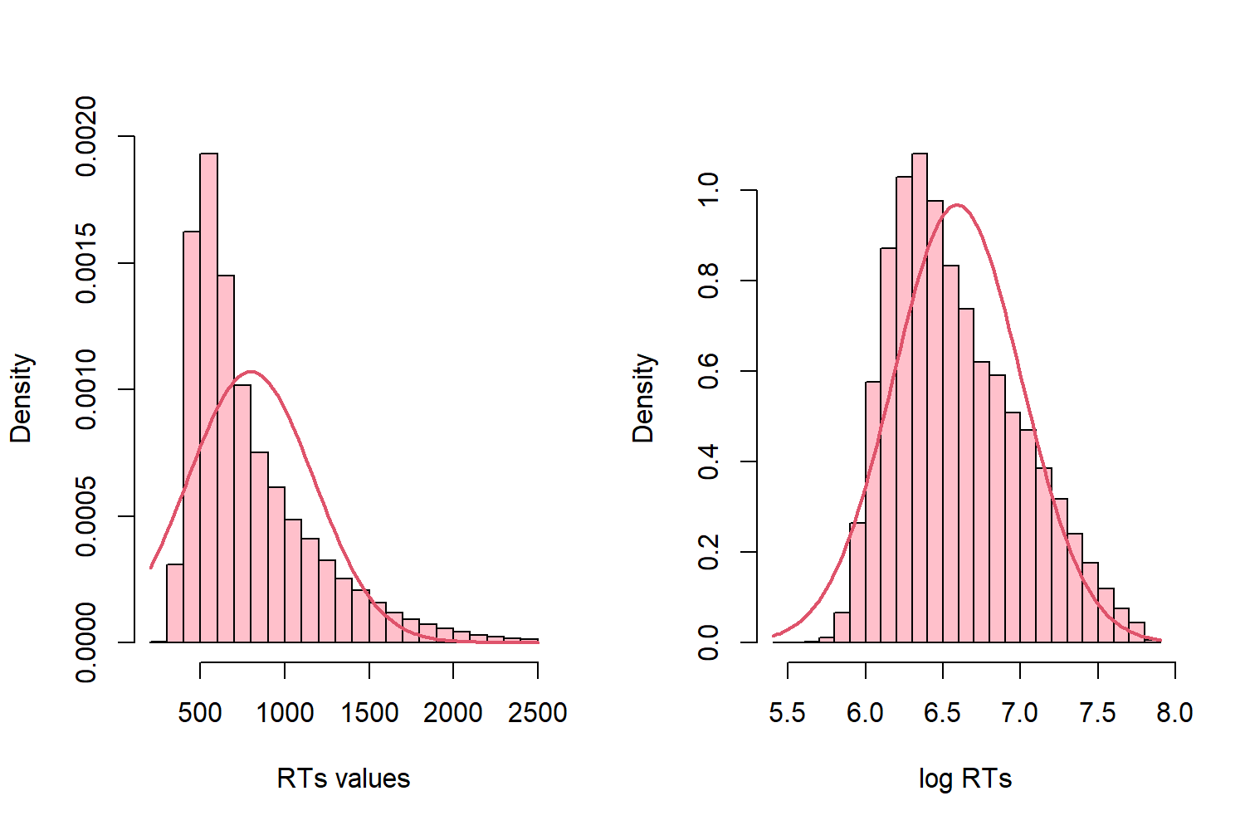

Table . Between Subjects Study - Model on Rts

|  |  |  |  |  |  |
| --- | --- | --- | --- | --- | --- |
|  | Estimate | Std. Error | exp_Estimate | t value | Pr(>|t|) |
| (Intercept) | 6.882 | 0.233 | 975.047 | 29.484 | < .001 |
| task sw | 0.16 | 0.014 | 1.174 | 11.761 | < .001 |
| resp sw | 0.024 | 0.013 | 1.024 | 1.884 | 0.06 |
| context sw | 0.031 | 0.014 | 1.031 | 2.183 | < .05 |
| cocoa300 | -0.006 | 0.014 | 0.994 | -0.416 | 0.677 |
| expBRAC2 | -0.043 | 0.036 | 0.958 | -1.197 | 0.233 |
| blockNum | -0.058 | 0.001 | 0.944 | -39.679 | < .001 |
| sexmale | -0.068 | 0.035 | 0.934 | -1.973 | 0.05 |
| Participant.BrowserSafari | 0.012 | 0.071 | 1.012 | 0.169 | 0.866 |
| Participant.OSMacOs | -0.085 | 0.151 | 0.918 | -0.566 | 0.572 |
| Participant.OSWindows | -0.074 | 0.141 | 0.929 | -0.524 | 0.601 |
| handednessright-handed | 0.015 | 0.058 | 1.016 | 0.265 | 0.791 |
| prolific1 | 0.045 | 0.047 | 1.046 | 0.976 | 0.331 |
| respRepetitions | -0.001 | 0.001 | 0.999 | -1.154 | 0.25 |
| task sw x resp sw | -0.062 | 0.018 | 0.939 | -3.417 | < .001 |
| task sw x context sw | -0.028 | 0.019 | 0.972 | -1.44 | 0.15 |
| resp sw x context sw | -0.01 | 0.019 | 0.99 | -0.532 | 0.595 |
| task sw x cocoa300 | -0.012 | 0.019 | 0.988 | -0.634 | 0.526 |
| resp sw x cocoa300 | 0.007 | 0.018 | 1.007 | 0.364 | 0.716 |
| context sw x cocoa300 | -0.008 | 0.02 | 0.992 | -0.396 | 0.692 |
| task sw x expBRAC2 | -0.041 | 0.019 | 0.959 | -2.136 | < .05 |
| resp sw x expBRAC2 | -0.043 | 0.018 | 0.958 | -2.363 | < .05 |
| context sw x expBRAC2 | -0.031 | 0.02 | 0.969 | -1.573 | 0.116 |
| cocoa300 x expBRAC2 | -0.027 | 0.02 | 0.973 | -1.371 | 0.17 |
| task sw x resp sw x context sw | 0.001 | 0.026 | 1.001 | 0.054 | 0.957 |
| task sw x resp sw x cocoa300 | -0.006 | 0.026 | 0.994 | -0.217 | 0.828 |
| task sw x context sw x cocoa300 | 0.011 | 0.027 | 1.012 | 0.421 | 0.674 |
| resp sw x context sw x cocoa300 | -0.023 | 0.026 | 0.977 | -0.874 | 0.382 |
| task sw x resp sw x expBRAC2 | 0.069 | 0.026 | 1.071 | 2.654 | < .01 |
| task sw x context sw x expBRAC2 | 0.033 | 0.027 | 1.034 | 1.22 | 0.222 |
| resp sw x context sw x expBRAC2 | 0.034 | 0.026 | 1.035 | 1.317 | 0.188 |
| task sw x cocoa300 x expBRAC2 | 0.068 | 0.027 | 1.07 | 2.492 | < .05 |
| resp sw x cocoa300 x expBRAC2 | 0.028 | 0.026 | 1.028 | 1.073 | 0.283 |
| context sw x cocoa300 x expBRAC2 | 0.053 | 0.028 | 1.054 | 1.888 | 0.059 |
| task sw x resp sw x context sw x cocoa300 | 0.038 | 0.037 | 1.039 | 1.028 | 0.304 |
| task sw x resp sw x context sw x expBRAC2 | -0.023 | 0.037 | 0.977 | -0.631 | 0.528 |
| task sw x resp sw x cocoa300 x expBRAC2 | -0.064 | 0.037 | 0.938 | -1.729 | 0.084 |
| task sw x context sw x cocoa300 x expBRAC2 | -0.053 | 0.038 | 0.948 | -1.392 | 0.164 |
| resp sw x context sw x cocoa300 x expBRAC2 | -0.018 | 0.037 | 0.982 | -0.484 | 0.628 |
| task sw x resp sw x context sw x cocoa300 x expBRAC2 | -0.006 | 0.052 | 0.994 | -0.124 | 0.901 |

Table . Between-subjects model on Errors

|  |  |  |  |  |  |
| --- | --- | --- | --- | --- | --- |
|  | Estimate | Std. Error | z value | OddRatio | Pr(>|z|) |
| (Intercept) | -2.528 | 0.457 | -5.532 | 0.08 | < .001 |
| task sw | 0.494 | 0.129 | 3.84 | 1.638 | < .001 |
| resp sw | -0.364 | 0.144 | -2.529 | 0.695 | < .05 |
| context sw | -0.098 | 0.15 | -0.653 | 0.907 | 0.514 |
| cocoa300 | -0.268 | 0.155 | -1.735 | 0.765 | 0.083 |
| expBRAC2 | -0.028 | 0.175 | -0.16 | 0.972 | 0.873 |
| blockNum | -0.24 | 0.015 | -15.72 | 0.787 | < .001 |
| sexmale | 0.144 | 0.098 | 1.462 | 1.155 | 0.144 |
| Participant.BrowserSafari | -0.041 | 0.201 | -0.202 | 0.96 | 0.84 |
| Participant.OSMacOs | 0.256 | 0.423 | 0.607 | 1.292 | 0.544 |
| Participant.OSWindows | 0.097 | 0.395 | 0.246 | 1.102 | 0.806 |
| handednessright-handed | -0.087 | 0.168 | -0.518 | 0.917 | 0.604 |
| prolific1 | 0.001 | 0.133 | 0.005 | 1.001 | 0.996 |
| respRepetitions | 0.059 | 0.05 | 1.189 | 1.061 | 0.234 |
| task sw x resp sw | -0.133 | 0.188 | -0.71 | 0.875 | 0.478 |
| task sw x context sw | -0.02 | 0.187 | -0.106 | 0.98 | 0.916 |
| resp sw x context sw | 0.254 | 0.205 | 1.237 | 1.289 | 0.216 |
| task sw x cocoa300 | 0.258 | 0.189 | 1.367 | 1.294 | 0.172 |
| resp sw x cocoa300 | 0.548 | 0.206 | 2.657 | 1.73 | < .01 |
| context sw x cocoa300 | 0.205 | 0.217 | 0.942 | 1.227 | 0.346 |
| task sw x expBRAC2 | -0.008 | 0.186 | -0.046 | 0.992 | 0.964 |
| resp sw x expBRAC2 | -0.106 | 0.21 | -0.506 | 0.899 | 0.613 |
| context sw x expBRAC2 | 0.029 | 0.212 | 0.137 | 1.029 | 0.891 |
| cocoa300 x expBRAC2 | 0.176 | 0.218 | 0.808 | 1.193 | 0.419 |
| task sw x resp sw x context sw | -0.304 | 0.273 | -1.114 | 0.738 | 0.265 |
| task sw x resp sw x cocoa300 | -0.502 | 0.268 | -1.87 | 0.605 | 0.061 |
| task sw x context sw x cocoa300 | -0.067 | 0.267 | -0.25 | 0.936 | 0.803 |
| resp sw x context sw x cocoa300 | -0.699 | 0.292 | -2.395 | 0.497 | < .05 |
| task sw x resp sw x expBRAC2 | 0.147 | 0.271 | 0.542 | 1.158 | 0.588 |
| task sw x context sw x expBRAC2 | -0.082 | 0.265 | -0.308 | 0.922 | 0.758 |
| resp sw x context sw x expBRAC2 | 0.089 | 0.29 | 0.307 | 1.093 | 0.759 |
| task sw x cocoa300 x expBRAC2 | -0.246 | 0.268 | -0.919 | 0.782 | 0.358 |
| resp sw x cocoa300 x expBRAC2 | -0.033 | 0.293 | -0.112 | 0.968 | 0.911 |
| context sw x cocoa300 x expBRAC2 | 0.18 | 0.299 | 0.601 | 1.197 | 0.548 |
| task sw x resp sw x context sw x cocoa300 | 0.59 | 0.384 | 1.534 | 1.804 | 0.125 |
| task sw x resp sw x context sw x expBRAC2 | 0.128 | 0.383 | 0.334 | 1.136 | 0.738 |
| task sw x resp sw x cocoa300 x expBRAC2 | 0.047 | 0.38 | 0.124 | 1.048 | 0.901 |
| task sw x context sw x cocoa300 x expBRAC2 | 0.03 | 0.372 | 0.081 | 1.031 | 0.935 |
| resp sw x context sw x cocoa300 x expBRAC2 | -0.047 | 0.403 | -0.117 | 0.954 | 0.907 |
| task sw x resp sw x context sw x cocoa300 x expBRAC2 | -0.17 | 0.532 | -0.319 | 0.844 | 0.749 |

## Between-subjects Raw Means Table

The 4 tables that follow report the data plotted in Figure 5 and in Figure 6. Raw means table report the means in the conditions, first averaged between each subject and then between subjects. Predicted means table report the data partialling out the effects of the control variables.

Table . Raw RTs means

|  |  |  |  |  |  |  |  |
| --- | --- | --- | --- | --- | --- | --- | --- |
| task_R | ANSWER_R | context_R | cocoa | exp | meanmeanrt | n | se |
| 0 | 0 | 0 | 0 | BRAC1 | 760.3021 | 71 | 22.02915 |
| 1 | 0 | 0 | 0 | BRAC1 | 910.2592 | 71 | 29.76659 |
| 0 | 1 | 0 | 0 | BRAC1 | 775.1942 | 71 | 20.5031 |
| 1 | 1 | 0 | 0 | BRAC1 | 863.1909 | 71 | 25.08894 |
| 0 | 0 | 1 | 0 | BRAC1 | 793.8304 | 71 | 24.1787 |
| 1 | 0 | 1 | 0 | BRAC1 | 903.8983 | 71 | 28.34415 |
| 0 | 1 | 1 | 0 | BRAC1 | 792.8456 | 71 | 22.60934 |
| 1 | 1 | 1 | 0 | BRAC1 | 855.7085 | 71 | 25.33548 |
| 0 | 0 | 0 | 300 | BRAC1 | 749.899 | 71 | 22.28793 |
| 1 | 0 | 0 | 300 | BRAC1 | 882.3058 | 71 | 26.36235 |
| 0 | 1 | 0 | 300 | BRAC1 | 784.046 | 71 | 22.75082 |
| 1 | 1 | 0 | 300 | BRAC1 | 854.1953 | 71 | 27.55719 |
| 0 | 0 | 1 | 300 | BRAC1 | 776.3194 | 71 | 24.23542 |
| 1 | 0 | 1 | 300 | BRAC1 | 887.9722 | 71 | 27.41845 |
| 0 | 1 | 1 | 300 | BRAC1 | 764.6174 | 71 | 21.95018 |
| 1 | 1 | 1 | 300 | BRAC1 | 856.415 | 71 | 25.88838 |
| 0 | 0 | 0 | 0 | BRAC2 | 717.6741 | 74 | 16.58112 |
| 1 | 0 | 0 | 0 | BRAC2 | 829.3558 | 74 | 24.46428 |
| 0 | 1 | 0 | 0 | BRAC2 | 711.1182 | 74 | 15.62924 |
| 1 | 1 | 0 | 0 | BRAC2 | 818.2487 | 74 | 22.50611 |
| 0 | 0 | 1 | 0 | BRAC2 | 727.0544 | 74 | 16.21646 |
| 1 | 0 | 1 | 0 | BRAC2 | 827.3888 | 74 | 22.05567 |
| 0 | 1 | 1 | 0 | BRAC2 | 735.7459 | 74 | 18.02928 |
| 1 | 1 | 1 | 0 | BRAC2 | 825.3235 | 74 | 22.28777 |
| 0 | 0 | 0 | 300 | BRAC2 | 702.4925 | 74 | 16.42302 |
| 1 | 0 | 0 | 300 | BRAC2 | 846.0471 | 74 | 22.01453 |
| 0 | 1 | 0 | 300 | BRAC2 | 710.8089 | 74 | 16.52403 |
| 1 | 1 | 0 | 300 | BRAC2 | 807.213 | 74 | 23.19066 |
| 0 | 0 | 1 | 300 | BRAC2 | 736.219 | 74 | 16.75901 |
| 1 | 0 | 1 | 300 | BRAC2 | 857.0265 | 74 | 20.89833 |
| 0 | 1 | 1 | 300 | BRAC2 | 738.2087 | 74 | 16.50011 |
| 1 | 1 | 1 | 300 | BRAC2 | 821.2394 | 74 | 23.98016 |

Table . Raw Error means

|  |  |  |  |  |  |  |  |
| --- | --- | --- | --- | --- | --- | --- | --- |
| task_R | ANSWER_R | context_R | cocoa | exp | meanmeanerror | n | se |
| 0 | 0 | 0 | 0 | BRAC1 | 0.071346 | 71 | 0.009005 |
| 1 | 0 | 0 | 0 | BRAC1 | 0.105924 | 71 | 0.00995 |
| 0 | 1 | 0 | 0 | BRAC1 | 0.048764 | 71 | 0.005987 |
| 1 | 1 | 0 | 0 | BRAC1 | 0.067409 | 71 | 0.007867 |
| 0 | 0 | 1 | 0 | BRAC1 | 0.066095 | 71 | 0.008301 |
| 1 | 0 | 1 | 0 | BRAC1 | 0.096462 | 71 | 0.009081 |
| 0 | 1 | 1 | 0 | BRAC1 | 0.057389 | 71 | 0.006658 |
| 1 | 1 | 1 | 0 | BRAC1 | 0.057686 | 71 | 0.007165 |
| 0 | 0 | 0 | 300 | BRAC1 | 0.053545 | 71 | 0.007026 |
| 1 | 0 | 0 | 300 | BRAC1 | 0.104984 | 71 | 0.0095 |
| 0 | 1 | 0 | 300 | BRAC1 | 0.064714 | 71 | 0.006711 |
| 1 | 1 | 0 | 300 | BRAC1 | 0.072967 | 71 | 0.00875 |
| 0 | 0 | 1 | 300 | BRAC1 | 0.058976 | 71 | 0.007133 |
| 1 | 0 | 1 | 300 | BRAC1 | 0.107945 | 71 | 0.01054 |
| 0 | 1 | 1 | 300 | BRAC1 | 0.047507 | 71 | 0.005639 |
| 1 | 1 | 1 | 300 | BRAC1 | 0.062241 | 71 | 0.008162 |
| 0 | 0 | 0 | 0 | BRAC2 | 0.061855 | 74 | 0.007726 |
| 1 | 0 | 0 | 0 | BRAC2 | 0.101831 | 74 | 0.011181 |
| 0 | 1 | 0 | 0 | BRAC2 | 0.041208 | 74 | 0.005144 |
| 1 | 1 | 0 | 0 | BRAC2 | 0.069858 | 74 | 0.008625 |
| 0 | 0 | 1 | 0 | BRAC2 | 0.063188 | 74 | 0.007858 |
| 1 | 0 | 1 | 0 | BRAC2 | 0.086532 | 74 | 0.008575 |
| 0 | 1 | 1 | 0 | BRAC2 | 0.056318 | 74 | 0.00689 |
| 1 | 1 | 1 | 0 | BRAC2 | 0.06769 | 74 | 0.006958 |
| 0 | 0 | 0 | 300 | BRAC2 | 0.060243 | 74 | 0.007993 |
| 1 | 0 | 0 | 300 | BRAC2 | 0.09681 | 74 | 0.008607 |
| 0 | 1 | 0 | 300 | BRAC2 | 0.062836 | 74 | 0.006311 |
| 1 | 1 | 0 | 300 | BRAC2 | 0.068164 | 74 | 0.00735 |
| 0 | 0 | 1 | 300 | BRAC2 | 0.082489 | 74 | 0.00808 |
| 1 | 0 | 1 | 300 | BRAC2 | 0.111827 | 74 | 0.008815 |
| 0 | 1 | 1 | 300 | BRAC2 | 0.059723 | 74 | 0.006449 |
| 1 | 1 | 1 | 300 | BRAC2 | 0.069991 | 74 | 0.007747 |

Table . Predicted RTs Means

|  |  |  |  |  |  |
| --- | --- | --- | --- | --- | --- |
| task_R | ANSWER_R | context_R | cocoa | exp | response |
| 0 | 0 | 0 | 0 | BRAC1 | 702.9235 |
| 1 | 0 | 0 | 0 | BRAC1 | 824.9753 |
| 0 | 1 | 0 | 0 | BRAC1 | 720.1129 |
| 1 | 1 | 0 | 0 | BRAC1 | 794.016 |
| 0 | 0 | 1 | 0 | BRAC1 | 725.0626 |
| 1 | 0 | 1 | 0 | BRAC1 | 827.4749 |
| 0 | 1 | 1 | 0 | BRAC1 | 735.4946 |
| 1 | 1 | 1 | 0 | BRAC1 | 789.7117 |
| 0 | 0 | 0 | 300 | BRAC1 | 698.8615 |
| 1 | 0 | 0 | 300 | BRAC1 | 810.2875 |
| 0 | 1 | 0 | 300 | BRAC1 | 720.7811 |
| 1 | 1 | 0 | 300 | BRAC1 | 780.6938 |
| 0 | 0 | 1 | 300 | BRAC1 | 715.2423 |
| 1 | 0 | 1 | 300 | BRAC1 | 815.6721 |
| 0 | 1 | 1 | 300 | BRAC1 | 713.9334 |
| 1 | 1 | 1 | 300 | BRAC1 | 791.2566 |
| 0 | 0 | 0 | 0 | BRAC2 | 673.1544 |
| 1 | 0 | 0 | 0 | BRAC2 | 758.0341 |
| 0 | 1 | 0 | 0 | BRAC2 | 660.3414 |
| 1 | 1 | 0 | 0 | BRAC2 | 748.2792 |
| 0 | 0 | 1 | 0 | BRAC2 | 672.9082 |
| 1 | 0 | 1 | 0 | BRAC2 | 761.7612 |
| 0 | 1 | 1 | 0 | BRAC2 | 676.3643 |
| 1 | 1 | 1 | 0 | BRAC2 | 753.8975 |
| 0 | 0 | 0 | 300 | BRAC2 | 651.1964 |
| 1 | 0 | 0 | 300 | BRAC2 | 775.2411 |
| 0 | 1 | 0 | 300 | BRAC2 | 661.4247 |
| 1 | 1 | 0 | 300 | BRAC2 | 739.2298 |
| 0 | 0 | 1 | 300 | BRAC2 | 680.954 |
| 1 | 0 | 1 | 300 | BRAC2 | 781.451 |
| 0 | 1 | 1 | 300 | BRAC2 | 680.4808 |
| 1 | 1 | 1 | 300 | BRAC2 | 740.4116 |

Table . Predicted Error Means

|  |  |  |  |  |  |
| --- | --- | --- | --- | --- | --- |
| task_R | ANSWER_R | context_R | cocoa | exp | prob |
| 0 | 0 | 0 | 0 | BRAC1 | 0.059416 |
| 1 | 0 | 0 | 0 | BRAC1 | 0.093797 |
| 0 | 1 | 0 | 0 | BRAC1 | 0.042051 |
| 1 | 1 | 0 | 0 | BRAC1 | 0.059201 |
| 0 | 0 | 1 | 0 | BRAC1 | 0.054169 |
| 1 | 0 | 1 | 0 | BRAC1 | 0.084245 |
| 0 | 1 | 1 | 0 | BRAC1 | 0.048788 |
| 1 | 1 | 1 | 0 | BRAC1 | 0.050512 |
| 0 | 0 | 0 | 300 | BRAC1 | 0.046074 |
| 1 | 0 | 0 | 300 | BRAC1 | 0.092929 |
| 0 | 1 | 0 | 300 | BRAC1 | 0.054863 |
| 1 | 1 | 0 | 300 | BRAC1 | 0.061218 |
| 0 | 0 | 1 | 300 | BRAC1 | 0.050996 |
| 1 | 0 | 1 | 300 | BRAC1 | 0.094642 |
| 0 | 1 | 1 | 300 | BRAC1 | 0.039716 |
| 1 | 1 | 1 | 300 | BRAC1 | 0.05367 |
| 0 | 0 | 0 | 0 | BRAC2 | 0.057869 |
| 1 | 0 | 0 | 0 | BRAC2 | 0.090737 |
| 0 | 1 | 0 | 0 | BRAC2 | 0.036954 |
| 1 | 1 | 0 | 0 | BRAC2 | 0.059423 |
| 0 | 0 | 1 | 0 | BRAC2 | 0.054222 |
| 1 | 0 | 1 | 0 | BRAC2 | 0.077616 |
| 0 | 1 | 1 | 0 | BRAC2 | 0.048036 |
| 1 | 1 | 1 | 0 | BRAC2 | 0.059213 |
| 0 | 0 | 0 | 300 | BRAC2 | 0.053056 |
| 1 | 0 | 0 | 300 | BRAC2 | 0.08435 |
| 0 | 1 | 0 | 300 | BRAC2 | 0.055343 |
| 1 | 1 | 0 | 300 | BRAC2 | 0.058325 |
| 0 | 0 | 1 | 300 | BRAC2 | 0.071321 |
| 1 | 0 | 1 | 300 | BRAC2 | 0.099113 |
| 0 | 1 | 1 | 300 | BRAC2 | 0.050916 |
| 1 | 1 | 1 | 300 | BRAC2 | 0.059322 |