1 stop St Lucia Port Castries

9 00 - 18 30

Scooter rent: +17584522059. Has reviews, 40 min walk from port, 5 min by car.

<https://maps.app.goo.gl/dQnbHGQb9ssABjp78>

from port to old town 20 min walk

To see:

The Pitons in Saint Lucia

from port to piton 1-30 min by car - book a tour?

May be stop is closer, no need to go right there, but to see from nearby:

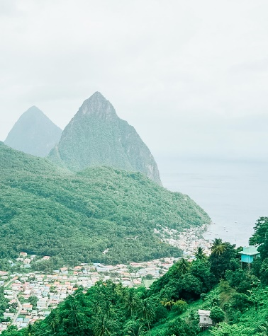

Maps point to the exact point:

Sulphur Springs parc next to volcanos has mud bath and hot springs. Admission 10 usd for mud/hot springs and there is possibility to purchase combo entry.

Same location, cocoa plantation, if have time.

More info: <https://cruisingkids.co.uk/top-things-to-do-at-port-castries-st-lucia/#more-1912>

<https://www.iqcruising.com/ports/caribbean/saint-lucia/overview-saint-lucia-castries-cruise-port.html>

Tour: <https://www.viator.com/tours/Castries/St-Lucia-Highlights-Tour/d50293-8083P1> - 70 total, start 9 am, admission is not included.

2 stop Barbados Port Castries

7 00 - 17 30

Pebbles Beach – beach with racehorses, 50 min walk, 15 min car.

**Taxi Fares from Bridgetown Cruise Port (2023) \***

| **ACCRA BEACH** | **BOAT YARD BEACH** | **CARLISLE BAY BEACH** | **MIAMI BEACH / OISTINS** | **MULLINS BEACH** | **PAYNES BAY BEACH** | **BRIDGETOWN** |
| --- | --- | --- | --- | --- | --- | --- |
| US$7.50 | US$5 | US$5 | US$10 | US$10 | US$7.50 | US$2 |

* Fares are per person, one way, sharing a Taxi.

Parliament Building in Bridgetown – in the center. Walk in the center.

The Barbados Wildlife Reserve: 40 min by car. 24 usd enty. Taxi 50 usd

Harrison’s Cave: 20 min by car. 30 usd entry. Taxi 30 usd

<https://chukka.com/destinations/barbados/harrisons-cave/> - adventure park Starting from US $179.00