Macaque Face Re-Identification — Augmentation and Averaging
Augmentation and rotation averaging · 28 October 2026

What I did (summary)
- Completed experiments. Trained three augmentation policies for 30 epochs each on the current 149-identity dataset, then compared ordinary inference with seven-angle mean and max pooling.
- Averaging run completed. Job 39152253 finished successfully. Its separate results section compares single-image prediction, seven-angle averaging and max pooling for the same checkpoint.
- Best measured result. The ±30° policy with probability averaging reached test Top-1 84.51% and macro-F1 0.8284. The previous baseline scored 82.51% and 0.8027.
- Fair comparison. All test comparisons cover the same 1,498 image/identity pairs. Model/pooling selection used validation results before the test comparison.
- Main finding. Moderate additional augmentation helped in this experiment. The ±100° policy was weaker and the ±150° policy struggled to fit the strongly transformed data. There was one training fit per policy.

1. Headline results on the current test set
Metric | Original baseline:  single image | ±30° policy:  single image | ±30° policy:  seven-angle mean
Top-1 accuracy | 82.51% | 83.51% | 84.51%
Top-3 accuracy | 88.65% | 88.45% | 89.65%
Top-5 accuracy | 89.85% | 89.99% | 90.72%
Macro-F1 | 0.8027 | 0.8189 | 0.8284
Weighted F1 | 0.8239 | 0.8349 | 0.8444

Original baseline is the previous model (affine ±15° plus RandAugment). The ±30° policy is the new model; seven-angle mean reuses its checkpoint and averages probabilities from seven rotated test views. Top-1 gains are +1.00 point from the training policy, then +1.00 from averaging: +2.00 combined, or 30 more correct images. The policy also changes scale, noise and blur.
These are measured results from individual fits. They do not establish repeated-seed reliability or statistical significance. The historical 156-label reports use an earlier label taxonomy; the comparison here uses 149 canonical identities throughout.

2. What changed from the baseline?
The previous strong profile explicitly used RandomAffine(degrees=15), sampling −15° to +15°. Restricted RandAugment then selected two operations at magnitude 5. In torchvision 0.17.2, a selected Rotate operation adds +5° or −5° and operations can repeat, so the total baseline rotation could exceed ±15°.
The new policies each use one affine transformation and omit RandAugment. Their angle labels describe ranges, not fixed angles. They also change zoom, translation, noise, blur and erasing, so this is a comparison of whole policies rather than rotation alone.

Geometry
Policy | Affine rotation | Scale | Translation
Baseline | ±15° + possible RA rotation | 0.90–1.10 | ±8%
±30° | −30° to +30° | 0.80–1.25 | ±10%
±100° | −100° to +100° | 0.70–1.35 | ±12%
±150° | −150° to +150° | 0.60–1.50 | ±15%

Noise, blur and occlusion
Policy | Noise: σ / probability | Blur: σ / probability | Erasing: probability / area
Baseline | No explicit Gaussian noise | 0.1–2.0 / 35% (5×5) | 30% / 2–12%
±30° | 0.03 / 35% | 0.2–2.0 / 40% (7×7) | 20% / 2–10%
±100° | 0.05 / 45% | 0.2–2.5 / 50% (7×7) | 25% / 2–12%
±150° | 0.08 / 50% | 0.3–3.0 / 60% (7×7) | 30% / 2–15%

Noise is applied to float images in [0,1] before normalization. The baseline also uses a random resized crop and RandAugment; the new policies resize to 224×224 and use explicit colour jitter. The baseline geometry row describes only its affine step. None of these four policies mirrors images horizontally.
Common training recipe: ImageNet-pretrained ResNet50, 256-dimensional embeddings, ArcFace margin 0.5 and scale 30, cross-entropy, batch size 32, AdamW with LR 3e-4 and weight decay 0.01, cosine schedule, seed 42, GPU/AMP, and 30 epochs without early stopping.

3. Averaging run results — job 39152253
Completed 28 October 2026 at 00:14:34 · elapsed 17m 55s · exit code 0:0. This job evaluated all three trained models using single-image prediction, seven-angle probability averaging and max pooling: 18 validation/test comparisons.
The results below compare the same ±30° model checkpoint (training epoch 29). Mean TTA is probability averaging across −30°, −20°, −10°, 0°, +10°, +20° and +30°. The model and averaging method were selected on validation before test scoring.
Scoring method | Validation Top-1 | Test Top-1 | Test Top-3 | Test Top-5 | Test macro-F1
Single image | 82.49% | 83.51% | 88.45% | 89.99% | 0.8189
Seven-angle mean | 83.56% | 84.51% | 89.65% | 90.72% | 0.8284
Seven-angle max | 83.26% | 84.31% | 89.45% | 90.65% | 0.8251
Averaging improves this model from 83.51% to 84.51% test accuracy (+1.00 percentage point), or 15 more correct test images: 1,266 instead of 1,251. Macro-F1 improves from 0.8189 to 0.8284. Max pooling scores 84.31%; mean is ahead by three images. Baseline TTA was not tested.
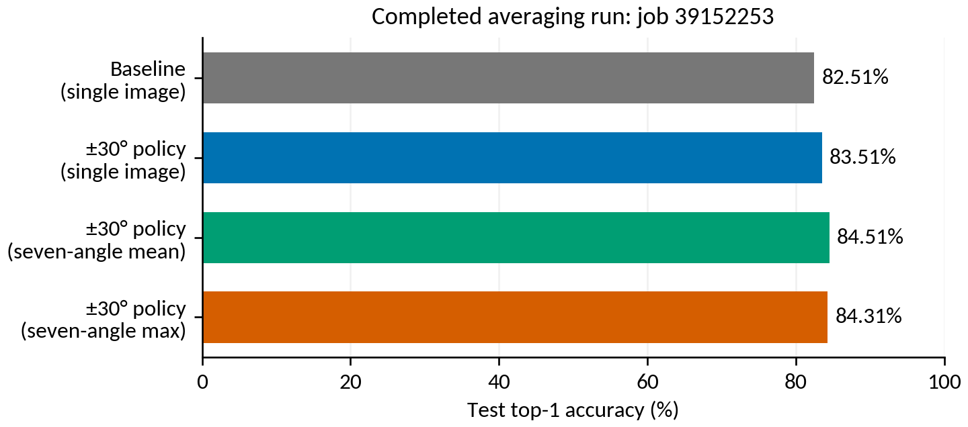
Figure 1. Completed averaging run: the baseline bar is single-image inference; the remaining bars use the same ±30° trained model.
Averaging evaluates saved weights; the loss curves elsewhere belong to the training runs. The newer ±45°/±60° averaging submission is job 39484294, whose results are not available here yet.
Completed averaging-job log (39152253)

All policies and pooling methods
Inference uses views at −30°, −20°, −10°, 0°, +10°, +20° and +30° for every model. Each view is scored with margin-free ArcFace logits followed by softmax. Mean averages class probabilities; max takes each class’s maximum view probability and renormalizes. Model weights are not averaged.

Test results: same 1,498 crops and 149 identities
Training policy | Single-image Top-1 | Mean TTA Top-1 | Max TTA Top-1 | Mean TTA macro-F1
Baseline | 82.51% | Not tested | Not tested | Not tested
±30° policy | 83.51% | 84.51% | 84.31% | 0.8284
±100° policy | 81.44% | 82.44% | 81.84% | 0.7999
±150° policy | 56.94% | 58.41% | 57.48% | 0.4636

The baseline was not evaluated with TTA. The combined two-point improvement therefore includes a training-policy change and an inference change. Mean versus max differs by only three test images for the ±30° model; that small difference should not be generalized from one run.

Validation results used for selection
Training policy | Single-image Top-1 | Mean TTA Top-1 | Max TTA Top-1
Baseline | 80.49% | Not tested | Not tested
±30° policy | 82.49% | 83.56% | 83.26%
±100° policy | 79.49% | 81.26% | 80.72%
±150° policy | 56.30% | 58.06% | 55.99%

Each model’s checkpoint was selected by its ordinary validation Top-1 during training. All nine model/pooling combinations were then compared on validation; ±30° + mean won at 83.56%. Test scoring followed that choice. Post-hoc logit adjustment was disabled (tau=0).

4. Loss curves: baseline and all policies
These are the actual logged losses, without smoothing. Both training and validation loss use cross-entropy on ArcFace logits with the training margin. Accuracy and final evaluation use margin-free logits. Loss magnitudes are therefore not the cross-entropy of the final reported probabilities. Checkpoints were chosen by validation accuracy, not minimum loss.
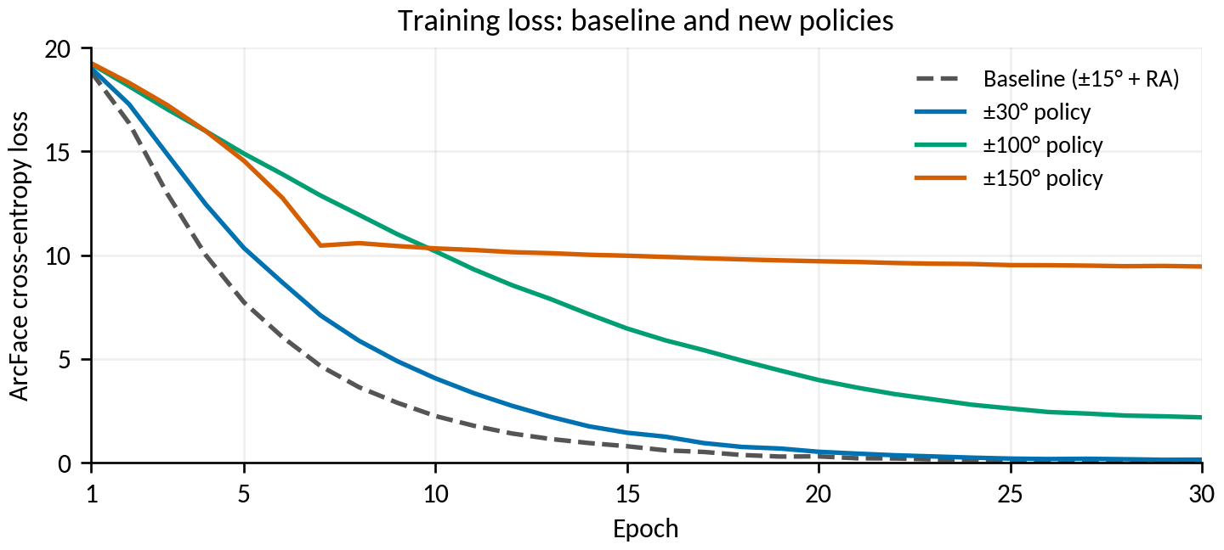
Figure 2. Training loss under the same 30-epoch budget; inputs differ by policy.
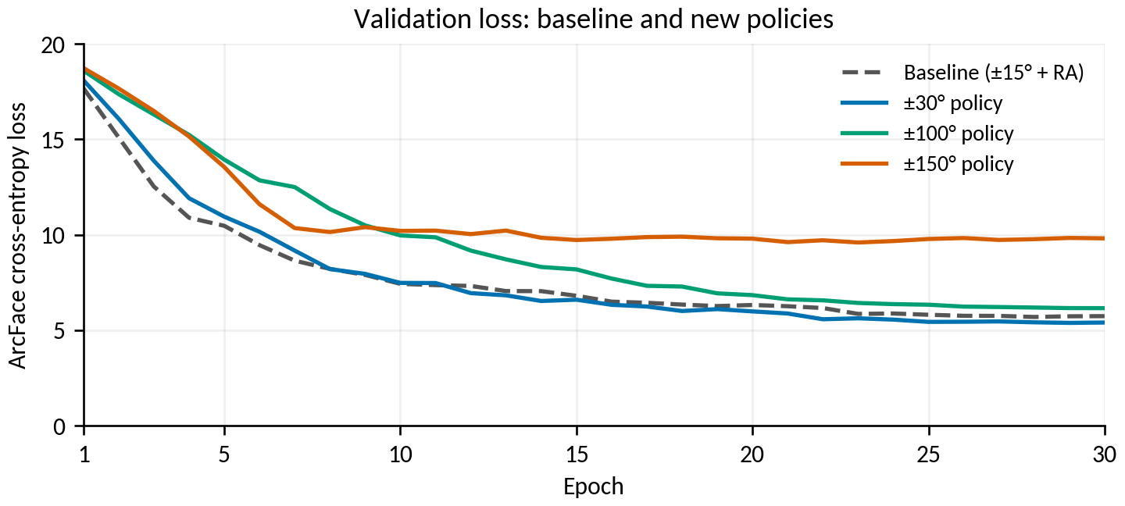
Figure 3. Validation loss on the common unaugmented validation split.

5. Loss curves for each new policy
Dotted grey is baseline validation loss. Vertical dashed lines mark the checkpoint chosen by validation Top-1. All three panels use the same loss range.
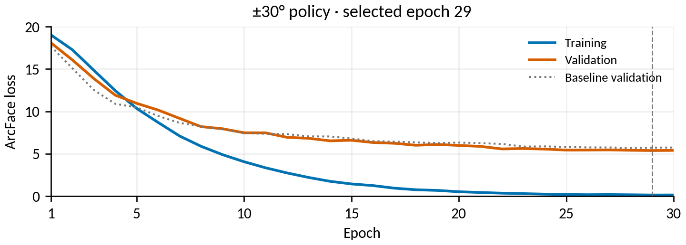
Figure 4. ±30° policy: training and validation loss; best epoch 29.
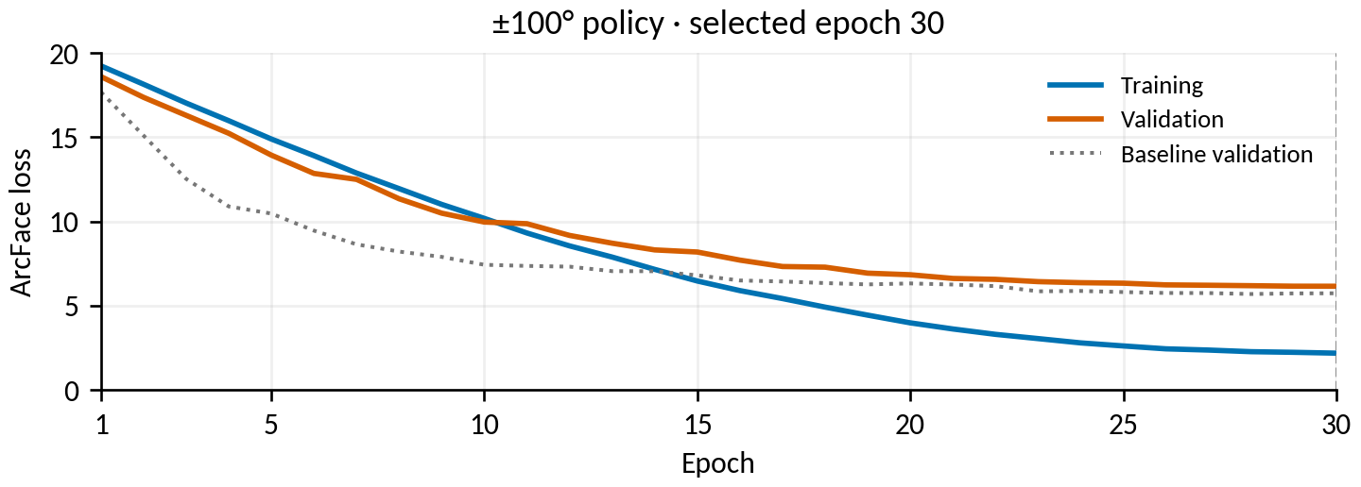
Figure 5. ±100° policy: training and validation loss; best epoch 30.
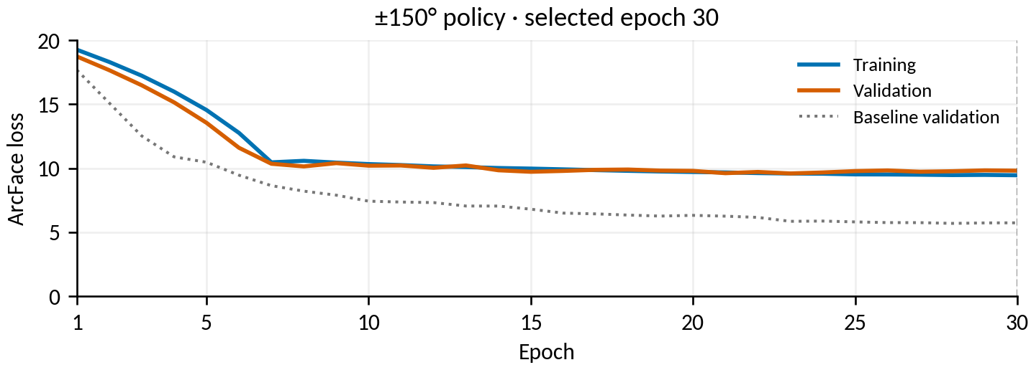
Figure 6. ±150° policy: training and validation loss; best epoch 30.

6. Learning behaviour and interpretation
Policy | Best epoch | Best validation Top-1 | Final training Top-1 | Final training loss
Baseline | 28 | 80.49% | 99.79% | 0.096
±30° policy | 29 | 82.49% | 99.82% | 0.153
±100° policy | 30 | 79.49% | 96.83% | 2.191
±150° policy | 30 | 56.30% | 59.29% | 9.456

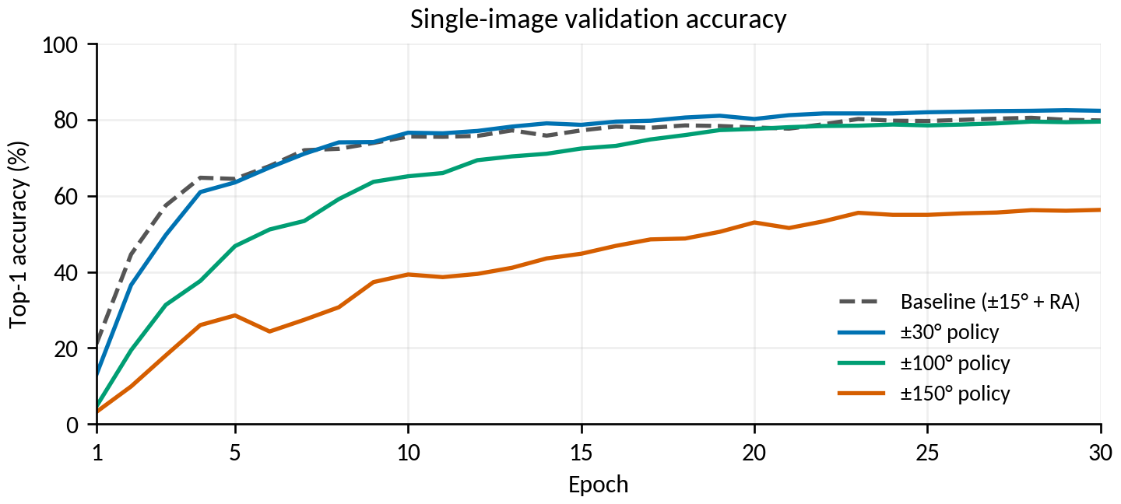
Figure 7. Margin-free single-image validation accuracy; TTA is scored after training.
- Moderate augmentation helped. The ±30° policy improved single-image validation and test scores. Its lower validation loss is consistent with the measured identification gain.
- The strongest policy struggled. The ±150° model finished at 59.29% accuracy on its augmented training batches and 56.30% validation accuracy. It was struggling with that training task at the chosen budget, rather than simply fitting it perfectly and failing to generalize.
- Mechanism remains an interpretation. Large rotations with zoom/translation can move useful facial regions out of the crop; blur, noise and erasing may obscure the remaining identity cues. Several factors changed together, so the experiment does not isolate a causal operation. Training accuracy also measures inputs of different difficulty across policies.

7. Per-class results and reproducibility
For the selected ±30° + mean model, macro precision is 84.54% and macro recall is 82.92%. Overall improvement does not imply that every individual improved. The five lowest-recall identities are shown below.
Identity | Test images | Recall / accuracy | F1
Caro | 3 | 0.00% | 0.0000
Racoon | 4 | 25.00% | 0.4000
Scarlet | 5 | 40.00% | 0.3333
Adele | 8 | 50.00% | 0.5714
Carole | 4 | 50.00% | 0.4444

The selected model fixes 67 baseline errors and introduces 37 errors where the baseline was correct, a net gain of 30 images. Low-support class scores remain coarse: for a class with four test images, one image changes recall by 25 percentage points.
Job | Task | Date completed | Wall time
38494871 | Baseline | 23 Oct 2026 | 24m 36s
39152252_0 | ±30° training | 26 Oct 2026 | 26m 12s
39152252_1 | ±100° training | 26 Oct 2026 | 12m 15s
39152252_2 | ±150° training | 26 Oct 2026 | 27m 54s
39152253 | TTA comparison | 28 Oct 2026 | 17m 55s

All jobs completed with exit code 0:0. Wall times include startup and I/O and are not a controlled compute-speed comparison. The 6,665 / 1,302 / 1,498 train/validation/test crops use the current 149-identity registry dated 14 October. Image-path and true-label pairs match across all test comparisons.
Full Markdown report, figures, interpretation and source links
All 18 validation/test comparisons (CSV)
Validation-only selection record (JSON)
Selected model per-class metrics (CSV)
Source curve data, hashes and job metadata (JSON)

8. Caveats and advice on further experiments
- One fit per policy. Measured gains are not confidence intervals or proof of repeated-run reliability. Repeat the most promising candidates across seeds before interpreting small differences as robust.
- The policies are bundled. Rotation, noise, blur, scale, translation and erasing changed together. The baseline also has a different crop/RandAugment pipeline. This comparison does not locate an optimal rotation limit.
- Baseline TTA is missing. The effect of applying the same seven-angle inference to the previous baseline is unknown. It would be a useful checkpoint-only comparison before committing to a large new training search.
- Fixed training budget. The experiment compares 30-epoch runs. Longer training could change a curve, but these data do not justify automatically increasing to 150 epochs.
- Historical reports differ. The earlier progress document includes 156-label and pre-cleanup results. Do not compare those raw rows directly with this 149-label evaluation without matching the image cohort and taxonomy.

Is a range between 30° and 100° worth testing?
Yes, as a small controlled follow-up. I would first consider ±45° and ±60°, with all other settings kept at the current ±30° policy: the same noise, blur, scale, translation, erasing, split, seed and 30-epoch budget. This would test rotation range directly. Keep ±30° as the reference and select on validation.
I would not start a broad sweep or assume that a value between 30° and 100° must win. If ±45°/±60° show a useful validation gain, repeat the strongest candidates across seeds; otherwise retain the simpler ±30° setting. All proposals in this section are advice only: no additional experiments, training trials or model evaluations were run or submitted for this report.

Reference and related reports
Previous progress report (formatting reference; historical results)
Current baseline report: 23 October 2026
Report index and folder layout
Torchvision 0.17 RandomAffine documentation
Torchvision 0.17.2 RandAugment implementation

