Macaque Face Re-Identification — Augmentation and Averaging
Augmentation and rotation averaging · 28 October 2026 · revised 30 October 2026

What I did (summary)
- Completed experiments. Five training policies completed 30 epochs each. The original averaging job produced 18 comparisons; the ±45°/±60° follow-up produced 12 more, using the same 149 identities and splits.
- Averaging runs completed. Jobs 39152253 and 39484294 completed successfully. The follow-up finished on 29 October at 13:53:14 GMT after 30m 12s.
- Best measured top-1. The validation-selected ±45° + mean follow-up reached 85.11% test top-1 and 83.74% macro F1, versus 84.51% and 82.84% for ±30° + mean. The previous baseline scored 82.51% and 80.27%.
- Fair comparison. All test comparisons cover the same 1,498 image/identity pairs. Model/pooling selection used validation results before the test comparison.
- Main finding. ±30° remains highest on single-image validation accuracy; ±30° and ±45° tie on single-image test accuracy. With averaging, ±45° scores highest on test top-1. One fit per policy does not establish repeated-seed reliability.

1. Headline results on the current test set
Configuration | Test top-1 | Test top-3 | Test top-5 | Macro F1 | Weighted F1
Original baseline | 82.51% | 88.65% | 89.85% | 80.27% | 82.39%
±30° single | 83.51% | 88.45% | 89.99% | 81.89% | 83.49%
±30° mean | 84.51% | 89.65% | 90.72% | 82.84% | 84.44%
±45° single | 83.51% | 88.92% | 90.52% | 81.67% | 83.33%
±45° mean (selected) | 85.11% | 89.92% | 91.32% | 83.74% | 84.97%

Original baseline is the previous model (affine ±15° plus RandAugment). ±45° single-image accuracy is 83.51%, a 1.00-point gain over baseline; seven-angle mean adds 1.60 points. The combined gain is 2.60 points: 1,275 instead of 1,236 correct images. Compared with ±30° + mean, the gain is 0.60 points or nine images. Macro F1 increases by 0.90 points over ±30° mean and 3.47 points over baseline.
These are measured results from individual fits. They do not establish repeated-seed reliability or statistical significance. The historical 156-label reports use an earlier label taxonomy; the comparison here uses 149 canonical identities throughout.

2. What changed from the baseline?
The previous strong profile explicitly used RandomAffine(degrees=15), sampling −15° to +15°. Restricted RandAugment then selected two operations at magnitude 5. In torchvision 0.17.2, a selected Rotate operation adds +5° or −5° and operations can repeat, so the total baseline rotation could exceed ±15°.
The original policies use one affine transformation and omit RandAugment, while also changing other settings. The ±45°/±60° follow-up changes only rotation relative to ±30°: scale, translation, noise, blur, erasing, split, seed and training budget match. Angle labels are training ranges, not fixed inference angles.

Geometry
Policy | Affine rotation | Scale | Translation
Baseline | ±15° + possible RA rotation | 0.90–1.10 | ±8%
±30° | −30° to +30° | 0.80–1.25 | ±10%
±45° | −45° to +45° | 0.80–1.25 | ±10%
±60° | −60° to +60° | 0.80–1.25 | ±10%
±100° | −100° to +100° | 0.70–1.35 | ±12%
±150° | −150° to +150° | 0.60–1.50 | ±15%

Noise, blur and occlusion
Policy | Noise: σ / probability | Blur: σ / probability | Erasing: probability / area
Baseline | No explicit Gaussian noise | 0.1–2.0 / 35% (5×5) | 30% / 2–12%
±30° | 0.03 / 35% | 0.2–2.0 / 40% (7×7) | 20% / 2–10%
±45° | 0.03 / 35% | 0.2–2.0 / 40% (7×7) | 20% / 2–10%
±60° | 0.03 / 35% | 0.2–2.0 / 40% (7×7) | 20% / 2–10%
±100° | 0.05 / 45% | 0.2–2.5 / 50% (7×7) | 25% / 2–12%
±150° | 0.08 / 50% | 0.3–3.0 / 60% (7×7) | 30% / 2–15%

Noise is applied to float images in [0,1] before normalization. The baseline also uses a random resized crop and RandAugment; the new policies resize to 224×224 and use explicit colour jitter. The baseline geometry row describes only its affine step. None of these six policies mirrors images horizontally.
Common training recipe: ImageNet-pretrained ResNet50, 256-dimensional embeddings, ArcFace margin 0.5 and scale 30, cross-entropy, batch size 32, AdamW with LR 3e-4 and weight decay 0.01, cosine schedule, seed 42, GPU/AMP, and 30 epochs without early stopping.

Meeting examples: original and augmented training images
Prepared for the meeting discussion requested by Majid. These are real training-set crops of Abby, Harry and Warty, alongside samples generated using the same augmentation code and saved configurations as the experiments.
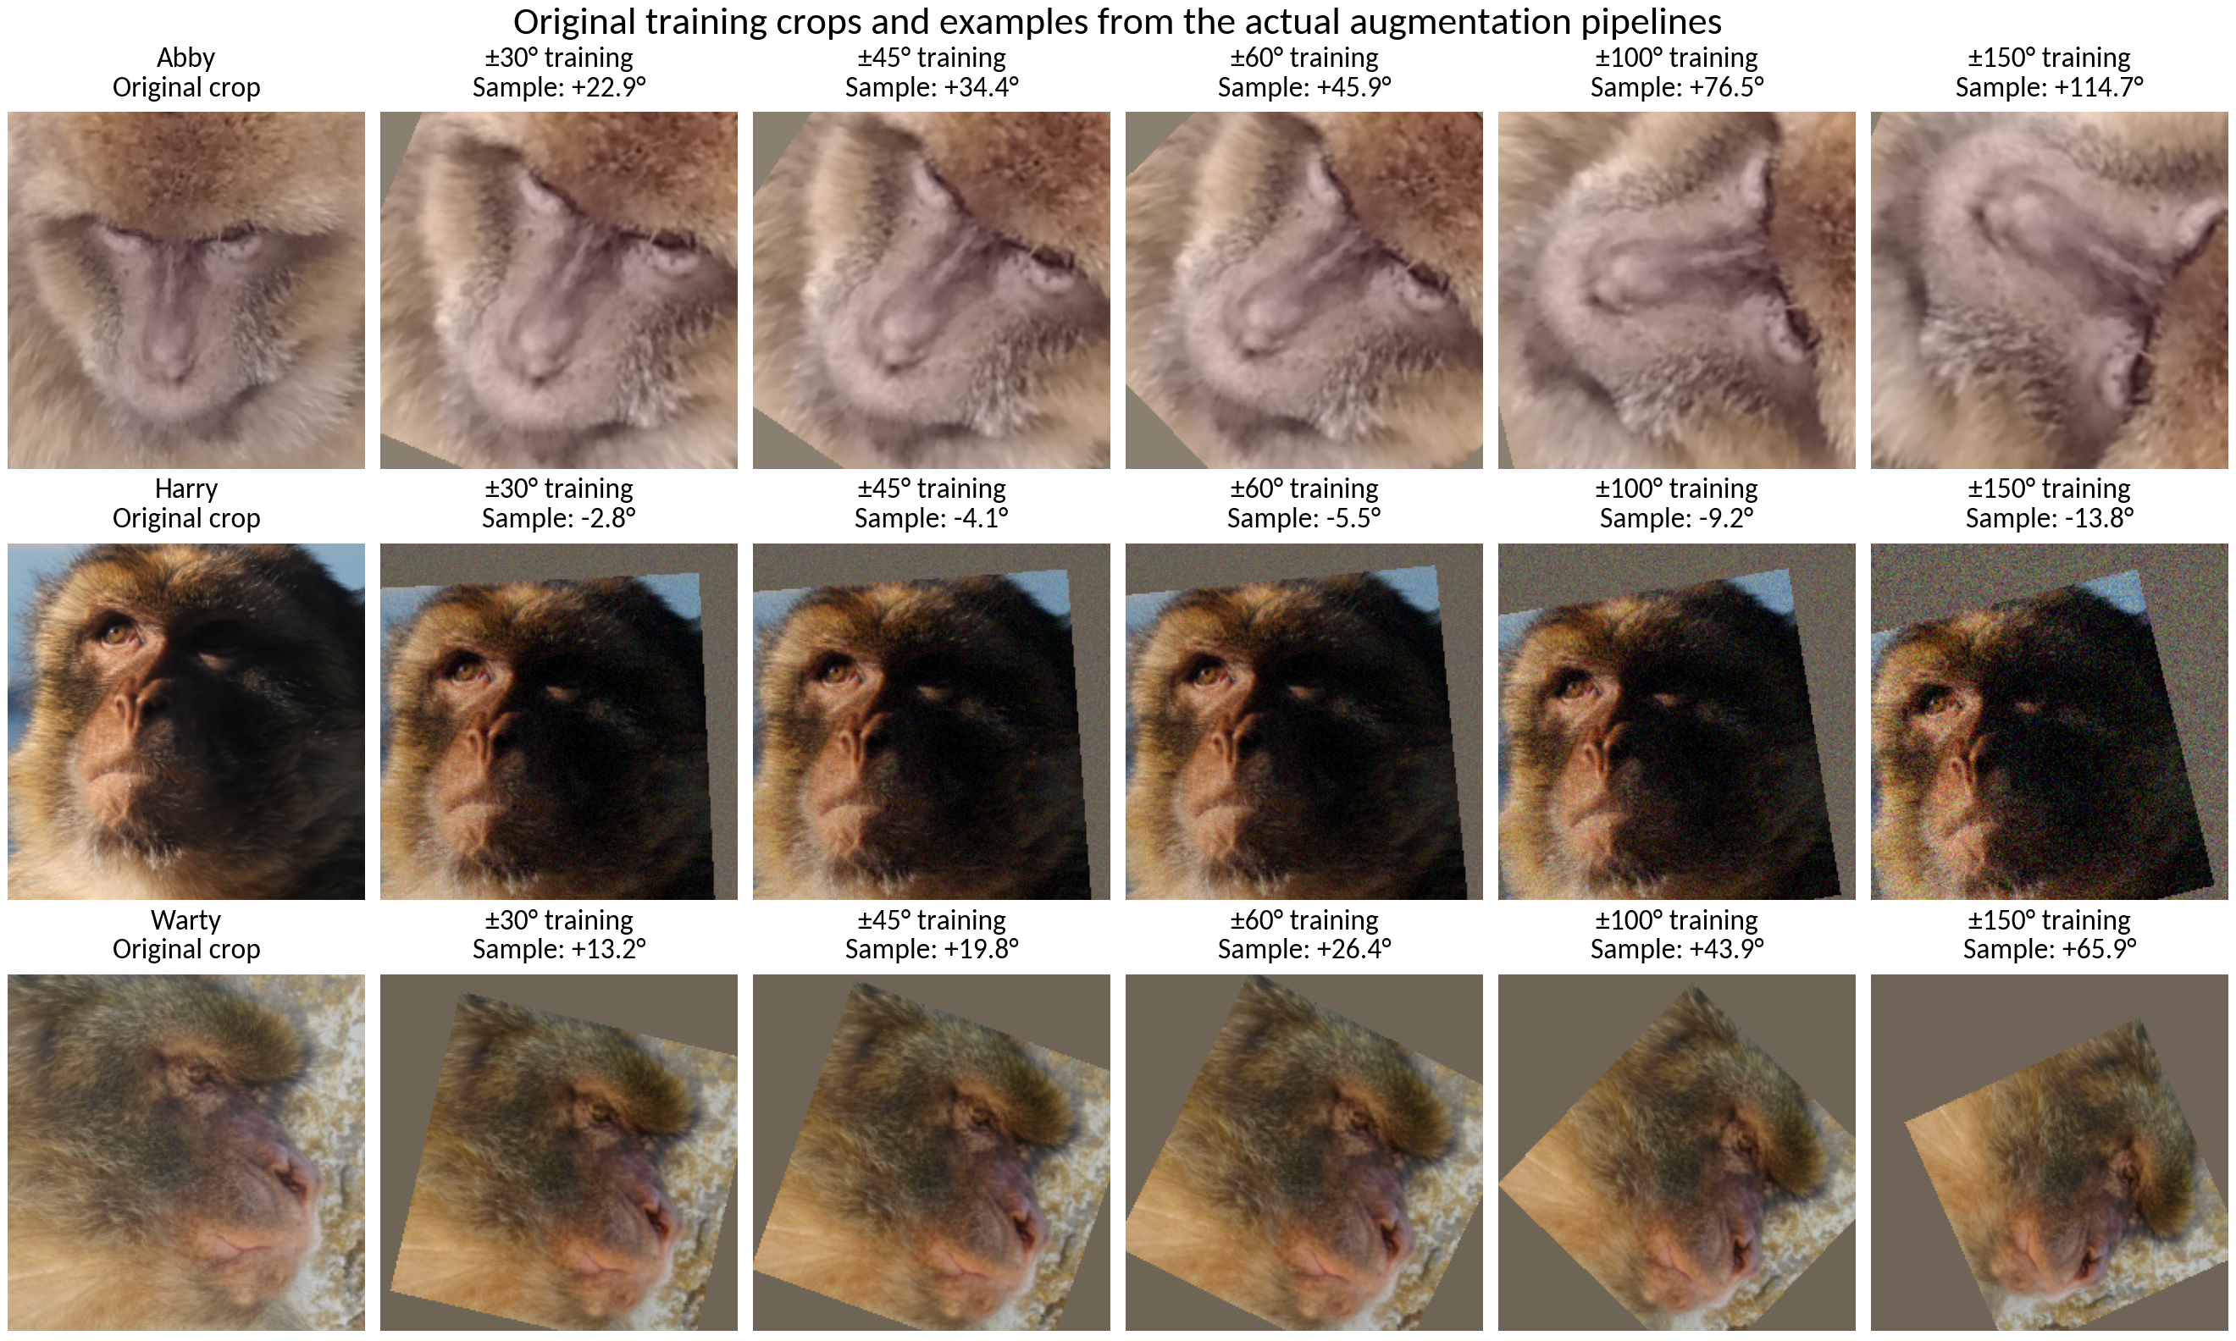
Figure 1. Original crops (left) and actual training-pipeline samples for ±30°, ±45°, ±60°, ±100° and ±150°. Labels show each configured rotation range and the sampled angle.
Each original crop is resized to 224×224 without augmentation for display. The other columns run the full training pipeline: affine rotation, zoom and translation, colour jitter, and probabilistic blur, noise and erasing. ±30°/±45°/±60° share all other settings; ±100°/±150° also change other augmentation strengths. The same seed is reset for each policy within a row: 42, 43 and 44.
These are newly generated illustrations, not recovered historical training batches. Normalization is reversed and values clipped to [0,1] for display. Grey borders and erased regions come from the pipeline. No horizontal mirroring is used. Originals are existing detection crops, not full camera photographs.
Full-size training sheet (PNG)
Training sheet for presenting or printing (PDF)

Meeting examples: the seven inference views used for averaging
The same Abby training crop demonstrates the deterministic inference transform. The original is shown as a reference; it is not an eighth view. The seven views include 0° exactly once.
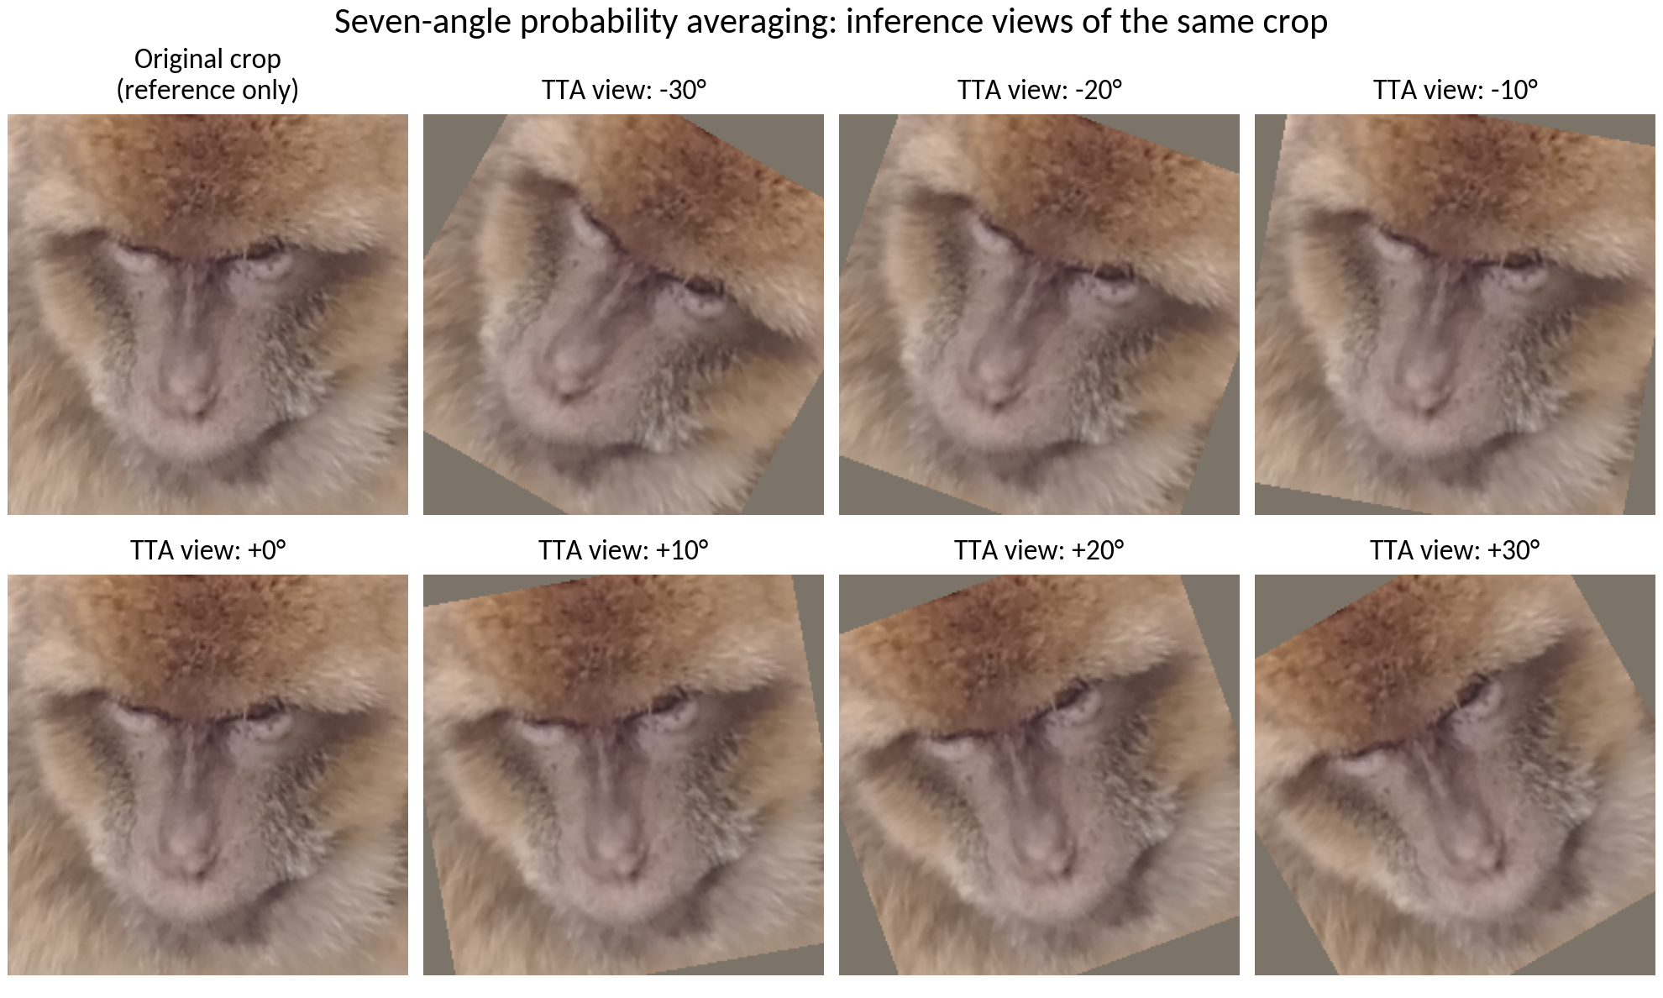
Figure 2. Reference original and the seven TTA views: −30°, −20°, −10°, 0°, +10°, +20° and +30°.
At inference, the saved model scores each rotated view and averages class probabilities. Pixels and model weights are not averaged. Unlike training augmentation, TTA adds no random colour jitter, noise, blur or erasing. These seven inference angles also apply to the models trained with ±45° and ±60° rotation ranges.
Full-size inference-view sheet (PNG)
Inference-view sheet for presenting or printing (PDF)
Example sources, hashes, seeds and sampled parameters (JSON)
Reproduction script and individual images

3. Averaging run results — job 39152253
Completed 28 October 2026 at 00:14:34 · elapsed 17m 55s · exit code 0:0. This job evaluated all three trained models using single-image prediction, seven-angle probability averaging and max pooling: 18 validation/test comparisons.
The results below compare the same ±30° model checkpoint (training epoch 29). Mean TTA is probability averaging across −30°, −20°, −10°, 0°, +10°, +20° and +30°. In the original suite, the model and averaging method were selected on validation before test scoring.
Scoring method | Validation Top-1 | Test Top-1 | Test Top-3 | Test Top-5 | Test macro-F1
Single image | 82.49% | 83.51% | 88.45% | 89.99% | 0.8189
Seven-angle mean | 83.56% | 84.51% | 89.65% | 90.72% | 0.8284
Seven-angle max | 83.26% | 84.31% | 89.45% | 90.65% | 0.8251
Averaging improves this model from 83.51% to 84.51% test accuracy (+1.00 percentage point), or 15 more correct test images: 1,266 instead of 1,251. Macro-F1 improves from 0.8189 to 0.8284. Max pooling scores 84.31%; mean is ahead by three images. Baseline TTA was not tested.
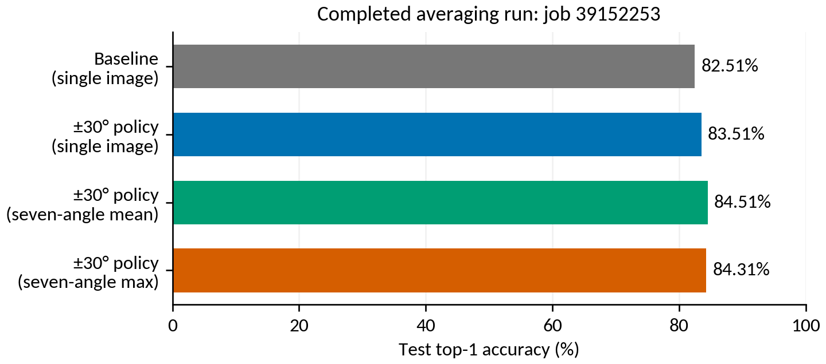
Figure 3. Completed averaging run: the baseline bar is single-image inference; the remaining bars use the same ±30° trained model.
Averaging evaluates saved weights; loss curves belong to training. The completed ±45°/±60° follow-up, job 39484294, is documented in the following section. The preceding ±30° results and Figure 3 describe the original suite.
Completed averaging-job log (39152253)

Follow-up averaging results — job 39484294
Revision: 29 October 2026. Completed at 13:53:14 GMT; start 13:23:02; elapsed 30m 12s; exit code 0:0. Two models × three scoring methods × validation/test produced 12 comparisons. The original report date remains 28 October.
Only the training rotation range changes relative to ±30°. All models use the same seven inference angles: −30°, −20°, −10°, 0°, +10°, +20°, +30°. Other augmentation settings, split, seed and 30-epoch budget match.
Training | Scoring | Validation top-1 | Test top-1 | Test macro F1 | Correct / 1,498
±45° | Single image | 82.10% | 83.51% | 81.67% | 1,251/1,498
±45° | Seven-angle mean | 83.56% | 85.11% | 83.74% | 1,275/1,498
±45° | Seven-angle max | 83.49% | 84.78% | 83.49% | 1,270/1,498
±60° | Single image | 82.18% | 83.11% | 81.20% | 1,245/1,498
±60° | Seven-angle mean | 83.41% | 84.98% | 83.37% | 1,273/1,498
±60° | Seven-angle max | 83.03% | 84.98% | 83.78% | 1,273/1,498
The follow-up selected ±45° + mean on validation before test scoring. Its 85.11% test top-1 is 24 images above its own single-image score and nine above ±30° mean. ±60° mean and max score 84.98% (1,273 images). ±60° max has slightly higher test macro F1, 83.78%, than ±45° mean (83.74%); this does not change the validation-based selection.
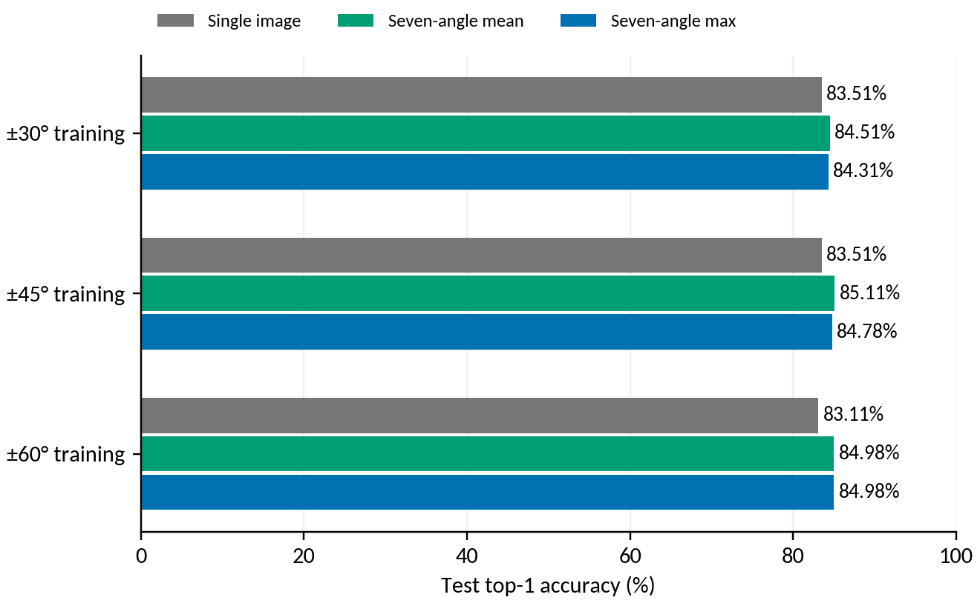
Figure 4. Test top-1 for ±30°, ±45° and ±60° training, using single-image inference and the same seven-angle mean/max methods.
Follow-up sources: comparison CSV · validation selection · job log

All policies and pooling methods
Inference uses views at −30°, −20°, −10°, 0°, +10°, +20° and +30° for every model. Each view is scored with margin-free ArcFace logits followed by softmax. Mean averages class probabilities; max takes each class’s maximum view probability and renormalizes. Model weights are not averaged.

Test results: same 1,498 crops and 149 identities
Training policy | Single-image Top-1 | Mean TTA Top-1 | Max TTA Top-1 | Mean TTA macro-F1
Baseline | 82.51% | Not tested | Not tested | Not tested
±30° policy | 83.51% | 84.51% | 84.31% | 82.84%
±45° policy | 83.51% | 85.11% | 84.78% | 83.74%
±60° policy | 83.11% | 84.98% | 84.98% | 83.37%
±100° policy | 81.44% | 82.44% | 81.84% | 79.99%
±150° policy | 56.94% | 58.41% | 57.48% | 46.36%

Baseline TTA was not evaluated. The combined 2.60-point improvement includes a training-policy change and an inference change. The ±45° mean result is nine test images ahead of ±30° mean; these small differences require repeated-seed confirmation.

Validation results used for selection
Training policy | Single-image Top-1 | Mean TTA Top-1 | Max TTA Top-1
Baseline | 80.49% | Not tested | Not tested
±30° policy | 82.49% | 83.56% | 83.26%
±45° policy | 82.10% | 83.56% | 83.49%
±60° policy | 82.18% | 83.41% | 83.03%
±100° policy | 79.49% | 81.26% | 80.72%
±150° policy | 56.30% | 58.06% | 55.99%

Each checkpoint was chosen by ordinary validation top-1 during training. Job 39152253 compared nine model/pooling combinations and selected ±30° mean; job 39484294 compared six and selected ±45° mean, before test scoring. Across suites, the mean methods tie at 1,088/1,302 validation images (83.56%). ±45° has higher validation macro F1 (80.11% versus 79.82%), consistent with the recorded tie-break rule. Logit adjustment was disabled (tau=0).

4. Loss curves: baseline and the original three policies
These are the actual logged losses, without smoothing. Both training and validation loss use cross-entropy on ArcFace logits with the training margin. Accuracy and final evaluation use margin-free logits. Loss magnitudes are therefore not the cross-entropy of the final reported probabilities. Checkpoints were chosen by validation accuracy, not minimum loss. The overview figures cover the baseline and the original ±30°/±100°/±150° runs; the per-policy section now also includes all 30 epochs for ±45° and ±60° on the same loss scale.
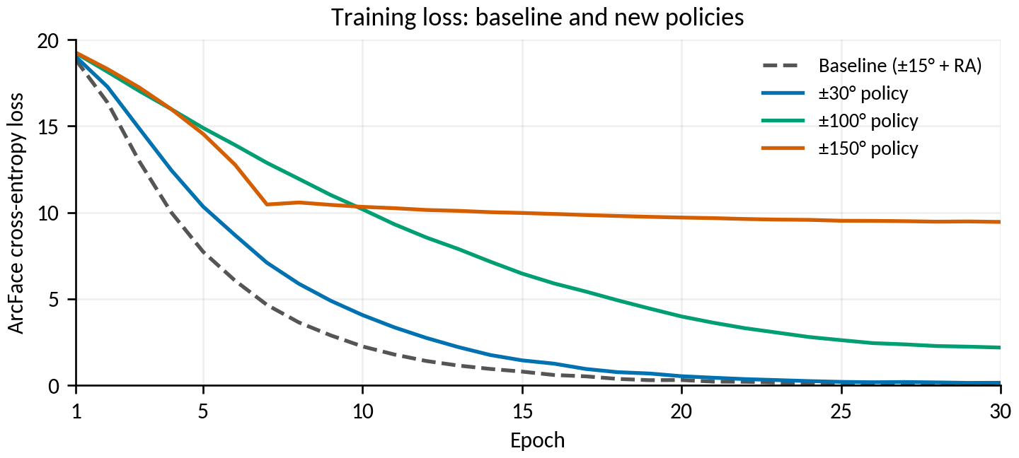
Figure 5. Training loss under the same 30-epoch budget; inputs differ by policy.
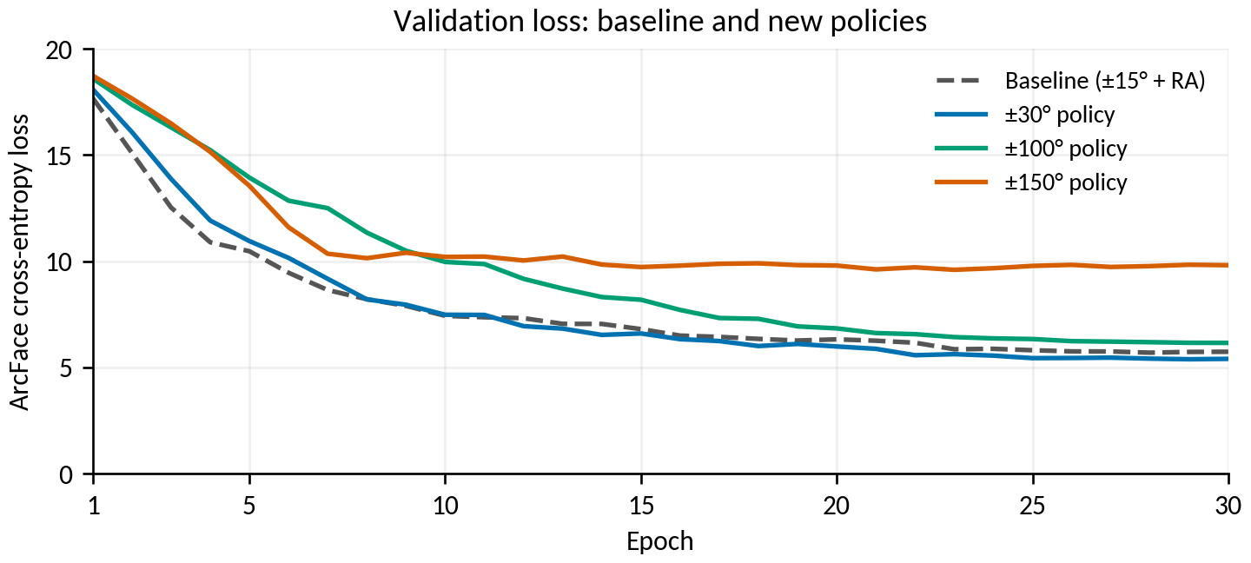
Figure 6. Validation loss on the common unaugmented validation split.

5. Loss curves for each policy
Dotted grey is baseline validation loss. Vertical dashed lines mark the checkpoint chosen by validation top-1. All five per-policy panels use the same 0–20 loss range; the ±45°/±60° follow-up appears on the next page.
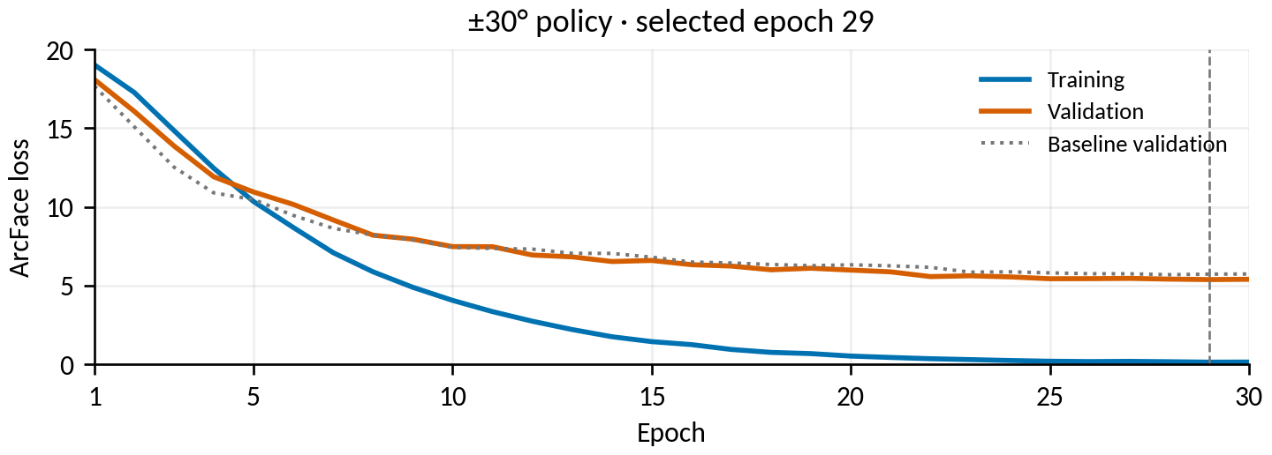
Figure 7. ±30° policy: training and validation loss; best epoch 29.
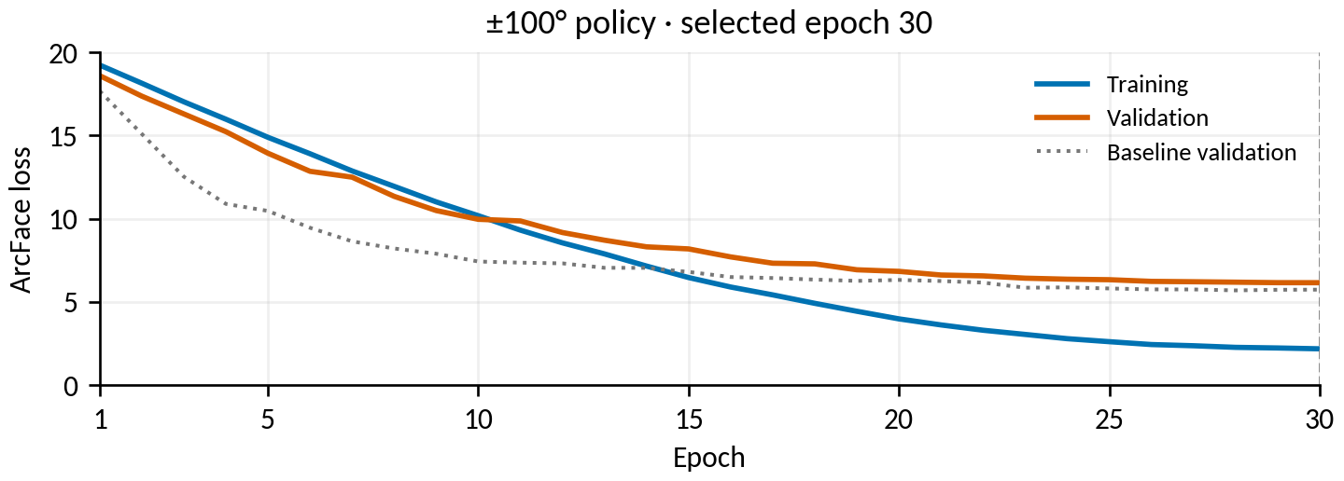
Figure 8. ±100° policy: training and validation loss; best epoch 30.
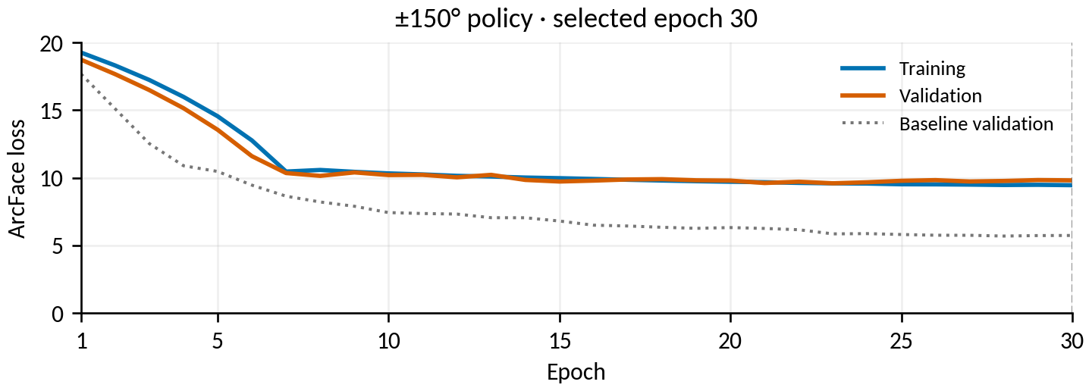
Figure 9. ±150° policy: training and validation loss; best epoch 30.

Loss curves for the ±45° and ±60° follow-up
Added 30 October 2026. All 30 full-precision epoch records from each training CSV were checked against stdout. Blue: training; orange: validation; dotted grey: original baseline validation. Both panels retain the common 0–20 loss scale.
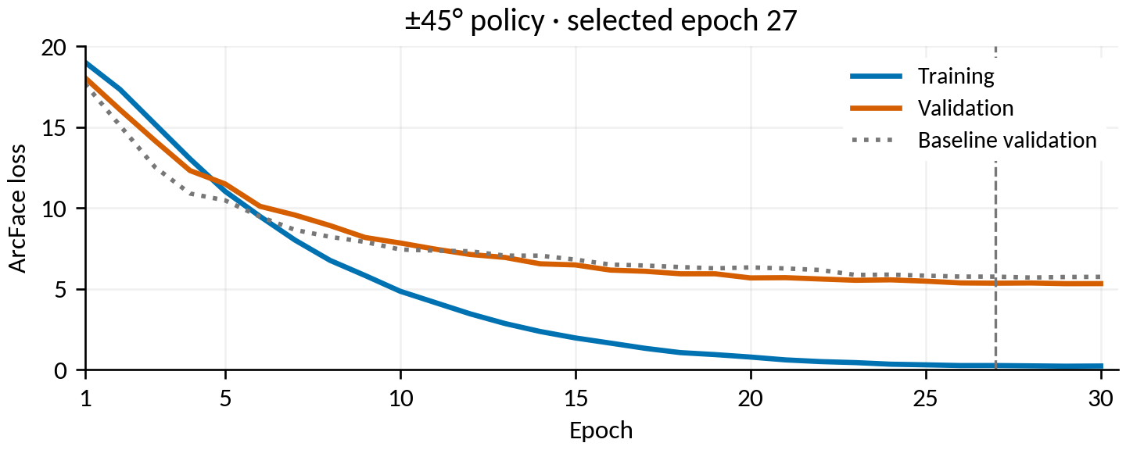
Figure 10. ±45° policy: training and validation loss; selected epoch 27.
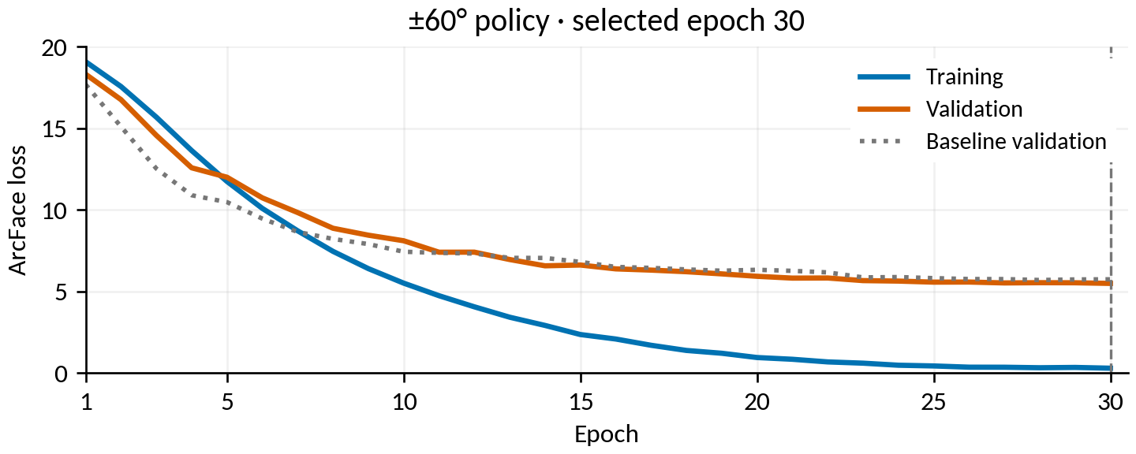
Figure 11. ±60° policy: training and validation loss; selected epoch 30.
Dashed markers use the best ordinary validation top-1, not minimum loss: epoch 27 for ±45° and 30 for ±60°. Final train/validation loss is 0.2350 / 5.3246 and 0.2986 / 5.4917, respectively. Loss uses margin-adjusted logits; averaging does not produce a separate training curve.
Sources: ±45° epoch CSV · ±60° epoch CSV · curve data and hashes
Full-size exports: ±45° PDF · ±60° PDF · both panels PDF

6. Learning behaviour and interpretation
Policy | Best epoch | Best validation Top-1 | Final training Top-1 | Final training loss
Baseline | 28 | 80.49% | 99.79% | 0.096
±30° policy | 29 | 82.49% | 99.82% | 0.153
±45° policy | 27 | 82.10% | 99.61% | 0.235
±60° policy | 30 | 82.18% | 99.70% | 0.299
±100° policy | 30 | 79.49% | 96.83% | 2.191
±150° policy | 30 | 56.30% | 59.29% | 9.456

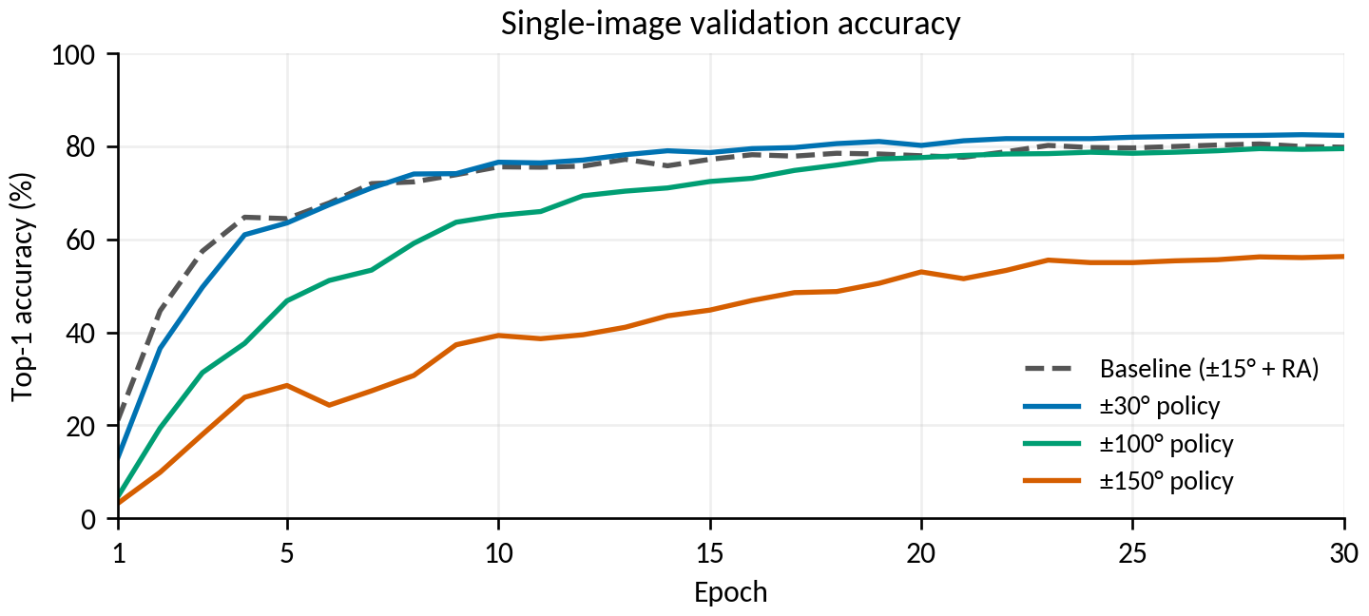
Figure 12. Margin-free single-image validation accuracy; TTA is scored after training.
- Moderate augmentation and averaging helped. ±30° has the highest single-image validation score (82.49%); ±30° and ±45° tie at 83.51% on the test set. Averaging gives ±45° the highest measured test top-1, 85.11%, versus 84.51% for ±30° mean.
- The strongest policy struggled. The ±150° model finished at 59.29% accuracy on its augmented training batches and 56.30% validation accuracy. It was struggling with that training task at the chosen budget, rather than simply fitting it perfectly and failing to generalize.
- Mechanism remains an interpretation. The original policies vary several augmentation settings. The ±30°/±45°/±60° follow-up holds those settings fixed apart from rotation, but one fit per angle cannot establish a robust optimal range. Large transformations may remove identity cues; that mechanism was not separately measured.

7. Per-class results and reproducibility
For the selected ±45° + mean follow-up, test macro precision is 85.15% and macro recall is 84.09%. Overall improvement does not imply that every individual improved. The five lowest-recall identities are shown below.
Identity | Test images | Recall / accuracy | F1
Caro | 3 | 0.00% | 0.00%
Thief | 3 | 33.33% | 50.00%
Harry | 7 | 42.86% | 54.55%
Racoon | 4 | 50.00% | 66.67%
Nathalie | 9 | 55.56% | 62.50%

The selected follow-up fixes 72 baseline errors and introduces 33 errors where the baseline was correct: a net gain of 39 images. It correctly identifies 1,275/1,498 test images. Caro remains at zero recall. Low-support class scores are coarse: one image changes recall by 25 points for a class with four images.
Job | Task | Date completed | Wall time
38494871 | Baseline | 23 Oct 2026 | 24m 36s
39152252_0 | ±30° training | 26 Oct 2026 | 26m 12s
39152252_1 | ±100° training | 26 Oct 2026 | 12m 15s
39152252_2 | ±150° training | 26 Oct 2026 | 27m 54s
39152253 | TTA comparison | 28 Oct 2026 | 17m 55s
39484293_0 | ±45° training | 28 Oct 2026 | 26m 24s
39484293_1 | ±60° training | 28 Oct 2026 | 26m 24s
39484294 | ±45°/±60° TTA | 29 Oct 2026 | 30m 12s

All jobs completed with exit code 0:0. Wall times include startup and I/O and are not a controlled compute-speed comparison. The 6,665 / 1,302 / 1,498 train/validation/test crops use the current 149-identity registry dated 14 October. Image-path and true-label pairs match across all test comparisons. Both saved split/registry SHA-256 pairs match. There are 30 validation/test comparisons across the two suites, and all 15 non-baseline test prediction files were checked against the baseline image/identity pairs.
Full Markdown report, figures, interpretation and source links
Original suite: 18 validation/test comparisons (CSV)
Original suite: validation-only selection record (JSON)
Selected ±45° + mean per-class metrics (CSV)
Source curve data, hashes and job metadata (JSON)

8. Caveats and advice on further experiments
- One fit per policy. Measured gains are not confidence intervals or proof of repeated-run reliability. Repeat the most promising candidates across seeds before interpreting small differences as robust.
- Rotation follow-up controlled. The original policies bundle several changes, while ±45°/±60° vary rotation only relative to ±30°. The remaining settings, split, seed and 30-epoch budget match. Single fits and small differences do not locate a robust optimal angle.
- Baseline TTA is missing. The effect of applying the same seven-angle inference to the previous baseline is unknown. It would be a useful checkpoint-only comparison before committing to a large new training search.
- Fixed training budget. The experiment compares 30-epoch runs. Longer training could change a curve, but these data do not justify automatically increasing to 150 epochs.
- Historical reports differ. The earlier progress document includes 156-label and pre-cleanup results. Do not compare those raw rows directly with this 149-label evaluation without matching the image cohort and taxonomy.

Completed rotation-only follow-up: ±45° and ±60°
The proposed follow-up is complete. Both models trained on 28 October; their averaging evaluation finished on 29 October. ±45° + mean ties ±30° + mean on validation top-1 and has higher validation macro F1. Its measured test gain is 0.60 points (nine images). ±60° mean and max both score 84.98% test top-1.
Repeat the strongest candidates across seeds before treating this ranking as robust. Baseline TTA remains unevaluated. The selected follow-up checkpoint is artifacts/augmentation_sweeps/20261028T164412Z_JmVXbV/checkpoints/macaque-resnet50-arcface_aggressive_rot45_canonical_20261014_best.pt. This documentation revision launches no additional training or evaluation jobs.

Reference and related reports
Previous progress report (formatting reference; historical results)
Current baseline report: 23 October 2026
Report index and folder layout
Torchvision 0.17 RandomAffine documentation
Torchvision 0.17.2 RandAugment implementation

