Macaque Face Re-Identification — Progress Report
CS update for Tilo & Majid · July 2026

What I did (summary)
- Evaluation fix. Found and fixed a bug in the evaluation code that was under-reporting accuracy by ~15 points; verified the correction two independent ways.
- Training fix. Fixed the same issue in the training-time validation metric and re-ran training on GPU under a consistent, faster setup.
- Ablations. Ran controlled ablations (stronger augmentation; class-balanced long-tail loss). None gave a measurable improvement — differences are within run-to-run noise.
- Long-tail analysis. After the fix, the apparent long-tail problem largely disappears; instead the analysis surfaced a data-quality question (individuals split across multiple labels).

1. Evaluation fix (the headline)
The ArcFace head subtracts an angular margin from the true class during training to force better separation — a training-only term that requires the ground-truth label. The evaluation code was applying that margin at test time as well, penalising the correct class and deflating every metric. Scoring the same checkpoints correctly (plain cosine similarity, no margin) raises Top-1 from 0.68 to 0.83, with no retraining. Verified by an independent from-scratch cosine recompute and a gallery k-NN check (both ≈0.83).
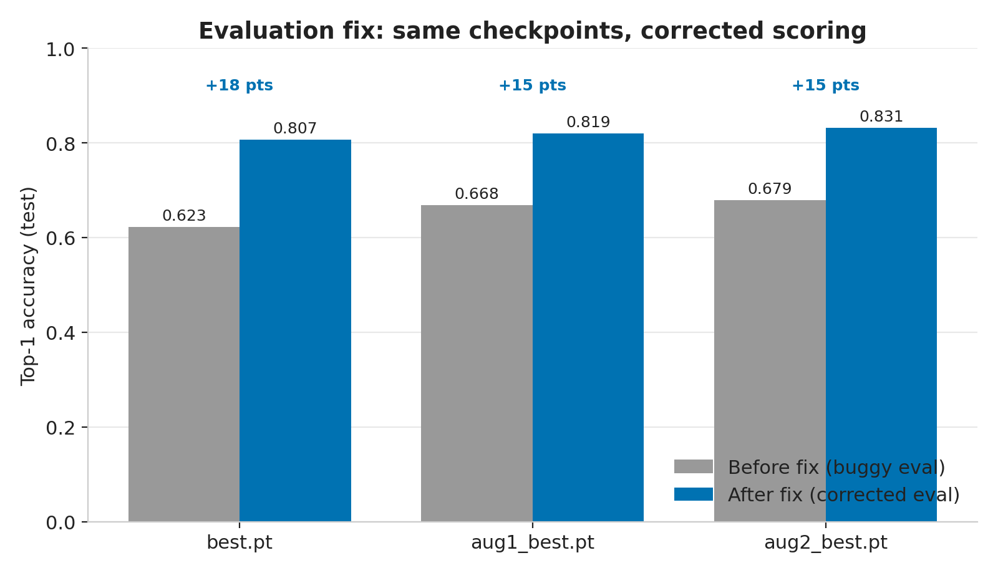
Figure 1. Same checkpoints, re-scored without the test-time margin: +15–18 points.
Checkpoint | Top-1 (before) | Top-1 (after) | Macro-F1 (before) | Macro-F1 (after)
best.pt | 0.6225 | 0.8068 | 0.5822 | 0.7891
aug1_best.pt | 0.6679 | 0.8194 | 0.6351 | 0.8091
aug2_best.pt | 0.6793 | 0.8314 | 0.6324 | 0.8196

2. Ablations: augmentation and long-tail loss (no measurable effect)
I ran matched GPU experiments changing one variable at a time: stronger augmentation (RandAugment, no horizontal flip, blur, larger rotation/shift/occlusion) and a class-balanced “long-tail” loss. All recent runs land within 0.818–0.820, while simply re-running an identical recipe (aug2 → aug2_gpu) moved 1.2 points. The run-to-run variation is ~10× larger than any measured effect. On a 1584-image test set the standard error is ≈0.9%, so single-seed differences below ~2% cannot be resolved.
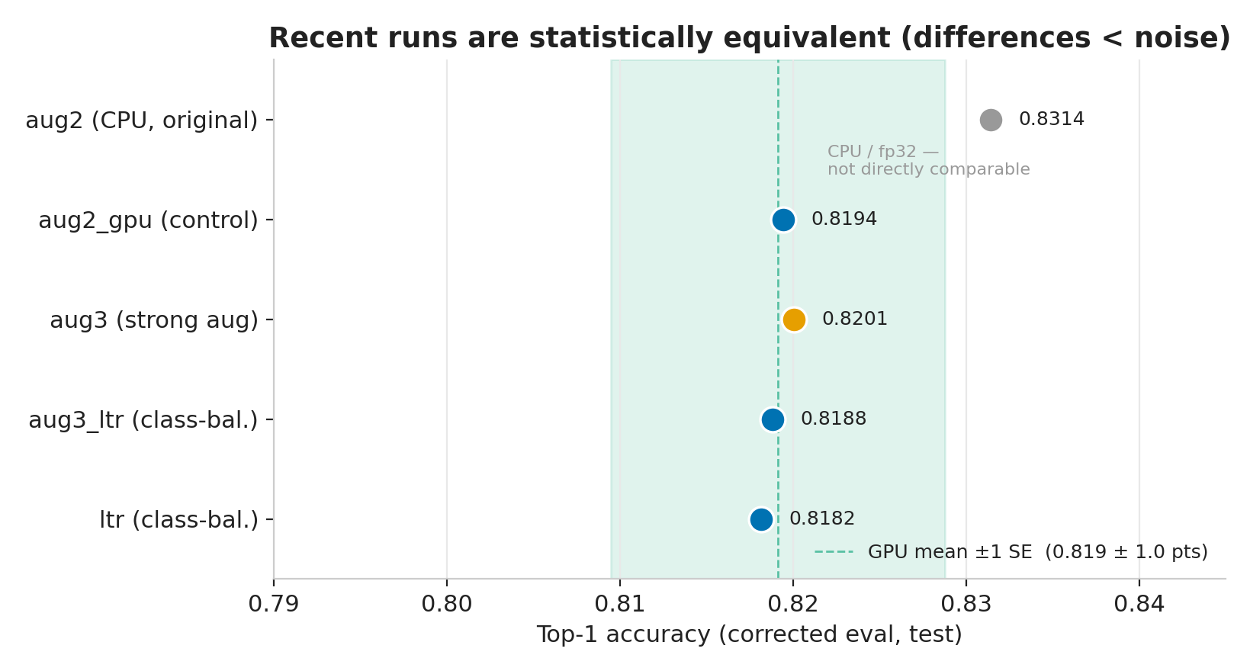
Figure 2. All recent GPU runs fall inside the noise band; the CPU run differs only by hardware.
Comparison | Variable changed | Top-1 | Verdict
aug2_gpu vs aug3 | basic → strong aug (no flip) | 0.8194 → 0.8201 | No effect
aug3 vs aug3_ltr | plain CE → class-balanced loss | 0.8201 → 0.8188 | No effect
aug2 vs aug2_gpu | same recipe, re-run (CPU→GPU) | 0.8314 → 0.8194 | Run-to-run noise

3. Long-tail analysis
After the eval fix, the gap between well- and poorly-represented individuals shrank from 0.28 to 0.03, and the “7 individuals at 0% accuracy” turned out to be entirely an artefact of the bug (now 0).
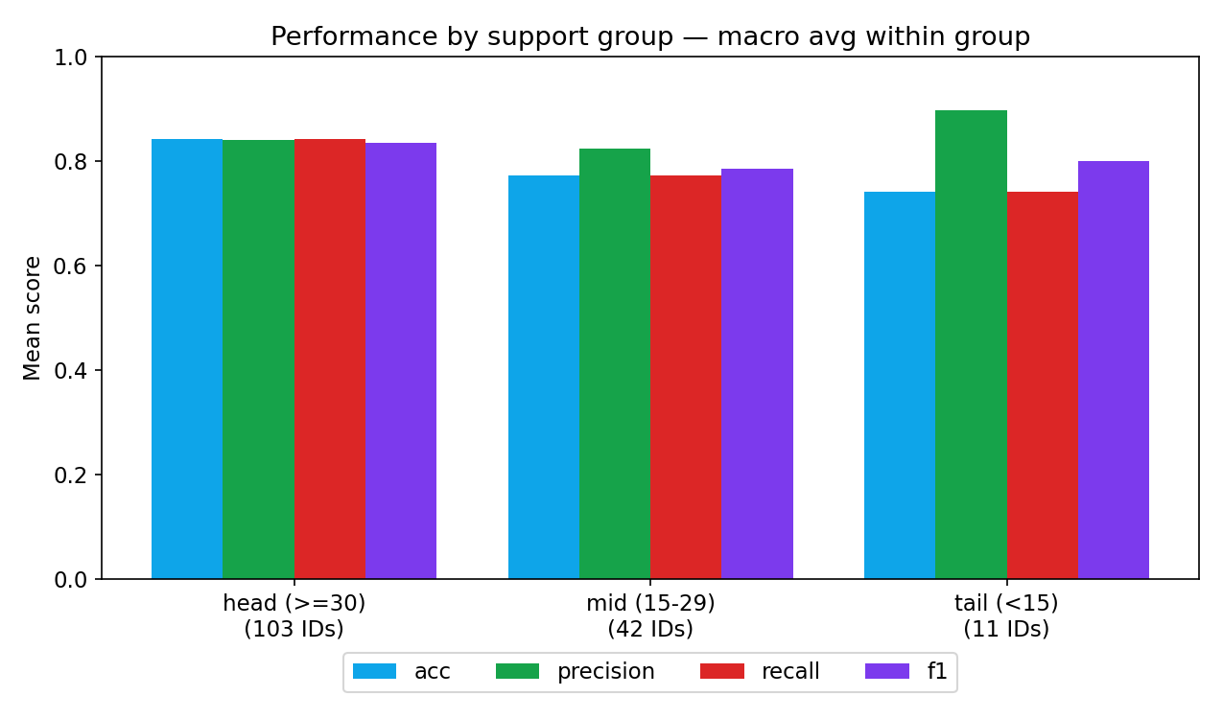
Figure 3. Head / mid / tail performance (corrected eval). Head–tail F1 gap is only 0.03.
Group | #IDs | Mean train imgs | Accuracy | Precision | Recall | F1
head (≥30) | 103 | 53.9 | 0.84 | 0.84 | 0.84 | 0.84
mid (15–29) | 42 | 22.7 | 0.77 | 0.82 | 0.77 | 0.79
tail (<15) | 11 | 9.5 | 0.74 | 0.90 | 0.74 | 0.80

Training-image count explains only ~4% of the variance in per-class accuracy (r = 0.20) — i.e. simply collecting more images of rare individuals is unlikely to help much.
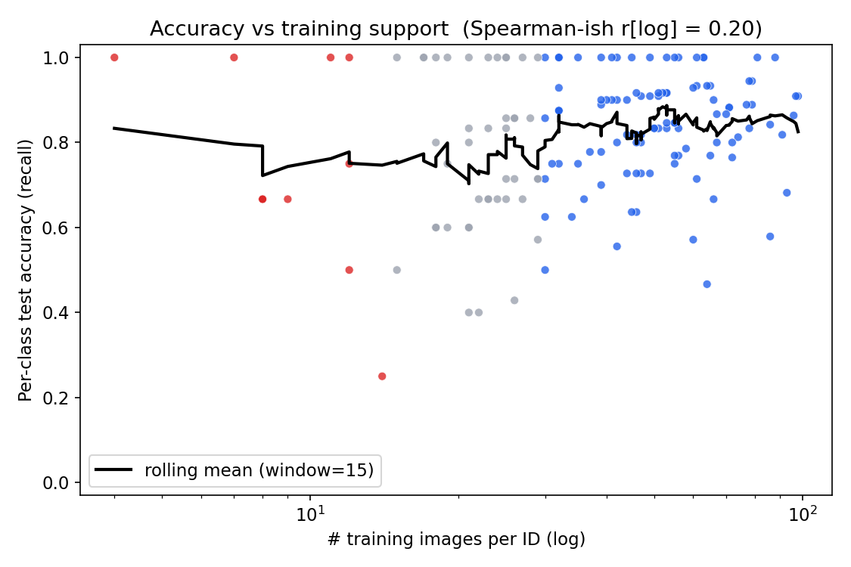
Figure 4. Per-class accuracy vs training-set size: weak relationship (r = 0.20).

Open question (needs your steer)
Several IDs appear to be the same animal split across multiple labels by life event or season — e.g. ‘Tack before emigrating’ / ‘Tack after move to CC’ / ‘Tack temporary’, and various ‘W22-23’ suffixes. If these are the same individuals, the model is being asked to tell an animal apart from itself. Merging them would reduce the class count and may improve accuracy. I will confirm the biology side separately, but wanted your view on how to handle it.

4. Full corrected results (all runs)
All rows use the corrected (no-margin) evaluation on the same 1584-image test split.
Checkpoint | Recipe | HW | Top-1 | Top-3 | Top-5 | Macro-F1 | Macro-P | Macro-R
best.pt | basic aug, CE | CPU | 0.8068 | 0.8718 | 0.8889 | 0.7891 | 0.8106 | 0.7867
aug1_best.pt | basic aug, CE | CPU | 0.8194 | 0.8826 | 0.8958 | 0.8091 | 0.8351 | 0.8038
aug2_best.pt | basic aug, CE | CPU | 0.8314 | 0.8807 | 0.9034 | 0.8196 | 0.8405 | 0.8161
aug2_gpu_best.pt | basic aug, CE | GPU | 0.8194 | 0.8807 | 0.9003 | 0.8046 | 0.8340 | 0.7992
aug3_best.pt | strong aug (no flip), CE | GPU | 0.8201 | 0.8744 | 0.8908 | 0.8010 | 0.8183 | 0.8001
aug3_ltr_best.pt | strong aug, class-balanced | GPU | 0.8188 | 0.8801 | 0.8958 | 0.8044 | 0.8371 | 0.7983
ltr_best.pt | strong aug, class-balanced | GPU | 0.8182 | 0.8737 | 0.8914 | 0.8028 | 0.8309 | 0.7970

5. Notes, caveats & next steps
- The 0.831 for aug2_best is a real measured checkpoint, but re-running the identical recipe gave 0.819 — so ~0.82–0.83 is the honest expected range rather than 0.831 being reproducible.
- Per-class metrics for rare individuals are coarse (2–4 test images each): one image shifts a class by 25–50 points, so individual tail rows are noisy.
- The test split is in-distribution (same source/curation as training). Real-world field photos will score lower; a dedicated out-of-distribution test set would be needed to measure that.
- Suggested next steps: (a) resolve the duplicate-identity labels; (b) build a small out-of-distribution test set to properly evaluate augmentation for field use; (c) if sub-2% effects matter, run multiple seeds per configuration to get error bars.

