Macaque Face Re-Identification — Baseline Evaluation
Evaluation: 23 October 2026 · Report prepared 28 October 2026

What I did (summary)
- Completed baseline retraining. Job 38494871 trained all 30 epochs and completed evaluation successfully in 24m 36s. The best checkpoint was selected at epoch 28.
- Current dataset. The evaluation uses 149 canonical identities and 1,498 test crops, with 6,665 training and 1,302 validation images. These are the reference scores for the later augmentation comparison.
- Measured result. Test Top-1 is 82.51% and macro-F1 is 0.8027. The best validation Top-1 is 80.49%. No test-time rotation averaging was used for this baseline.

1. Overall evaluation metrics
Metric | Baseline result
Test Top-1 | 82.51%
Test Top-3 | 88.65%
Test Top-5 | 89.85%
Macro-F1 | 0.8027
Macro precision | 82.46%
Macro recall | 80.42%
Weighted F1 | 0.8239
Best validation Top-1 / epoch | 80.49% / 28

The model is pretrained ResNet50 with 256-dimensional ArcFace embeddings (margin 0.5, scale 30). Training uses cross-entropy, AdamW at LR 3e-4, weight decay 0.01, cosine scheduling, batch size 32, seed 42 and GPU/AMP. The evaluation scores margin-free logits, with logit adjustment disabled.
Rotation before the new experiments: explicit affine rotation −15° to +15°, followed by restricted RandAugment with two magnitude-5 operations. Each selected Rotate adds +5° or −5° in torchvision 0.17.2, so the total is not strictly bounded at ±15°. The strong profile also uses random resized crops, blur and erasing, without horizontal mirroring.

2. Logged loss and accuracy curves
The figures use the 30 actual logged epochs without smoothing. Both loss curves use margin-adjusted ArcFace logits; accuracy uses margin-free logits. The vertical line marks epoch 28, selected by validation Top-1 rather than minimum loss.
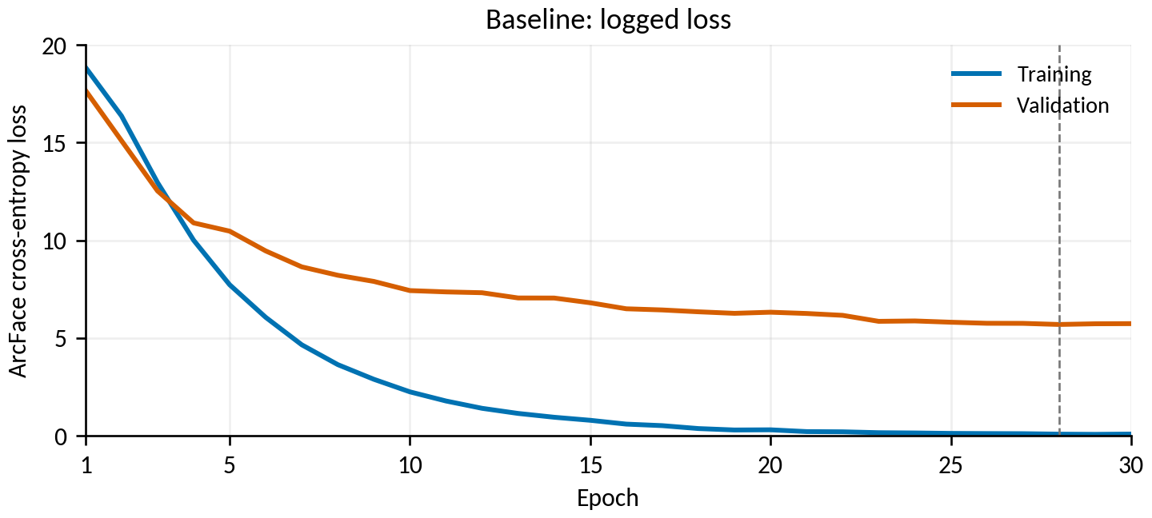
Figure 1. Baseline training and validation cross-entropy on ArcFace margin logits.
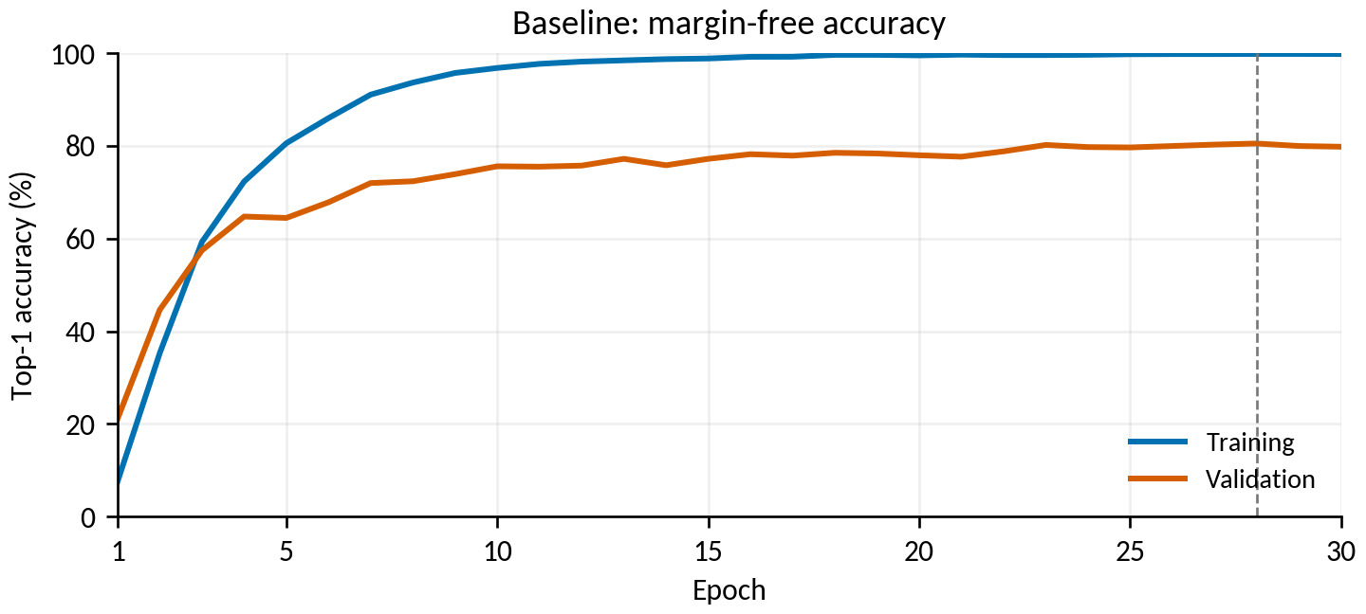
Figure 2. Baseline margin-free training and validation Top-1 accuracy.

3. Per-class results, caveats and evidence
Identity | Test images | Recall / accuracy | F1
Racoon | 4 | 0.00% | 0.0000
Brookes | 5 | 20.00% | 0.3333
Caro | 3 | 33.33% | 0.4000
Leigh | 3 | 33.33% | 0.3333
SAM to be named | 3 | 33.33% | 0.4000

Rare identities have few test images, so individual errors can make large changes in their reported recall. This single fit is a baseline measurement, not an estimate of run-to-run variability or performance on an independently collected field dataset. Earlier 156-label results are historical and should not be substituted for this 149-label baseline.
The original evaluation timestamp is 23 October 2026 at 13:15:10 (as logged). This dated Word version preserves those metrics; preparing it on 28 October does not represent a new evaluation. The later augmentation report evaluates the same 1,498 image/identity pairs.
Baseline Markdown report
Baseline metrics summary (JSON)
Baseline per-class results (CSV)
Baseline 30-epoch training metrics (CSV)
Later augmentation and averaging report: 28 October 2026
Report index

