Macaque Face Re-Identification — Progress Report
CS update for Tilo & Majid · July 2026 · Updated 8 October 2026

What I did (summary)
- Evaluation fix. Found and fixed a bug in the evaluation code that was under-reporting accuracy by ~15 points; verified the correction two independent ways.
- Training fix. Fixed the same issue in the training-time validation metric and re-ran training on GPU under a consistent, faster setup.
- Ablations. Ran controlled ablations (stronger augmentation; class-balanced long-tail loss). None gave a measurable improvement — differences are within run-to-run noise.
- Long-tail analysis. After the fix, the apparent long-tail problem largely disappears; instead the analysis surfaced a data-quality question (individuals split across multiple labels).
- October cleanup and retrain. Re-trained the Aug2 GPU recipe on the cleaned crop split: Top-1 82.78%, macro-F1 0.8102. On the same 1,498 retained test images, this is above the original baseline (81.44%) and closely matches the previous Aug2 GPU run (82.91%).

1. Evaluation fix (the headline)
The ArcFace head subtracts an angular margin from the true class during training to force better separation — a training-only term that requires the ground-truth label. The evaluation code was applying that margin at test time as well, penalising the correct class and deflating every metric. Scoring the same checkpoints correctly (plain cosine similarity, no margin) raises Top-1 from 0.68 to 0.83, with no retraining. Verified by an independent from-scratch cosine recompute and a gallery k-NN check (both ≈0.83).
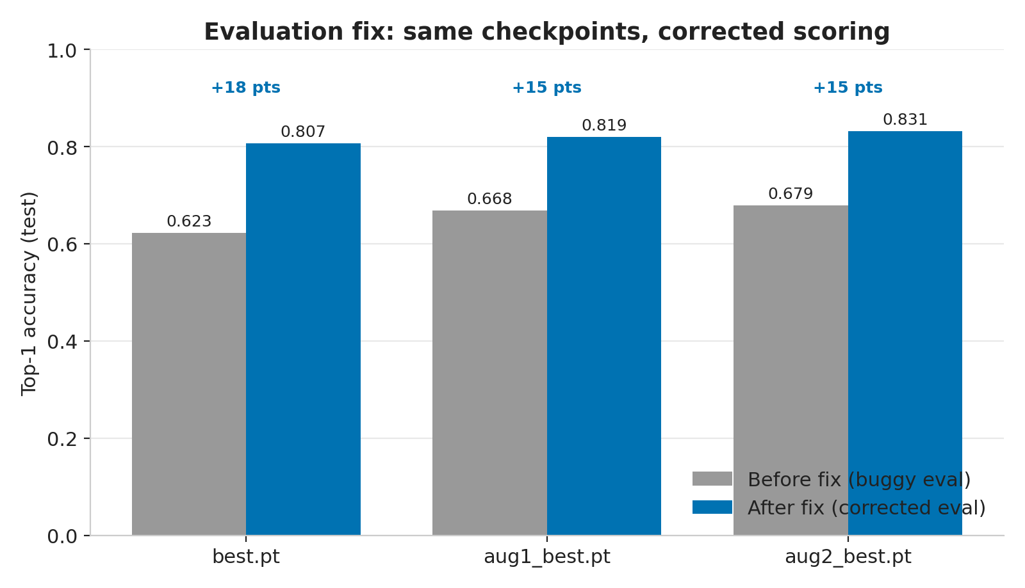
Figure 1. Same checkpoints, re-scored without the test-time margin: +15–18 points.
Checkpoint | Top-1 (before) | Top-1 (after) | Macro-F1 (before) | Macro-F1 (after)
best.pt | 0.6225 | 0.8068 | 0.5822 | 0.7891
aug1_best.pt | 0.6679 | 0.8194 | 0.6351 | 0.8091
aug2_best.pt | 0.6793 | 0.8314 | 0.6324 | 0.8196

2. Ablations: augmentation and long-tail loss (no measurable effect)
I ran matched GPU experiments changing one variable at a time: stronger augmentation (RandAugment, no horizontal flip, blur, larger rotation/shift/occlusion) and a class-balanced “long-tail” loss. All recent runs land within 0.818–0.820, while simply re-running an identical recipe (aug2 → aug2_gpu) moved 1.2 points. The run-to-run variation is ~10× larger than any measured effect. On a 1584-image test set the standard error is ≈0.9%, so single-seed differences below ~2% cannot be resolved.
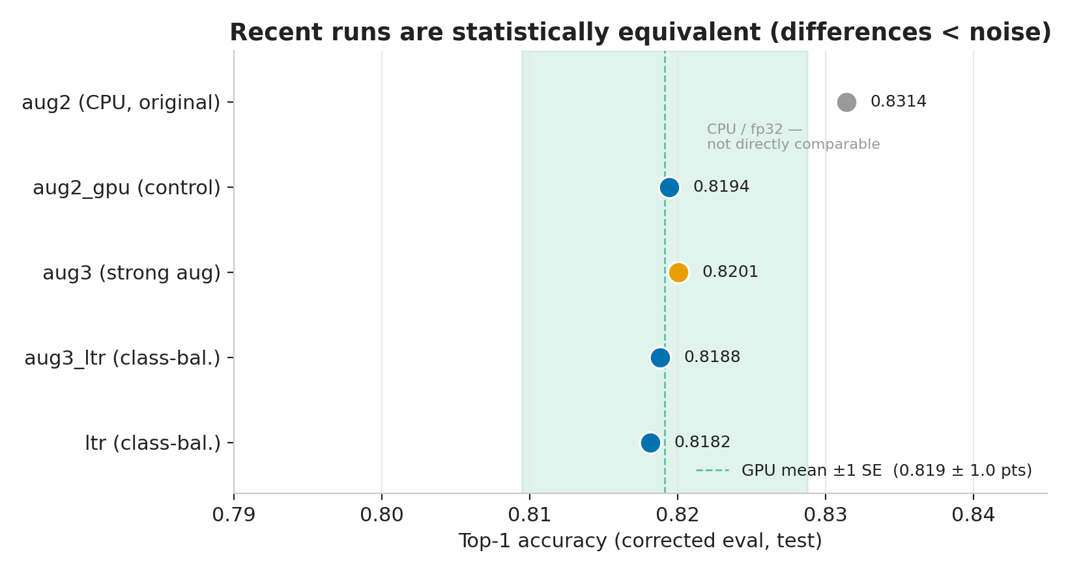
Figure 2. All recent GPU runs fall inside the noise band; the CPU run differs only by hardware.
Comparison | Variable changed | Top-1 | Verdict
aug2_gpu vs aug3 | basic → strong aug (no flip) | 0.8194 → 0.8201 | No effect
aug3 vs aug3_ltr | plain CE → class-balanced loss | 0.8201 → 0.8188 | No effect
aug2 vs aug2_gpu | same recipe, re-run (CPU→GPU) | 0.8314 → 0.8194 | Run-to-run noise

3. Long-tail analysis
After the eval fix, the gap between well- and poorly-represented individuals shrank from 0.28 to 0.03, and the “7 individuals at 0% accuracy” turned out to be entirely an artefact of the bug (now 0).
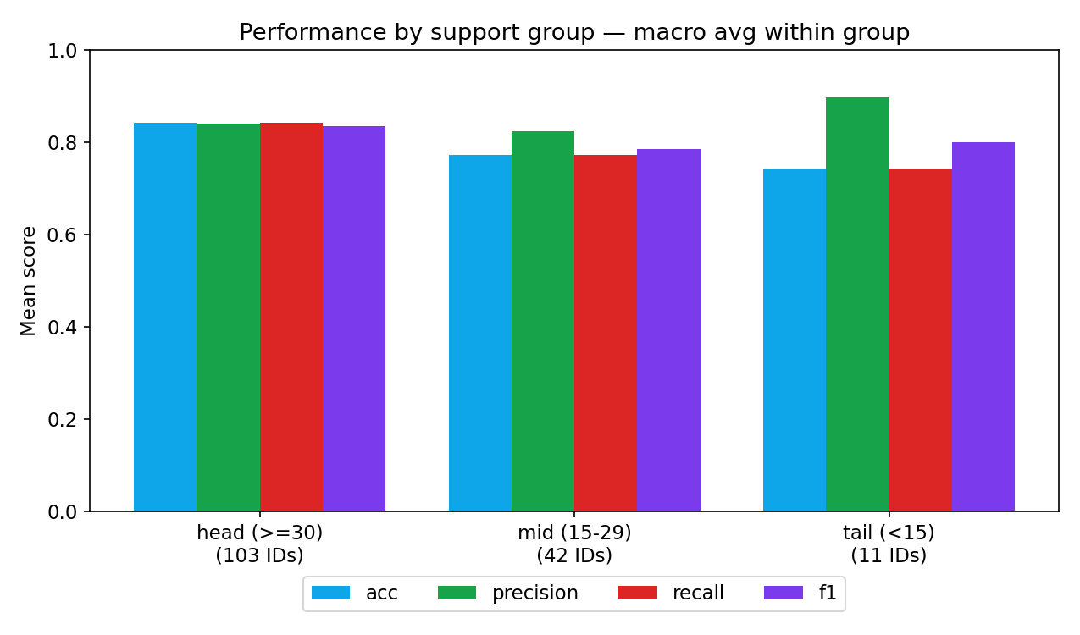
Figure 3. Head / mid / tail performance (corrected eval). Head–tail F1 gap is only 0.03.
Group | #IDs | Mean train imgs | Accuracy | Precision | Recall | F1
head (≥30) | 103 | 53.9 | 0.84 | 0.84 | 0.84 | 0.84
mid (15–29) | 42 | 22.7 | 0.77 | 0.82 | 0.77 | 0.79
tail (<15) | 11 | 9.5 | 0.74 | 0.90 | 0.74 | 0.80

Training-image count explains only ~4% of the variance in per-class accuracy (r = 0.20) — i.e. simply collecting more images of rare individuals is unlikely to help much.
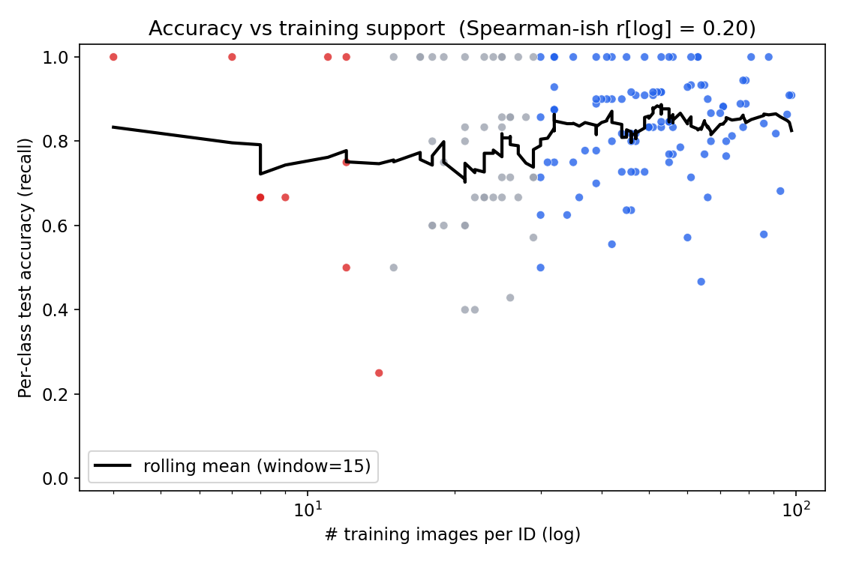
Figure 4. Per-class accuracy vs training-set size: weak relationship (r = 0.20).

Open question (needs your steer)
Several IDs appear to be the same animal split across multiple labels by life event or season — e.g. ‘Tack before emigrating’ / ‘Tack after move to CC’ / ‘Tack temporary’, and various ‘W22-23’ suffixes. If these are the same individuals, the model is being asked to tell an animal apart from itself. Merging them would reduce the class count and may improve accuracy. I will confirm the biology side separately, but wanted your view on how to handle it.

4. Full corrected results before cleanup (all runs)
These historical rows use the corrected (no-margin) evaluation on the same 1,584-image test split before cleanup. Section 5 reports the October retrain and compares models on the 1,498 retained test images.
Checkpoint | Recipe | HW | Top-1 | Top-3 | Top-5 | Macro-F1 | Macro-P | Macro-R
best.pt | basic aug, CE | CPU | 0.8068 | 0.8718 | 0.8889 | 0.7891 | 0.8106 | 0.7867
aug1_best.pt | basic aug, CE | CPU | 0.8194 | 0.8826 | 0.8958 | 0.8091 | 0.8351 | 0.8038
aug2_best.pt | basic aug, CE | CPU | 0.8314 | 0.8807 | 0.9034 | 0.8196 | 0.8405 | 0.8161
aug2_gpu_best.pt | basic aug, CE | GPU | 0.8194 | 0.8807 | 0.9003 | 0.8046 | 0.8340 | 0.7992
aug3_best.pt | strong aug (no flip), CE | GPU | 0.8201 | 0.8744 | 0.8908 | 0.8010 | 0.8183 | 0.8001
aug3_ltr_best.pt | strong aug, class-balanced | GPU | 0.8188 | 0.8801 | 0.8958 | 0.8044 | 0.8371 | 0.7983
ltr_best.pt | strong aug, class-balanced | GPU | 0.8182 | 0.8737 | 0.8914 | 0.8028 | 0.8309 | 0.7970

5. October update: Aug2 retraining after duplicate cleanup
The latest completed recognition run (GPU job 37568170, 8 October 2026) reached Top-1 accuracy of 82.78% (1,240/1,498), Top-3 87.98%, Top-5 89.92%, and macro-F1 0.8102 across 156 identity labels. Training completed all 30 epochs; the selected checkpoint was from epoch 26, with validation Top-1 81.26%.

Training recipe
Training settings match train_macaque_arcface_aug2_gpu.yaml: pretrained ResNet50, 256-dimensional ArcFace embeddings, basic augmentation, plain cross-entropy, 224-pixel input, batch size 32, 30 epochs, learning rate 0.0003, cosine schedule, seed 42, and GPU/AMP. The clean config uses separate run/output names and the cleaned dataset.

What changed in the splits
No new random split was generated. The existing partition was reused and repaired, retaining 156 labels. However, cleanup was not deletion-only: 97 retained crops changed partition (38 validation to training, 47 test to training, and 12 test to validation), and 87 crop entries were excluded overall. The counts below refer to the recognition crops, rather than the raw source photos or detector box-annotation dataset.
Crop split | Before cleanup | After cleanup
Training | 6,607 | 6,665
Validation | 1,361 | 1,302
Test | 1,584 | 1,498
Total | 9,552 | 9,465
The current 1,498 test images are a same-label subset of the original 1,584. Of the 86 images no longer in the test set, 59 moved to training or validation and 27 were excluded.

Comparison on the same retained test images
The table separates the original reported scores from scores on the same 1,498 retained test filenames and labels. The old retained-test scores were recomputed from complete archived per-image predictions, after confirming that the full-test scores reproduce the saved metrics. No old-checkpoint inference was rerun. This reconstruction assumes that the retained crop contents are unchanged since those evaluations.
Recognition model | Original Top-1  (n = 1,584) | Retained Top-1  (n = 1,498) | Retained macro-F1
Original baseline (CPU) | 80.68% | 81.44% | 0.7958
Previous Aug2 GPU | 81.94% | 82.91% | 0.8127
Previous Aug2 CPU best | 83.14% | 83.98% | 0.8271
New clean Aug2 GPU | — | 82.78% | 0.8102
- Original baseline. The cleaned Aug2 run is 1.34 percentage points higher on the retained test images: 1,240 versus 1,220 correct (+20).
- Previous Aug2 GPU. With the matching training recipe, the new run is 0.13 percentage points lower: 1,240 versus 1,242 correct (−2). Macro-F1 is 0.8102 versus 0.8127. Performance closely matches the prior GPU run.
- Previous Aug2 CPU best. On the retained images, the old best scores 83.98%; the new run is 1.20 percentage points lower, with 18 fewer correct predictions.
Interpretation. Comparing the report’s GPU score of 81.94% with the new 82.78% appears to show a 0.83-point improvement, but those scores use different test populations. On the same retained images the comparison is 82.91% versus 82.78%. The cleaned model exceeds the original baseline and maintains approximately the previous Aug2 GPU performance; it has not demonstrated an accuracy gain over the previous Aug2 model. Training inputs changed, older models were trained before duplicate cleanup, and only individual runs are available, so the differences do not isolate the effect of removing duplicates.
Exact-image cleanup is separate from the unresolved question of whether different identity labels refer to the same biological individual (Section 3).
Evidence: job log artifacts/ltr_logs/37568170.out; training config configs/train_macaque_arcface_clean.yaml; checkpoint artifacts/macaque-resnet50-arcface_clean_photo_split_20261007_best.pt; comparison data data/macaque_faces/source_split_repair_2026_10_07/report_comparison_2026_10_08.json. All paths are relative to animal-face-id.

6. Notes, caveats & next steps
- The 0.831 for aug2_best is a real measured checkpoint, but re-running the identical recipe gave 0.819 — so ~0.82–0.83 is the honest expected range rather than 0.831 being reproducible.
- Per-class metrics for rare individuals are coarse (2–4 test images each): one image shifts a class by 25–50 points, so individual tail rows are noisy.
- The test split is in-distribution (same source/curation as training). Real-world field photos will score lower; a dedicated out-of-distribution test set would be needed to measure that.
- Suggested next steps: (a) resolve the duplicate-identity labels; (b) build a small out-of-distribution test set to properly evaluate augmentation for field use; (c) if sub-2% effects matter, run multiple seeds per configuration to get error bars.

