**Variability of Ocean Transports in the Atlantic from Space**

**Research Fellowship from the Leverhulme Trust**

**Abstract**

The meridional overturning circulation (MOC) transports heat poleward, playing a key role in climate. A collapse of this circulation has been linked to dramatic predicted cooling in the UK. Since 2004, the RAPID project has been monitoring the strength of the MOC to better understand variability. We propose to use the RAPID observations to develop a satellite and autonomous float-based estimate of transport variability. Validating the method at two further locations, we will extend the observation-based estimate across the subtropical Atlantic to reveal how the ocean transports heat, and further use these estimates to understand atmospheric drivers of variability.

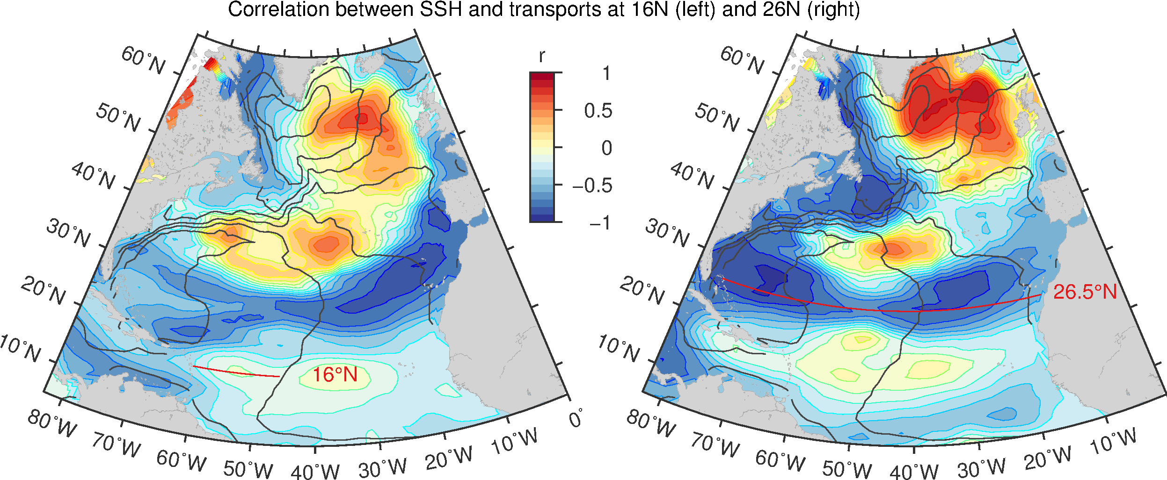

**People**

Eleanor Frajka-Williams

Collaborators at JPL