UGAthens Transit:

Project Plan

A Website that Integrates UGA and Athens Transit Data

## 

By

Eleanor Madderra, Keerthana Ramesh, Isra Naweed, Anjali Devarapalli, Ryan Majd, and Shreyan Bose

### 

December 8, 2024

Table of Contents

**INTRODUCTION 3**

Project Overview 3

Client 4

Project Deliverables 4

Definitions 5

**PROJECT ORGANIZATION 6**

Organizational Structure 6

Project Responsibilities 7

**MANAGERIAL PROCESS 7**

Management Objectives and Priorities 7

Assumptions, Dependencies, and Constraints 8

Risk Management 8

Configuration Management 9

Monitoring and Controlling 9

**TECHNICAL PROCESS 10**

Methods, Tools, and Techniques 10

Development Environment 10

**WBS, SCHEDULE, AND BUDGET 11**

Work Breakdown Structure 11

WBS Chart 13

UGAthens Flowchart 14

Use Cases 14

Dependencies 15

Resource Requirements 16

Schedule 16

Iterations 18

Budget 19

Resource Allocation 19

# 

# 

# **INTRODUCTION**

## **Project Overview**

As students, traveling across campus and throughout Athens is something we do daily. The Athens and UGA Transit systems offer a free and convenient alternative for those without cars as well as those who prefer to avoid the hassle of driving and parking on and off campus. Securing a parking spot on campus is both expensive and very competitive, so taking advantage of free public transportation is a great option for those who live off campus.

One of the biggest challenges of utilizing public transportation in Athens is understanding and managing the different bus routes and stops. While both the Athens and UGA Transit tracking websites are helpful, needing to switch between the two when trying to find the most efficient route to take can be both overwhelming and time-consuming.

The UGAthens Transit website aims to address these challenges by providing Athens residents with a more accessible way to navigate UGA’s campus and the city, ultimately enhancing their public transportation experience. By making public transportation easy to navigate, we hope to encourage those who live in Athens to try taking the bus for the first time or use Athens public resources more often.

This project has the potential to grow and evolve based on user demand, but the scope of this project is confined to a basic website that will enable UGA students, Athens residents, and Athens visitors to view a consolidated list UGA and Athens Transit bus routes, stops, and live bus tracking. This project will also feature a back-end database to keep track of users’ favorite bus routes and stops, though users will be able to access the website as a guest.

It is the goal of this project to create a working, functional website that effectively combines UGA and Athens Transit data in a way that satisfies potential users.

This team defines project goals to be:

* Ability for users to select a route and see all stops on that route as well as all active buses
* Ability for users to select a stop and see all routes that stop there
* Ability for users to login and save favorite bus routes and stops

This team defines project success by the following criteria:

* All project goals above are met
* 85% of test users find our website easy to navigate
* The members of this team understand the different roles in software development
* The members of this team are able to work together to create a working product and all necessary deliverables

## **Client**

In this project, we are both the developers and the client. By developing this website for ourselves as both students and Athens residents, we are able to address the needs and challenges that our potential users face. This unique perspective allows us to approach this project with first-hand experience and insight, enabling us to develop a solution that is both practical and relevant for UGA students and Athens residents like ourselves.

## **Project Deliverables**

| **Deliverable** | **Submittal Date** |
| --- | --- |
| Project Macro Plan | October 17, 2024 |
| GitHub Project and Repository Creation | October 20, 2024 |
| Organizational Structure Diagram | October 22, 2024 |
| Baseline Requirements/Functional and Nonfunctional Requirements | October 27, 2024 |
| Figma Design | November 3, 2024 |
| First Iteration | November 7, 2024 |
| Authorization Set UP | November 14, 2024 |
| Database Creation | November 14, 2024 |
| Use Case Diagram | November 14, 2024 |
| Second Iteration | November 14, 2024 |
| Organizational Structure Diagram | November 15, 2024 |
| Webpage Flowchart | November 15, 2024 |
| WBS Chart/Diagram | November 19, 2024 |
| Project Plan Document | November 20, 2024 |
| Authorization/User Account Creation | November 20, 2024 |
| Third Iteration | November 21, 2024 |
| Class Diagram | November 23, 2024 |
| Fourth Iteration | November 25, 2024 |
| Final Presentation | November 26, 2024 |
| Software Requirements | December 5, 2024 |
| Software Design Document | December 6, 2024 |
| Testing Document | December 1, 2024 |
| Final Product | December 6, 2024 |

## **Definitions**

| **Users** | People who will exclusively use the front end of the website.  Includes UGA students, Athens residents, and Athens visitors |
| --- | --- |
| **Firebase** | Authentication tool that securely manages user logins |
| **Firestore** | The database within Firebase that stores and syncs real-time data, such as a user’s favorite bus routes and stops across all users |
| **UGA Transit** | The UGA transportation service. Provides public access to UGA bus routes, stops, and live tracking. Any member of the public may use the UGA buses for free. |
| **Athens Transit** | The Athens transportation service. Provides public access to UGA bus routes, stops, and live tracking. Any member of the public may use the Athens buses for free. |
| **Route** | The designated path of a bus. Routes loop. |
| **Stop** | The different places a bus will let people on and off the bus. Stops may be used in one or more routes. |

# **PROJECT ORGANIZATION**

## **Organizational Structure**

This team has six members and every member has a main responsibility. These responsibilities include: project management, web design, documentation, testing, and backend development**.**

The team will help out others with their responsibilities when needed, though team members' main responsibilities will take priority as outlined in the section below.



## **Project Responsibilities**

| **Project Manager**  *Ryan Majd* | * Identify and assign tasks as needed * Monitors process of team and keeps everyone on track * Helps in different areas of the project as needed * Work on front end development   + Turn figma design into a useable website |
| --- | --- |
| **Architect/Documentor**  *Eleanor Madderra* | * Maintains the GitHub Repository * Maintains and updates the GitHub Project page * Keeps up with documentation including the project plan, software design document, and the software requirements specification |
| **Website Tester**  *Shreyan Bose* | * Designs test cases * Tests different test cases, checking for ways users may accidently or maliciously abuse different aspects of the website * Document test plans and test results * Ensure that the website shows accurate, easily readable information |
| **Web Designer**  *Isra Naweed*  *Keke Ramesh* | * Determines the overall look and feel of the website * Keeps in mind user need while designing * Ensures easy usability |
| **Back End Developer**  *Anjali Devarapalli*  *Keke Ramesh*  *Isra Naweed* | * Build the backend * Scrape the Athens and UGA Transit websites and combine route information * Create a working map with live bus tracking |

# **MANAGERIAL PROCESS**

## **Management Objectives and Priorities**

Project Management provides team members with a clear vision of the project's objectives and helps team members understand how their individual assignments contribute to the overall goal. The manager will assign tasks and team members will be expected to estimate the time needed to complete the task, supporting a collaborative planning process and allowing for realistic timelines.

The manager is also responsible for monitoring team progress and keeping everyone on schedule. Team members are responsible for alerting the manager when their workload becomes too much and the manager will reassign tasks as needed. This team structure aims to create a balanced workload for all team members, ensuring that the project can stay on schedule and all of our project goals can be met.

## **Assumptions, Dependencies, and Constraints**

This team assumes that users will understand the basics of public transportation: there are different routes and stops that a user can take advantage of.

This team assumes that users know how to read a map and key.

This project will suffer a severe setback if a team member were to leave. The timeline of deliverables will be greatly affected and it may take quite a bit of time to fully recover.

This project is dependent on having access to both UGA and Athens Transit data. If access were to be revoked for some reason, the website may be rendered useless.

## **Risk Management**

The risks that this team faces are outlined below. They are ranked in order of priority and contain our responses to help mitigate the risk.

| **Risks** | **Responses** |
| --- | --- |
| Difficulties Overcoming Technical Inexperience | We will ensure that we have enough time to work on each iteration, so team members will have time to research new technologies and troubleshoot any issues that may arise. |
| Unrealistic Schedule | We will work on this project in iterations. The main functionality will be included in the beginning iterations. If scheduling issues occur and the team falls behind, the most important features will be completed and unnecessary features can be sacrificed. |
| Underestimating the Amount of Work Something May Require | We will work on this project in iterations. The most basic requirements will be addressed first so that if we run into issues or run out of time while working on a later requirement, we will still have the basics of our website completed. |
| Team Member Becomes Unavailable | Some things are out of our control and we may temporarily (or permanently) lose a teammate unexpectedly. We will make sure that everyone has access to all documents and files and not just one person has control. We will also assign more than one team member to some requirements that may be more difficult. |

## **Configuration Management**

The baseline for this project in terms of project planning will be the Project Plan document. The technological baseline for this project will be the Software Requirements document.

Any changes made to the project plan must be discussed with the entire team and approved by those that will be directly affected by the plan.

## **Monitoring and Controlling**

This project will implement an iterative, staged delivery model. By working in increments, we can ensure that a functional product will be able to be delivered quickly while prioritizing the most important features. This approach allows the team to develop the most essential features first and all of the non-essential features can be done during later increments. If an unforeseen issue occurs, the development team may sacrifice some of these features. The ultimate goal is to have a reliable, functioning product.

The team has agreed to meet up once per week when possible. As the project deadline approaches, the team will attempt to meet twice per week. On Wednesdays after class, the team will have a 5 - 10 minute SCRUM meeting. The team will briefly discuss what work has been completed the previous week and what everyone should be working on in the coming week. When needed, the team will meet on Thursdays to work together on the project in person. These meetings will typically last 1 - 4 hours.

# **TECHNICAL PROCESS**

## **Methods, Tools, and Techniques**

This project will utilize an iterative software development approach and follow agile methodologies. The team will use GitHub Projects to keep track of individual and team assignments, as well as to maintain the project schedule.

The team will utilize draw.io and Google Drawings to create the necessary diagrams.

Google Drive will be used to create documents and presentations so everyone on the team will have the ability to access and edit.

## **Development Environment**

| **Software Languages** | Javascript, CSS, ReactJS, NodeJS |
| --- | --- |
| **Website Design** | Figma |
| **Version Control** | GitHub |
| **Authorization** | Firebase |
| **APIs** | Google Maps, Google Maps Transit, Firebase |
| **Database** | Firestore (not implemented due to time constraints) |

# **WBS, SCHEDULE, AND BUDGET**

## **Work Breakdown Structure**

| **Deliverables** | **Activities** |
| --- | --- |
| Project Plan | * Assign roles to team members * Determine group structure and how much control the Project Manager has * Determine individual tasks for team members and estimate time needed * Create a timeline based off of the individual tasks * Create GitHub project board and transfer timeline to board * Write document |
| Requirements Document | * Meet with team to discuss necessary requirements * Create use cases and use case diagram * Write document |
| Figma/Front-End Design | * Create Figma document and share with all team members * Determine color palate * Create a design that can be integrated on both desktop and mobile devices |
| Design Document | * As website is being created, keep track of our process and sketch necessary diagrams * Once website is near completion, finalize diagrams |
| First Iteration | * Finalize Figma design * Create the front end of the website using previously made design |
| Second Iteration | * Research authentication and chose an authentication method * Create Firebase account and basics |
| Third Iteration | * Finalize and test authentication methods * Users will be able to create and account and log in and log out |
| Fourth Iteration | * Research data integration methods * Experiment with web scraping and different free and available APIs * Integrate UGA bus data onto the website * Integrate Athens Transit bus data onto the website * Complete basic testing involving data integration |
| Fifth Iteration | * Research map integration * Create a viewable map that has all bus stop locations marked * Complete final testing of the product |
| Test Document | * While website is being created, come up with a list of tests to run in the future * As each iteration is complete, test whatever possible and log results * Once website is complete, work on final round of testing * Complete document and log |
| Project Presentation | * Finalize project plan document * Determine presentation outline * Assign each team member a section to complete * Finalize presentation and assign speaking roles to team members * Determine which team member will be responsible for project demonstration |
| Final Product | * Final product is published |

## **WBS Chart**



## **UGAthens Flowchart**

The flowchart below is a depiction of the original project plan. The design of the final website can be found on the Software Design document.



## **Use Cases**

The use cases below were the use cases for the original design of the website. Due to time constraints, not all features were able to be implemented. The use cases for the final design of the website can be found in the Software Design document under Use Case View.

| **Use Case:** | **Sorting Through Bus Stops** |
| --- | --- |
| **Actors:** | Guest Users and Users |
| **Description:** | This use case begins when an individual visits the website. The user can be a guest user or a user with an account. The user will be able to sort through different bus stops of both UGA and Athens Transit systems. If a bus stop is selected, the website will display all routes that stop at that particular bus stop. |

| **Use Case:** | **Sorting Through Bus Routes** |
| --- | --- |
| **Actors:** | Guest Users and Users |
| **Description:** | This use case begins when an individual visits the website. The user can be a guest user or a user with an account. The user will be able to sort through different bus routes of both UGA and Athens Transit systems. If a route is selected, the website will show all stops on that route. |

| **Use Case:** | **Sorting Through Favorites** |
| --- | --- |
| **Actors:** | Users |
| **Description:** | This use case begins when an individual logs into their account. The user will be able to sort through a list of all of their favorite bus stops and routes. If a route or stop is selected, it will display all stops or routes associated with it. |

## **Dependencies**

Due to time constraints, aspects of project planning (scheduling, requirements, and architecture) and project development are occurring simultaneously. There are many aspects of project development that rely on sections of project planning being completed. The project manager kept these dependencies in mind while assigning tasks and forming the project schedule.

For example, the functional and nonfunctional requirements needed to be defined before our work could begin, so that was something we prioritized. As seen in the image below, our requirements were defined before we began to work on the back end.

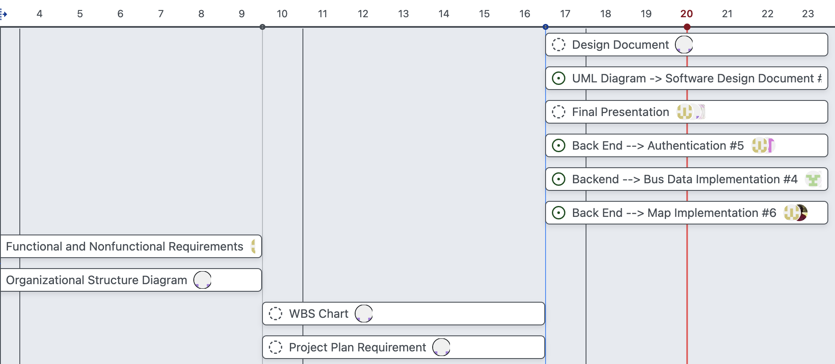

Some other dependencies include our Figma design and the frontend. Before we completed the front end, the web designers created a Figma mockup of the website so the developers had a design to follow. Later iterations of the UGAthens website will be improved upon using information gathered in the testing stage.

## **Resource Requirements**

Staff resource requirements include 6 team members including a project manager, front/back end developers, designers, testers, and documentors. All team members will be required to have access to a computer with internet access, a GitHub account, access to their preferred coding software, and Google Drive access.

## **Schedule**

The schedule for this project will be available to team members on the GitHub Project page. All assignments are given a size, and importance level, and assigned to 1 - 6 team members. The size of an assignment represents how much work and time the assignment requires. Sizes include XS, S, M, L, and XL. The importance level or priority represents how important each assignment is and how critical it is to the project as a whole. Priority 0 is the most important Priority 1 the next most important level and so and so forth. Priority levels include P0, P1, P2, and P3.

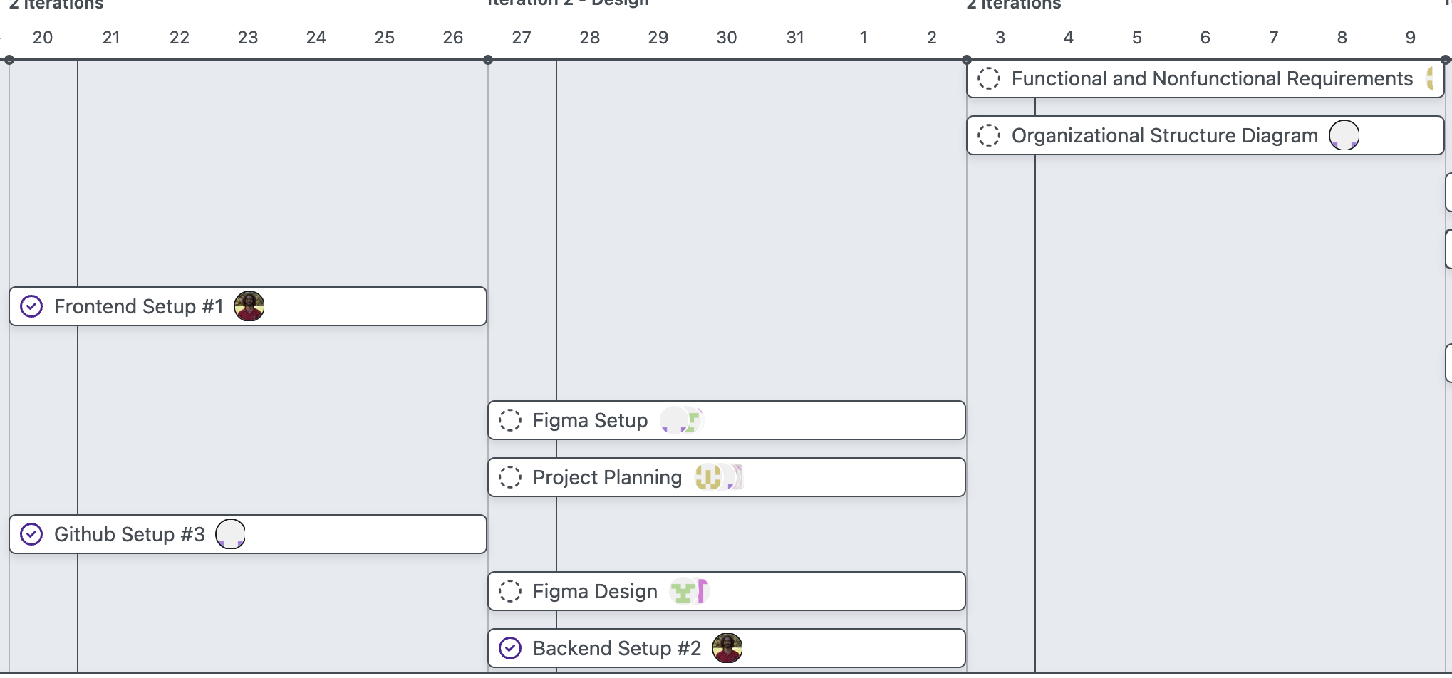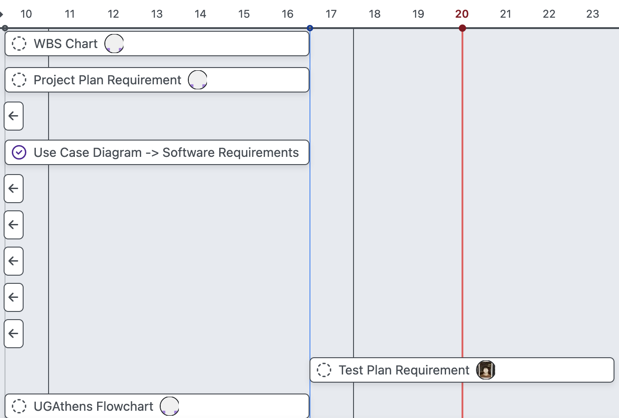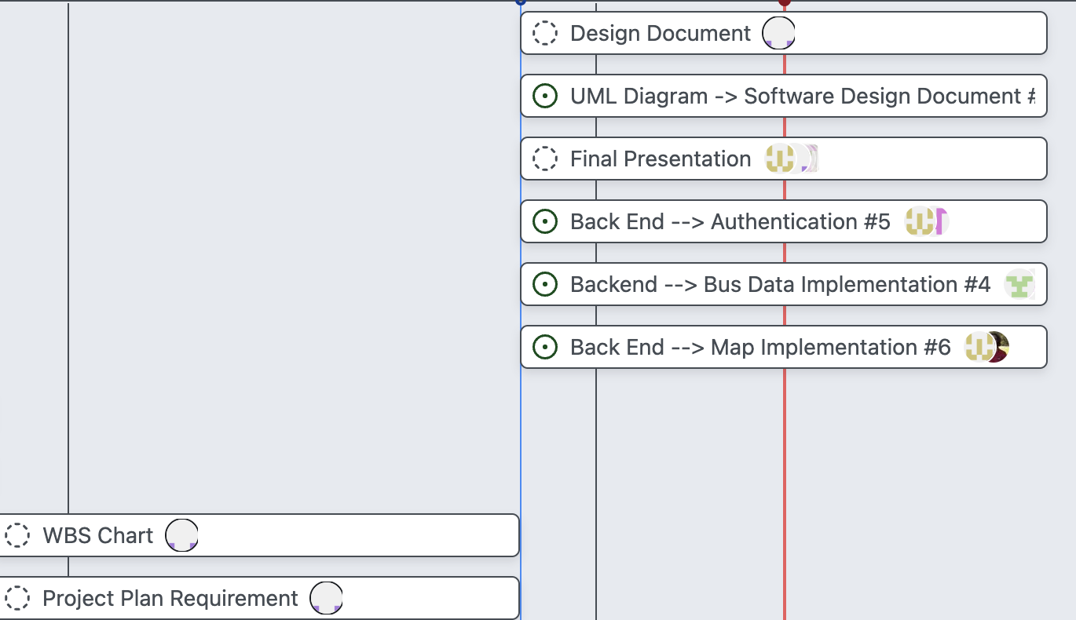

## **Iterations**

Each iteration is outlined below, with the focus of each iteration being determined by three main factors: importance, team availability, and task difficulty. The team prioritized completing the most critical aspects of the project first, especially those on which other sections depended on. While importance was the primary consideration, team availability and task difficulty also played a role.

At certain times, two or three different iterations were being worked on simultaneously. This overlap occured when team members could work independently and all necessary dependencies were completed. For example, the iterations that focused on authentication and data integration steps were begun during the same week. While data integration was more critical, the authentication focused iteration was completed first because it was less complex. Even though task difficulty and team availability sometimes caused the completion of certain iterations to be delayed, our flexible, iterative approach helped us maintain steady progress overall.

| **Iteration One** | * Front end website is able to be accessed with no errors |
| --- | --- |
| **Iteration Two** | * Authentication base is completed |
| **Iteration Three** | * Authentication is fully functional |
| **Iteration Four** | * Data is integrated * User is able to view website and see live arrival times of UGA and Athens buses |
| **Iteration Five** | * Map is implemented |

## **Budget**

There is no financial cost associated with this project. The team considered purchasing a domain name, but ultimately decided against it. If the website is ever to be officially published, it will be published under the domain name a team member has already purchased. While the full domain name may not fully match up with what we originally wanted, the save in cost will be worth it.

This project will also be budgeted according to time spent. By our estimates, each team member will spend 25 hours total on this project. This works out to about 5 hours per week. In total, our team will spend 150 hours to complete this project.

## **Resource Allocation**

The time spent on this project is broken down below. This table depicts both the estimated/budgeted time and the actual time spent on each section of the project. The hours spent will be rounded to the nearest hour for easy readability. The hours listed below are the total hours spent amongst the entire 6 person team.

| **Category** | **Budgeted Hours** | **Actual Hours** |
| --- | --- | --- |
| Brainstorming and Planning | 10 | 12 |
| Design | 10 | 6 |
| Documentation | 45 | 25 |
| Research | 10 | 6 |
| Front End Programming | 20 | 15 |
| Back End Programming | 45 | 45 |
| Testing | 10 | 3 |
| **Total** | **150** | **112** |