Pages, profiles, privacy

What’s the difference between a Page and a Profile?
An overview of the difference between a page and a profile:
http://www.socialreflections.com/difference-between-a-page-and-profile-on-facebook/

Facebook terms of use state that profiles should only be used for people, not organisations - so this probably applies to educational things, though it may not be a legal issue. Best practice is perhaps to use pages, or groups for all your educational needs.

Page
Pages are separate from a personal profile - the main things you can do with pages that you can't do with just a profile are:

- Have multiple pages!
- Multiple admins for each page
- Insights - aka statistics - https://developers.facebook.com/docs/insights/
- Facebook 'App Id' to add further html pages (other html pages 'linked' your Facebook page menu)
- Facebook app and third party app integration - use Page widgets on other web pages/ or show outside content on the FB Page (like Twitter, or other website feeds)
- Promote your page, create events for your page
- People can like you, but not 'be your friend'
- View posts by you (the page admin team), posts by others, highlights

LOGGED IN AS ADMIN (SOCIALMET)
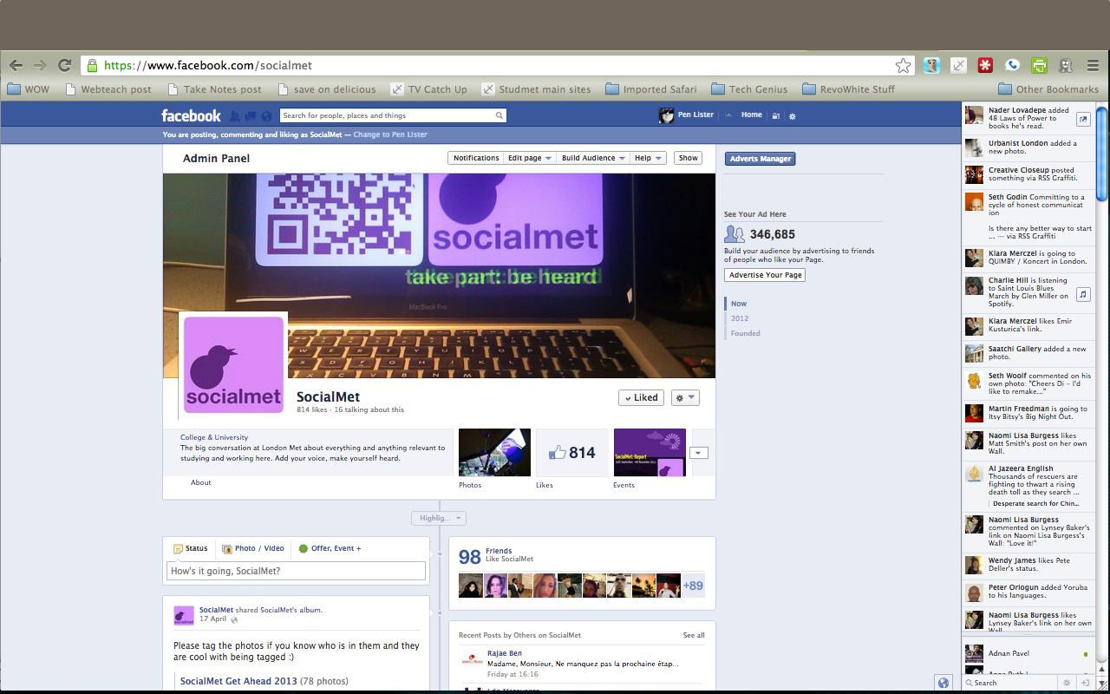

SHOWING ADMIN SUMMARY SECTION AT TOP OF FACEBOOK PAGE
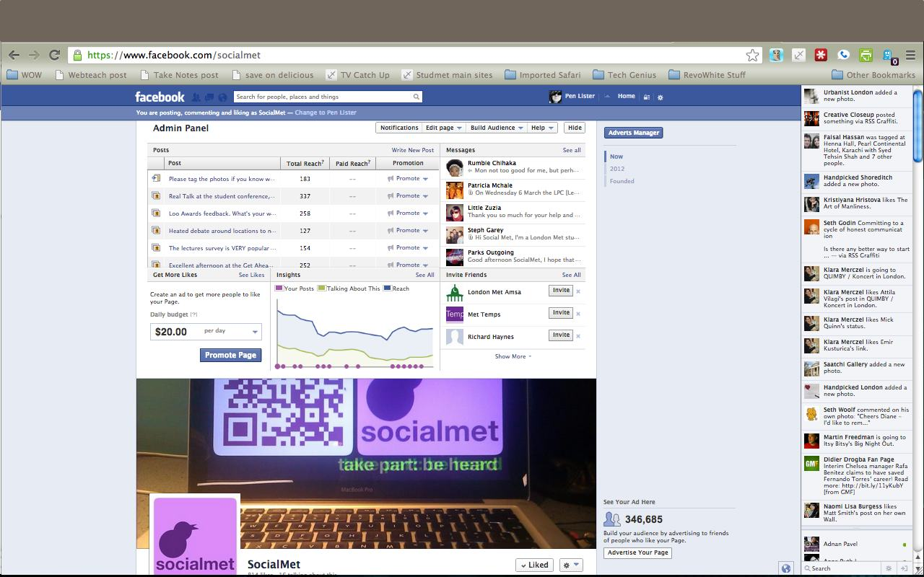

NOT LOGGED IN (AS USER OR ADMIN) (SOCIALMET)
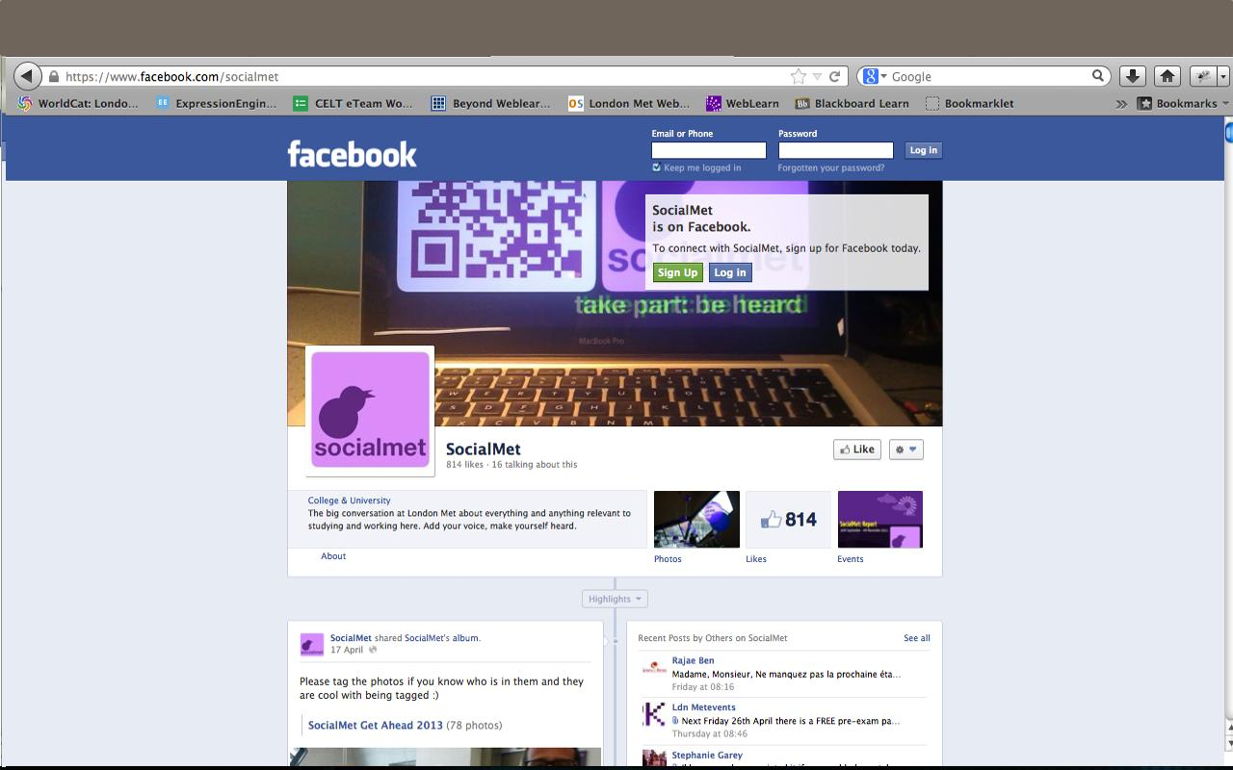

INSIGHTS (SOCIALMET)
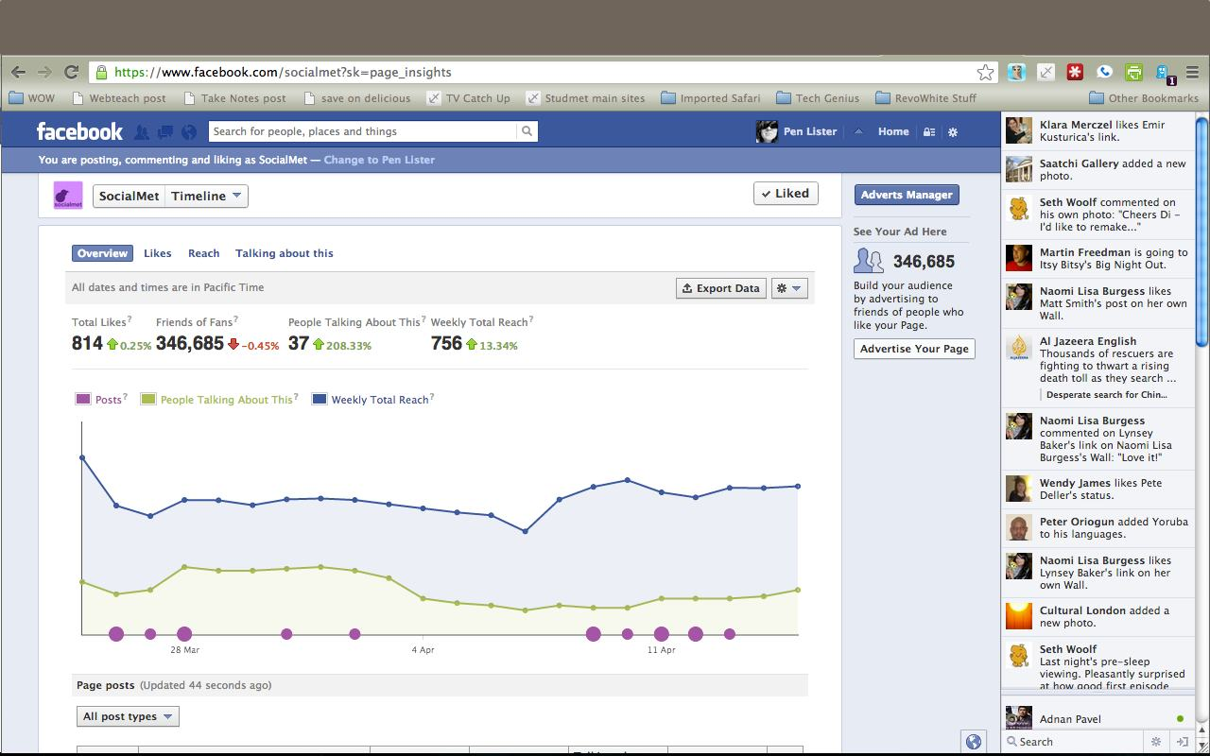

NB - Though Pages you administer are separate from your own profile account, you might wish to set up a ‘professional’ user profile account from which to administer them. This way, you can hand over the account to another colleague if you leave your current employment.

Profile
Aka Timeline, personal account, 'id', 'facebook id'

The concept of friends - what you have on a personal profile, that you don't have on a page, is used for a number of things that likes are not used for. Friends are the way Facebook determines how privacy is controlled, so it's important to know the difference.

- No Insights (aka statistics)
- No 'promote' (advertise your page)

Things both pages and profiles can do (main functions)

- Status updates appear in the newsfeed
- Users can opt for notifications
- Subscribe/follow, add to lists
- Add to interest lists
- Comment and share (depending on pivacy settings)
- Content can be hidden from people who are not logged in to Facebook, but to differing degrees.
- People can share, comment and reply to comments

PROFILE - LOGGED IN (PEN LISTER)
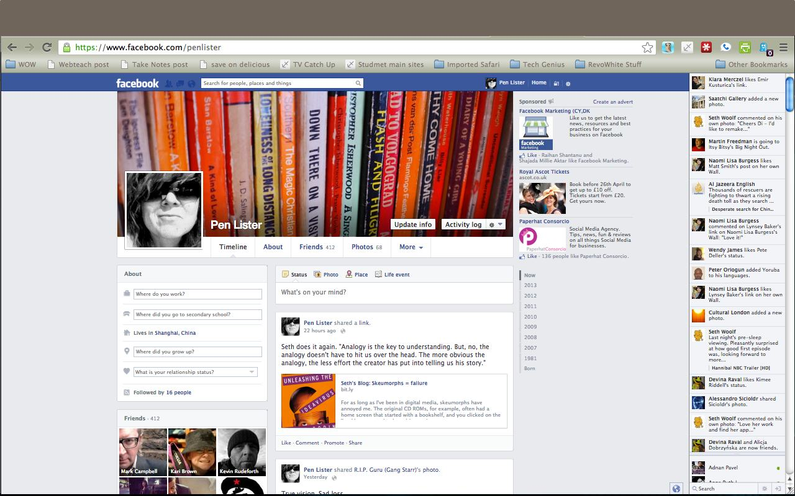

PROFILE NOT LOGGED IN (PEN LISTER)
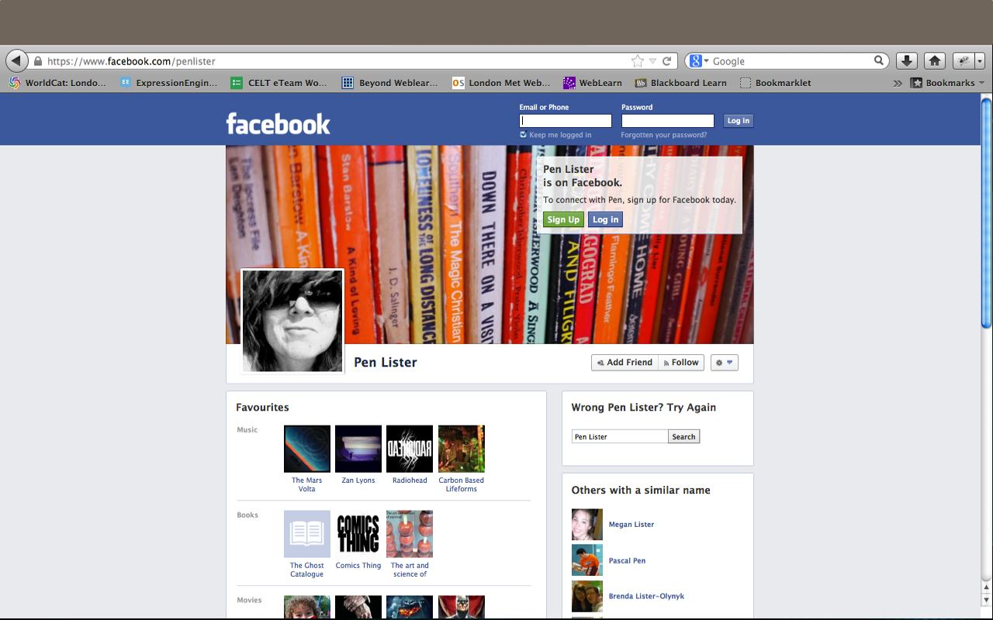

Id identifer - your name and number
http://graph.facebook.com/penlister - this information is used to identify you as a ‘unique’ user on facebook.

Converting profiles into pages
http://www.facebook.com/help/175644189234902/ - its quite straightforward to convert a profile into a page.

What about Groups?
The difference between a page and a group:
http://www.facebook.com/blog/blog.php?post=324706977130

Groups can be great if you want:
- A public open group of a specific interest, which does not want to be in a newsfeed or list
- Private small community of work which is easy for members to access and be notified about new activity
- Closed environment but visible environment – these groups are visible to everyone on Facebook, but only as ‘existing’, and who is in them, their content is only visible to members
- ‘Secret’ environment (completely closed, not visible to anyone outside of the group)
- Create documents and edit between group members

Groups are a bad idea if you want:
- To promote what you are doing across Facebook or the wider web
- Newsfeed inclusion - Groups don’t have status updates delivered to the newsfeed (tbc)
- Want users to subscribe to you, or add you to a list
- Have statistical Insights into what is happening in your social media presence

PUBLIC GROUP (DIGITAL ART)
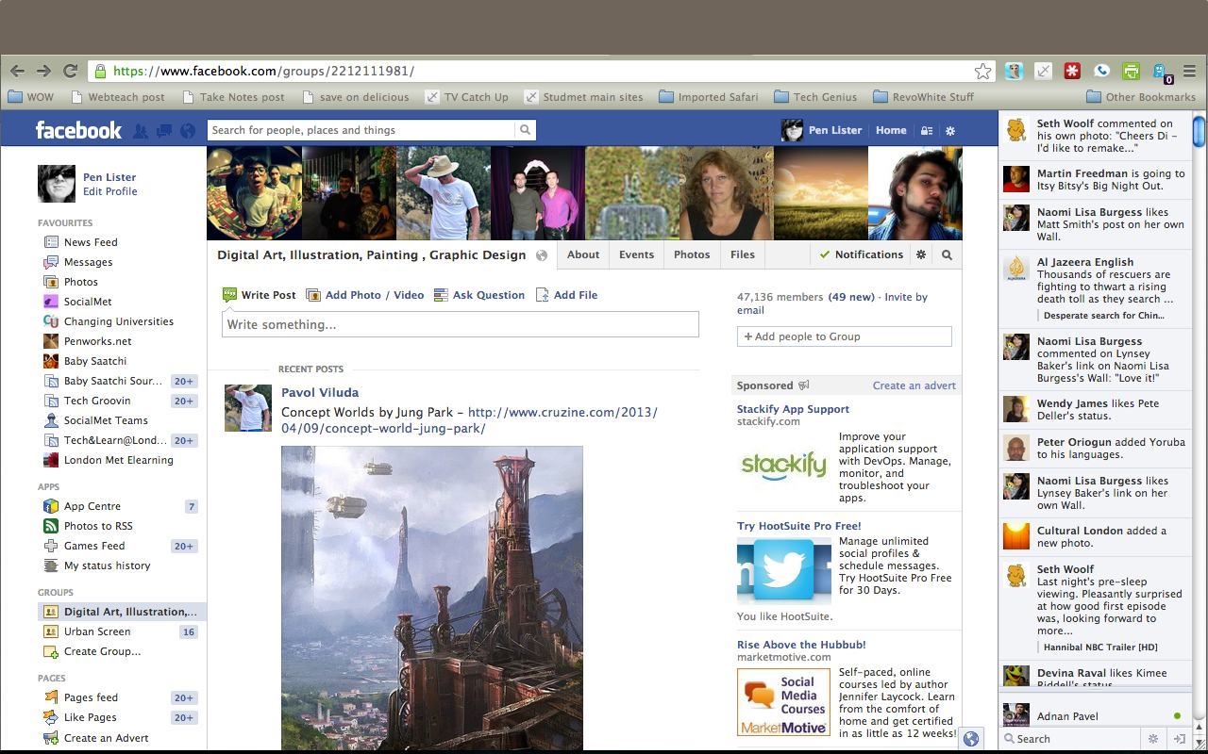

SECRET GROUP (SOCIALMET)

What about Privacy?

Concepts about privacy are changing - think about this:
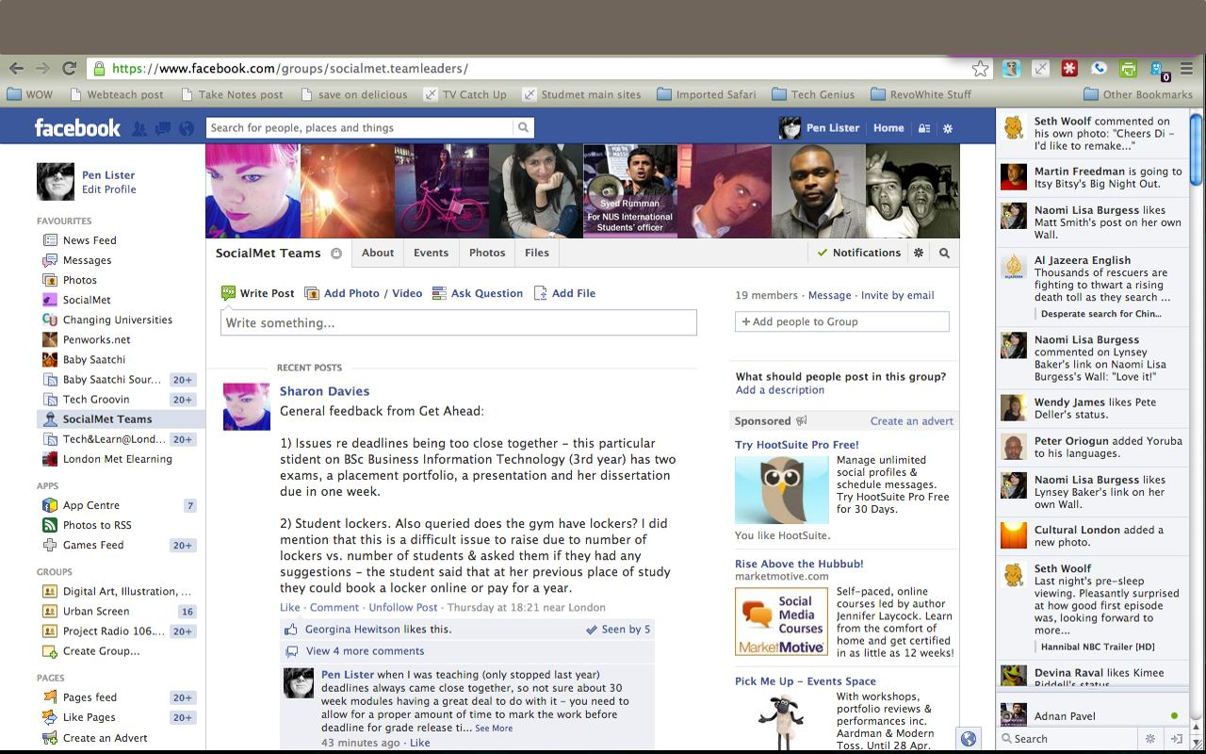
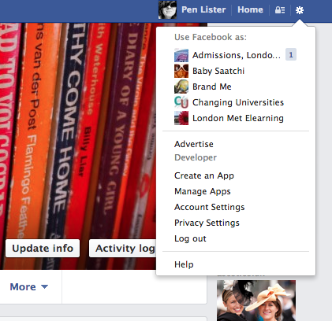
Click here
The pre digital generations may think that everything is private unless it is shared

The post digital generations may think that everything is shared unless it is made private

LOCATE YOUR PERSONAL PRIVACY SETTINGS

See opposite for how to access your personal privacy settings. These are set around the concepts of Friends, Aquaintances and Custom settings.

FACEBOOK HELP PAGES

http://docs.google.com/document/d/1CAOS75jY19lvswBYvn9I3zcBbyNfE-kxFzYnmpEbVeU/pub

http://newsroom.fb.com/News/547/Better-Controls-for-Managing-Your-Content

More on using Facebook

Visit http://www.celtelearning.org/tutorials/detail/pages-profiles-and-privacy for more information.

