This is the instruction of the test program.

1. Below is the chessboard you can use.

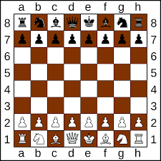

then this is the board I used:

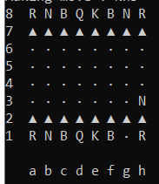

2. make sure the “AI_ouput.txt” and “op_input.txt” is clean, delete everyting in these files

3. Launch the “main” program, it will keep reading “op_input.txt”, which is your input, e.g.,

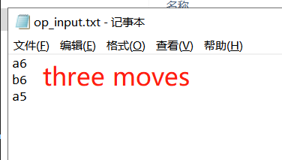

4. then it will output its result to “AI_output.txt”, you can read it to fight back.

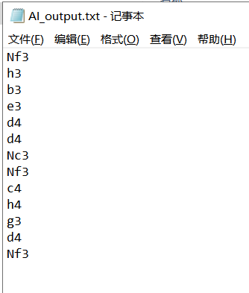

5. have fun

hint: a legal move looks like that:

Nc6

Na6

Nh6

Nf6

a6

a5

b6

b5

c6

c5

d6

d5

e6

e5

f6

f5

g6

g5

h6

h5