----------------------------------------------------------------------------------

-- Company:

-- Engineer:

-- Create Date: 00:38:27 04/01/2017

-- Design Name:

-- Module Name: fsm_mealy_mod - Behavioral

-- Project Name:

-- Target Devices:

-- Tool versions:

-- Description:

--

-- Dependencies:

--

-- Revision:

-- Revision 0.01 - File Created

-- Additional Comments:

--

----------------------------------------------------------------------------------

library IEEE;

use IEEE.STD_LOGIC_1164.ALL;

use IEEE.STD_LOGIC_ARITH.ALL;

use IEEE.STD_LOGIC_UNSIGNED.ALL;

---- Uncomment the following library declaration if instantiating

---- any Xilinx primitives in this code.

--library UNISIM;

--use UNISIM.VComponents.all;

entity fsm_mealy_mod is

Port ( reset : in STD_LOGIC;

clk : in STD_LOGIC;

x : in STD_LOGIC;

z : out STD_LOGIC);

end fsm_mealy_mod;

architecture Behavioral of fsm_mealy_mod is

type state_type is (S0, S1);

signal state, next_state : state_type;

begin

SYNC_PROC : process (clk)

begin

if rising_edge(clk) then

if (reset = '1') then

state <= S0;

else

state <= next_state;

end if;

end if;

end process;

NEXT_STATE_DECODE : process (state, x)

begin

z <= '0';

case (state) is

when S0 =>

if (x = '1') then

z <= '1';

next_state <= S1;

else

next_state <= S0;

end if;

when S1 =>

if (x = '1') then

next_state <= S0;

else

z <= '1';

next_state <= S1;

end if;

when others =>

next_state <= S0;

end case;

end process;

end Behavioral;

View RTL Schematic

View Technology Schematic  
  
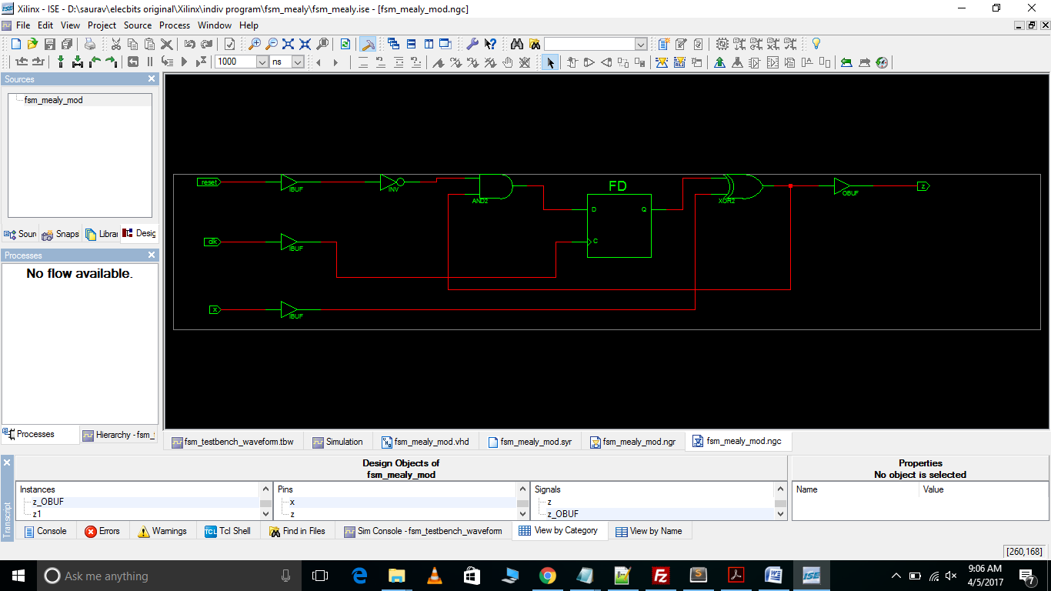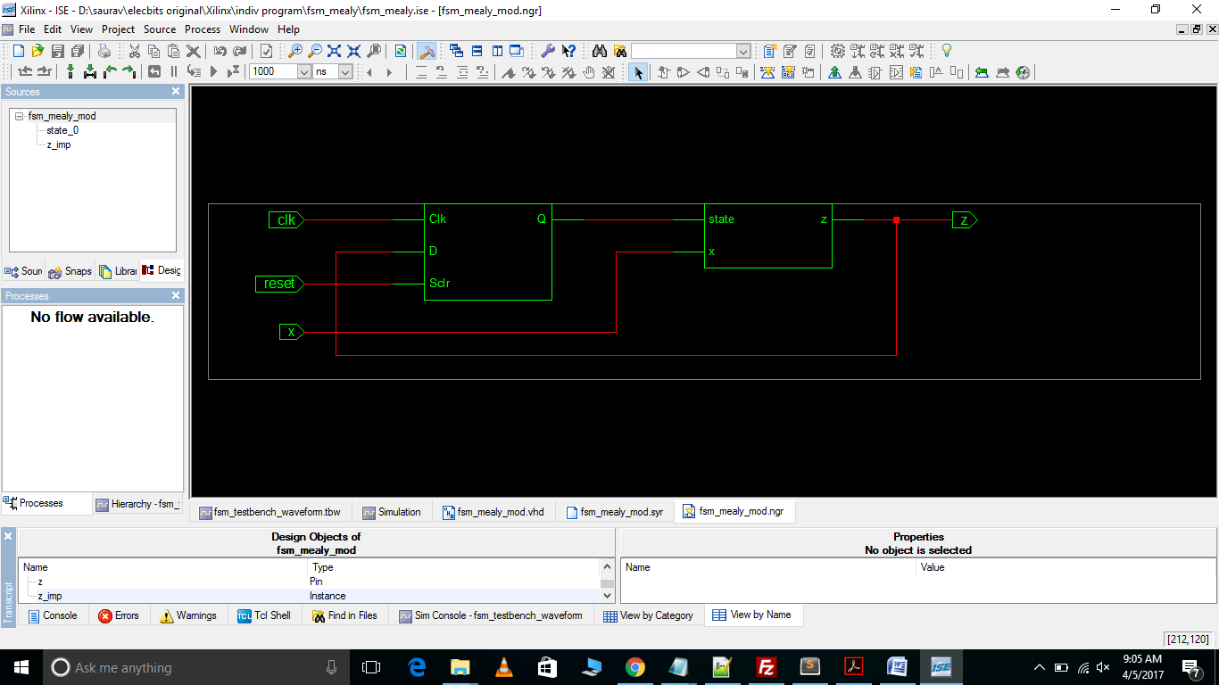

Test Bench Waveform

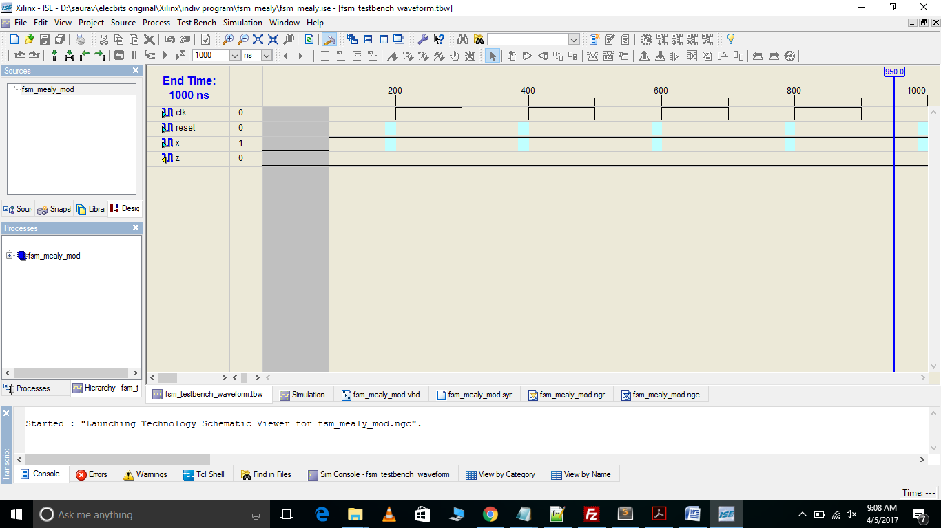

Stimulation  
  
