Finite State Machines

Finite State Machines

Introduction

Finite State Machines (FSM) are sequential circuit used in many digital systems to control the behavior of systems and dataflow paths. Examples of FSM include control units and sequencers. This lab introduces the concept of two types of FSMs, Mealy and Moore, and the modelling styles to develop such machines.

Objectives

After completing this lab, you will be able to:

- Model Mealy FSMs
- Model Moore FSMs

Mealy FSM Part 1

A finite-state machine (FSM) or simply a state machine is used to design both computer programs and sequential logic circuits. It is conceived as an abstract machine that can be in one of a finite number of user-defined states. The machine is in only one state at a time; the state it is in at any given time is called the current state. It can change from one state to another when initiated by a triggering event or condition; this is called a transition. A particular FSM is defined by a list of its states, and the triggering condition for each transition.

The behavior of state machines can be observed in many devices in modern society performing a predetermined sequence of actions depending on a sequence of events with which they are presented. Simple examples are vending machines which dispense products when the proper combination of coins are deposited, elevators which drop riders off at upper floors before going down, traffic lights which change sequence when cars are waiting, and combination locks which require the input of combination numbers in the proper order.

The state machines are modelled using two basic types of sequential networks- Mealy and Moore. In a Mealy machine, the output depends on both the present (current) state and the present (current) inputs. In Moore machine, the output depends only on the present state.

A general model of a Mealy sequential machine consists of a combinatorial network, which generates the outputs and the next state, and a state register which holds the present state as shown below. The state register is normally modelled as D flip-flops. The state register must be sensitive to a clock edge. The other block(s) can be modelled either using the always procedural block or a mixture of the always procedural block and dataflow modelling statements; the always procedural block will have to be sensitive to all inputs being read into the block and must have all output defined for every branch in order to model it as a combinatorial block. The two blocks Mealy machine can be viewed as
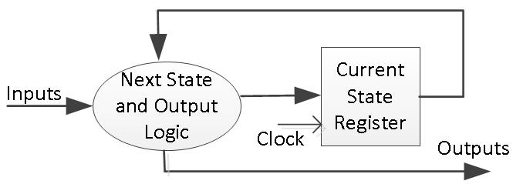

Here are the state diagram of a z checker Mealy machine and the associated model.

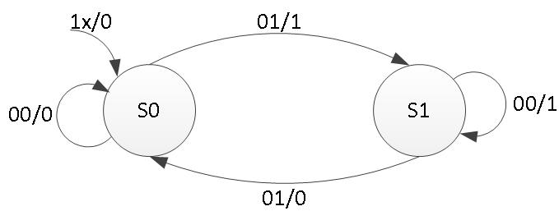

DEMUX is a combinational circuit that routes one input to various channels depending on the states. The states are defined by user in terms of binary input that is regulated by the type of DEMUX, for example the 2 X 4 DEMUX depends on 2 states and routes the output in 4 different outputs. In the above diagram, the states have values in the form of INPUT/OUTPUT, for example – input of S0 state is 00 and output is 0 and it goes back to its own state as shown in the diagram.
Analyzing the mealy circuit, we can say that it depends on both the output and next state. The output will change multiple times even for the same state depending upon the input. In a DEMUX the output is fixed and it cannot be changed with respect to the states, changing states can regulate output on different ports or channel but the value cannot be changed. So, a mealy circuit cannot be used to implement a DEMUX.

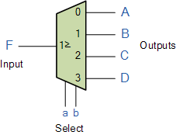
Moore FSM Part 2

A general model of a Moore sequential machine is shown below. Its output is generated from the state register block. The next state is determined using the present (current) input and the present (current) state. Here the state register is also modelled using D flip-flops. Normally Moore machines are described using three blocks, one of which must be a sequential and the other two can be modelled using always blocks or a combination of always and dataflow modelling constructs.

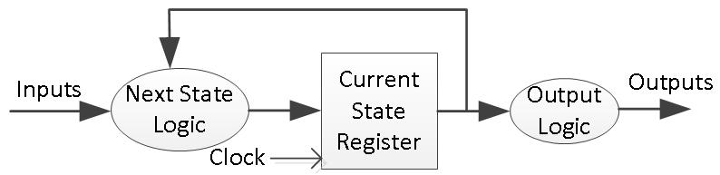

Here is the state graph of the same z checker to be modelled as a Moore machine. The associate model is shown below.
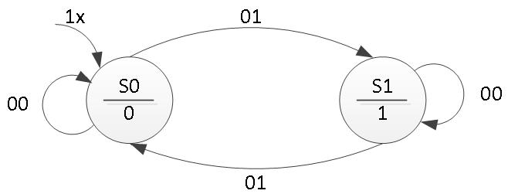

In Moore circuit, the output is dependent only on the next state and not on the output. They have a fixed output per state. The state has a stable output as shown in S0 has 0 and S1 has 1. In the consideration of DEMUX, the output is required to be fixed instead of depending on the inputs.
Hence the DEMUX structure can be implemented only in the Moore circuit.

Current State | Next State |  | Output
 | Input = 00 | Input = 01
S0 | S0 | S1 | 0
S1 | S1 | S1 | 1

