**PROJECT REPORT ON**

**“PC based control of dc motor”**

**Submitted in Partial Fulfillment of the Requirements**

**For the Award**

**Of**

**Degree of B. Tech**

**To**



**University,**

**Under the Guidance of**

**Submitted By:**

**\*Member1* *Member2\***

**\*Member3* *Member4\***



**Electronics and Communication Department**

**\*College Name\***

**CERTIFICATE**

We hereby certify that the work which is being presented in the project report entitled

**“PC BASED CONTROL OF DC MOTOR”** in the partial fulfillment of the requirements for the awardof **Bachelor of Tech.** in **Electronics and Communication Engineering** and submitted tothe **Electronics and Communication Engineering Department** of *College name*, Jaipur is an authentic record of my own work carried out during a period from **______ 2016 to _____ 2016**, under the guidance of **\*Coordinator name\***, Electronics and Communication Engineering Department. The matter presented in this project has not been submitted by us for the award of other degree elsewhere.

**\*Member1* *Member2\***

**\*Member3* *Member4\***

This is to certify that the above statement made by the candidate is correct to the best of our knowledge.

**(Project Coordinator) (Project Mentor)**

**(Project Coordinator) (H.O.D. ECE Department)**

**(Project Coordinator)**

**ACKNOWLEDGEMENT**

We would like to acknowledge the contributions of the following people, without whose help and guidance this project would not have been completed.

We acknowledge the counsel and support of our project mentor *Coordinator Name*, Electronics and Communication Engineering Department, with respect and gratitude whose expertise, guidance, support, encouragement, and enthusiasm has made this project possible. His feedback vastly improved the quality of this report and provided an enthralling experience. I am indeed proud and fortunate to be supervised by her.

We are also thankful to **H.O.D.** Electronics and Communication Engineering Department, *College Name\***,** New Delhi for his constant encouragement, valuable suggestions and moral support and blessings.

We shall ever remain indebted to the faculty members of **\*College Name*,.**

Finally, yet importantly, we would like to express our heartfelt thanks to our friends/classmates for their help and wishes for successful completion of this project. This acknowledgement will remain incomplete if we fail to express our deep sense of obligation to our parents and god for their consistent blessings and encouragement.

**\*Member1* *Member2\***

**\*Member3* *Member4\***

**CONTENTS**

certificatei

acknowledgementii

abstract1

introduction2

hardware and software requirements3

hardware used3

JUMPER WIRES3

RFID EM 187

RFID TAGS8

ARDUINO UNO10

*FEMALE HEADER PIN*S*10*

SERVO MOTORS3

BUZZER7

PCB PLATE8

software used11

ARDUINO SDK13

block diagram21

BREADBOARD diagram22

schematic diagram22

working25

conclusion25

appendix a21

code for the project 21

references27

1. **ABSTRACT**

This project is about how to make a wireless home security system using RFID (RADIO FREQUENCY IDENTIFICATION). All home security systems work on the same basic principle of securing entry points, like doors and windows, as well as interior space containing valuables like art, computers, guns, and coin collections. Regardless of the size of your home, or the number of doors and windows or interior rooms a homeowner decides to protect, the only real difference is in the number of security components deployed throughout the home and monitored by the control panel. In this project, Servo motors are used to lock doors of the house and can be opened only with the use of Correct RFID Tags

Until the correct RFID Tag is shown, the doors will remain lock. Whenever anyone tries to enter in the house he need to swap the correct RFID card therefore only the ones with the correct Tag will be able to enter. If the wrong tag is shown then the system will get locked and alarm will be activated.

* **ABOUT RFID**

RFID stands for Radio-Frequency Identification. The acronym refers to small electronic devices that consist of a small chip and an antenna. The chip typically is capable of carrying 2,000 bytes of data or less. The RFID device serves the same purpose as a bar code or a magnetic strip on the back of a credit card or ATM card; it provides a unique identifier for that object. And, just as a bar code or magnetic strip must be scanned to get the information, the RFID device must be scanned to retrieve the identifying information.

#### RFID Works Better Than Barcodes

A significant advantage of RFID devices over the others mentioned above is that the RFID device does not need to be positioned precisely relative to the scanner. We're all familiar with the difficulty that store checkout clerks sometimes have in making sure that a barcode can be read. And obviously,

* **WORKING PRINCIPLE**

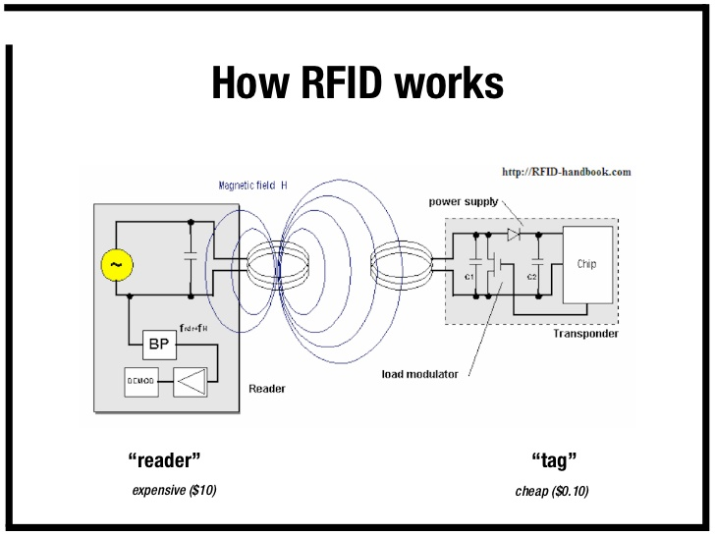

In this project, Servo motors are used to lock doors of the house and can be opened only with the use of Correct RFID Tags

Until the correct RFID Tag is shown, the doors will remain lock. Whenever anyone tries to enter in the house he need to swap the correct RFID card therefore only the ones with the correct Tag will be able to enter. If the wrong tag is shown then a warning system will be activated and if the wrong tag is shown 3 times, the system will get locked and alarm will be activated.

1. **HARDWARE AND SOFTWARE REQUIREMENTS**
   1. **HARDWARE USED**

The Hardware which can be employed to implement the code generated in this project is listed below:

* Jumper wires
* Arduino uno
* RFID EM18 Module
* RFID tags
* Female header pins
* Servo motor
* Buzzer
* PCB plate
  + 1. **JUMPER WIRES**

A jump wire (also known as jumper, jumper wire, jumper cable, DuPont wire, or DuPont cable – named for one manufacturer of them) is an electrical wire or group of them in a cable with a connector or pin at each end (or sometimes without them – simply "tinned"), which is normally used to interconnect the components of a breadboard or other prototype or test circuit, internally or with other equipment or components, without soldering.

Individual jump wires are fitted by inserting their "end connectors" into the slots provided in a breadboard, the header connector of a circuit board, or a piece of test equipment.

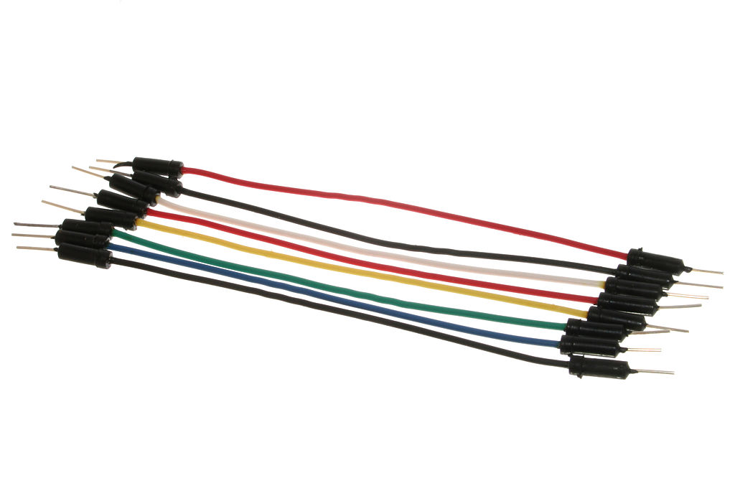

Figure Jumper wires

* + 1. **ARDUINO UNO**

Arduino is an open-source project that created microcontroller-based kits for building digital devices and interactive objects that can sense and control physical devices.

The project is based on microcontroller board designs, produced by several vendors, using various microcontrollers. These systems provide sets of digital and analog input/output (I/O) pins that can interface to various expansion boards (termed shields) and other circuits. The boards feature serial communication interfaces, including Universal Serial Bus (USB) on some models, for loading programs from personal computers. For programming the microcontrollers, the Arduino project provides an integrated development environment (IDE) based on a programming language named Processing, which also supports the languages C and C++.

The first Arduino was introduced in 2005, aiming to provide a low cost, easy way for novices and professionals to create devices that interact with their environment using sensors and actuators. Common examples of such devices intended for beginner hobbyists include simple robots, thermostats, and motion detectors.

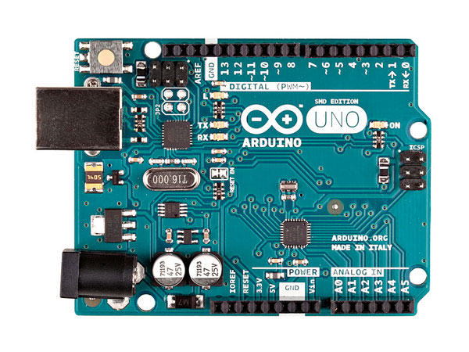

* + 1. **RFID EM 18 MODULE**

[EM-18 RFID reader](https://electrosome.com/shop/em-18-rfid-reader-module/) is one of the commonly used [RFID](https://electrosome.com/rfid-radio-frequency-identification/) reader to read 125KHz tags. It features low cost, low power consumption, small form factor and easy to use. It provides both UART and Wiegand26 output formats. It can be directly interfaced with microcontrollers using UART and with PC using an RS232 converter.

The module radiates 125KHz through its coils and when a 125KHz passive RFID tag is brought into this field it will get energized from this field. These passive RFID tags mostly consist of CMOS IC EM4102 which can get enough power for its working from the field generated by the reader.

By changing the modulation current through the coils, tag will send back the information contained in the factory programmed memory array.

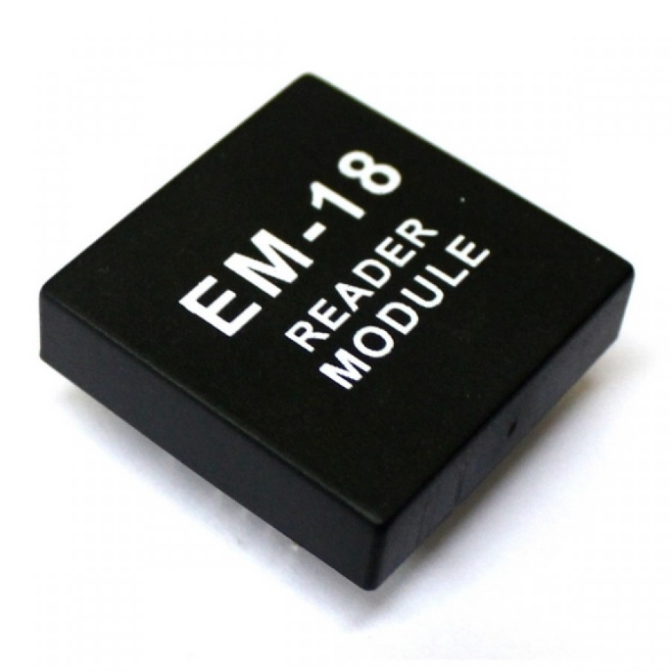

Figure EM18 MODULE

**3.1.5 RFID TAGS**

RFID tagging is an ID system that uses small radio frequency identification devices for identification and tracking purposes. An RFID tagging system includes the tag itself, a read/write device, and a host system application for data collection, processing, and transmission.

RFID tags that contain their own power source are known as active tags. Those without a power source are known as passive tags. A passive tag is briefly activated by the radio frequency ( RF ) scan of the reader. The electrical current is small -- generally just enough for transmission of an ID number. Active tags have more memory and can be read at greater ranges.

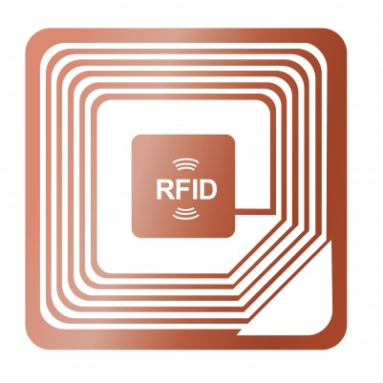

Figure RFID Tags

**3.1.6 FEMALE HEADER PINS**

Pin header connectors are thus "male" connectors ("female" counterparts do exist, but these are normally just called female header (FH) or header connector, without "pin") and are mostly used inside equipment, rather than being used as a connector on the outside of the device.

Figure Female Header Pins 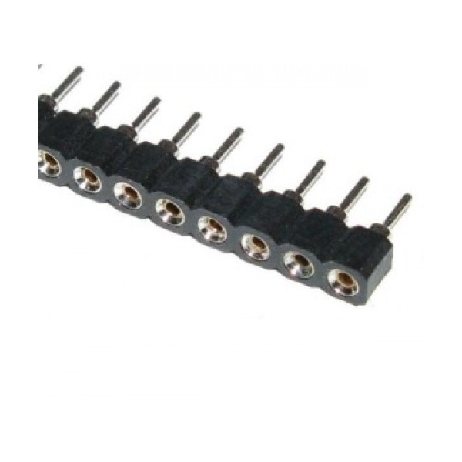

* + 1. **SERVO MOTOR**

Servo motors have been around for a long time and are utilized in many applications. They are small in size but pack a big punch and are very energy-efficient. These features allow them to be used to operate remote-controlled or radio-controlled toy cars, robots and airplanes. Servo motors are also used in industrial applications, robotics, in-line manufacturing, pharmaceutics and food services. The servo circuitry is built right inside the motor unit and has a positional shaft, which usually is fitted with a gear (as shown below). The motor is controlled with an electric signal which determines the amount of movement of the shaft.

To fully understand how the servo works, you need to take a look under the hood. Inside there is a pretty simple set-up: a small DC motor, potentiometer, and a control circuit. The motor is attached by gears to the control wheel. As the motor rotates, the potentiometer's resistance changes, so the control circuit can precisely regulate how much movement there is and in which direction it’s moving. When the shaft of the motor is at the desired position, power supplied to the motor is stopped. If not, the motor is turned in the appropriate direction. The desired position is sent via electrical pulses through the signal wire. The motor's speed is proportional to the difference between its actual position and desired position. So if the motor is near the desired position, it will turn slowly, otherwise it will turn fast. This is called proportional control. This means the motor will only run as hard as necessary to accomplish the task at hand, a very efficient little guy.

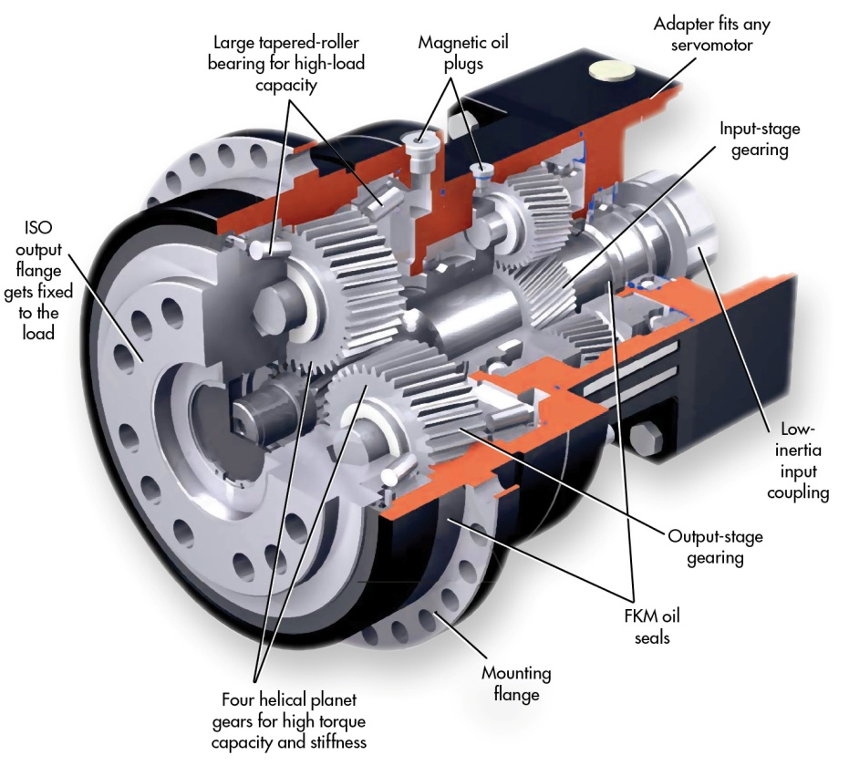

Figure Switch Servo Motor

* + 1. **BUZZER**

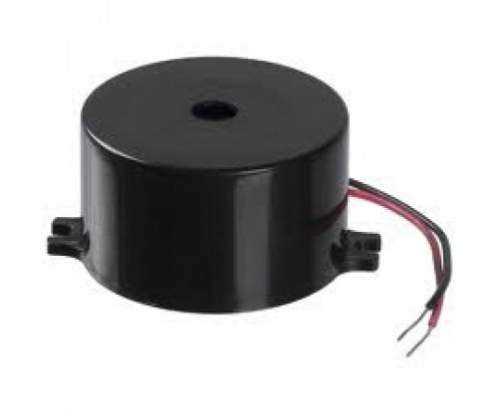It is an electrical device that makes a buzzing noise and is used for signaling.

Figure Buzzer

* + 1. **PCB (Printed Circuit Board)**

A printed circuit board (PCB) mechanically supports and electrically connects electronic components using conductive tracks, pads and other features etched from copper sheets laminated onto a non-conductive substrate. Components – capacitors, resistors or active devices – are generally soldered on the PCB.

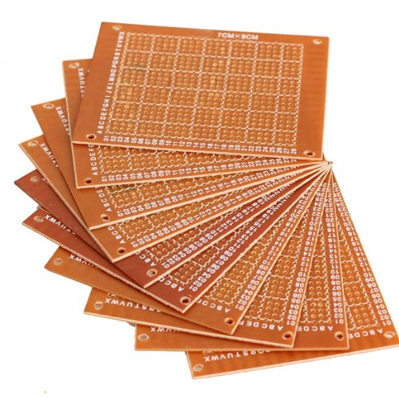

Figure PCB

**3.2.0 Lcd display 16*2**

LCD (Liquid Crystal Display) screen is an electronic display module and find a wide range of applications. A 16x2 LCD display is very basic module and is very commonly used in various devices and circuits. These modules are preferred over [seven segments](http://www.engineersgarage.com/content/seven-segment-display) and other multi segment [LED](http://www.engineersgarage.com/content/led)s. The reasons being: LCDs are economical; easily programmable; have no limitation of displaying special & even [custom characters](http://www.engineersgarage.com/microcontroller/8051projects/create-custom-characters-LCD-AT89C51) (unlike in seven segments), [animations](http://www.engineersgarage.com/microcontroller/8051projects/display-custom-animations-LCD-AT89C51) and so on.

A **16x2 LCD** means it can display 16 characters per line and there are 2 such lines. In this LCD each character is displayed in 5x7 pixel matrix. This LCD has two registers, namely, Command and Data.

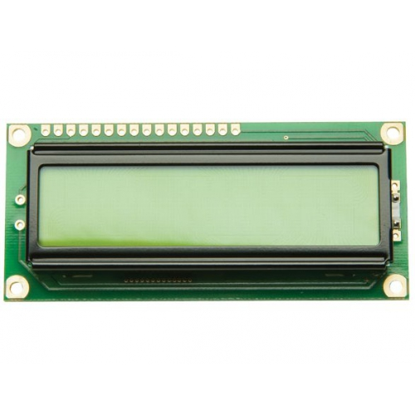

* 1. **SOFTWARE USED**
* **Arduino IDE**

The Arduino Integrated Development Environment - or Arduino Software (IDE) - contains a text editor for writing code, a message area, a text console, a toolbar with buttons for common functions and a series of menus. It connects to the Arduino and Genuino hardware to upload programs and communicate with them.

### Writing Sketches

Programs written using Arduino Software (IDE) are called sketches. These sketches are written in the text editor and are saved with the file extension .ino. The editor has features for cutting/pasting and for searching/replacing text. The message area gives feedback while saving and exporting and also displays errors. The console displays text output by the Arduino Software (IDE), including complete error messages and other information. The bottom righthand corner of the window displays the configured board and serial port. The toolbar buttons allow you to verify and upload programs, create, open, and save sketches, and open the serial monitor.

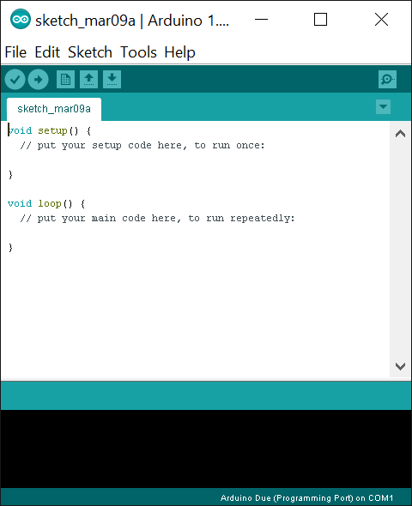

1. **BLOCK DIAGRAM**

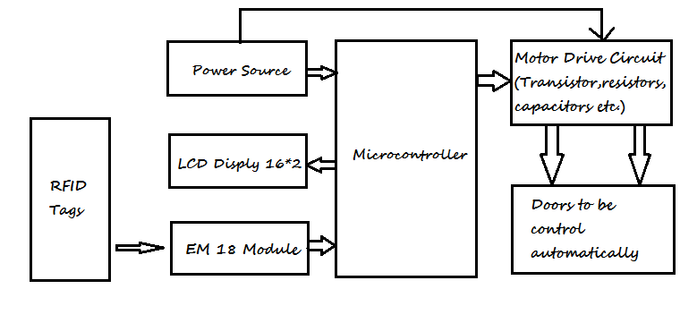

1. **BREADBOARD DIAGRAM**

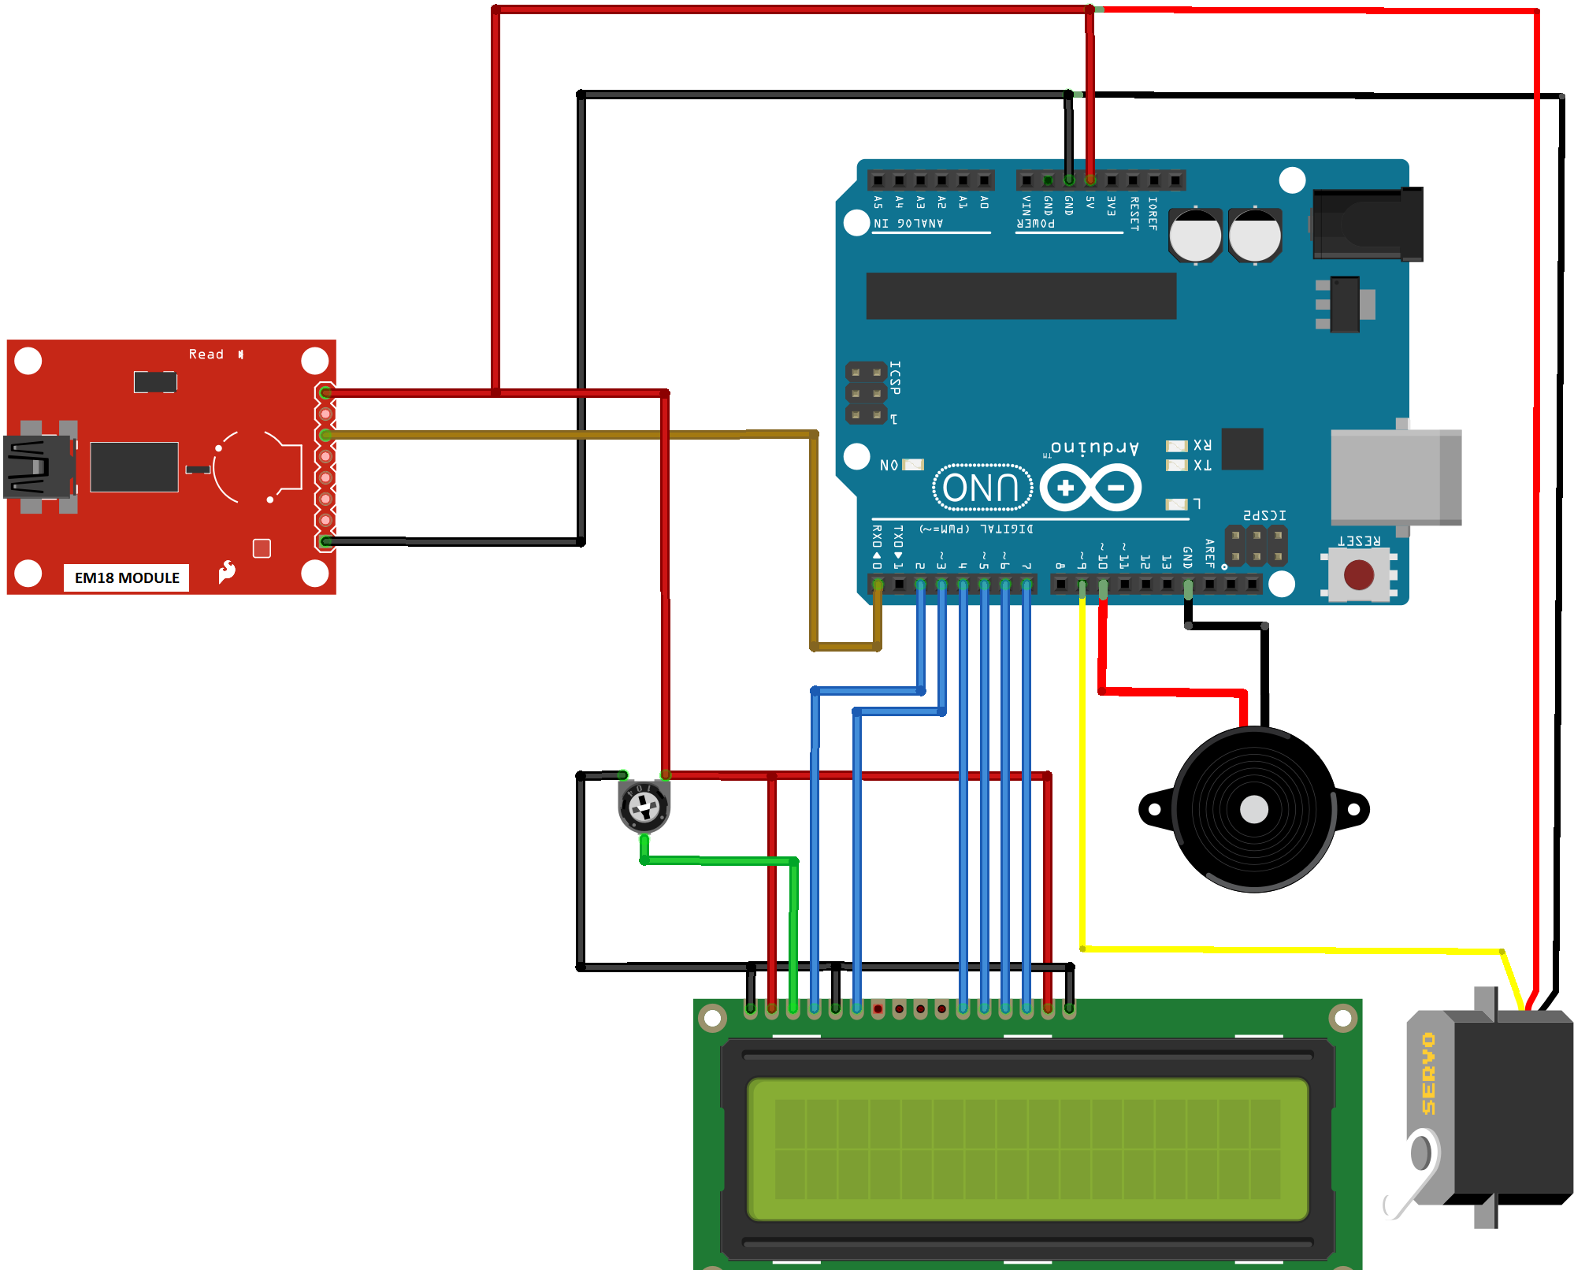

1. **SCHEMATIC DIAGRAM**

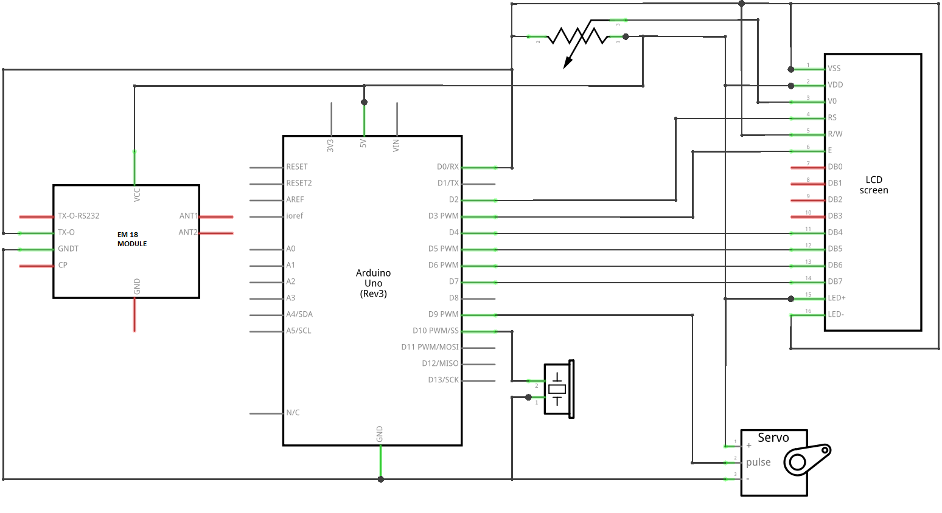

* **WORKING OF THE PROJECT**

The working of this project mainly depends upon the EM18 Module and Arduino Microcontroller can be divided in the following points:

* Detection of RFID Tags
* Reading the value of the card
* Comparing the value of the card
* If the card is correct, Open Servo control
* If the card is incorrect, activate alarm

We will discuss above mentioned each point in brief now:

1. **Detection of RFID Tags**



The EM18 Module use in the project is responsible for the detection of the RFID Tags. Whenever a tag is moved close to this module, the ac current in the module transfer power wirelessly to the RFID Tag and reads the value on it and after that it send this value to the microcontroller.

1. **Reading the value of the card**

After the data is send to the microcontroller from the EM18 Module, the microcontroller reads this data and store the swiped card value into a string for further processing. The below mention part of the code is responsible for reading the value of the swiped cards:

if(Serial.available()) // check if card has been swiped

{

count = 0; // start reading card number

while(Serial.available() && count < 12) // Read 12 characters and store them in input array

{

input[count] = Serial.read(); // storing the card number

count++;

delay(5);

}

1. **Comparing the value of the card**

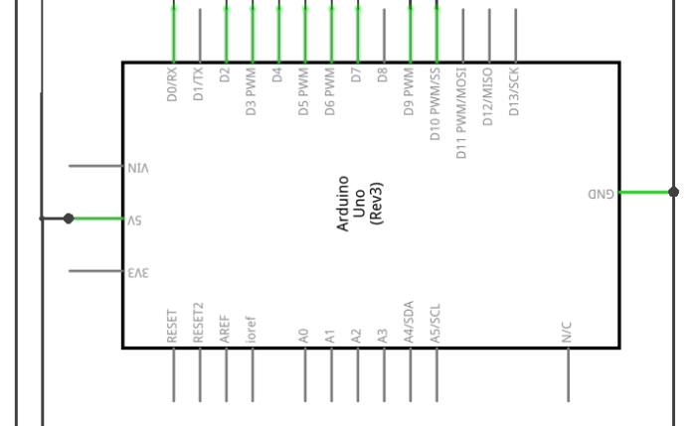

Once the card is swiped and read, the value is compared with the value of the valid card (the value of the valid card is already there in the code). All this processing is done by the microcontroller

1. **If the card is correct, open the servo control**



Once the value is checked and if the swiped card is valid one, the microcontroller signals the servo and servo is switched on.

1. **If the card is incorrect, activate alarm**



If the card is valid, servo changes its position for 10 seconds but if the swiped card is not the valid one, then the microcontroller activates the alarm.

All the above ongoing process such as opening and closing of doors, activation of alarm, etc. is showed on the LCD Screen.

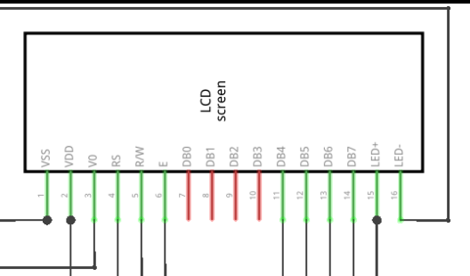

* **APPLICATIONS OF RFID TECHNOLOGY**

### RFID doesn’t need line of sight: RFID tags don’t need to be directly in sight of an RFID reader.

### An RFID tag is read/write: RFID tags can be read, and the data on the tag can be rewritten or modified as needed.

### RFID tags are durable and reusable: Depending on your application, you can find RFID tags specifically designed to work in harsh conditions.

### Data is encrypted: With RFID tags, your data is much more secure as the information has the ability to be encrypted.

### RFID tags are capable of storing more data: An RFID tag actually stores data in non-volatile memory and is capable of storing up to 8 kilobytes of data in certain tags.

### Read rate is greatly increased: Since RFID readers are capable of reading hundreds of tags at once, the increase in read rate saves you time that can be spent elsewhere.

* **APPENDIX A**
* **Code for the Project:**

#include <Servo.h> // servo library

Servo myservo; // variable to store the servo position

#include <LiquidCrystal.h> // lcd library

LiquidCrystal lcd(2,3,4,5,6,7); // lcd pins

int i = 0; // variable

int pos = 0; // variable to store the servo position

int buzzer = 9; // digital pin for buzzer

int count = 0; // variable count

char input[12]; // character array of size 12

boolean flag = 0;

boolean flag_2 = 0;

int card_1[10] = {48, 50, 48, 48, 52, 52, 55, 54, 53, 57 }; // number of valid card

void setup()

{

Serial.begin(9600); // serial communication starts

pinMode(buzzer, OUTPUT); // setting the buzzer pin as output

myservo.attach(10); // attaches the servo on pin 10 to the servo object

lcd.begin(16, 2); // defining lcd screen

lcd.setCursor(0,0); // setting cursor

lcd.print("Home Security"); // to print on lcd screen

lcd.setCursor(6,1); // setting cursor

lcd.print("Using RFID");

delay(2000); // to define delay

lcd.clear(); // clearing the lcd to write again

lcd.setCursor(0,0);

lcd.print("Please wait till");

lcd.setCursor(0,1);

lcd.print(" the servo sync");

for (pos = 180; pos >= 12; pos -= 1)

{

myservo.write(pos); // tell servo to go to position in variable 'pos'

delay(15);

}

lcd.clear();

lcd.setCursor(0,0);

lcd.print("Current Status :");

lcd.setCursor(5,1);

lcd.print("Door Closed");

}

void loop() // loop function starts

{

flag_2 = 0;

if(Serial.available()) // check if card has been swiped

{

count = 0; // start reading card number

while(Serial.available() && count < 12) // Read 12 characters and store them in input array

{

input[count] = Serial.read(); // storing the card number

count++;

delay(5);

}

lcd.clear();

lcd.setCursor(0,0);

lcd.print("Card Detected");

lcd.setCursor(0,1);

lcd.print("Chechking...");

delay(1000);

int i=0;

while(i<10) // check the card

{

if(input[i] != card_1[i] ) // if the swiped card is same as the valid card

flag_2 = 1;

++i;

}

if(flag_2 == 0) // if the card is right

{

for (pos = 12; pos <= 90; pos += 1) // goes from 12 degrees to 90 degrees in steps of 1 degree

{

myservo.write(pos); // tell servo to go to position in variable 'pos'

delay(15); // waits 15ms for the servo to reach the position

}

lcd.clear();

lcd.setCursor(0,0);

lcd.print("Door Opened");

lcd.setCursor(0,1);

lcd.print("Closing in : ");

for(i=9; i>0; i--) // loop to wait for 10 seconds before closing the door

{

lcd.setCursor(12,1);

lcd.print(i);

delay(900);

}

for (pos = 90; pos >= 12; pos -= 1) // goes from 90 degrees to 12 degrees in steps of 1 degree

{

myservo.write(pos); // tell servo to go to position in variable 'pos'

delay(15); // waits 15ms for the servo to reach the position

}

lcd.clear();

lcd.setCursor(0,0);

lcd.print("Current Status :");

lcd.setCursor(5,1);

lcd.print("Door Closed");

}

else // if the card is wrong

{

lcd.clear();

lcd.setCursor(0,0);

lcd.print("Wrong card ");

lcd.setCursor(0,1);

lcd.print("Alarm Activated");

tone(buzzer, 500); // activating alarm

delay(3000); // wait for 3 seconds

noTone(buzzer); // stop the alarm

lcd.clear();

lcd.setCursor(0,0);

lcd.print("Current Status :");

lcd.setCursor(5,1);

lcd.print("Door Closed");

}

}

delay(200); // wait 200 milliseconds for smooth functioning

} // repeat over again

* **REFERENCES**

<http://www.technovelgy.com/ct/technology-article.asp>

https://en.wikipedia.org/wiki/Radio-frequency_identification

<http://www.instructables.com/id/ARDUINO-WIRELESS-HOME-SECURITY-SYSTEM/>

<http://www.projectsof8051.com/home-security-system/>

<http://www.circuitsgallery.com/2012/09/home-security-alarm2.html>

http://blog.atlasrfidstore.com/rfid-vs-barcodes