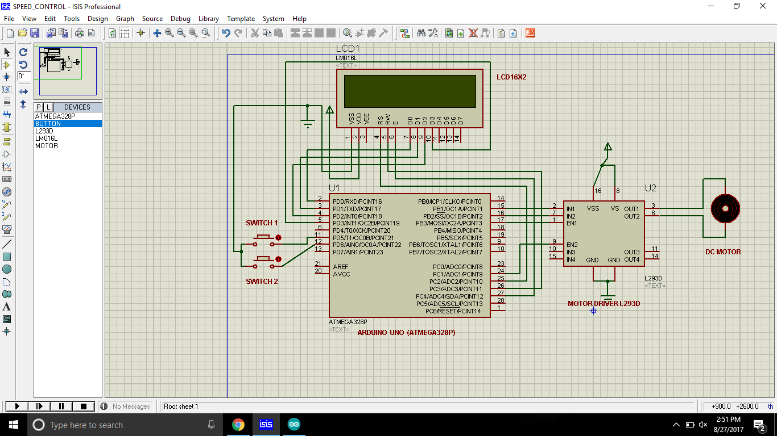

Fig1.0 Proteous design of the circuit

TO CONTROL THE SPEED OF THE DC MOTOR(AS GIVEN IN THE QUERY) , WE HAD TO USE PWM(PULSE WIDTH MODULATION)

Pulse Width Modulation, or PWM, is a technique for getting analog results with digital means. Digital control is used to create a square wave, a signal switched between on and off. This on-off pattern can simulate voltages in between full on (5 Volts) and off (0 Volts) by changing the portion of the time the signal spends on versus the time that the signal spends off. The duration of "on time" is called the pulse width. To get varying analog values, you change, or modulate, that pulse width.

In the graphic below, the green lines represent a regular time period. This duration or period is the inverse of the PWM frequency. In other words, with Arduino's PWM frequency at about 500Hz, the green lines would measure 2 milliseconds each. A call to [analogWrite](https://www.arduino.cc/en/Reference/AnalogWrite)() is on a scale of 0 - 255, such that analogWrite(255) requests a 100% duty cycle (always on), and analogWrite(127) is a 50% duty cycle (on half the time) for example.

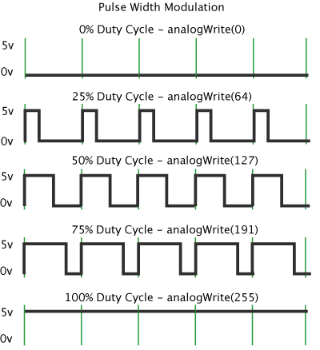

In the Above circuit design, as switch 1 is ON DC Motor starts rotating with full RPM ie complete +5 VOLT(upto 255) is provided.

If switch 2 is press the DC Motor rotates with half of the initial speed ie +2.5 volts(upto 127).