ADDITIONS WITH REFRENCES

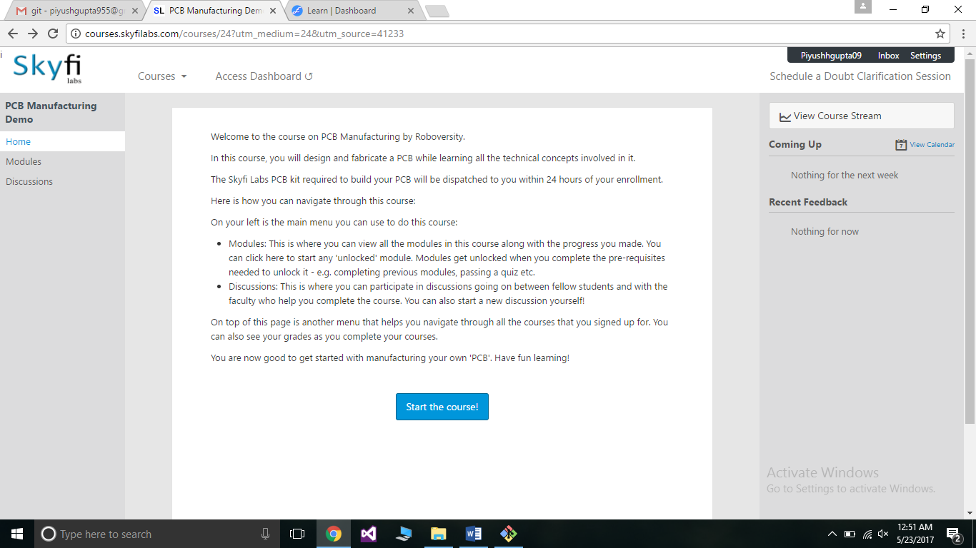

We have to add a side bar on the right side for the course stream to be displayed

We should also have link available for the doubt clarification session and this is very important .

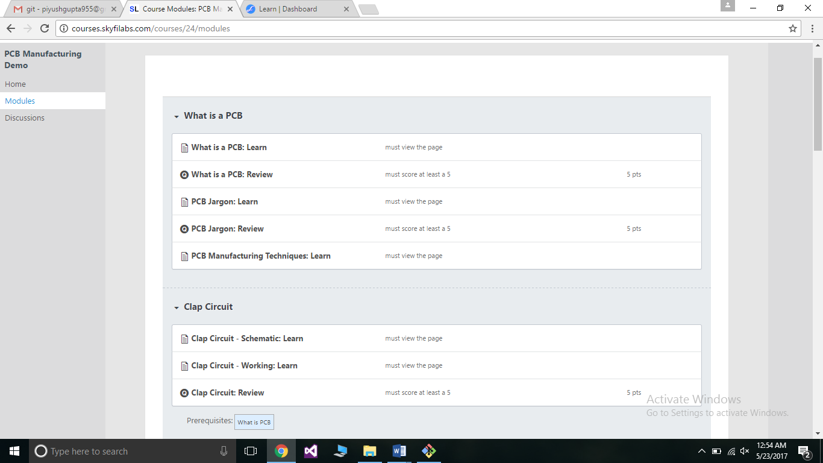

We should also add a modules page so that it can give complete insight of the course .

We must also add viedos with subtitles or captions to be more clear in the videos.

IMPROVEMENT WITH REFRENCES