**ADDITIONS WITH REFRENCES**

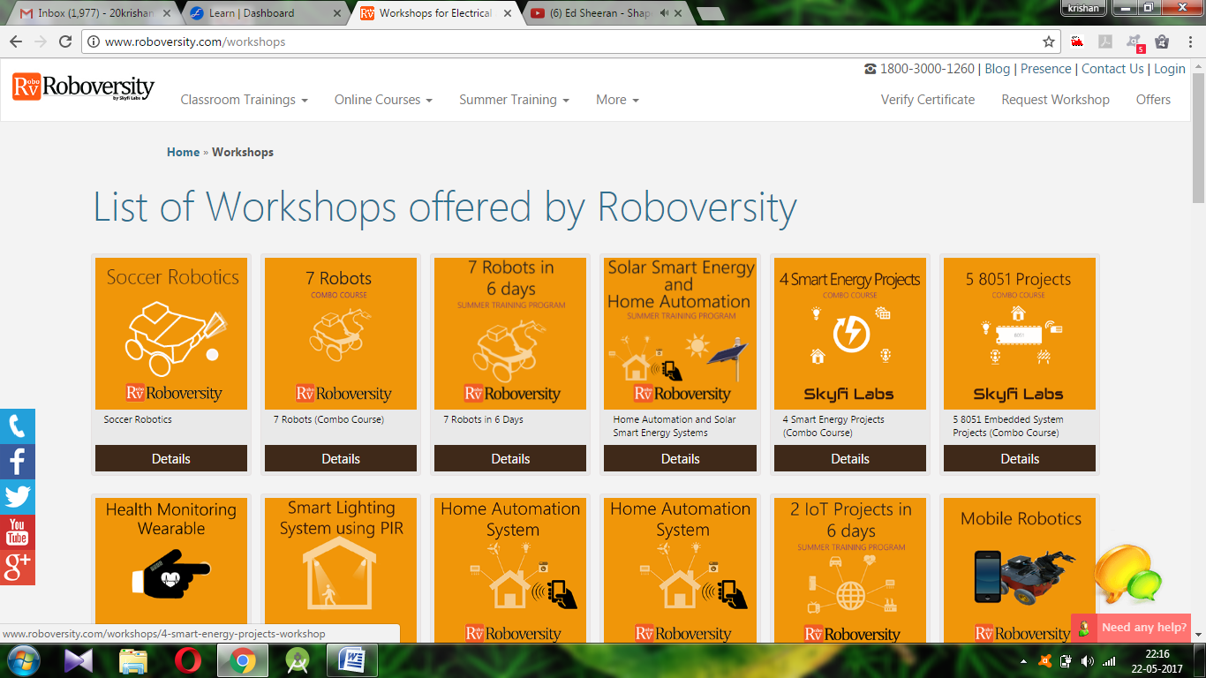

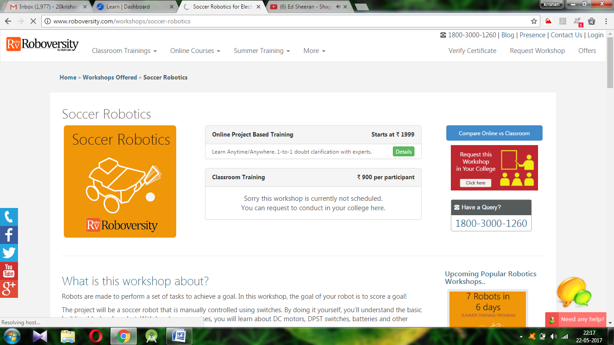

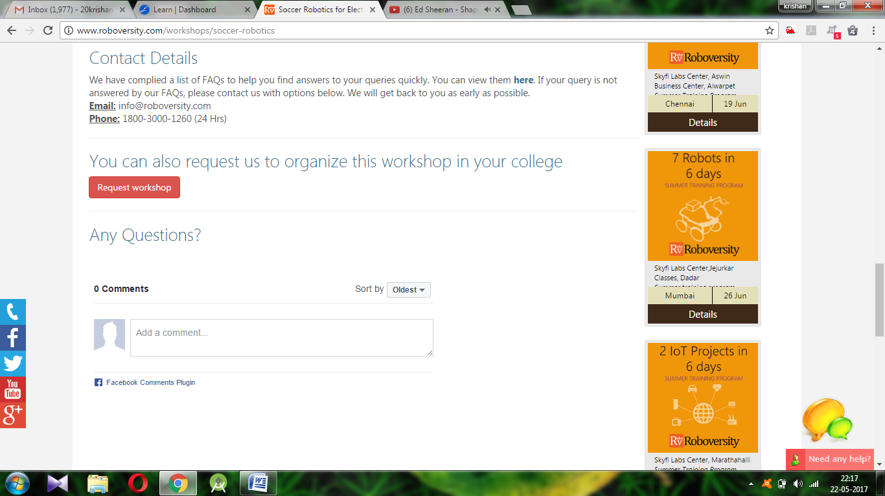

**IMPROVEMENT WITH REFRENCES**

The improvements that we need to implement are :-

1. We have to make a page for the projects so the user can choose from them rather than to go through other projects.

2.We have to implement the material design (everybody get the basic idea about material design).

3.We have to provide a comment section for the user.

4.The UI needs to be improved very very much guys and because only saurav has all the burden of it we all should try and give him codes for the sections like the square shapes the images and all other stuffs.

5.Videos are required

Lets start by making these changes then we could move on other changes.