

**COURSE DOCUMENT – A STEP GUIDE FOR DATA DOCUMENTATION**

* **TITLE OF THE PROJECT –(Max 6 words)**“Electronic Voting Machine”
* **CATEGORIES – (**Take reference from categories.txt**)**

1. Arduino/AVR Projects

2. Simple Electronics Projects

3. Security Based Projects

* **EASY HIGHLIGHTS (Max 10)**

1. Microcontroller Based
2. Uses Arduino for Programming
3. Self Explanatory Kit Available
4. How-to-make Videos Available
5. Synopsis Available
6. Complete File Available

**HARDWARE AND SOFT WARE-(Write as many as possible)**

Arduino Uno

16x2 LCD

Push button

Bread board

Power

Connecting wires

**SOFTWARE**

Microcontroller HEX File Uploader

* **ABSTRACT + DESCRIPTION**

“EVM or Electronic Voting machine is used to cast votes electronically. They are a secure machine and programmed using Arduino. When a person cast a vote to a particular party, the given segment gets incremented by 1. These machines are highly used in Elections and being tested regularly to maintain a fair result. ”

* **ABOUT THE TECHNOLOGY WE ARE USING**

“We have used four different candidates to implement this, though we can increase this number. When a voter press any of the required buttons the variable associated with that particular party gets incremented by 1. Circuit of this project is quite easy which contains Arduino, push buttons and LCD. Arduino controls the complete processes like reading button, incrementing vote value, generating result and sending vote and result to LCD.”

* **WORKING PRINCIPLE (100-200 words)**

“

”

* **APPLICATIONS -(Write as many as possible)**

➔ Fair and Secure Voting

➔ Automated Results

➔ A mobile device

➔ Accurate Result

.

* **REFRENCES -(Write as many as possible)**

<https://circuitdigest.com/microcontroller-projects/electronic-voting-machine-using-arduino>

<http://www.instructables.com/id/Arduino-Voting-machine/>

* **BLOCK DIAGRAM**

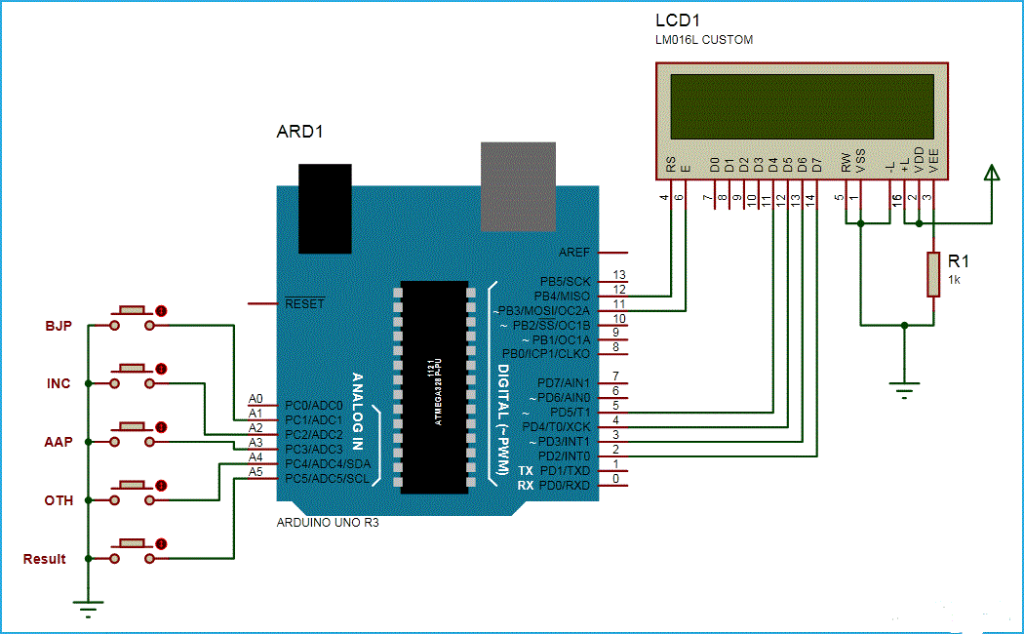

* **PROJECT IMAGE (ABSTRACT)  
    
  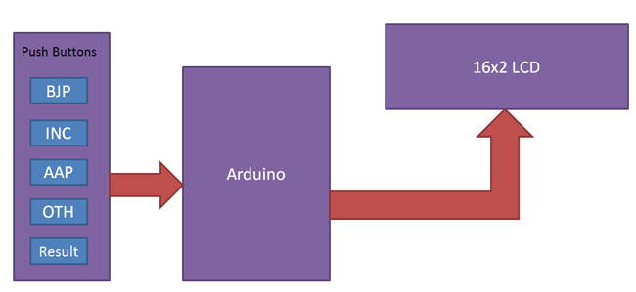**
* **Note :**

1. You can experiment new things on your own.

2. The word limit is just to provide a general idea of how much written part would be appropriate.

3. Block diagram: 2472 X 824 (Maintain a ratio 3:1)

4. Project Image: 400 X 300 (Maintain a ratio 4:3)

5. Image ratio is approx.