

**COURSE DOCUMENT – A STEP GUIDE FOR DATA DOCUMENTATION**

* **TITLE OF THE PROJECT –(Max 6 words)**“Gesture Control Robotic Vehicle”
* **CATEGORIES – (**Take reference from categories.txt**)**

1. Artificial Intelligence Projects

2. Gesture Control Projects

3. Communication Projects

4. Bluetooth Based Projects

* **EASY HIGHLIGHTS (Max 10)**

1. Uses Bluetooth Modules for Communication

2. Four Controls of Freedom

3. Respond according to the tilt of the hand

4. Self-Explanatory Kit Available

5. Synopsis Available

6. Project file available

* **HARDWARE AND SOFT WARE-(Write as many as possible)**

1. DC Motors
2. Capacitors
3. Resistors
4. Diodes
5. Connecting Wires
6. Jumper wires
7. General Purpose Board
8. Darlington Pair TIP122
9. HC-05 Bluetooth Module
10. Accelerometer sensor ADXL335

**SOFTWARE**

Microcontroller HEX File Uploader

* **ABSTRACT + DESCRIPTION**

“Nowadays, robotics is becoming one of the most advanced sectors the field of technology. The robotics are mainly involve in automobiles, medical, construction, defence and also used as a fire fighting robot to help people from fire accidents. But, controlling the robot with a remote or a switch is quite complicated. So, a new project is developed that is, an accelerometer based gesture control robot. The main goal of this project is to control the movement of the robot with hand gesture using accelerometer.

A gesture controlled robot using an accelerometer is one kind of robot which can be operated by the movement of hand by placing an accelerometer on it. This project is divided into two parts transmitter device and receiver device. Where a gesture device works as a transmitter device and a robot works as a receiver device. When a transmitting device (accelerometer) is placed on the hand, then it will send signals to the robot for the required operation.

In this project the robotic vehicle is controlled by using different gestures of human hand. The robotic vehicle movement in the respective directions that is left, right, front and backwards is controlled in accordance with tilting the hand in the respective directions.”

* **ABOUT THE TECHNOLOGY WE ARE USING**

“Gesture recognition is a topic in computer science and language technology with the goal of interpreting human gestures via mathematical algorithms. Gestures can originate from any bodily motion or state but commonly originate from the face or hand. Current focuses in the field include emotion recognition from face and hand gesture recognition. Many approaches have been made using cameras and computer vision algorithms to interpret sign language.

Gesture recognition enables humans to communicate with the machine (HMI) and interact naturally without any mechanical devices. Using the concept of gesture recognition, it is possible to point a finger at the computer screen so that the cursor will move accordingly.

Gesture recognition can be conducted with techniques from computer vision and image processing. The literature includes ongoing work in the computer vision field on capturing gestures or more general human pose and movements by cameras connected to a computer

In computer interfaces, two types of gestures are distinguished. We consider online gestures, which can also be regarded as direct manipulations like scaling and rotating. In contrast, offline gestures are usually processed after the interaction is finished; e. g. a circle is drawn to activate a context menu.”

* **WORKING PRINCIPLE (100-200 words)**

“This project is divided into two parts transmitter device and receiver device. Where a gesture device works as a transmitter device and a robot works as a receiver device. When a transmitting device (accelerometer) is placed on the hand, then it will send signals to the robot for the required operation.

Accelerometer based gesture controlled robot moves according to the movement of hand as we place the accelerometer on your hand. When we tilt hand with an accelerometer in front of the robot, then the robot starts moving forward until the next movement is given. When we tilt hand in backward direction, then the robot changes its direction and state. Then it starts moving in backward direction until the next signal is given. When we tilt hand on left side, then the robot moves into left side until the next signal is given. In the same way, when we tilt hand in right side, then the robot moves right side.”

* **APPLICATIONS -(Write as many as possible)**

➔ Switching Channels, Without A TV Remote

➔ Automated Homes

Connected using Wi-Fi, the gesture recognition system uses gestures such as waving your arms, punching, and kicking.

➔ Driving To Safety

more than gestures, the automobile industry has seen more sensor assistance, for blind-spot recognition, and parking assist.

➔ Gestures for Work

this one is for those workaholics who spend half their work life making presentations, and the other half presenting them.

* **REFRENCES -(Write as many as possible)**

https://en.wikipedia.org/wiki/Gesture_recognition

https://www.elprocus.com/accelerometer-based-gesture-control-robot/

http://www.engineersgarage.com/contribution/accelerometer-based-hand-gesture-controlled-robot

http://2embeddedrobotics.blogspot.in/2012/05/gesture-controlled-robot-is-kind-of.html

http://electronicsforu.com/electronics-projects/hardware-diy/wireless-gesture-controlled-robot

<http://electronicsforu.com/electronics-projects/hardware-diy/wireless-gesture-controlled-robot>

* **BLOCK DIAGRAM**

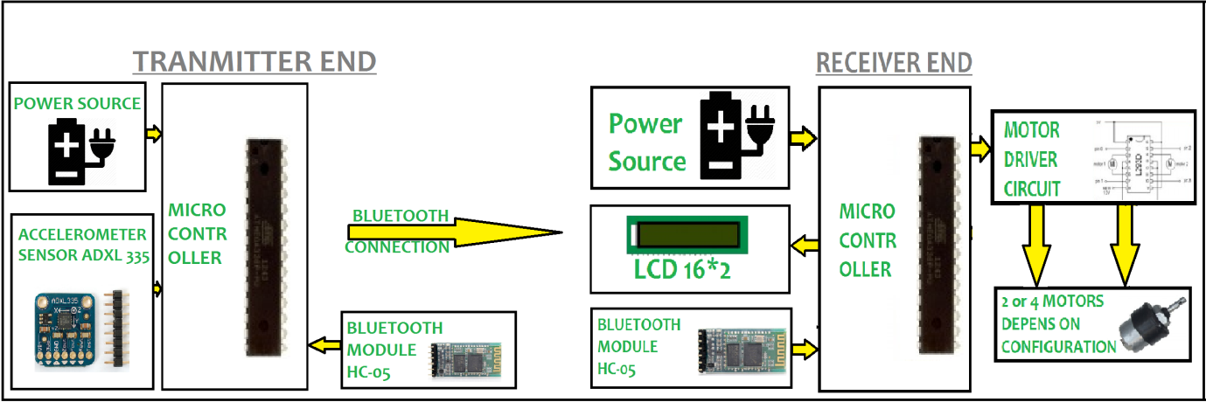

* **PROJECT IMAGE (ABSTRACT)  
  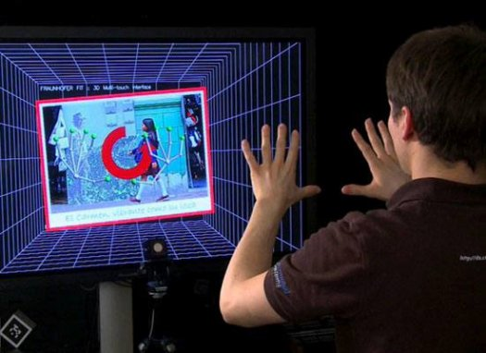**
* **Note :**

1. You can experiment new things on your own.

2. The word limit is just to provide a general idea of how much written part would be appropriate.

3. Block diagram: 2472 X 824 (Maintain a ratio 3:1)

4. Project Image: 400 X 300 (Maintain a ratio 4:3)

5. Image ratio is approx.