

**COURSE DOCUMENT – A STEP GUIDE FOR DATA DOCUMENTATION**

* **TITLE OF THE PROJECT –(Max 6 words)**“SMART TV using Raspberry Pi”
* **CATEGORIES – (**Take reference from categories.txt**)**

1. Raspberry Pi Projects

2. WiFi Projects

3. Without Microcontrollers

4. Advanced Projects

* **EASY HIGHLIGHTS (Max 10)**

1. Can convert an ordinary TV into Smart TV

2. Controlled via smart Phone

3. Can be used for using Internet on TV

4. Self-Explanatory Kit Available

5. Synopsis Available

6. Project file available

* **HARDWARE AND SOFT WARE-(Write as many as possible)**

1. Raspberry Pi
2. USB Wi-fi Adapter
3. Ethernet Cable
4. Power Supply

**SOFTWARE**

* Putty
* Xming
* Advanced IP scanner
* Microsoft Visual Studio
* Python IDE
* Kodi

**ABSTRACT + DESCRIPTION**

“The one thing which is persistent is change. We are changing rapidly and our television sets are not far behind in this race. Television sets are no longer just slave of few channels. The smart TV segment has millions of internet channels and can be controlled via network. Using Raspberry pi an ordinary TV can be converted into a smart TV”

* **ABOUT THE TECHNOLOGY WE ARE USING**

“Raspberry Pi a pocket sized computer which can be loaded with various kinds of operating systems. These operating systems provide the user an environment to develop and test different applications. One the application we’ll be using is KODI, made by XBOX Media Centre. Configuring the general connection, we can use the pi to install various plug-in and then operate them via phone application..”

* **WORKING PRINCIPLE (100-200 words)**

“For making any normal TV a smart TV we are using KODI, media centre for raspberry pi. The steps are as follows:

1. Go to site Openelec and click on the RPI2 ARMv7

2. Extract the downloaded file into the memory card.

3. Now go to applications and configure the system.

4. After configuring it into the memory card, connect TV screen with the raspberry pi using HDMI cable and power the raspberry pi with the help of micro USB.

5. To make it like a real TV, we need a remote control as well.

6. Download an application in your android app store.

7. For further connections and betterment of the TV, we need to alter some features in the mobile application such as host name and host port for connection with the WIFI network.

8. Edit host name and host port for the mobile application according to the Wi-Fi network for full wireless connection.

9. Now we are ready to play the media centre on any kind of normal TV.”

* **APPLICATIONS -(Write as many as possible)**

➔ Using Smartphone as TV remote

➔ It can be used to convert ordinary Monitors into fully functioning smart TVs.

➔ Can be used at public places to display information without connecting a heavy mechanism of complete computer set.

* **REFRENCES -(Write as many as possible)**

<https://www.raspberrypi.org/documentation/usage/kodi>

<http://kodi.wiki/view/HOW-TO:Install_Kodi_on_Raspberry_Pi>

<https://www.raspberrypi.org/documentation/usage/kodi/>

* **BLOCK DIAGRAM**

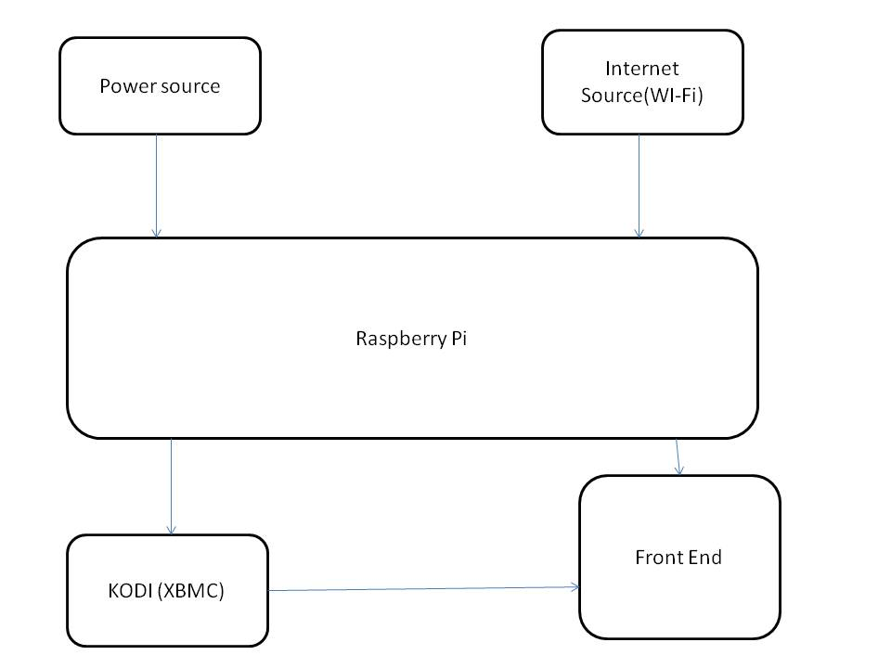

* **PROJECT IMAGE (ABSTRACT)  
  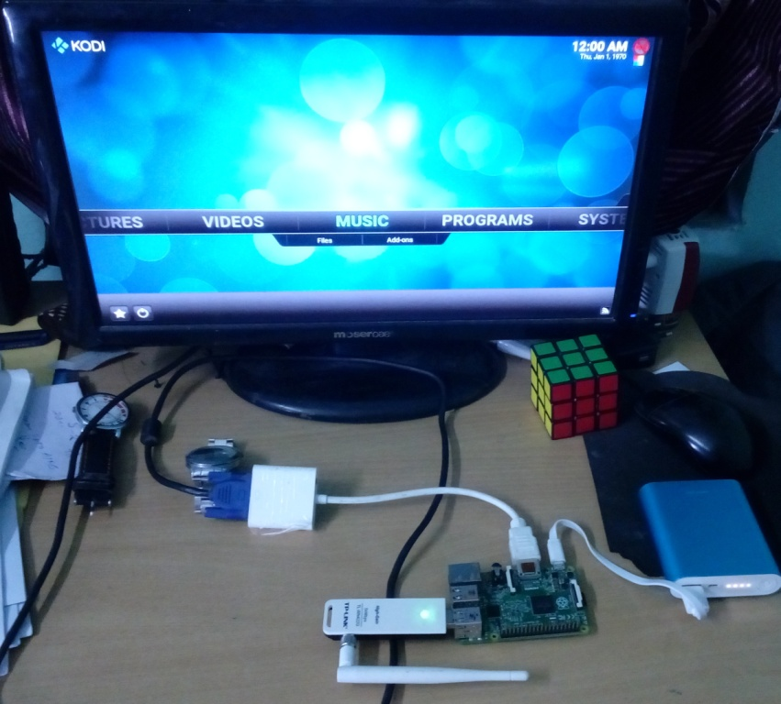**
* **Note :**

1. You can experiment new things on your own.

2. The word limit is just to provide a general idea of how much written part would be appropriate.

3. Block diagram: 2472 X 824 (Maintain a ratio 3:1)

4. Project Image: 400 X 300 (Maintain a ratio 4:3)

5. Image ratio is approx.