**PROJECT DEVELOPMENT AGREEMENT**

|  |  |
| --- | --- |
| **NAME OF THE PROJECT** | Water ATM Sensor Detection |
| **OWNER NAME** | Saurav Kumar |
| **OWNER CONTACT** | 8860394267 |
| **WHATSAPP CONTACT** | 9975612467 |
| **PROJECT ID** | ELRMD059043 |
| **LOCATION** | Delhi |
| **LAST DATE** | 27/12/2017 |
| **MAKER NAME** | AKASH DIXIT |
| **MAKER CONTACT** | 7415770162 |

**DESCRIPTION –**

A sensor that can help maintain water level in water ATM. Whenever the water gets beneath a given level the sensor triggers the GSM shield and that will send a message to the given authority to refill the tank. The authority contact can be updated using a keypad attached with the sensor.

**APPLICATION –**

1. **A water sensor that can trigger GSM shield.**
2. **A GSM shield that can send a SMS whenever there’s a trigger.**
3. **Reset the contact of the authority using the keypad attached to the Shield.**

**HARDWARE MATERIAL –** Water sensor,Arduino, GSM shield, keypad board.

**SOFTWARE MATERIAL –** Arduino IDE

**DEVELOPMENT PROCESS –**

* First take the Water sensor and connect it to arduino Uno.
* Then take GSM shield and insert in Arduino uno.
* Take keypad Board and connect it with arduino Uno
* Insert the simcard in GSM shield.
* Establish a connection between GSM module and the arduino.
* Program the arduino Board.

**TESTING PROCESS –**

* When water is full in the water ATM machine the water sensor is fully dipped in the water and it sensed by the sensor and sensor tells water is full so we will get positive response .Now when the water is low so sensor is not dipped so sensor gives the negative response.
* Now when we get negative response from the sensor then with the help of programming we activate the GSM module so GSM will send the message on the control authority mobile phone.
* So as control authority will get information regarding water empty then they will fill the water.
* And in the coding section we ask the user to enter the mobile number once .so when the user want to update the mobile number he/she can just press the reset switch in the arduino and code start running from the beginning so it will ask for new contact number again.

**CIRCUIT/SCHEMATIC DIAGRAM (ANY ONE) –**

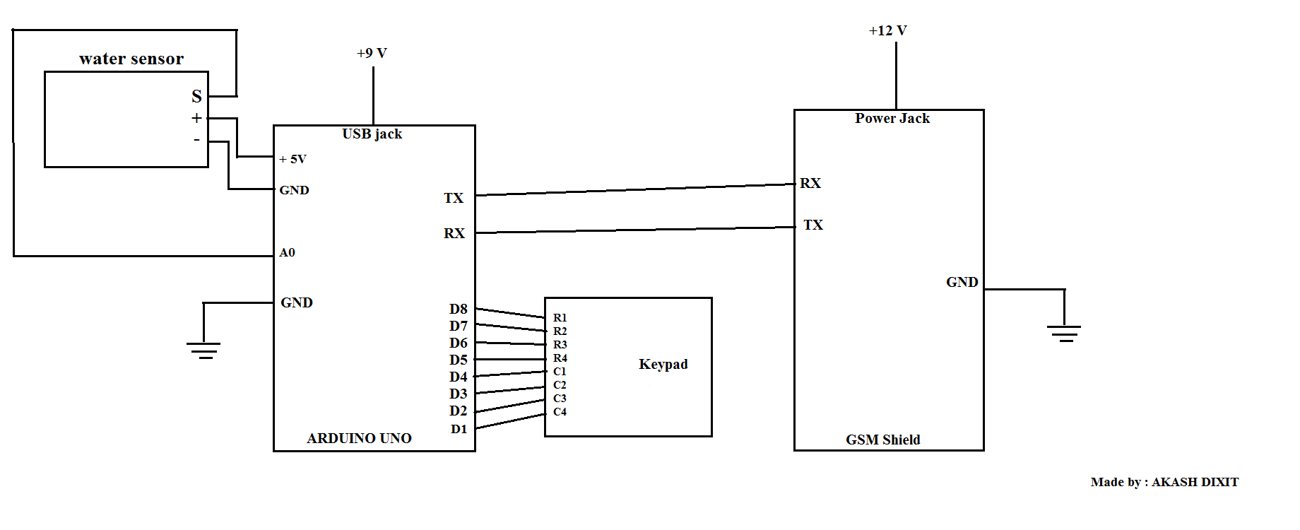

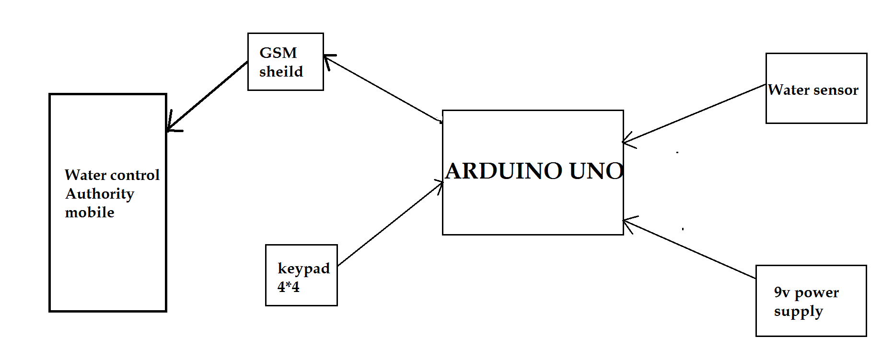**FLOW DIAGRAM -**