**PROJECT DEVELOPMENT AGREEMENT**

|  |  |
| --- | --- |
| **NAME OF THE PROJECT** | Water ATM Sensor Detection |
| **OWNER NAME** | Saurav Kumar |
| **OWNER CONTACT** | 8860394267 |
| **WHATSAPP CONTACT** | 9975612467 |
| **PROJECT ID** | ELRMD059043 |
| **LOCATION** | Delhi |
| **LAST DATE** | 27/12/2017 |
| **MAKER NAME** | Amol Disale |
| **MAKER CONTACT** | 7276913016 |

**DESCRIPTION –**

A sensor that can help maintain water level in water ATM. Whenever the water gets beneath a given level the sensor triggers the GSM shield and that will send a message to the given authority to refill the tank. The authority contact can be updated using a keypad attached with the sensor.

**APPLICATION –**

1. A water sensor that can trigger GSM shield.
2. A GSM shield that can send a SMS whenever there’s a trigger.
3. Reset the contact of the authority using the keypad attached to the Shield.

**HARDWARE MATERIAL –**

* Atmega328
* Water Level Float Sensor
* Membrane 4x3 Matrix Keypad
* GSM Module
* Power Supply Circuit
* Resistors, Capacitors, Crystal, IC Socket, Berg Strips, etc.
* Battery (if required)

**SOFTWARE MATERIAL –**

* Arduino IDE

**DEVELOPMENT PROCESS –**

* Testing the whole project using Arduino Uno and GSM Module
* Optimizing the code for better performance
* Testing the power supply circuit
* Designing the PCB
* Sourcing the components and ordering the PCB
* Burning the boot loader into the micro-controller so that it can be programmed serially
* Burning the firmware into the micro-controller
* Soldering the components

**TESTING PROCESS –**

* Testing for Hardware Fault e.g. open and closed circuit on the PCB
* Performance of the firmware e.g. is the code blocking somewhere

**CIRCUIT/SCHEMATIC DIAGRAM (ANY ONE) –**

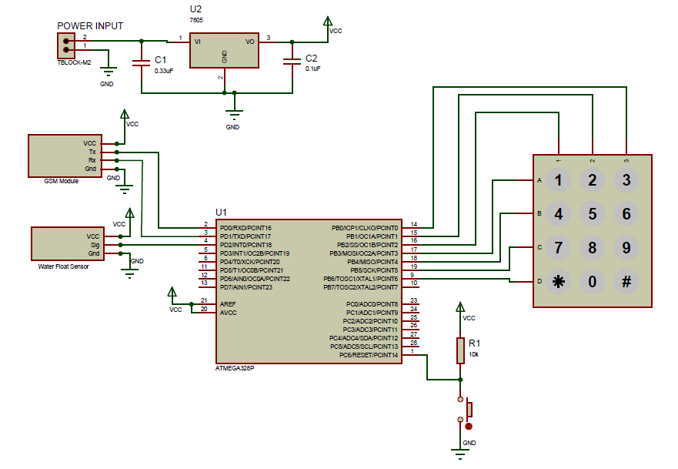

**FLOW DIAGRAM –**

