**PROJECT DEVELOPMENT AGREEMENT**

|  |  |
| --- | --- |
| **NAME OF THE PROJECT** | Water ATM Sensor Detection |
| **OWNER NAME** | Saurav Kumar |
| **OWNER CONTACT** | 8860394267 |
| **WHATSAPP CONTACT** | 9975612467 |
| **PROJECT ID** | ELRMD059043 |
| **LOCATION** | Delhi |
| **LAST DATE** | 27/12/2017 |
| **MAKER NAME** | Gagan Parmar |
| **MAKER CONTACT** | 7354565615 |

**DESCRIPTION –**

A sensor that can help maintain water level in water ATM. Whenever the water gets beneath a given level the sensor triggers the GSM shield and that will send a message to the given authority to refill the tank. The authority contact can be updated using a keypad attached with the sensor.

**APPLICATION –**

1. **A water sensor that can trigger GSM shield.**
2. **A GSM shield that can send a SMS whenever there’s a trigger.**
3. **Reset the contact of the authority using the keypad attached to the Shield.**

**HARDWARE MATERIAL – Arduino Uno Rev3, SIM 900D (GSM module), Ultrasonic Sensor (HC-SR04), Keypad**

**SOFTWARE MATERIAL – Proteus, Arduino IDE**

**DEVELOPMENT PROCESS –** The Ultrasonic Sensor module works on the natural phenomenon of ECHO of sound. A pulse is sent for about 10us to trigger the module. After which the module automatically sends 8 cycles of 40 KHz ultrasound signal and checks its echo. The signal after striking with an obstacle returns back and is captured by the receiver. Thus the distance of the obstacle from the sensor is simply calculated by the formula given as.

**Distance= (time x speed)/2.**

1. Total distance is divided by 2 because the total time is it took to reach the obstacle and return back
2. With increases of water level the distance calculated in decreases.
3. When tank of water ATM is completely filled, Initialization of GSM is done a message is sent using AT command to the saved numbers.

**TESTING PROCESS –**

For testing the ultrasonic sensor is mounted on measuring scale, when an obstacle is in front of it values get changed. So a set of values (ultrasonic sensor) is noted along with the distance measured using scale. On the basis of these readings. The Ultrasonic sensor is mounted over the top of water ATM tank. When it get emptied a message is sent to the authority using GSM module.

**CIRCUIT/SCHEMATIC DIAGRAM (ANY ONE) –**

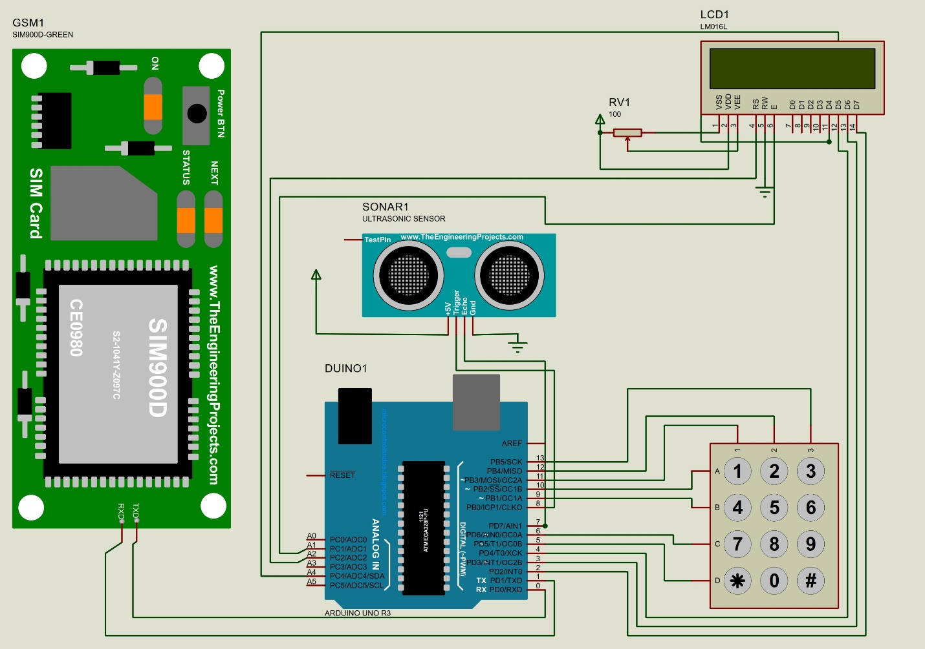

**FLOW DIAGRAM –**

1. In Setup initialization of ultrasonic sensor and GSM module is done.
2. 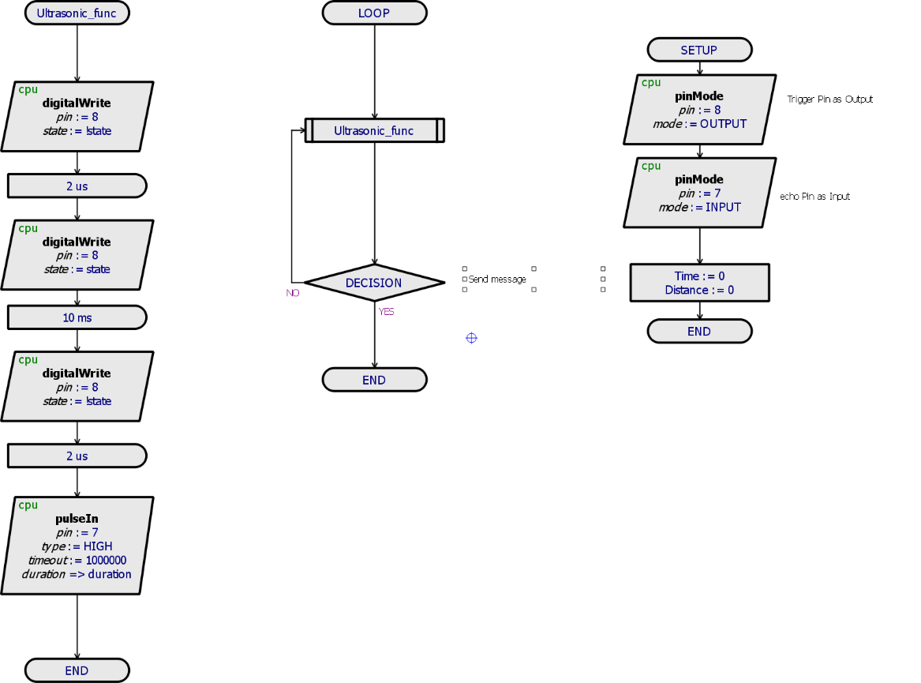In Ultrasonic subroutine, a pulse of 10us is sent to trigger the module.
3. By Reading echo pin distance between the obstacle and sensor is calculated.
4. Decision is taken on the basis of reading calculated a message is sent to authority using GSM module.