**PROJECT DEVELOPMENT AGREEMENT**

|  |  |
| --- | --- |
| **NAME OF THE PROJECT** | Ship Intrusion System Using 3 axis Accelerometer |
| **OWNER NAME** | Saurav Kumar |
| **OWNER CONTACT** | 8860394267 |
| **WHATSAPP CONTACT** | 9975612467 |
| **PROJECT ID** | ELRMD059046 |
| **LOCATION** | Delhi |
| **LAST DATE** | 27/12/2017 |
| **MAKER NAME** | AKASH DIXIT |
| **MAKER CONTACT** | 7415770162 |

**DESCRIPTION –**

Detecting waves generated by a small boat model using 3 axis accelerometer connected to Arduino Uno. Sending the data detected to laptop by a wireless module. Comparing the data detected with a data already stored.

**Points to ponder -**

1. In the ideal state the water will be having silent/uniform waveform.
2. The device will record the waves from a particular distance.
3. The motion of boat will have a particular range in order to generate waves in particular range.
4. The data can be sent using Bluetooth/Wi-Fi either by Http post or any other feasible method.

**APPLICATION –**

1. Whenever the boat will pass through water, waves will be created. Wave’s unit/range will be created using the device.
2. The device will wirelessly send the data to the system/database.
3. The localhost system will have a web based control panel that can be used to show reporting of the data and further analyze the activities in the water.
4. The data can be used to compare the identified boat and unidentified boat using their specific wave creation power based on their velocity.

**HARDWARE MATERIAL –** ARDUINO UNO (2 quantity ), Accelerometer (ADXL 345), Temperature Sensor (LM35), Reciver Zigbee, Transmitter Zigbee,9v Power supply.

**SOFTWARE MATERIAL –** Proteous ISIS, Arduino IDE, Microsoft Visiual Basic.

**DEVELOPMENT PROCESS –**

* Accelerometer sensor (ADXL 345) and LM35 Temperature sensor is used to detect the intrusion on the basis of distance and angle, So Place accelerometer and Temperature sensor at sea surface .
* Take one arduino uno and connect Accelerometer (ADXL 345) with it, accelerometer will sense the vibration and the shocks and send this data to the Arduino Uno board.
* Now we will connect Temperature Sensor (LM35) with same Arduino Uno. Here Temperature sensor will detect the temperature, which is used to detect the obstacle in the sea by sensing the surround temperature, now as ship will enter in our desired localized area temperature increases which is sensed by the temperature sensor.
* Now we will connect one Zigbee with same Arduino Uno board and this transmitter Zigbee take all the accelerometer data and tempreture sesnsor data and send it to the receiver Zigbee which is connected to another Arduino Uno.

**TESTING PROCESS –**

* We will test the circuit using the Microsoft Visual software which will give the output or the received data from Zigbee in the Graph form, so when there is no ship then the temperature is somewhat same near around and vibration is also constant just minute but when ship will enter in our desired area then Due to heat produce by the ship the surrounding temperature gets changed and which is detected by the temperature sensor and it sends data to the Arduino which transmit data to the transmitter zigbee which takes data and send it to the receiver zigbee wirelessly so receiver Zigbee takes the data and plot the graph in Microsoft Visual software and in the graph we can see if waveform started changing with high frequency then we can analyze that there is a ship nearby and same process is done for accelerometer data so that if ship comes there will be so many vibration and shocks so the waveform pattern start getting change so that we can figure out that ship is detected.

**SCHEMATIC / CIRCUIT DIAGRAM (ANY ONE) –**

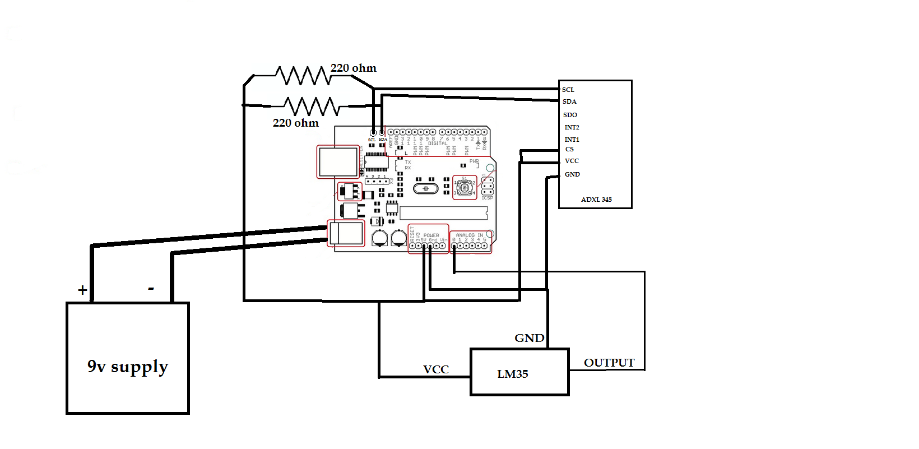

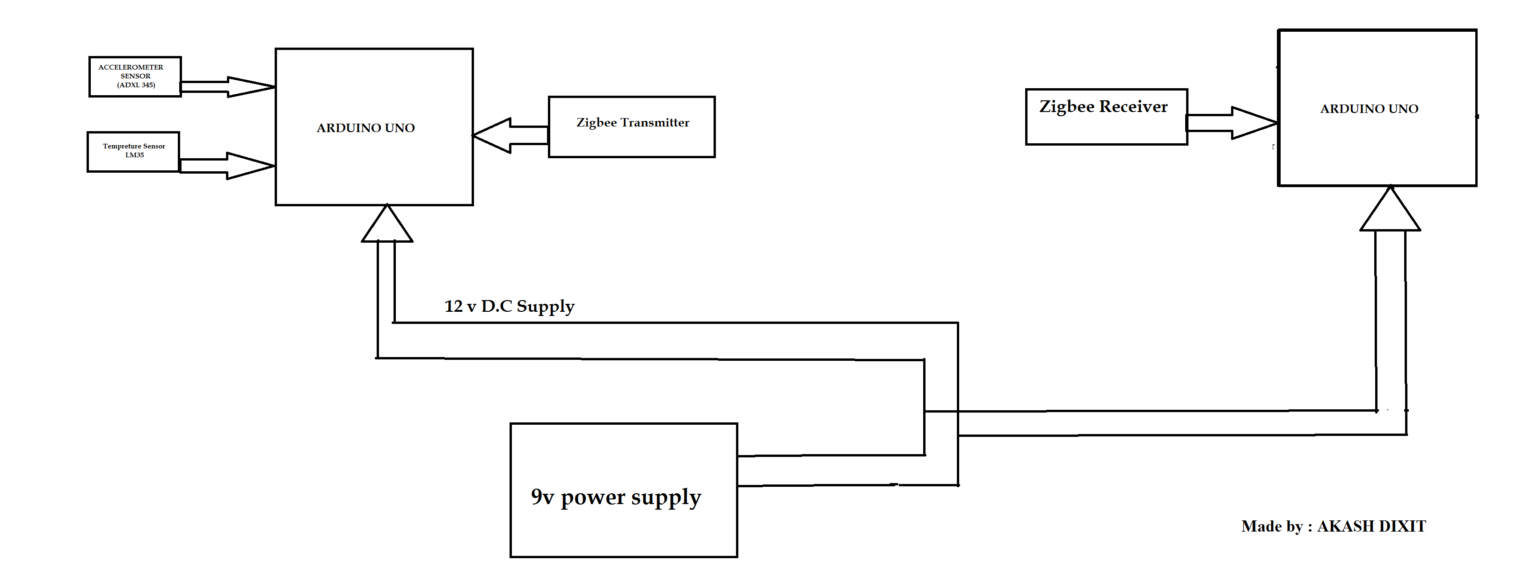**FLOW DIAGRAM -**