**PROJECT DEVELOPMENT AGREEMENT**

|  |  |
| --- | --- |
| **NAME OF THE PROJECT** | Ship Intrusion System Using 3 axis Accelerometer |
| **OWNER NAME** | Saurav Kumar |
| **OWNER CONTACT** | 8860394267 |
| **WHATSAPP CONTACT** | 9975612467 |
| **PROJECT ID** | ELRMD059046 |
| **LOCATION** | Delhi |
| **LAST DATE** | 27/12/2017 |
| **MAKER NAME** | ISHAN GULATI |
| **MAKER CONTACT** | 9582271558 |

**DESCRIPTION –**

Detecting waves generated by a small boat model using 3 axis accelerometer connected to Arduino Uno. Sending the data detected to laptop by a wireless module. Comparing the data detected with a data already stored.

Points to ponder -

1. In the ideal state the water will be having silent/uniform waveform.
2. The device will record the waves from a particular distance.
3. The motion of boat will have a particular range in order to generate waves in particular range.
4. The data can be sent using Bluetooth/Wi-Fi either by Http post or any other feasible method.

**APPLICATION –**

1. Whenever the boat will pass through water, waves will be created. Wave’s unit/range will be created using the device.
2. The device will wirelessly send the data to the system/database.
3. The localhost system will have a web based control panel that can be used to show reporting of the data and further analyze the activities in the water.
4. The data can be used to compare the identified boat and unidentified boat using their specific wave creation power based on their velocity.

**HARDWARE MATERIAL –LCD,ULTRASONIC SENSOR,MICROCONTROLLER,AXIS SENSOR,ZIGBEE,BUZZER,GSM.**

**SOFTWARE MATERIAL – LAB VIEW OR MATLAB, ARDUINO 1.8**

**DEVELOPMENT PROCESS –** Equipped with ultrasonic sensors, deploy an experimental WSN (Wireless Sensor Networks) on the sea’s surface to detect ships. This will be intimated to the microcontroller by emitting digital signal from the sensors. . These digital signals will be formed as a packet consisting of date, time and node id will be sent to the server node using Zigbee. The server will receive this signal using Zigbee in the receiving side and it will be displayed in LabVIEW software. An alert message will be sent to control room using GSM. The conducted evaluations with real data collected in our initial experiments, and provide quantitative analysis of the detection system, such as the successful detection ratio, detection latency, and an estimation of an intruding vessel’s velocity.

It is used to detect the obstacle in the sea and measure the distance. Here by using step down transformer to convert 230V AC supply into 12V AC supply. Using the bridge rectifier, AC signal is converted to DC signal and to reduce the ripple, capacitor of 1000µf is used. IC 7805 voltage regulator is used for converting the 12V into 5V for the input. The input of the ultrasonic sensor and accelerometer sensor is given to the microcontroller. If the intruder is present, the distance of the obstacle and the measured angle is displayed in LCD. Power driver is used to convert low voltage into high voltage for indication. From the microcontroller the output signal is transmitted through Zigbee and this signal will be intimated to the microcontroller by emitting digital signal from the sensors. These digital signals will be formed as a packet consisting of date, time and node id will be sent to the server node using Zigbee. The server will receive this signal from Zigbee in the receiver side and it will be displayed by LabVIEW software. An alert message will be sent to control room using GSM and the database can be maintained in the personal computer.

**TESTING PROCESS –** If the ship arrives, when the sensor senses the value above the set value alert levels is indicated. During the normal conditions the sensors does not detect any of the values that are greater than the set limit. It refers that the uniform oscillations of the normal sea waves and it visually monitors that there is no change in the values. There are two alert levels. The first level indication is accelerometer sensor, with this input we cannot able to predict the intruder. So with the ultrasonic sensor as second level indication we able to decide that there is an intruder present in the border. The variations of ultrasonic and accelerometer sensors can be noted down. According to the sensor values the alert level gets automatically active and buzzers are used to indicate the presences of intruder in the sea.

**SCHEMATIC / CIRCUIT DIAGRAM (ANY ONE) –**

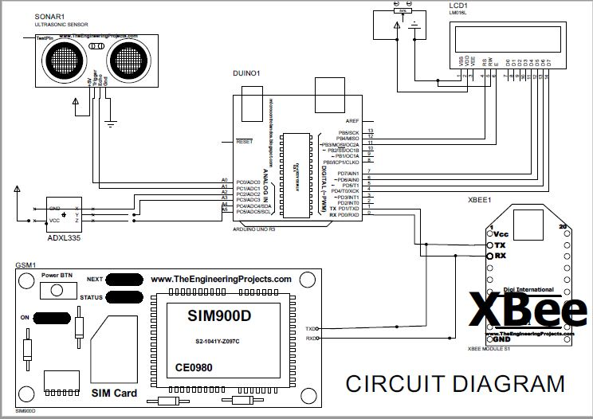

**FLOW DIAGRAM –**

POWER SUPPLY

LCD

ULTRASONIC SENSOR

ACCELEROMETER

GSM

BUZZER

ZIGBEE/BLUETOOTH

MICRO-CONTROLLER