**PROJECT DEVELOPMENT AGREEMENT**

|  |  |
| --- | --- |
| **NAME OF THE PROJECT** | Ship Intrusion System Using 3 axis Accelerometer |
| **OWNER NAME** | Saurav Kumar |
| **OWNER CONTACT** | 8860394267 |
| **WHATSAPP CONTACT** | 9975612467 |
| **PROJECT ID** | ELRMD059046 |
| **LOCATION** | Delhi |
| **LAST DATE** | 27/12/2017 |
| **BID WITH OUR COMPONENTS** | 4400 |
| **BID WITH YOUR OWN COMPONENTS** | 6400 |

**DESCRIPTION –**

Detecting waves generated by a small boat model using 3 axis accelerometer connected to Arduino Uno. Sending the data detected to laptop by a wireless module. Comparing the data detected with a data already stored.

Points to ponder -

1. In the ideal state the water will be having silent/uniform waveform.
2. The device will record the waves from a particular distance.
3. The motion of boat will have a particular range in order to generate waves in particular range.
4. The data can be sent using Bluetooth/Wi-Fi either by Http post or any other feasible method.

**APPLICATION –**

1. Whenever the boat will pass through water, waves will be created. Wave’s unit/range will be created using the device.
2. The device will wirelessly send the data to the system/database.
3. The localhost system will have a web based control panel that can be used to show reporting of the data and further analyze the activities in the water.
4. The data can be used to compare the identified boat and unidentified boat using their specific wave creation power based on their velocity.

**HARDWARE MATERIAL – Arduino Uno, ADXL345 (accelerometer), Esp8266 (Wi-Fi Module), Ultrasonic Sensor HC-SR04, 16*2 LCD display, Buzzer**

**SOFTWARE MATERIAL – Arduino IDE, Node.js, JavaScript, MongoDB (Database)**

**DEVELOPMENT PROCESS –**

The Ultrasonic Sensor module works on the natural phenomenon of ECHO of sound. A pulse is sent for about 10us to trigger the module. After which the module automatically sends 8 cycles of 40 KHz ultrasound signal and checks its echo. The signal after striking with an obstacle returns back and is captured by the receiver. Thus the distance of the obstacle from the sensor is simply calculated by the formula given as.

**Distance= (time x speed)/2.**

1. Total distance is divided by 2 because the total time is it took to reach the obstacle and return back
2. The 3-axis accelerometer gives the value on the basis of angle
3. Using Esp8266 module, the data is sent via http request.
4. A simple webserver using node.js is used to serve the data over webpage using JavaScript.
5. The data collected is saved to MongoDB and later it will compared with the already available data.

**TESTING PROCESS –**

1. Ultrasonic sensor and accelerometer is mounted on scale with protractor, readings along with the angle in degree is noted down to take decision for alarm using buzzer.

**SCHEMATIC / CIRCUIT DIAGRAM (ANY ONE)**

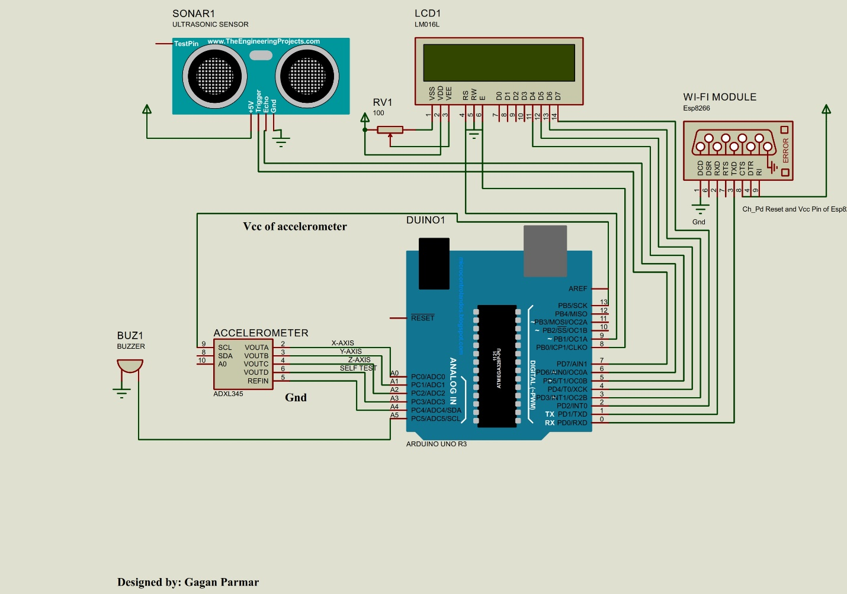

**FLOW DIAGRAM –**

1. In setup Initialization of Pins for accelerometer and Ultrasonic Sensor is done.
2. Two different Functions are used for accelerometer and ultrasonic sensor
   1. In ultrasonic sensor trigger pin is used as output pin, while echo is used as input pin. A pulse is sent for about 10us to trigger the module. Here ultrasonic sensor is used for obstacle detection
   2. Distance of obstacle is calculated by Reading based on echopin.
3. In subroutine of Accelerometer reading of all the three axis is obtain on the basis of the reading a buzzer tone is generated.

