**PROJECT REPORT ON**

**“Ship Intrusion System Using Accelerometer”**

**Submitted in Partial Fulfillment of the Requirements**

**For the Award**

**Of**

**Degree of B. Tech**

**To**



**University,**

**Under the Guidance of**

**Submitted By:**

**\*Member1* *Member2\***

**\*Member3* *Member4\***



**Electronics and Communication Department**

**\*College Name\***

**CONTENTS**

hardware and software requirements

hardware used

JUMPER WIRES

ADXL345

Esp8266

ARDUINO UNO

software used

ARDUINO SDK

XAMPP

working

1. **HARDWARE AND SOFTWARE REQUIREMENTS**
   1. **HARDWARE USED**

The Hardware which can be employed to implement the code generated in this project is listed below:

* Jumper wires
* Arduino uno
* Esp8266
* ADXL345
  + 1. **JUMPER WIRES**

A jump wire (also known as jumper, jumper wire, jumper cable, DuPont wire, or DuPont cable – named for one manufacturer of them) is an electrical wire or group of them in a cable with a connector or pin at each end (or sometimes without them – simply "tinned"), which is normally used to interconnect the components of a breadboard or other prototype or test circuit, internally or with other equipment or components, without soldering.

Individual jump wires are fitted by inserting their "end connectors" into the slots provided in a breadboard, the header connector of a circuit board, or a piece of test equipment.

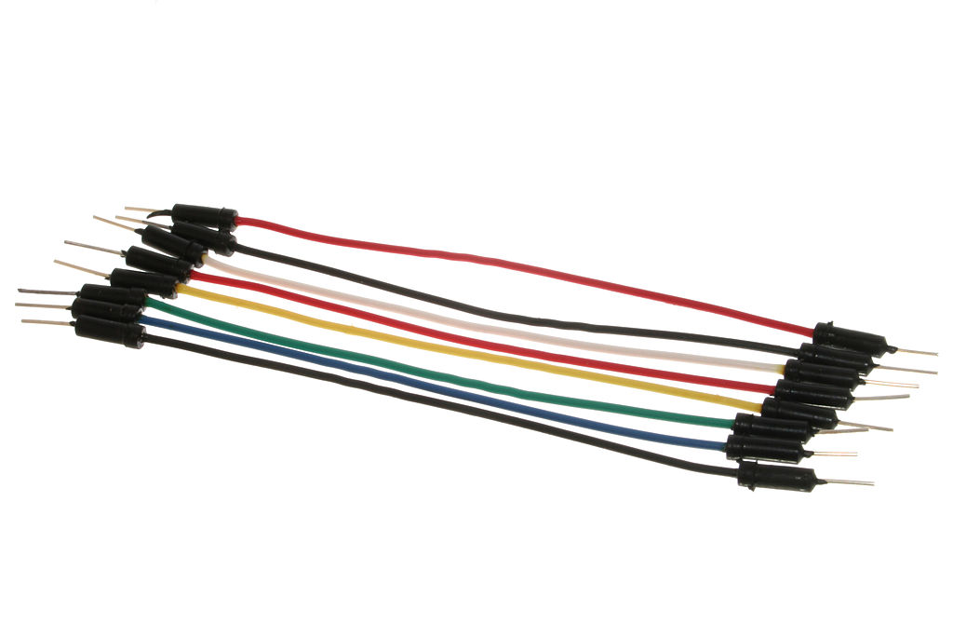

Figure Jumper wires

* + 1. **ARDUINO UNO**

Arduino is an open-source project that created microcontroller-based kits for building digital devices and interactive objects that can sense and control physical devices.

The project is based on microcontroller board designs, produced by several vendors, using various microcontrollers. These systems provide sets of digital and analog input/output (I/O) pins that can interface to various expansion boards (termed shields) and other circuits. The boards feature serial communication interfaces, including Universal Serial Bus (USB) on some models, for loading programs from personal computers. For programming the microcontrollers, the Arduino project provides an integrated development environment (IDE) based on a programming language named Processing, which also supports the languages C and C++.

The first Arduino was introduced in 2005, aiming to provide a low cost, easy way for novices and professionals to create devices that interact with their environment using sensors and actuators. Common examples of such devices intended for beginner hobbyists include simple robots, thermostats, and motion detectors.

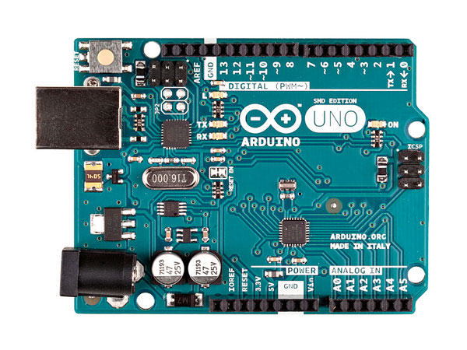

* + 1. **ESP8266**

The ESP8266 is a low-cost Wi-Fi microchip with full TCP/IP stack and microcontroller capability produced by Shanghai-based Chinese manufacturer, Espressif Systems.

The chip first came to the attention of western makers in August 2014 with the ESP-01 module, made by a third-party manufacturer, Ai-Thinker. This small module allows microcontrollers to connect to a Wi-Fi network and make simple TCP/IP connections using Hayes-style commands. However, at the time there was almost no English-language documentation on the chip and the commands it accepted. The very low price and the fact that there were very few external components on the module which suggested that it could eventually be very inexpensive in volume, attracted many hackers to explore the module, chip, and the software on it, as well as to translate the Chinese documentation.

The ESP8285 is an ESP8266 with 1 MiB of built-in flash, allowing for single-chip devices capable of connecting to Wi-Fi.

The successor to these microcontroller chips is the ESP32.

* + 1. **ADXL345**

The ADXL345 is a small, thin, ultra low power, 3-axis accelerometer with high resolution (13-bit) measurement up to ±16 g. Digital output data is formatted as 16-bit twos complement and is accessible through either a SPI (3- or 4- wire) or I2C digital interface.

The ADXL345 is well suited for mobile device applications. It measures the static acceleration of gravity in tilt-sensing applications, as well as dynamic acceleration resulting from motion or shock. Its high resolution (4mg/LSB) enables resolution of inclination changes of as little as 0.25°.

Several special sensing functions are provided. Activity and inactivity sensing detect the presence or lack of motion and if the acceleration on any axis exceeds a user-set level. Tap sensing detects single and double taps. Free-Fall sensing detects if the device is falling. These functions can be mapped to interrupt output pins. An integrated 32 level FIFO can be used to store data to minimize host processor intervention.

* 1. **SOFTWARE USED**
* **Arduino IDE**

The Arduino Integrated Development Environment - or Arduino Software (IDE) - contains a text editor for writing code, a message area, a text console, a toolbar with buttons for common functions and a series of menus. It connects to the Arduino and Genuino hardware to upload programs and communicate with them.

1. Arduino Link  
 <https://www.arduino.cc/download_handler.php>

2. Wifi Link(esp8266 setup link)

<http://www.instructables.com/id/How-to-Install-ESP8266-Into-Arduino-IDE/>

* **Xampp**

XAMPP is a free and open source cross-platform web server solution stack package developed by Apache Friends,consisting mainly of the Apache HTTP Server, MariaDB database, and interpreters for scripts written in the PHP and Perl programming languages. XAMPP stands for Cross-Platform (X), Apache (A), MariaDB (M), PHP (P) and Perl (P). It is a simple, lightweight Apache distribution that makes it extremely easy for developers to create a local web server for testing and deployment purposes. Everything needed to set up a web server – server application (Apache), database (MariaDB), and scripting language (PHP) – is included in an extractable file. XAMPP is also cross-platform, which means it works equally well on Linux, Mac and Windows. Since most actual web server deployments use the same components as XAMPP, it makes transitioning from a local test server to a live server extremely easy as well..

Xampp Link –

<https://www.apachefriends.org/xampp-files/7.2.0/xampp-win32-7.2.0-0-VC15-installer.exe>

* **WORKING OF THE PROJECT**

1. In this system, the ship intrusion is going to be detected by placing three-axis accelerometers at the sea surface.
2. The waves which are generated by the ocean and intruder ships are analyzed by the accelerometer and the signal is processed by the controller. Hereby using Battery Pack the Microcontroller is powered up, the input of the accelerometer sensor is given to the microcontroller.
3. The controller will transmit the data from the sea-shore section to the server pc via a wireless communication medium (Wi-Fi).The accelerometer will distinguish both the signals and sends an individual data to the controller.
4. The accelerometer and ship status is displayed in the system which is connected to the Wi-Fi Network.
5. Once connected you have to open the link - <http://localhost/ship_int/>

And operate on the controls provided.

* **XAMPP SETUP**

1. Install Xampp using the link provided-<https://www.apachefriends.org/xampp-files/7.2.0/xampp-win32-7.2.0-0-VC15-installer.exe>
2. Once installed, open start menu and search Xampp, open the control panel and start the Apache and Mysql Services. Make sure both of them turn green.
3. Download the mailed folder and extract – ship_int folder. The folder should be placed in Local Disk C:/xampp/htdocs.
4. Open <http://localhost/phpmyadmin/> , on the left side click New. Use the Database name – ship_int and create. Once created, you’ll see on the left side you’ll see ship_int as database name. Now go to the top panel and click import.
5. Browse the file, ship_int.sql present in C:/xampp/htdocs/ship_int/ . Import the file and you can see the addition of table name – record.
6. Open <http://localhost/ship_int/> to start the controlling and Monitoring.

* **BASIC SETUP**

1. Power on the Arduino Board and Wifi Board.
2. Once the power is on , scan wi-fi network in your controlling system i.e the laptop. Connect to the network.
3. Open Open <http://localhost/ship_int/> to start the controlling and Monitoring.