Arduino Nano – 3 pieces:

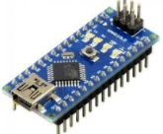

4\*4 matrix keypad – 3 Pieces

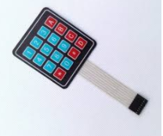

434 MHz Tx/Rx – 3 pieces

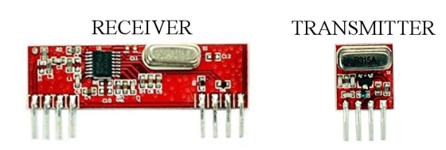

LCD Screen 16\*2

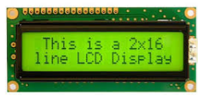

9V battery & Clip-3 pieces

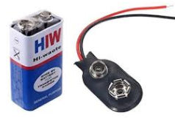

Male to male jumper wires – 15

10K or 20K ohm potentiometer

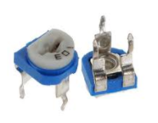

General purpose PCB Plates – 3 Pieces

