(College logo)


Project synopsis on
Electronic Voting Machine 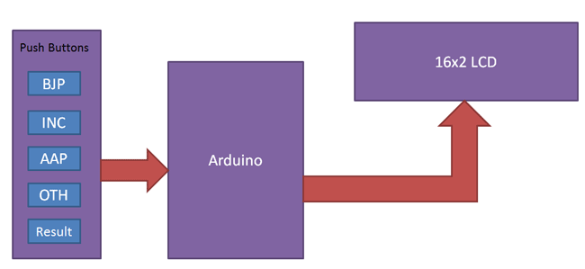
Under taken by:
Name 1 Roll no. 1 Name 2 Roll no. 2
Name 3 Roll no. 3 Name 4 Roll no. 4

ABSTRACT:
EVM or Electronic Voting machine is used to cast votes electronically. They are a secure machine and programmed using Arduino. When a person cast a vote to a particular party, the given segment gets incremented by 1. These machines are highly used in Elections and being tested regularly to maintain a fair result.
ABOUT THE TECHNOLOGY:
We have used four different candidates to implement this, though we can increase this number. When a voter press any of the required buttons the variable associated with that particular party gets incremented by 1. Circuit of this project is quite easy which contains Arduino, push buttons and LCD. Arduino controls the complete processes like reading button, incrementing vote value, generating result and sending vote and result to LCD.

HARDWARE USED

- Arduino Uno
- 16x2 LCD
- Push button
- Bread board
- Power
- Connecting wires
SOFTWARE
Microcontroller HEX File Uploader
APPLICATIONS:
- Fair and Secure Voting
- Automated Results
- A mobile device
- Accurate Result

REFERENCES:

https://circuitdigest.com/microcontroller-projects/electronic-voting-machine-using-arduino

http://www.instructables.com/id/Arduino-Voting-machine/

