(College logo)

Project synopsis on
SUN TRACKING SOLAR PANEL
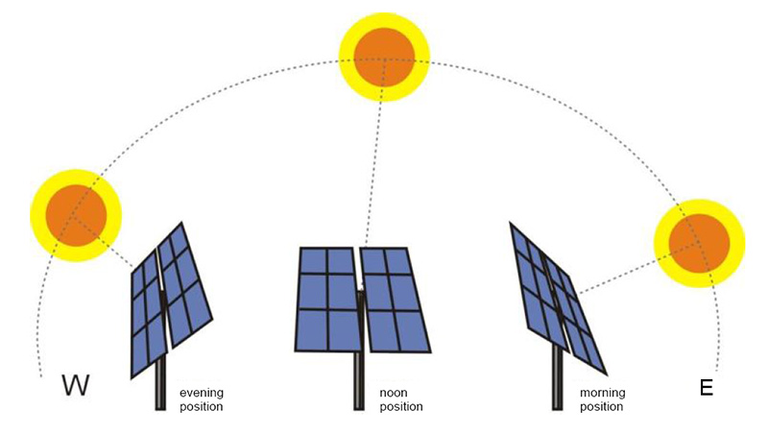
Under taken by:
Name 1 Roll no. 1 Name 2 Roll no. 2
Name 3 Roll no. 3 Name 4 Roll no. 4
ABSTRACT:
As the non-renewable energy resources are decreasing, use of renewable resources for producing electricity is increasing. Solar panels are becoming more popular day by day. Solar panel absorbs the energy from the Sun and is stored in the battery. This energy can be utilized when required. Utilization of the energy stored in batteries is mentioned in below given applications. Solar panels should absorb energy to a maximum extent. This can be done only if the panels are continuously placed towards Sun direction. So solar panel should continuously rotate in the direction of Sun. This project describes about circuit that rotates solar panel.
The project uses a solar panel coupled to a stepper motor to track the Sun so that maximum sun light is incident upon the panel at any given time of the day. This is better compared to light sensing method that may not be accurate always for example during cloudy days.
Use of solar panel to convert sun’s energy to electrical is very popular, but due to transition of the Sun from east to west the fixed solar panel may be able to generate optimum energy. The proposed system solves the problem by an arrangement for the solar panel to track the Sun.
This tracking movement is achieved by coupling a stepper motor to the solar panel such that the panel maintains its face always perpendicular to the Sun to generate maximum energy. This is achieved by using a programmed microcontroller to deliver stepped pulses in periodical time intervals for the stepper motor to rotate the mounted panel as desired.
Further the project can be enhanced by using RTC (Real Time Clock) to follow the Sun. This helps in maintaining the required position of the panel even if the power is interrupted for some time.

WORKING PRINCIPLE
The Sun tracking solar panel consists of two LDRs, solar panel and stepper motor and Arduino Micro controller.
Two light dependent resistors are arranged on the edges of the solar panel. Light dependent resistors produce low resistance when light falls on them. The stepper motor connected to the panel rotates the panel in the direction of Sun. Panel is arranged in such a way that light on two LDRs is compared and panel is rotated towards LDR which have high intensity i.e. low resistance compared to other. Stepper motor rotates the panel at certain angle.
When the intensity of the light falling on right LDR is more, panel slowly moves towards right and if intensity on the left LDR is more, panel slowly moves towards left. In the noon time, Sun is ahead and intensity of light on both the panels is same. In such cases, panel is constant and there is no rotation.
The stepper motor is driven by an interfacing IC as the controller is not capable of handling the power requirements of the stepper motor. The project is provided with a dummy solar panel which can be used for demonstration purpose only.

- HARDWARE

- Arduino UNO
- LCD Screen 16*2
- Stepper Motor
- Solar Panel
- L293D Motor Driver IC
- Electrolytic Capacitor
- Ceramic Capacitor
- DC Power Supply
- LDR

- SOFTWARE

- Arduino IDE

BLOCK DIAGRAM
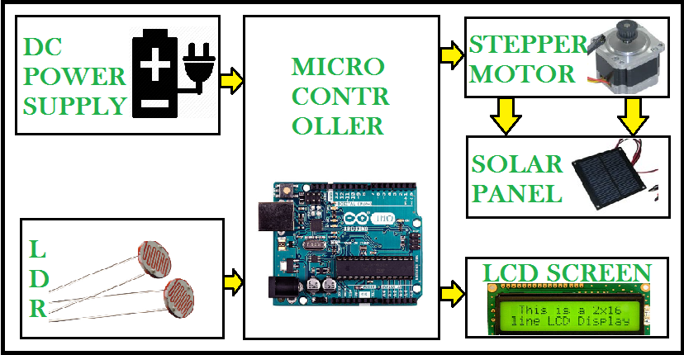

APPLICATIONS
- Trackers generate more electricity than their stationary counterparts due to increased direct exposure to solar rays. This increase can be as much as 10 to 25% depending on the geographic location of the tracking system.
- There are many different kinds of solar trackers, such as single-axis and dual-axis trackers, all of which can be the perfect fit for a unique jobsite. Installation size, local weather, degree of latitude and electrical requirements are all important considerations that can influence the type of solar tracker best suited for a specific solar installation.
- Solar trackers generate more electricity in roughly the same amount of space needed for fixed tilt systems, making them ideal for optimizing land usage.
- In certain states some utilities offer Time of Use (TOU) rate plans for solar power, which means the utility will purchase the power generated during the peak time of the day at a higher rate. In this case, it is beneficial to generate a greater amount of electricity during these peak times of day. Using a tracking system helps maximize the energy gains during these peak time periods.
- Advancements in technology and reliability in electronics and mechanics have drastically reduced long-term maintenance concerns for tracking systems.

REFERENCES:
faadooengineers.com/threads/5453-Automatic-sun-tracking-system-seminar-report-pdf-ppt-download
http://www.electronicshub.org/sun-tracking-solar-panel/
https://www.slideshare.net/shasze/automatic-sun-tracking-system
http://electrofriends.com/projects/basic-electronics/automatic-solar-tracking-system-2/
https://en.wikipedia.org/wiki/Solar_tracker

